**Introduction and Problem Statement:** Power systems are under fundamental changes in their structure, moving from centralized operation to distributed operation. In such a transformation, distributed energy resources (DERs) play a significant role in providing energy locally at customer side for benefits such as avoiding long distance power transmission, causing extra costs and power losses. Due to DER’s intermittent generation, uncertain power flow fluctuation becomes a key issue in the power system transformation. For this reason, customer owned battery systems (COBS) are introduced to ensure controllability of DERs for a safe system operation. With states passing laws requiring an significant increases of their dependability on DER [1], widespread use of COBS is inevitable because their flexible operation can manage variable energy generation and increase on renewable generation capacity of circuits [2]. Identifying and operating COBS, however, will be nontrivial mainly because of their distributed nature and the limited knowledge and control utilities will have over the devices. For example, many utilities do not have policies requiring customers to report PV or COBS installations. Even worse, since batteries are not yet commonly adopted, there is not enough data to witness the impacts. Finally, there is no simple, efficient, and accurate way for utilities to assess the benefits of a COBS (or a network of COBSs) on a distribution circuit. Therefore, it is likely utilities will be forced to limit the DER on a circuit, even though it may be capable of handling much more with the widespread use of COBS. Such an underutilization problem is faced by many utilities in U.S. and nationwide.

The question, therefore is “What can be done to prepare utilities to leverage benefits of COBS?” While one can look into the transmission grid to learn from its operational approach for its large-scale batteries, it is hard for utilities to employ the strategies due to limited monitoring and control capability for many fast-aging local grids. Fortunately, new (heterogeneous) sources of data are being collected by smart meters and other sensor technologies, giving utilities the ability to monitor their circuits better than ever before. But, unfortunately, most utilities (if not all of them) have been unable to fully leverage this new wealth of data. This proposal will combine modern techniques and new technology to use accessible utility data based on the PI’s working experience in Duquesne Light Company (DLC) in Pittsburgh, PA to accurately identify COBS locations, extract their physical and operational parameters, and assess their impact on a distribution circuit. Leveraging the existing NDA between Arizona State University and DLC, I will collaborate with the experts at ASU to merge data, employ rigorous mathematical analysis, and engineer new services for COBS applications. For example, Fig. 1 is a big data platform for power system analysis that locates at the lab that I am currently working at. With such a platform capable of analyzing Terabytes of data in a few seconds, the lab aims at using machine learning algorithms for knowledge discovery and artificial intelligence. My research will leverage such a platform and the diversified courses in the power area and computer sciences area provided by ASU.

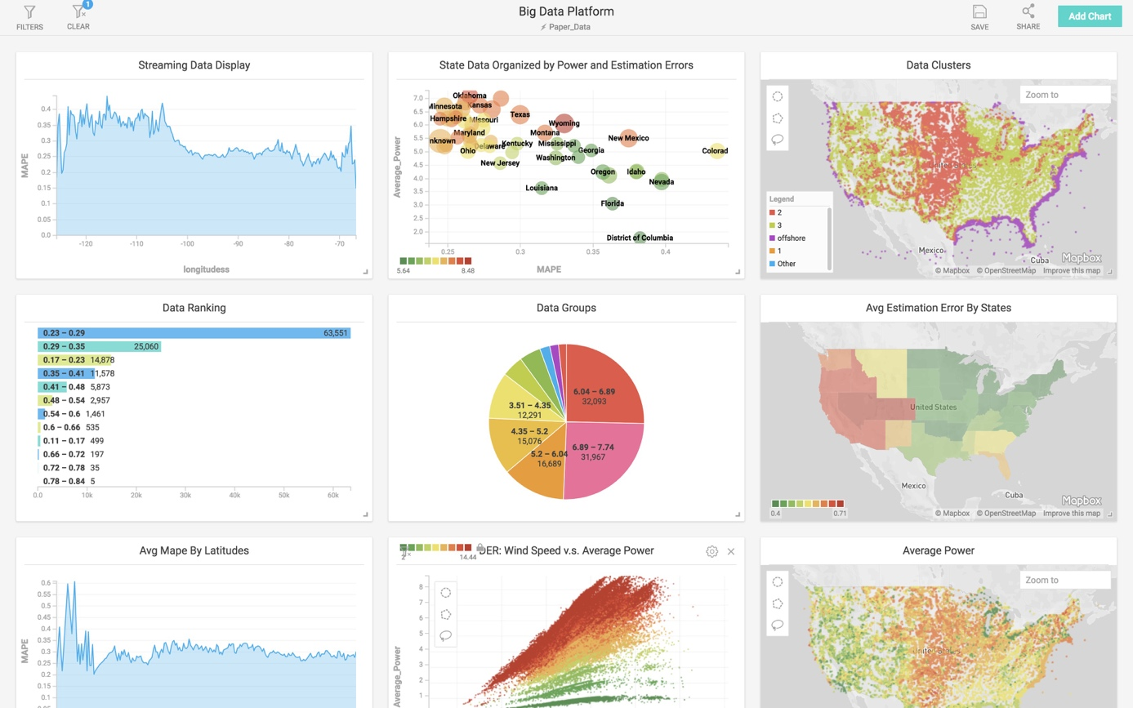

*Figure 1: Big data analytics platform at ASU.*

**Intellectual Merit:** This work significantly expands on the current state-of-the-art PV identification work completed by ASU [3] to battery identification, e.g., COBS. For example, Figure 2 displays an idea example of how a COBS alters a load profile by shifting the peak load. With such a unique pattern on load change, one can easily design a process for COBS identification. Such an identification can immediately reveal key information for distribution system operators. For example, one can extract operational and physical parameters such as battery size, discharge and charging rate, normal operational function, starting charge time, and potentially even the current state-of-charge (SOC). Consequently, accurate system modeling can be achieved for grid monitoring and control.

However, it would be nearly impossible for an engineer to see the ideal case like Figure 2. This is because one cannot easily determine the uncertainties of customer loads, making COBS identification hard with diversified customer load patterns. This calls for a data-driven approach for online pattern recognition and real-tiem adaptation. The goal is to create an eco-system for machine learning algorithms to interact with the vast spectrum of heterogeneous data types.

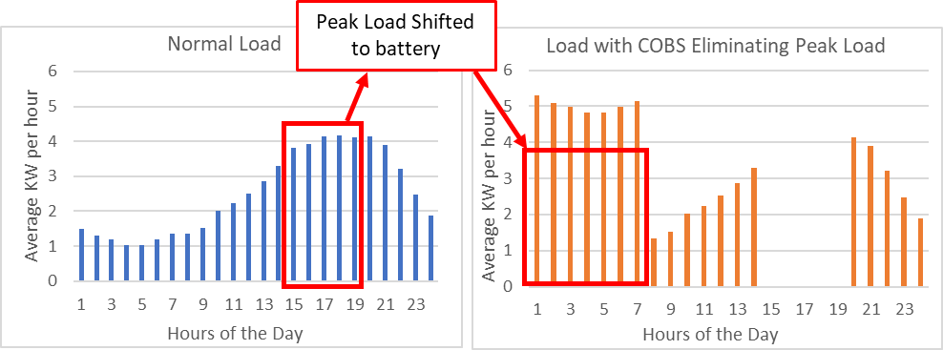

*Figure 2:* The peak demand rate spans 3-8pm. The right profile shows the altered smart meter data if the peak load seen by the utility was eliminated by a battery. Normal load profile data extracted from [4].

Specifically, data are the key for designing the machine learning algorithms when COBS has a large penetration in the near future. However, there is a in the current system So, I will first extract typical battery control algorithms from utility the smart meter data. Then, such algorithms will be used to generate a large-scale customer load profiles with a wide-variety of patterns to mimicking different sizes and operations of COBS.

To make the data more realistic on a utility scale, we will combine the generated data with other heterogenous data types (expected PV generation, utility rates, temperature, etc.) for our learning algorithms. For this purpose, a probabilistic graphical model for quantify uncertainties will be created to guide development of a computationally efficient data-driven framework for COBS identification and parameter extraction. The results from the probabilistic model will be implanted in a supervised machine learning algorithm which will be trained to identify COBS and extract their parameters. By correlating different key factors in a graphical model, our proposed data-driven process will ensure a highly accurate and mathematically verifiable tool for COBS analysis.

Contingent upon successful COBS identification and parameter extraction, I will develop a software addition for OpenDSS, which is an open source distribution system simulator. The goal is to use the extracted battery parameters to test the impact of COBS on a distribution circuit model. Further, engineers could use this tool to adjust COBS operational parameters to investigate if they can improve and/or optimize distribution circuit performance.

**Broader Impact:** Successful application of the proposed project will give distribution system operators and planning engineers necessary information and tools to fully leverage COBS benefits on different distribution circuit nationwide. These tools will be able to assess the impact of storage devices on the distribution system, provide solutions to improve system operation, and give planning engineers the capability to safely increase the allowable DER in their systems. This will ultimately allow utilities to maximize DER integration on their circuits for achieving 100% renewable resource dependability. The implementation will use real data that are currently available to utilities, resulting in an inexpensive yet deliciated solution for modernizing the century-old power grid. Finally, this project will expand upon the wealth of knowledge and experience in machine learning for power systems at ASU. Realistic data from existing NDAs with geographically complementary locations (Salt River Public Utility in Phoenix (Southwest) and Duquesne Light Company in Pittsburgh (Northeast)) will be used for validation the use cases in different areas of United States.

**References:**

|  |  |
| --- | --- |
| [1] | U.S. Energy Information Administration (EIA), "U.S. Energy Information Administration - EIA - Independent Statistics and Analysis," [Online]. Available:  https://www.eia.gov/state/analysis.php?sid=AZ. [Accessed 2018]. |
| [2] | S. Hashemi and J. Østergaard, "Efficient Control of Energy Storage for Increasing the PV Hosting Capacity of LV Grids," *IEEE Transactions on Smart Grid,* vol. 9, no. 3, pp. 2295-2303, May 2018. |
| [3] | Y. Weng, C. Faloutos and M. Ilic, "PowerScope: Early Event Detection and Identification in Electric Power Systems," in *The European Conference on Machine Learning and Principles and Practice of Knowledge Discovery in Databases (ECML/PKDD)*, Nancy, France, 2014. |
| [4] | OpenEI, "OpenEI Datasets," [Online]. Available:  https://openei.org/datasets/files/961/pub/EPLUS_TMY2_RESIDENTIAL_BASE/. [Accessed 2018]. |