**Introduction and Problem Statement:** Customer Owned Battery Systems (COBS) can be used to ensure safe operation of distributed energy resources (DER). With laws in Hawaii and California requiring 100% renewable energy dependability in the next few decades and other states passing laws requiring increases in DER [1], widespread use of distributed COBS is inevitable because their flexible operation can increase DER penetration on a circuit [2]. Identifying and operating COBS, however, will be nontrivial mainly because of their distributed nature and the limited knowledge and control utilities will have over the devices. For one reason, many utilities do not have policies requiring customers to report PV or COBS installations. Second, since batteries are not yet commonly adopted, there is not enough data to witness the impacts. Finally, there is no simple, efficient, and accurate way for utilities to assess the benefits of a COBS (or a network of COBSs) on a distribution circuit. Unless utilities are prepared for the widespread use of COBS, utilities will be forced to limit the DER on a circuit, even though it may be capable of handling much more.

The question, therefore is “What can be done to prepare utilities to leverage benefits of COBS?” The answer lies in harnessing modern techniques and tools to create a framework for COBS identification and control. New (heterogeneous) sources of data are being collected by smart meters and a range of sensor technologies. New software has been developed that can efficiently complete power flow analysis and leverage the new data available to utilities. Also, algorithms developed at ASU can identify other customer owned PV that could be expanded to identify COBS [3]. This proposal will leverage both the technology and theory of the new tools to accurately identify and assess the impact COBS have on the distribution system. Specifically, by collaborating with the experts at ASU I will merge data, rigorous mathematical analysis, and engineering applications into machine learning algorithms with provable performance.

**Intellectual Merit:** This work significantly expands on the current state of the art PV identification by implementing the extraction and operation of COBS. Not only will it identify the locations of the COBS, but operational and physical parameters can be extracted such as battery size, discharge rate, normal operational function (back-up power or peak shaving), normal charging time, charging rate, and even the current state-of-charge (SOC). First, I will use battery control algorithms on a database of utility smart meter data to generate a wide variety of data representing different sizes and operations of COBS. This is necessary because of the lack of COBS being used today. Second, I will use probabilistic graphical models to guide development of a computationally efficient data-driven framework for COBS identification and parameter extraction. Specifically, a supervised machine learning algorithm capable of using heterogenous data types (historical smart meter data, expected PV generation at a customer’s location, utility rates, and others) to identify COBS. By training the algorithm with data from customers with and without COBS it will be able to separate the customers and use the nuances in the data to extract the battery parameters. Figure 1 shows an example of how AMI data seen by the utility might differ if a customer installed a battery capable of powering all the load during the peak hours. Once a COBS is identified, the operation of the battery is expected to be periodic enough to extract the parameters after a couple of days with high degree of accuracy.

I will then develop a software tool tailored for OpenDSS, an open source distribution system simulator, to use the extracted battery parameters to test the impact of the COBS on a distribution circuit. Lastly, an algorithm will be developed to adjust operational parameters of the COBS to optimize distribution circuit performance. Together, these tools will be able to assess the impact of storage devices on the distribution system, provide solutions to improve system operation, and give planning engineers the capability safely integrate DER into their system.

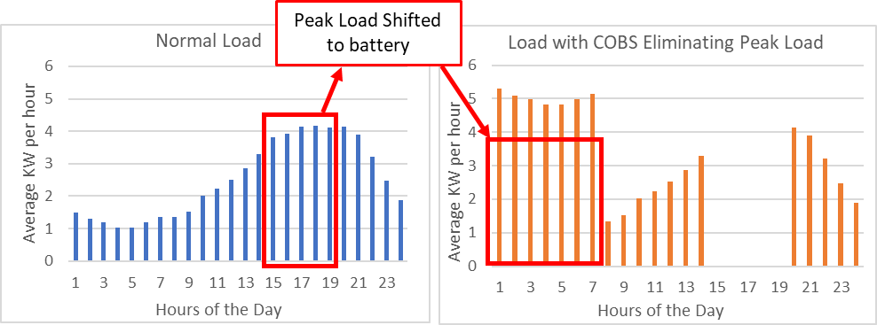

*Figure 1:* The peak hours span 5 hours (3-8pm). The figure on the right shows what AMI data seen by the utility may look like if all the load during the peak hours was powered by a battery. Eliminating peak load will significantly reduce the monthly bill for many utilities rates. Load data was taken from [4].

**Broader Impact:** Successful application of the proposed project will give distribution system operators and planning engineers all the information necessary to fully leverage the COBS in a distribution system. This will ultimately allow utilities to maximize DER integration on their circuits, which will be necessary to achieve 100% renewable resource dependability. It will use heterogenous data that utilities normally have access to and previously installed communication networks, resulting in an inexpensive yet sophisticated solution. This project will expand on the wealth of knowledge and experience in machine learning for power systems at ASU. Realistic data from existing NDAs (Salt River Public Utility in Phoenix and Duquesne Light Company in Pittsburgh) will be used for validation.

**References**

**:**

|  |  |
| --- | --- |
| [1] | U.S. Energy Information Administration (EIA), "U.S. Energy Information Administration - EIA - Independent Statistics and Analysis," [Online]. Available:  https://www.eia.gov/state/analysis.php?sid=AZ. [Accessed 2018]. |
| [2] | S. Hashemi and J. Østergaard, "Efficient Control of Energy Storage for Increasing the PV Hosting Capacity of LV Grids," *IEEE Transactions on Smart Grid,* vol. 9, no. 3, pp. 2295-2303, May 2018. |
| [3] | Y. Weng, C. Faloutos and M. Ilic, "PowerScope: Early Event Detection and Identification in Electric Power Systems," in *The European Conference on Machine Learning and Principles and Practice of Knowledge Discovery in Databases (ECML/PKDD)*, Nancy, France, 2014. |
| [4] | OpenEI, "OpenEI Datasets," [Online]. Available:  https://openei.org/datasets/files/961/pub/EPLUS_TMY2_RESIDENTIAL_BASE/. [Accessed 2018]. |