使用autolayout后获取frame不正确

1. 简述：如题。
2. 解决方法：从view controller生命周期看，

view did load

view will appear

view will layout subviews

view did layout subviews

view did appear

view will disappear

view did disappear

分别在view did load, view will appear, view will layout subviews, view did layout subviews, view did appear里面打印下image view 的frame.

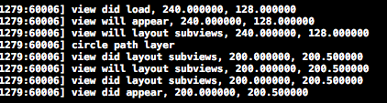

屏幕快照 2016-01-15 上午11.18.54.png

发现，从view did layout subviews开始才正确。所以应该把视图配置代码放在这个方法里，并且设置flag防止多次执行配置代码