////////////////////////////////////////////

Nural Network Model Report

////////////////////////////////////////////

Overview:

--------------------------------------------

The purpose of this analysis was to create a model to be used to predict the success rate of applicants who requested funding from a fictional non-profit.

Such a model would allow for only applicants likely to succeed undergoing additional review for selection, both improving the odds of funding successful ventures and saving time for reviewers.

Results:

--------------------------------------------

Data Preprocessing

Model Targets:

“IS_SUCCESSFUL” column from provided CSV

Model Variables:

“APPLICATION_TYPE”, “AFFILIATION”, “CLASSIFICATION”, “USE_CASE”, “ORGANIZATION”, “INCOME_AMT”, “SPECIAL_CONSIDERATIONS”, and “ASK_AMT” columns from provided CSV

Columns Removed from Model:

“NAME”, “EIN”, “STATUS” columns from provided CSV

These columns should have no effect on the success rate and thus may hinder the model rather than help.

Compiling, Training, and Evaluating the Model

The end model used 4 layers of 110, 55, 25, and 1 neuron, respectively. The activation functions used were relu for the first 3 and sigmoid for the output layer.

This is because there were 55 features after PCA was completed. 110 neurons on the first layer left 2 for each feature and narrowed down to 1 for the output. This output layer used sigmoid as the activation function so we would be returned a probability between 0 and 1.

Unfortunately, after trying multiple different layouts, we were not able to achieve the desired 75% accuracy score, instead with a score of 72.95%

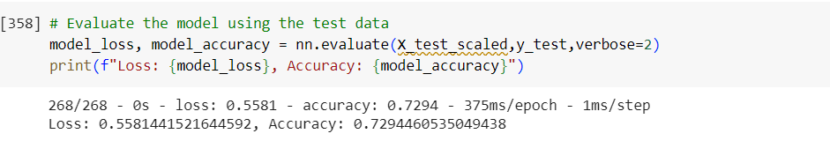

There were 3 attempts made at optimization total, per the requirements.

Attempt 1:

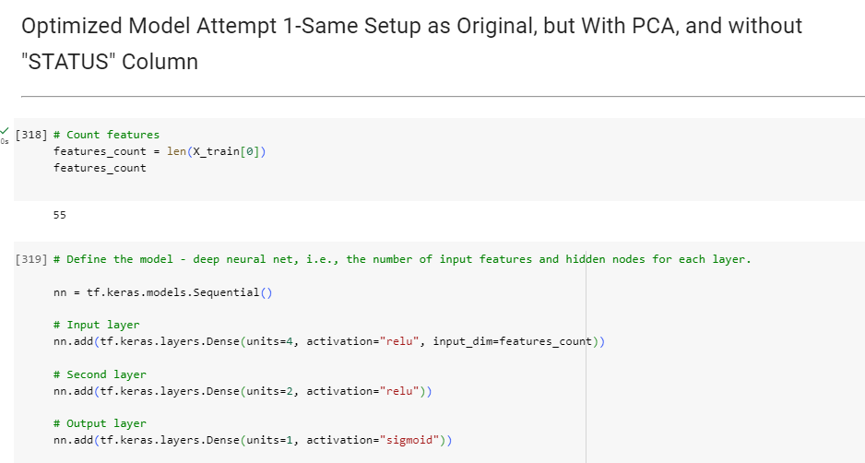

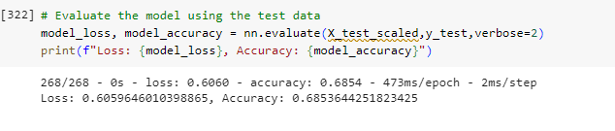

Attempt 2:

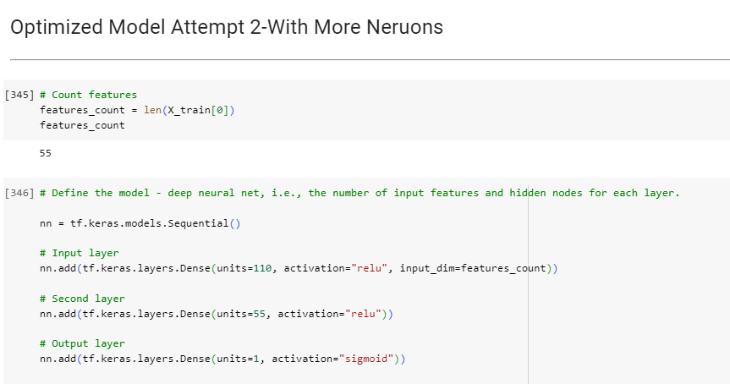

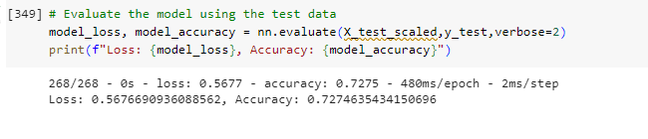

Attempt 3: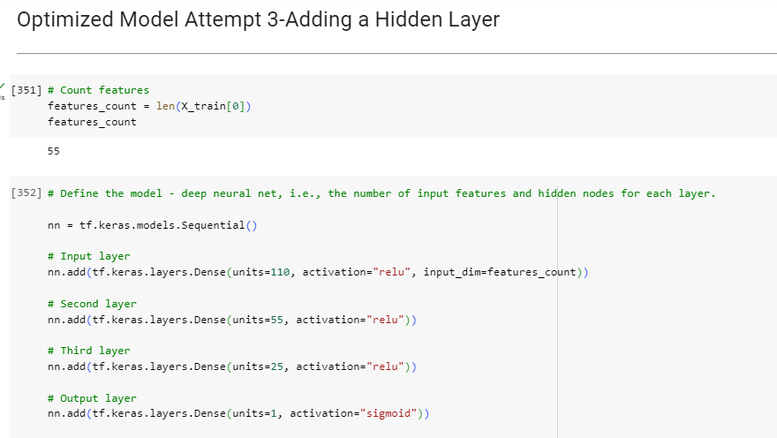

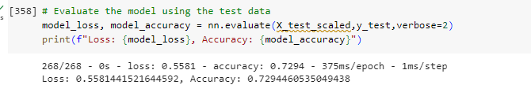

Summary:

--------------------------------------------

Overall, this model did succeed in predicting the success or failure of applicants for funding from the non-profit using the provided data, but not with enough certainty to rely heavily on it.

In order to create a better, more accurate model, it would be interesting to try a supervised learning model, such as birch or random forest as not only may this provide better results, but added explainability for the model’s use in the business if audited on the decision-making process.

Another way to get potentially more accurate results would be to collect more data on the applicants to train the model.