Project 3 Proposal

* A brief articulation of your chosen topic and rationale
  + Our chosen topic is the visualization of data for various soccer leagues, teams, and players designed in an interactable table that allows filtering by multiple criteria and provides additional statistics for individual players when clicked.
* A link to your dataset(s) and a screenshot of the metadata, if it exists.
  + Leagues: <http://sports.core.api.espn.com/v2/sports/soccer/leagues?lang=en&region=us>

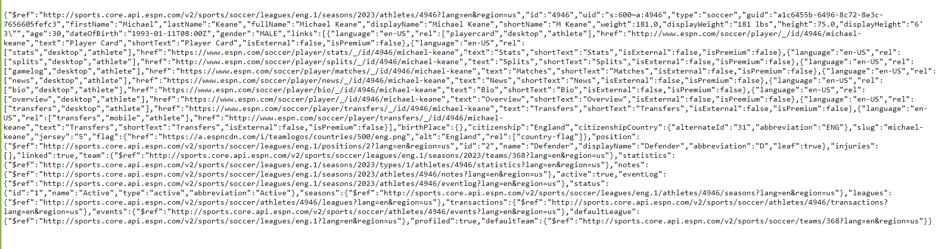

* Three or four screenshots of relevant, “inspiring” visualizations that show your creative ideas.

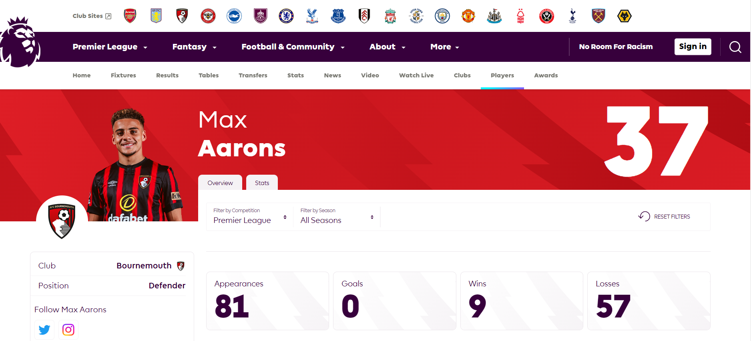

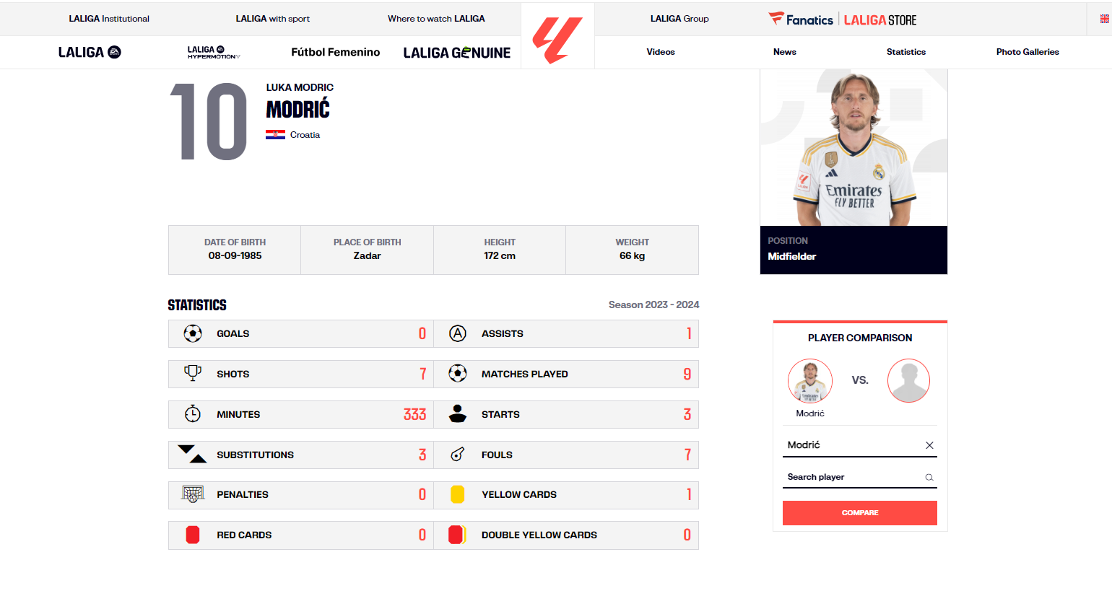

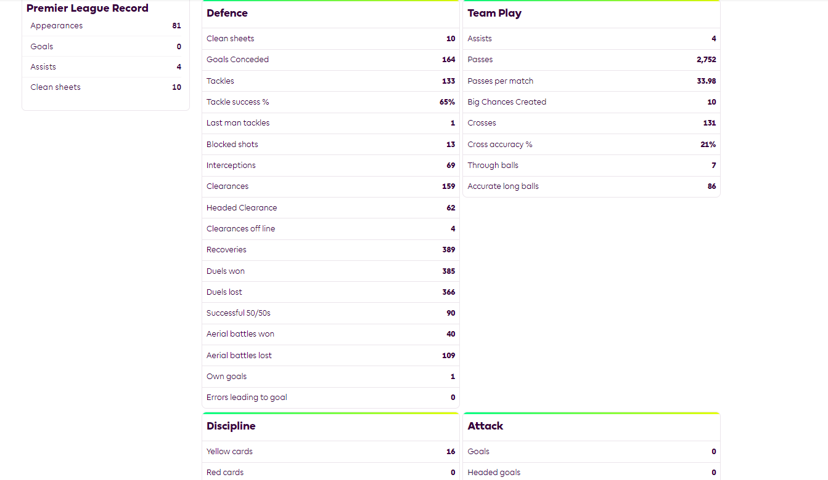

* A sketch of the final design

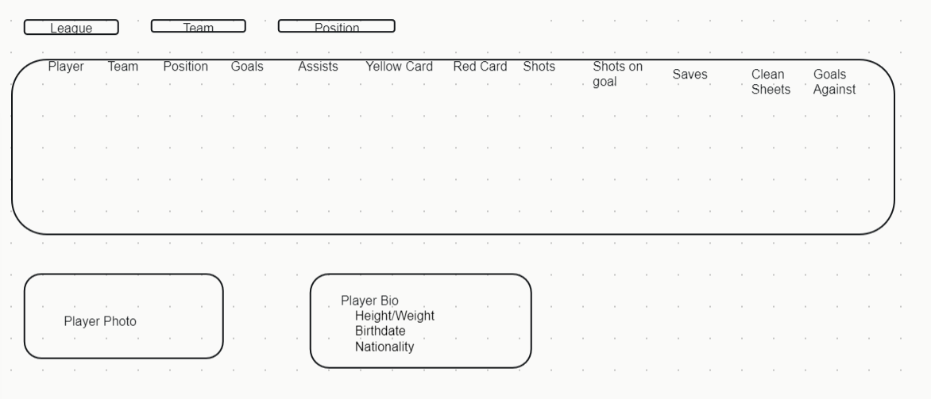

* A link to the primary GitHub repository where you’ll be housing your work
  + <https://github.com/cwolf1424/Project_3.git>