Lab 2: Introduction to Arduino - Part 2

|  |  |
| --- | --- |
| to: | Chad McConnell |
| from: | Cory Wolfe and prehit patel |
| section: | MAE 311L - 06 |
| Lab date: | 24/01/2017 |
| Due Date: | 31/01/2017 |
|  |  |

1. SUMMARY

For this lab report the group performed a series of basic functions with an Arduino, LEDs, resistors, a breadboard and a button. The experiment covered basics such as debouncing and the use of the serial monitor. The serial monitor was used to display what the code was doing, while the LED and resistor were a physical representation of what was happening. In addition, debouncing was accomplished through code, in order to make the button perform more appropriately.

1. results and analysis
2. Subsection 1

The first section of the lab involved opening up the serial monitor in the IDE and displaying information through the Arduino on the computer. This was initially used to count to 100, then moved on to displaying which of a series of LEDs was turned on. After this, the utilization of the serial monitor was extended to the use of buttons. The button was wired in a way that allowed it to turn on the LED, while sensing the status of a pin. This allowed the group to utilize the read function, as shown in Figure 1. The use of the buttion also allowed the group to experience problems with "bouncing" which was resolved later in the lab. The solution for the bouncing issue, debouncing, is shown in Figure 2 and checked for random fluctiuations in the button's state. After the debouncing was solved, the LED was then wired to utilize button states, which allow for the cycling of functions, such as turning off or blinking the LED.

|  |
| --- |
|  |

**Figure 1: Reading From Pins**

**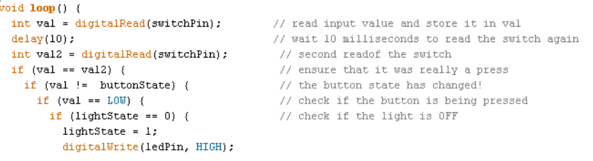  
Figure 2: Debouncing**

Exercises I:

**3. References**

1. Armentrout, D., “MAE 311L Lab 1: Introduction to Arduino,” Lab Manual, MAE Dept., Univ. Alabama in Huntsville, 2015.
2. Simon Monk, *Programming Arduino: Getting Started with Sketches*, 2nd ed, McGraw Hill, 2016.