|  |
| --- |
| **Mini Project**  MAE 311L - Section 06 |
| *Authors: Prehit Patel*  Cory Wolfe  *Lab Performed: 2017-01-31*  *Due Date: 2017-02-14*  *Lab Instructor:*Chad McConnell |

# Abstract

For this Project the group was tasked with completing a series of tasks involving LEDs and buttons. The end goal of the Project was to extend the group's ability to program and utilize the Arduino. This was done by running the LEDs through several light patterns, either dependent on time or whether a button has been pressed. This allowed the group to independently develop skills for utilizing the Arduino and its ability to interface with other devices.

# Background

## Initial Setup and Given Information

The group began by constructing the circuit diagram as shown in Figure Figure. In addition to the layout of the circuit diagram the group also received tables that directed how the light should operate in two of its three light states. These tables are shown in Tables 1 and 2, the third light stateis simply all LEDs turned off.

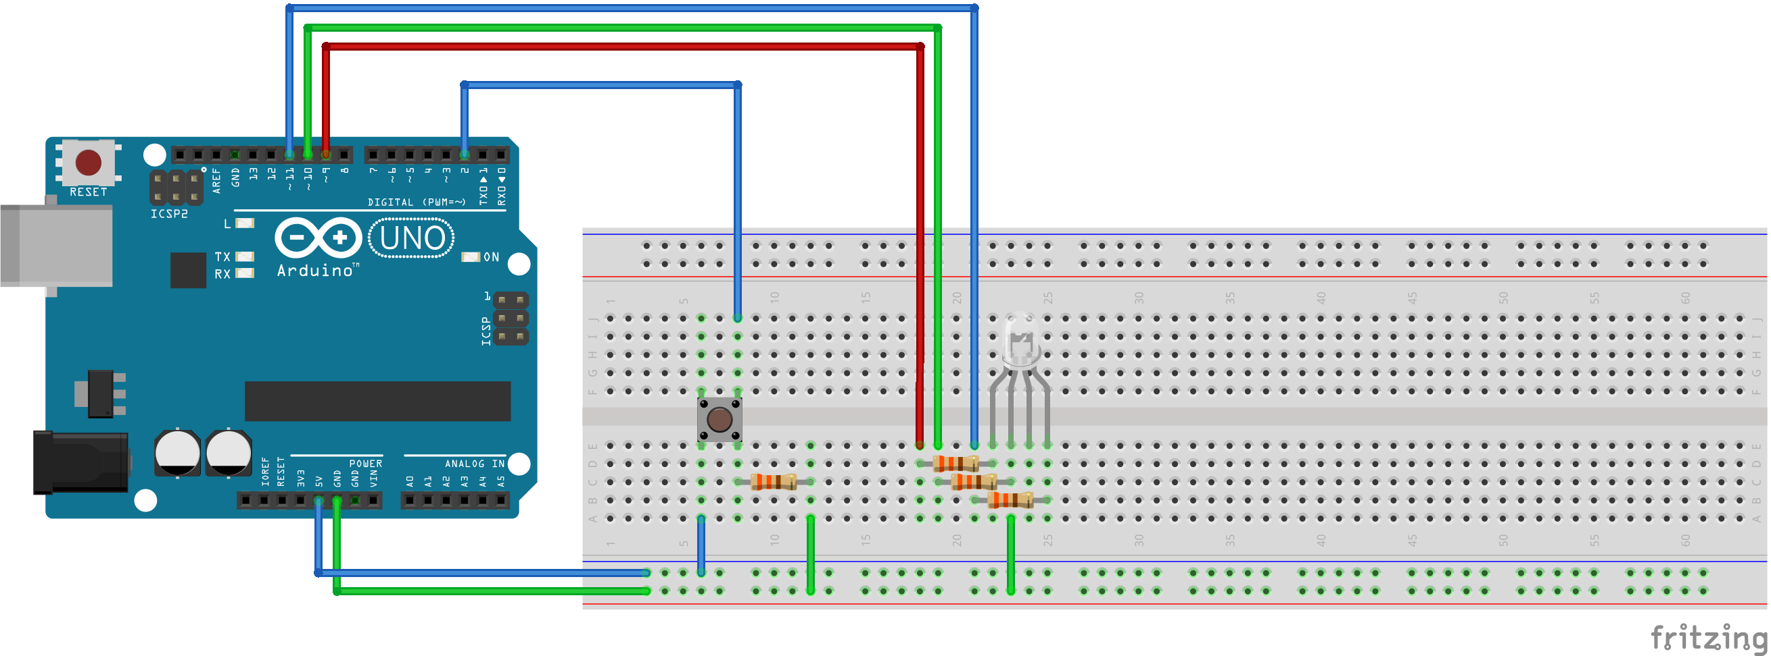  
Figure 1: Circuit Diagram

|  |  |  |  |
| --- | --- | --- | --- |
| **Time Delay(msec)** | **Red Intesity** | **Green Intensity** | **Blue Intensity** |
| 500 | 250 | 0 | 0 |
| 500 | 250 | 250 | 250 |
| 500 | 0 | 0 | 250 |
| **Repeat Pattern** | | | |

Table 1: Light State 1 Pattern

|  |  |  |  |
| --- | --- | --- | --- |
| **Time Delay(msec)** | **Red Intesity** | **Green Intensity** | **Blue Intensity** |
| 500 | 0-250 | 0-250 | 0-250 |
| 500 | 255 | 0 | 0 |
| 500 | 0 | 0 | 255 |
| 500 | 250-0 | 250-0 | 250-0 |
| **Repeat Pattern** | | | |

Table 2: Light State 2 Pattern

# **Data**, **Analysis and Results**

## Procedure Modifications

The group attempted to make not modifications to the prescribed Project. Unfortunately, the Arduino assigned to the group has a non-functional pin 11, so a different pin was used to power the blue LED. The code used and the circuit diagram do not reflect this change, to allow for ease of grading and understanding.

## Explanation of Code

In order to complete the assigned task the code was split up into three main chunks. Initially it instantiates and defines variables, such as pins and useful variables as appropriate. The second chunk, now in the loop portion checks to see if the button is pressed. It utilizes some code to solve potential debouncing issues. Each time the button is pressed in increments, unless it goes up to step 3, at which time it resets to state 0.

Still in the loop section of the code, but separate of the section that increments light state is where the actual patterns are represented. For the first light state (lightState=0) the program sets each pin to 0, turning off each LED. For the second state a variable called 't' is used to keep track of the change in time in milliseconds. The time in which the light state begins is recorded after the button is pressed. The code uses if statements to set the lights according to Table 1 within each time period it correlates to. After the function reaches the maximum amount of time it redefines the starting time as the end time. Doing this allows for infinite looping of the pattern.

For the third light state (lightState=2) the same method for keeping track of time used in the second light state is used. The time is used to increment the colors as defined in the table. The time, in milliseconds, is divided by two for the first 500 milliseconds, leaving to a final value of 250. Between 500 and 1000 the table is followed. Then after 1000 ms the light is set to 1250-(t/2), allowing it to go from 250 to 0. After the time of 1500 ms is reached the base time is reset to the current time, thus causing the cycle to begin again.

# Conclusion

Overall this project allowed the group to develop several skills required for the use of Arduinos. In addition to teaching the analog functions, this lab also allowed for independent development of basic Arduino skills. These abilities should be incredibly useful, not only in future labs, but also in the more important final project for the class.

# References

1. Armentrout, D., “MAE 311L Lab 1: Introduction to Arduino,” Lab Manual, MAE Dept., Univ. Alabama in Huntsville, 2015.