|  |
| --- |
| **Mini Project**  MAE 311L - Section 06 |
| *Authors: Prehit Patel*  Cory Wolfe  *Lab Performed: 2017-01-31*  *Due Date: 2017-02-14*  *Lab Instructor:*Chad McConnell |

# Abstract

For this Project the group was tasked with completing a series of tasks involving LEDs and buttons. The end goal of the Project was to extend the group's ability to program and utilize the Arduino. This was done by running the LEDs through several light patterns, either dependent on time or whether a button has been pressed. This allowed the group to independently develop skills for utilizing the Arduino and its ability to interface with other devices.

# Background

## Subsection 1

The group began by constructing the circuit diagram as shown in Figure Figure. In addition to the layout of the circuit diagram the group also received tables that directed how the light should operate in two of its three light states. These tables are shown in Tables Table and Table, the third light stateis simply all LEDs turned off.

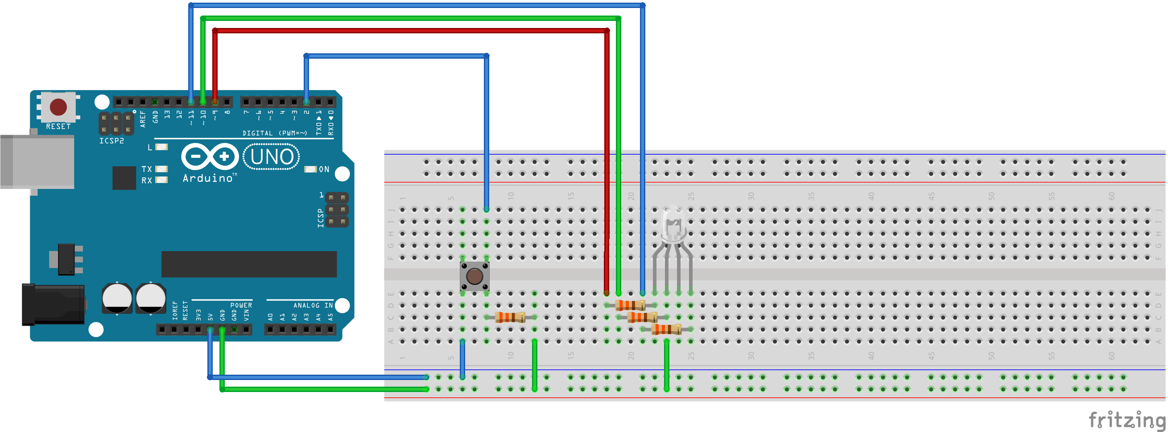  
Figure 1: Circuit Diagram

|  |  |  |  |
| --- | --- | --- | --- |
| **Time Delay(msec)** | **Red Intesity** | **Green Intensity** | **Blue Intensity** |
| 500 | 250 | 0 | 0 |
| 500 | 250 | 250 | 250 |
| 500 | 0 | 0 | 250 |
| **Repeat Pattern** | | | |

Table 1: Light State 1 Pattern

|  |  |  |  |
| --- | --- | --- | --- |
| **Time Delay(msec)** | **Red Intesity** | **Green Intensity** | **Blue Intensity** |
| 500 | 0-250 | 0-250 | 0-250 |
| 500 | 255 | 0 | 0 |
| 500 | 0 | 0 | 255 |
| 500 | 250-0 | 250-0 | 250-0 |
| **Repeat Pattern** | | | |

Table 2: Light State 2 Pattern

# **Data**, **Analysis and Results**

## Procedure Modifications

### The group attempted to make not modifications to the prescribed Project. Unfortunately, the Arduino assigned to the group has a non-functional pin 11, so a different pin was used to power the blue LED. The code used and the circuit diagram do not reflect this change, to allow for ease of grading and understanding.

## Subsection 2

## Subsection 3

# **Questions**

## Questions A

1. *Question 1?*
   * Answer
2. *Question 2?*
   * Answer

## Questions B

# Conclusion

Summary of experiments and results

# References

1. Peyret, R., and Taylor, T. D., Computational Methods in Fluid Flow, 2nd ed., Springer-Verlag, New York, 1983, Chaps. 7, 14.
2. Dornheim, M. A., “Planetary Flight Surge Faces Budget Realities,” Aviation Week and Space Technology, Vol. 145, No. 24, 9 Dec. 1996, pp. 44-46.
3. Armentrout, D., “MAE 311L Lab 1: Introduction to Arduino,” Lab Manual, MAE Dept., Univ. Alabama in Huntsville, 2015.

***List sources in order that they appear in text

**Reference Format Examples:**

*Book*

1. Peyret, R., and Taylor, T. D., *Computational Methods in Fluid Flow*, 2nd ed., Springer-Verlag, New York, 1983, Chaps. 7, 14.

*Periodical*

1. Dornheim, M. A., “Planetary Flight Surge Faces Budget Realities,” *Aviation Week and Space Technology*, Vol. 145, No. 24, 9 Dec. 1996, pp. 44-46.

*Internet Source*

1. Vickers, A., “10-110 mm/hr Hypodermic Gravity Design A,” *Rainfall Simulation Database*, URL: <http://www.geog.le.ac.uk/bgrg/lab.htm> [cited 15 March 1998].

*Lab Manual*

1. Armentrout, D., “MAE 311L Lab 1: Introduction to Arduino,” Lab Manual, MAE Dept., Univ. Alabama in Huntsville, 2015.

# Appendix

Includes supplementary material not appropriate in the body of the report

The Appendices section begins a new page.