MAE 370 laboratory section (9)

Laboratory (6): Torsion Test

Experiment conducted: (2016-10-28)

Report submitted: (2016-11-04)

Author:
Cory Wolfe

Group: C

I) Procedure
For this experiment the group measured the dimensions of two beams made of either brass or steel. After noting the dimensions the rods were loaded individually into the torsion device. The force display was turned on and set to .4 N after the rods were adequately tightened into the device. After it was set to .4 and the angle display was reset the torque knob was tightened until the force display read 5 Newtons at which point the force was set to zero and the torque was checked to ensure that the device was not set up incorrectly.
After this the torque knob was turned until the force display read increments of 1 N up to 5 N. At each increment the Angle of twist was read from the gage on one side of the device and the torque was calculated. After this was completed the beam was removed and the second one was inserted and the experiment was run again on that beam. The directions for this lab are in the handout available on canvas, instead of the regular handbook document.
Items used:
- Steel and Brass Rod
- Mounting Device
- Crank tool
- Caliper

Equations:
(eqn 1)
(eqn 2)
(eqn 3)
(eqn 4)
G in GPa
τ in Pa
T in N*m
J in m⁴
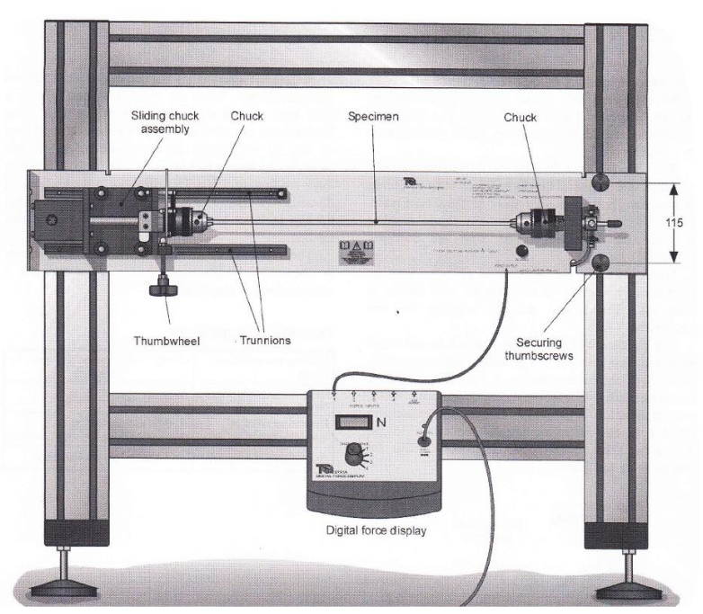
L,d in m
ϕ in degrees
γ unitless
Schematic:

II) Data Summary
Brass test:
Force (N) | Torque (N*m) | Angle of Twist (deg)
0 | 0 | 0
1 | .05 | 4
2 | .1 | 8
3 | .15 | 12.5
4 | .2 | 16.5
4.7 | .235 | 20
Steel test:
Force (N) | Torque (N*m) | Angle of Twist (deg)
0 | 0 | 0
1 | .05 | 3.5
2 | .1 | 7
3 | .15 | 10.5
4 | .2 | 14
5 | .25 | 17.5

III) Calculations (25 pts)
Brass: Steel:

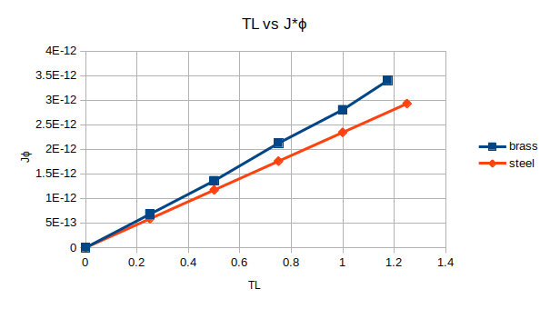

The graph of TL vs. Jϕ for both specimens is linear and looking at either line you can see that brass turns more per force than the steel does, which means that steel is the "stronger" material. The slope visible on the graph represents the inverse of the modulus of rigidity, G. For the steel a value of 427 and brass, 346, GPa; which supports the interpretation of the graph made earlier.
IV) Comparison and Discussion (25 pts)
The error calculated for the brass rod was a little over 9%, which is reasonable, however the steel rod had an error of almost fifty percent. This could be for any number of reasons, including the high potential that the group did not properly tighten the rod, or the measurements could have been off. According to the calculations steel had a higher stress, while brass had the greater strain. This is due to a combination of the maximum amount of forces and the physical properties of the materials. The modulus of rigidities would stay the same, as they are physical properties of the materials, though they would be less useful if an irregular shape was used.
Table 1: Standard material properties ^{[2]}
Material | Material Properties | Used in Laboratories:
Aluminum  (2024-T6) | E = 10.4x10⁶ psi  ν = 0.31 | 2, 3, and 4
Aluminum  (6061-T651) | E = 10 Msi  σ_{y} = 40 ksi  σ_{u} = 45 ksi  σ_{b} : no standard value  G = 3770 ksi  τ_{prop} = 22 ksi | 5 and 7
Steel  (1018) | E = 29.7 Msi  σ_{y} = 53.7 ksi  σ_{u} = 63.8 ksi  σ_{b} : no standard value  G = 11.6 Msi  τ_{prop} = 31 ksi | 5 and 7
Steel (unspecified) | E = 30x10⁶ psi | 6 and 8

V) References and Appendix (5 points)
- Gilbert, J. A., Carmen, C. L., Thota, J., MAE/CE 370 - MECHANICS OF MATERIALS - LABORATORY MANUAL, Version 3.0, (2015)

- MatWeb, http://www.matweb.com, accessed: 8/31/2016.
- Lab Manual Chapter from Canvas.
Appendix A: Units and conversions
Property | English unit(s) | Metric unit(s)
Width, thickness, length, deflection | in, ft | m, cm, mm
Angle | °, radians | °, radians
Percent error | % | %
Area | in², ft² | m², cm², mm²
Moment of Inertia | in⁴, ft⁴ | m⁴, cm⁴, mm⁴
Force, Load, Weight | lb | N
Torque | in-lb, lb-in | N-m
Stress (normal, shear) | lb/in² (psi) | N/m² (Pa)
Modulus of Elasticity  a.k.a. Young’s Modulus E | lb/in² (psi)  Msi=10⁶ psi | N/m² (Pa)  GPa=10⁹ Pa
Modulus of Rigidity  a.k.a. Shear Modulus G | lb/in² (psi)  Msi=10⁶ psi | N/m² (Pa)  GPa=10⁹ Pa
Poisson’s Ratio ν | unitless | unitless
Stress Concentration Factor K | unitless | unitless
Strain (normal, shear) | in/in, µε  µε=10⁻⁶ in/in | m/m, µε  µε=10⁻⁶ m/m

1 ksi | 1000 psi
1 in | 25.4 mm
1 lb | 4.448 N, 453.6 g

