MAE 370 laboratory section (9)

Laboratory (5): Beam Deflection

Experiment conducted: (2016-10-14)

Report submitted: (2016-10-21)

Author:
Cory Wolfe

Group: C

I) Procedure
The general setup for this lab involved mounting a beam on two supports and placing an array of gages on the beam that measured the displacement of the beam. After the beam was mounted and the hangers for the holding the weights were mounted the initial gages were placed in the appropriate location and zeroed out. A rough sketch of the beam is shown at the bottom of this section. The procdures discussed here come from section 11.4 of the provided MAE 370 Lab Manual.
The group then placed the weights on in the appropriate increments while recording the deflection on the beam. Due to the number of gages the group had to run the experiment multiple times with the gages placed at different increments on the beam. The group made use of a steel beam, the mounting harness, the gages, a series of weights and hangers to mount the weights to the beam.
Items used:
- Beam
- Weights
- Hanger
- Deflection gages
- Mounting device
(eqn 1)
(eqn 2)
(eqn 3)
Equations 1 and 2 for conditions with central load, equation 3 is for the overhanging load.
E in psi
I in in⁴
P in lb
x, L, y, a, b in in
Schematics:

II) Data Summary
Central:
Step | Load(lb) | Gage 1 | Gage 2 | Gage 3 | Gage 4
1 | 1 | .007 | .014 | .013 | .007
2 | 2 | .014 | .026 | .025 | .014
3 | 3 | .022 | .040 | .038 | .021
4 | 4 | .030 | .052 | .051 | .027
5 | 5 | .037 | .066 | .063 | .034
Dial Gages (in):
x₁ | 5
x₂ | 10
x₃ | 20
x₄ | 25

Overhanging:
Step | Load(lb) | Gage 1 | Gage 2 | Gage 3
1 | 1 | .012 | .015 | .011
2 | 2 | .022 | .030 | .022
3 | 3 | .033 | .045 | .034
4 | 4 | .045 | .060 | .045
5 | 5 | .056 | .075 | .057
Dial Gages (in):
x₁ | 7.5
x₂ | 15
x₃ | 22.5
Beam Dimensions (in):
L | 30
w | 1
t | .25
a | 5
b | 5

III) Calculations (25 pts)

Most of the calculations for this lab were performed in a separate excel sheet that is attached. In this Calculations section there is a plot of deflections and table of data from the overhanging load's data and calculations, to show the calculated data. Further information regarding this is found in the excel document that accompanies this report.

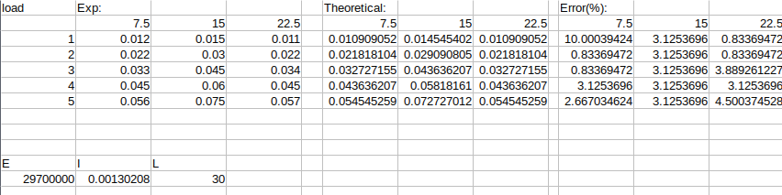
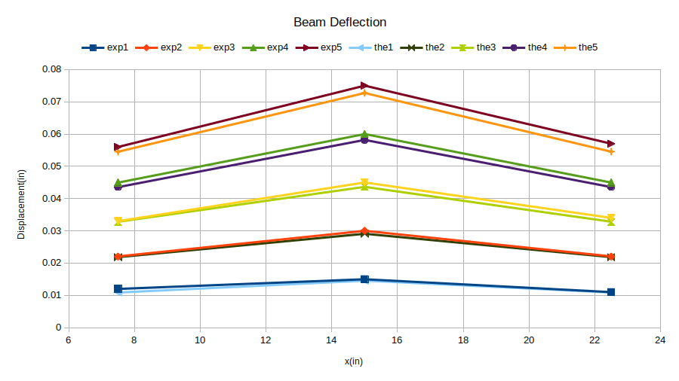

IV) Comparison and Discussion (25 pts)
Overall, and in all specific cases the data is acceptable in comparison to the theoretical values calculated. The worst error was a over twelve percent at 10 inches into the beam for the 1 pound central load. The gage reading was .014 and the theoretical value was .0124. There is a possibility that the error would have been lowered if the gage returned more signifigant figures.
Some possible sources of error include poor measurements with a tape measure, in addition to movement of the hanger and beam while the group moved gages and added weights. Overall these sources of error did not show a major effect on the groups result, as the average error was less than 4 percent overall.
Table 1: Standard material properties ^{[2]}
Material | Material Properties | Used in Laboratories:
Aluminum  (2024-T6) | E = 10.4x10⁶ psi  ν = 0.31 | 2, 3, and 4
Aluminum  (6061-T651) | E = 10 Msi  σ_{y} = 40 ksi  σ_{u} = 45 ksi  σ_{b} : no standard value  G = 3770 ksi  τ_{prop} = 22 ksi | 5 and 7
Steel  (1018) | E = 29.7 Msi  σ_{y} = 53.7 ksi  σ_{u} = 63.8 ksi  σ_{b} : no standard value  G = 11.6 Msi  τ_{prop} = 31 ksi | 5 and 7
Steel (unspecified) | E = 30x10⁶ psi | 6 and 8

V) References and Appendix (5 points)
- Gilbert, J. A., Carmen, C. L., Thota, J., MAE/CE 370 - MECHANICS OF MATERIALS - LABORATORY MANUAL, Version 3.0, (2015)

- MatWeb, http://www.matweb.com, accessed: 8/31/2016.
- Attached data for Fixed-Fixed test, received from TA.
Appendix A: Units and conversions
Property | English unit(s) | Metric unit(s)
Width, thickness, length, deflection | in, ft | m, cm, mm
Angle | °, radians | °, radians
Percent error | % | %
Area | in², ft² | m², cm², mm²
Moment of Inertia | in⁴, ft⁴ | m⁴, cm⁴, mm⁴
Force, Load, Weight | lb | N
Torque | in-lb, lb-in | N-m
Stress (normal, shear) | lb/in² (psi) | N/m² (Pa)
Modulus of Elasticity  a.k.a. Young’s Modulus E | lb/in² (psi)  Msi=10⁶ psi | N/m² (Pa)  GPa=10⁹ Pa
Modulus of Rigidity  a.k.a. Shear Modulus G | lb/in² (psi)  Msi=10⁶ psi | N/m² (Pa)  GPa=10⁹ Pa
Poisson’s Ratio ν | unitless | unitless
Stress Concentration Factor K | unitless | unitless
Strain (normal, shear) | in/in, µε  µε=10⁻⁶ in/in | m/m, µε  µε=10⁻⁶ m/m

1 ksi | 1000 psi
1 in | 25.4 mm
1 lb | 4.448 N, 453.6 g

