National University
Data Warehouse and Design
ANA 655
Instructor: Dr. Barbara Lauridsen
Submitted by Sharon McDermott and Charlene Wolthers

Week One – Part 1- Project: Digital Product Development and IT Strategy Management System

Overview: The proposed project for this course is to expand and improve upon an existing Digital Product Development and IT Strategy Management System that was created in the previous class (ANA 650). This system is designed to function as a centralized data repository, streamlining the management of digital product development processes and the organization's overall IT strategy. By integrating and organizing detailed data from various sources, the system facilitates better coordination between teams, supports informed decision-making, and enhances performance tracking across different business units.
The system will capture and store information related to ongoing projects, tasks, resource allocation, users, and reports, allowing project managers, IT strategists, developers, and other stakeholders to efficiently monitor and adjust their activities. By doing so, it helps ensure that the organization’s digital transformation efforts remain in line with its broader business objectives.
This application is critical for companies undergoing digital transformation because it provides structured data management and reporting capabilities. It allows executives and managers to have real-time insights into how resources are being utilized, whether projects are on track, and how the development efforts align with the company’s long-term strategy.
Moreover, this system fosters improved collaboration across departments by making critical project data accessible and transparent. For instance, project managers can reallocate resources based on shifting priorities, while IT strategists can adjust goals and align efforts with business KPIs. Developers can track progress and submit code for review, while data analysts can generate reports that inform strategic decisions.
Ultimately, the development and enhancement of this system is crucial for driving efficiency and ensuring that digital products and IT strategies are managed in a way that supports the organization’s overall growth and success. Through this course project, the system will be further refined to address the growing needs of the organization, improve scalability, and ensure that it continues to align digital transformation initiatives with the company’s business goals.

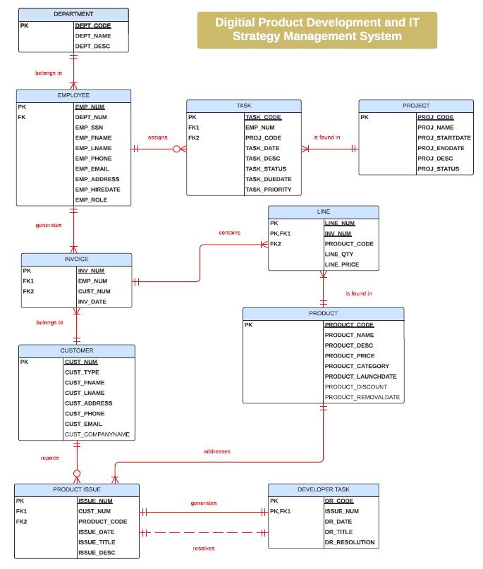
Figure 1: ERD designed in previous class

Scenario Narrative: The primary users of the system include Project Managers, IT Strategists, Developers, Data Analysts, Executive Leadership, and System Administrators. Each user role interacts with the system in different ways, and the database must be designed to support these various interactions efficiently.
The system will allow Project Managers to track progress on digital product development by monitoring milestones, task completion, and resource allocation. IT Strategists will use the system to assess alignment between IT initiatives and business goals, making strategic adjustments and reallocating resources as needed. Developers will log bugs, track tasks, and collaborate on code submissions, while Data Analysts will generate analytical reports to inform strategic decisions. Executive Leadership will oversee high-level performance metrics, reviewing and approving strategic changes, and System Administrators will manage user access, system performance, and security protocols.
The system's schema will be modeled dimensionally to support efficient querying and reporting. A star schema is proposed, where the fact tables will capture key transactions such as project progress, resource allocation, and strategic adjustments. Dimension tables will include user roles, task details, project information, time, and resources. This dimensional modeling will enable easy reporting on different aspects, such as project performance over time or resource allocation across departments.

Figure 2: Narrative Illustration
Challenges: Some of the primary challenges include integrating data from multiple sources to support real-time collaboration between various roles. Ensuring data consistency, managing large data volumes, and supporting concurrent users will require strategies such as data partitioning, indexing, and load balancing. Additionally, the system must address security concerns, including encrypting sensitive data and ensuring compliance with industry regulations. Maintaining scalability as the organization grows while keeping the system performance optimized will also be crucial.
Note: This database model was initially started in a previous class, and this month’s work will build upon that foundation, refining the schema design to accommodate advanced reporting features and ensuring it can handle larger data volumes and more complex queries. The final goal is to develop a robust schema diagram that fully supports the needs of all user roles within the system.

