Week Three – Part 2- Project:
Digital Product Development and IT Strategy Management System
GROUP:
Sharon McDermott & Charlene Wolthers
National University
Data Warehouse Design & Development
ANA 655 September 22, 2024

Introduction
TechSolutions Dynamics is a leading provider of enterprise software solutions designed to streamline procurement, market research, and acquisition services for organizations of all sizes. TechSolutions Dynamics delivers cutting-edge tools to help businesses optimize their operations, ensure compliance, and improve decision-making processes. Their flagship products—CoProcure Pro, MarketView Max, and AcquisAssist—are trusted by procurement professionals across various industries to simplify complex workflows and drive success.

CoProcure Pro (Cooperative Purchasing), MarketView Max (Market Research), and AcquisAssist (Assisted Acquisition Services) offer full-service cooperative purchasing and market research tools, allowing businesses to streamline their procurement processes. It includes Assisted Acquisition Services to manage purchasing from start to finish, with built-in support for compliance, cradle-to-grave contract management, and market analysis to identify the best vendor options.

Figure 1
Digital Product Development and IT Strategy Management System ER Diagram
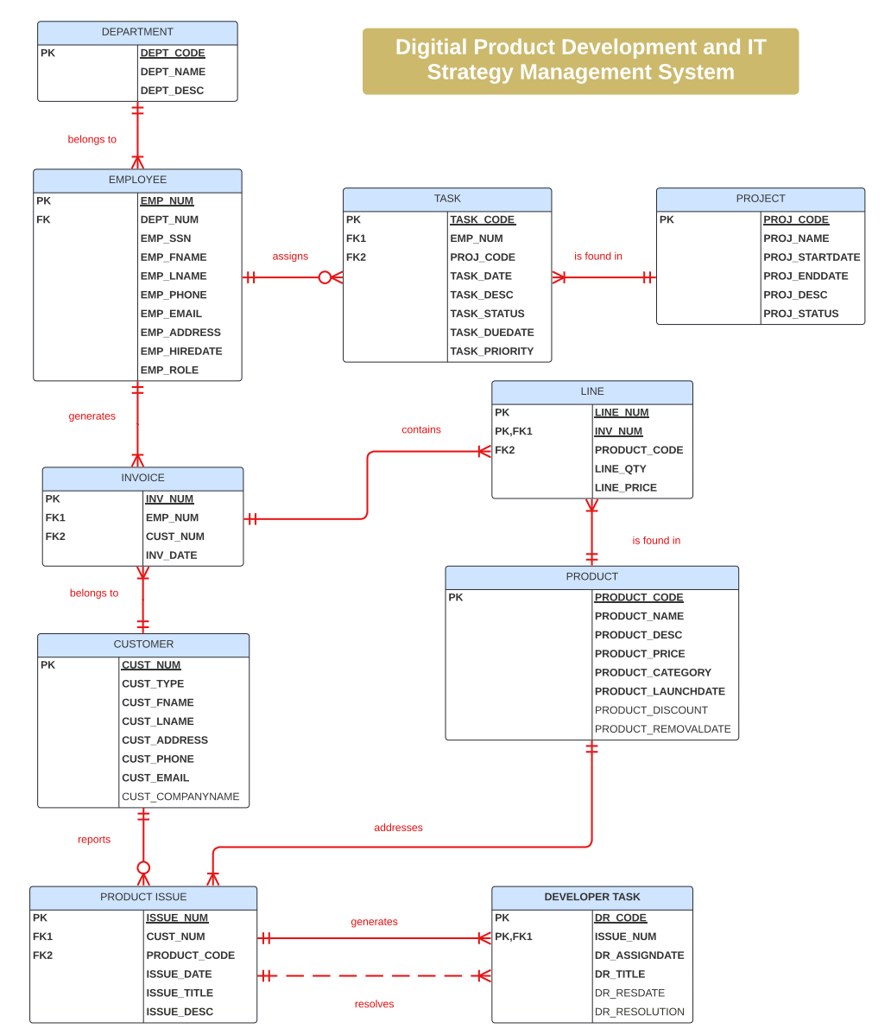

Assumptions
Several assumptions have been made regarding business rules. As show in Figure 1, it is assumed that employees are assigned to projects relevant to their department, ensuring that their tasks align with their expertise. It is also assumed that projects can have multiple tasks, but each task is assigned to a single employee to maintain accountability. On the customer side, it is assumed that customers may purchase multiple products, and issues reported for each product are tracked separately. Each issue generates a developer task aimed at resolving the problem, ensuring that all customer concerns are addressed systematically.

Figure 2
Product Issues Analysis Star Schema
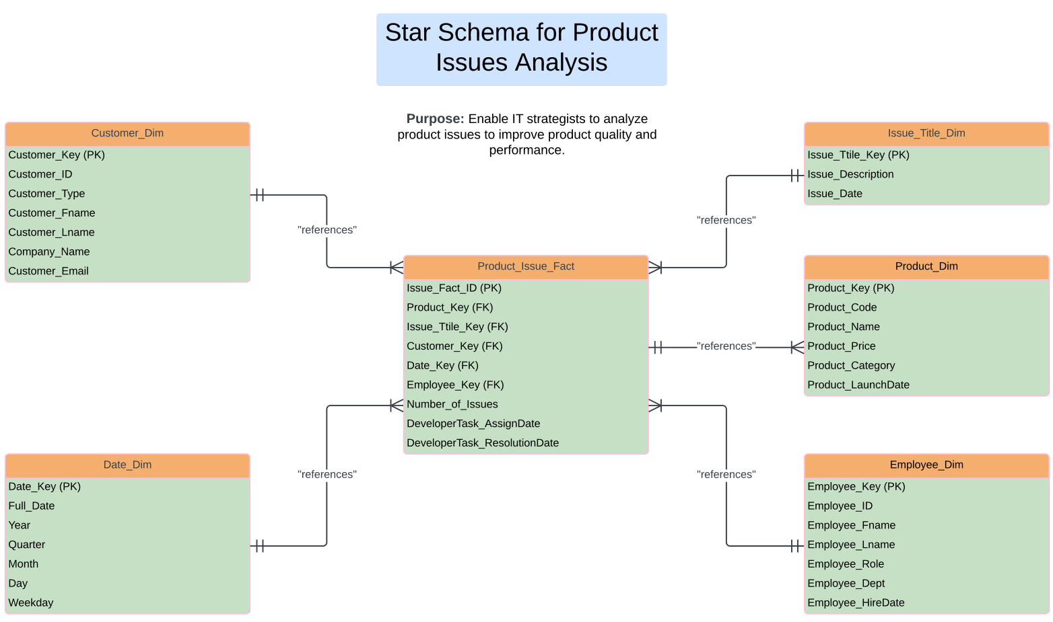

IT Strategists can leverage Product Issue Analysis Reports to systematically analyze trends in product performance and customer feedback, which enables targeted improvements and fixes. By reviewing data on the most frequently reported issues, IT strategists can prioritize resolving critical bugs or performance bottlenecks that affect customer satisfaction. For instance, the reports can reveal recurring problems across different product versions or customer segments, allowing IT teams to identify root causes and implement long-term fixes. Strategists can also use the reports to track the development team's efficiency in resolving issues by analyzing metrics such as time-to-resolution and developer task assignments. Furthermore, data insights from the reports can guide product enhancement strategies, enabling IT teams to proactively address potential failures and enhance product reliability in future releases.

In Figure 2, the Issue_Title_Key is an attribute within the Issue_Title_Dim table. It likely serves as a brief, descriptive label or heading that summarizes the nature of a reported issue related to a specific product. The Issue_Title_Key aids in organizing and managing product-related issues, especially when developers or support teams need to prioritize and resolve multiple issues.

Scenario: Product Issue
A customer named Julius Pepperwood, a Procurement Manager at DAISKI Corp, uses a software solution to streamline his company's procurement process; MarketView Max (Market Research). He encounters issues with the software product and reports them on the TechSolutions Dynamics' website.

The customer can select any of the 12 Potential Issues when reporting an issue on TechSolutions Dynamics' website:
- Vendor Comparison Fails to Load: The market research tool must load vendor comparison data.
- Purchase Order Errors: Incorrect data appears in the generated purchase orders.
- Contract Management System Glitches: Contracts are not updating correctly after making changes.
- Delayed Acquisition Support: Delays in receiving support for acquisition processes.
- Budget Forecasting Errors: The budget tool provides incorrect forecasts based on procurement history.
- Project Tracking Inaccuracies: Issues with tracking purchasing projects from inception to completion.
- Supplier Data Missing: Market research needs to show comprehensive supplier data.
- Compliance Flags Not Triggering: Compliance checks fail to alert users about non-conforming purchases.
- Approval Workflow Delays: Delays in the internal approval process for large purchases.
- Historical Data Missing: Past purchase data is not available for analysis in the system.
- Does not meet needs: The product does not meet the company's or individual's needs.
- Other

Step 1- Product Issue Report: Julius Pepperwood proceeds to report the issue on the website as shown below.

Issue Category | Vendor Comparison Fails to Load
Date of Purchase | March 7, 2024
Issue Reported | October 6, 2024
Description | Our team uses MarketView Max to compare vendors in his market research efforts, but the vendor comparison tool needs to load correctly, leaving us unable to evaluate suppliers effectively. Please address this as soon as possible.

Step 2- Assignment to Developer: The issue was assigned to Jessica Night, Senior Developer of market research software, on October 6, 2024, labeled "Fix Vendor Comparison Loading Issue in MarketView Max." Jessica analyzes the issue and finds that an overloaded server is causing the vendor comparison tool to time out and fail to load. She optimizes the server load balancing and updates the database queries to ensure the tool loads efficiently.

Step 3- Issue Resolution: The issue was resolved on October 8, 2024, and Jessica Night reports, "Optimized server load balancing and database queries. The vendor comparison tool is now loading quickly and accurately."

Step 4- Follow-Up with Customer: Jessica Night followed up with the customer on October 8, 2024, stating, "Dear Julius, the issue with the vendor comparison tool in MarketView Max has been resolved. Please check the tool and let us know if further assistance is needed."

Operational Sources
In this scenario, the operational sources are primarily the systems involved in handling customer-reported product issues and the internal developer workflows. When Julius Pepperwood reports an issue with the MarketView Max software on the TechSolutions Dynamics website, the system must capture and process the reported issue. This operational source is the Customer Issue Reporting System, which handles all aspects of customer interactions, from logging the issue to selecting the specific category of the problem, such as "Vendor Comparison Fails to Load."
Once the issue is reported, it is assigned internally to a developer, in this case, Jessica Night. This assignment occurs within the Developer Task Management System, which tracks the status and progress of issue resolution, detailing who is responsible for fixing the problem and how it is being addressed. This system manages the workflow for the developers, including task assignment, analysis of the issue, and reporting once the problem is resolved. Additionally, this system tracks the follow-up with the customer after the issue is resolved, ensuring proper communication between the development team and the customer.

