Regression Project - MPG Analysis for Motor Trend

Conrad Wong

November 7, 2015

## Executive Summary

#### This analysis will use the mtcars dataset to determine if there is a difference in MPG between manual and automatic cars. These are the steps to be followed:

#### - Data transformation and exploratory data analysis to get a sense of the shape and relationship between the different variables

#### - Find the regression model that maximizes the percentage of explained variance in MPG

#### - Drive conclusions for two questions:

* Is an automatic or manual transmission better for MPG?
* Quantify the MPG difference between automatic and manual transmissions

## Data transformation and exploratory data analysis

library(ggplot2)  
library(GGally)  
library(car)  
library(knitr)  
  
data <- mtcars  
  
data$trans <- as.factor(ifelse(mtcars$am==0, "Auto", "Manual"))  
data <- data[, -9]  
data$vs <- as.factor(ifelse(data$vs==0, "V", "Straight"))  
data$cyl <- as.factor(data$cyl)  
data$carb <- as.factor(data$carb)  
data$gear <- as.factor(data$gear)

#### Key Findings: The pairs plot (Figure 1 in the Appendix) suggests there might be some colinearity between the variables in the mtcars dataset, as there are some pairs that are correlated, for example:

* disp and weight with corr= 0.89
* disp and hp with corr = 0.79

#### In addition, the boxplot (Figure 2 in the Appendix) suggests manual cars have higher mpg than automatic cars.

## Model selection

### Model 1: Fit of mpg by transmission

fit.by.trans <- lm(mpg~trans, data=data)  
summary(fit.by.trans)$coefficients

## Estimate Std. Error t value Pr(>|t|)  
## (Intercept) 17.147368 1.124603 15.247492 1.133983e-15  
## transManual 7.244939 1.764422 4.106127 2.850207e-04

#### Key Findings: Fitting by type of transmission, results in a statistical significant coefficient (p-value < 0.05), but the adjusted r2 is only 0.34. Need to look for other variables that help explain a bigger percentage of the variance in mpg. Next step is to fit a model with all variables

### Model 2: Fit of mpg by all variables in the mtcars dataset

fit.by.all <- lm (mpg~. , data=data)  
summary(fit.by.all)$coefficients

## Estimate Std. Error t value Pr(>|t|)  
## (Intercept) 25.80998298 20.26412882 1.27367839 0.22216055  
## cyl6 -2.64869528 3.04089041 -0.87102622 0.39746642  
## cyl8 -0.33616298 7.15953951 -0.04695316 0.96317000  
## disp 0.03554632 0.03189920 1.11433290 0.28267339  
## hp -0.07050683 0.03942556 -1.78835344 0.09393155  
## drat 1.18283018 2.48348458 0.47627845 0.64073922  
## wt -4.52977584 2.53874584 -1.78425732 0.09461859  
## qsec 0.36784482 0.93539569 0.39325050 0.69966720  
## vsV -1.93085054 2.87125777 -0.67247551 0.51150791  
## gear4 1.11435494 3.79951726 0.29328856 0.77332027  
## gear5 2.52839599 3.73635801 0.67670068 0.50889747  
## carb2 -0.97935432 2.31797446 -0.42250436 0.67865093  
## carb3 2.99963875 4.29354611 0.69863900 0.49546781  
## carb4 1.09142288 4.44961992 0.24528452 0.80956031  
## carb6 4.47756921 6.38406242 0.70136677 0.49381268  
## carb8 7.25041126 8.36056638 0.86721532 0.39948495  
## transManual 1.21211570 3.21354514 0.37718957 0.71131573

vif(fit.by.all)

## GVIF Df GVIF^(1/(2*Df))  
## cyl 128.120962 2 3.364380  
## disp 60.365687 1 7.769536  
## hp 28.219577 1 5.312210  
## drat 6.809663 1 2.609533  
## wt 23.830830 1 4.881683  
## qsec 10.790189 1 3.284842  
## vs 8.088166 1 2.843970  
## gear 50.852311 2 2.670408  
## carb 503.211851 5 1.862838  
## trans 9.930495 1 3.151269

#### Key Findings: Fitting by all the variables in the mtcars dataset increases the adjusted r2 to 0.78, but non of the coefficients is statistical significant (all p-values are greater than 0.05). Looking at the VIF values suggests that there is colinearity between the variables. Next step is to remove the ones with a high GVIF^(1/(2*Df)) value.

### Model 3: Fit of mpg by all variables where GVIF^(1/(2*Df)) <= 3.15

# GVIF Df GVIF^(1/(2*Df))  
#drat 6.809663 1 2.609533  
#vs 8.088166 1 2.843970  
#gear 50.852311 2 2.670408  
#carb 503.211851 5 1.862838  
#trans 9.930495 1 3.151269  
  
fit.by.some <- lm(mpg~ drat + vs + gear + carb + trans, data=data )  
summary(fit.by.some)$coefficients

## Estimate Std. Error t value Pr(>|t|)  
## (Intercept) 11.115682 6.536428 1.7005744 0.10378643  
## drat 3.074948 2.026808 1.5171382 0.14414237  
## vsV -1.483798 2.373431 -0.6251698 0.53859439  
## gear4 2.593340 2.934638 0.8837000 0.38686357  
## gear5 2.358218 3.568533 0.6608369 0.51590172  
## carb2 -1.854541 2.163592 -0.8571583 0.40103386  
## carb3 -2.771974 2.905391 -0.9540795 0.35089759  
## carb4 -7.217473 2.640080 -2.7338088 0.01243960  
## carb6 -5.915280 4.407054 -1.3422299 0.19385353  
## carb8 -10.369284 4.427655 -2.3419360 0.02911938  
## transManual 2.493866 2.565009 0.9722643 0.34198573

vif(fit.by.some)[,3]^2

## drat vs gear carb trans   
## 4.321481 5.265793 3.896788 1.517639 6.028156

#### Key Findings: The adjusted r2 decreases to 0.77, and we still have the problem of non statistical significant coefficients. Next step is to fit the model by a stepwise algorithm.

### Model 4: Fit of mpg following the stepwise algorithm

stepModel <- step(fit.by.all, k=log(dim(data)[1]), trace=FALSE)  
summary(stepModel)

##   
## Call:  
## lm(formula = mpg ~ wt + qsec + trans, data = data)  
##   
## Residuals:  
## Min 1Q Median 3Q Max   
## -3.4811 -1.5555 -0.7257 1.4110 4.6610   
##   
## Coefficients:  
## Estimate Std. Error t value Pr(>|t|)   
## (Intercept) 9.6178 6.9596 1.382 0.177915   
## wt -3.9165 0.7112 -5.507 6.95e-06 ***  
## qsec 1.2259 0.2887 4.247 0.000216 ***  
## transManual 2.9358 1.4109 2.081 0.046716 *   
## ---  
## Signif. codes: 0 '***' 0.001 '**' 0.01 '*' 0.05 '.' 0.1 ' ' 1  
##   
## Residual standard error: 2.459 on 28 degrees of freedom  
## Multiple R-squared: 0.8497, Adjusted R-squared: 0.8336   
## F-statistic: 52.75 on 3 and 28 DF, p-value: 1.21e-11

#### Key Findings: This approach results in the hightest adjusted r2: 0.83, and it finds three coefficients that are statistical significant (wt, qsec and transmission). The coefficient for manual transmission is 2.94, which means that manual cars deliver 2.94 MPG more than automatic cars.

#### Next step is to run some diagnostics for this model

### Diagnosis and residuals of stepwise model

#### Please refer to Figure 3 in the Appendix

#### Key Findings: There doesn't seem to be a pattern in the residuals, so the model is a good fit. It would be good to work with a subject matter expert to look at the lower and upper residuals in the QQ plot, and understand why they have a slight deviation from the normal distribution.

## Conclusion

### Is an automatic or manual transmission better for MPG?

#### - This analysis confirms that manual cars deliver more MPG than automatic cars

### Quantify the MPG difference between automatic and manual transmissions

coef <- summary(stepModel)$coefficients  
coef[4,1] + c(-1, 1) * qt(.975, df = stepModel$df) * coef[4, 2]

## [1] 0.04573031 5.82594408

#### - With 95% confidence, we estimate that manual cars deliver between 0.05 and 5.82 more MPG than automatic cars.

## Appendix

### Figure 1: GGPairs

ggpairs(data[, 2:11], lower=list(continuous="smooth"))

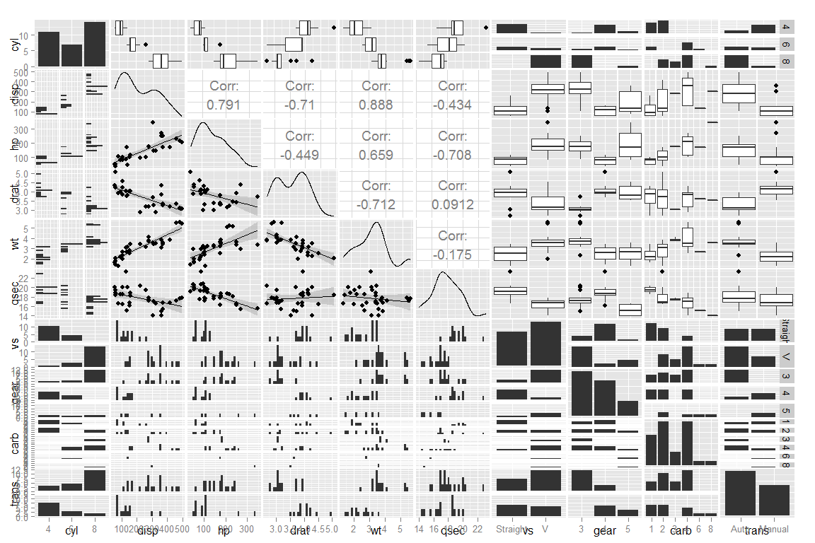

### Figure 2: Boxplot of MPG by Transmission

plot (mpg~trans, data=data)

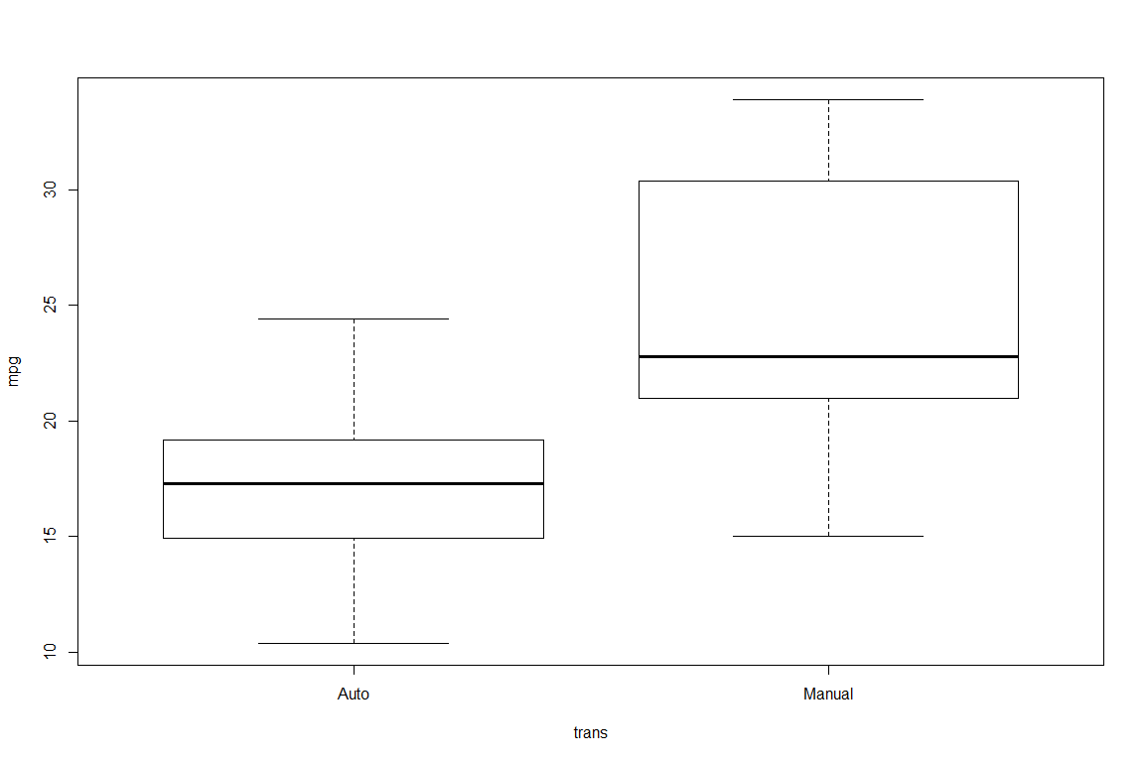

### Figure 3: Residuals

