# Release Information

|  |  |
| --- | --- |
| Release | Deployment |
| Leader | Connor Woodward |

This iteration we finalized a couple of features like exporting to a text file as well as added a lot of test cases.

# Progress

|  |  |  |  |  |
| --- | --- | --- | --- | --- |
| **Stories and spike solutions worked on during this release** | | | | |
| **Issue #** | **Labels** | **Description** | **% Impl.** | **Notes, plan for completion** |
| #38 | Task | Complete Test Coverage | 100 | Completed |
| #10 | Story | Export guitar configuration to a text file | 100 | Completed |

|  |  |  |
| --- | --- | --- |
| **Accomplishments by engineer** | | |
| **Team Member** | **Total Time (hrs)** | **Stories/tasks implemented** |
| Connor Woodward | 6 Hours | #38, #39 |
| Josh Wood | 6 Hours | #10, #38, #39 |
| Edward Pazdziora | 4 Hours | #39 |
| Mukesh mani Tripathi | 4 Hours | #39 |
| TEAM TOTAL | **20 Hours** |  |

|  |  |
| --- | --- |
| **Document updates** | |
| **Document** | **Changes** |
| ClassDiagram.png | Updated class diagram |

# Issues

Document anything that is not decided yet and needs to be resolved at some point.

|  |  |  |  |  |
| --- | --- | --- | --- | --- |
| **Issue Number** | **Discovery**  **Date** | **Resolution**  **Date (Est.–Act.)** | **Responsible Person** | **Description (Prob / Resolution)** |
| N/A | N/A | N/A | N/A | N/A |

# Screen Shots

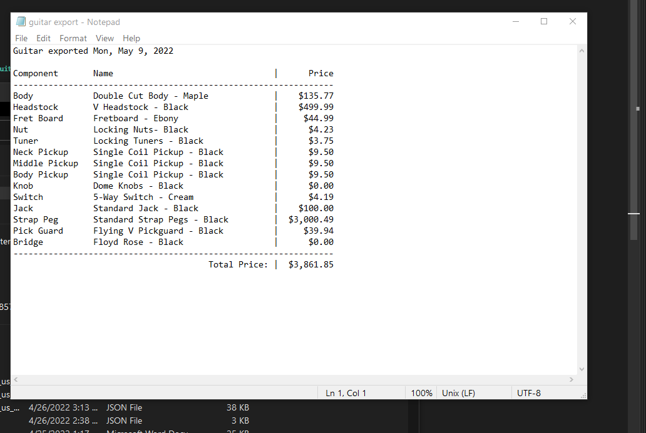

# Updated Design

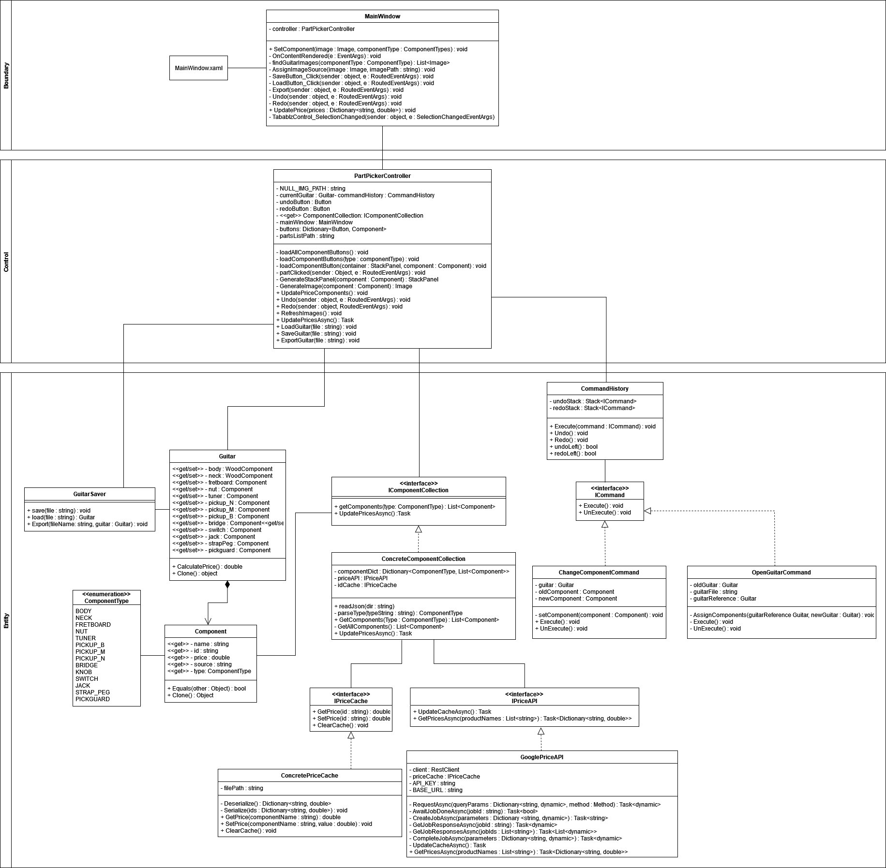

# Test Coverage Report

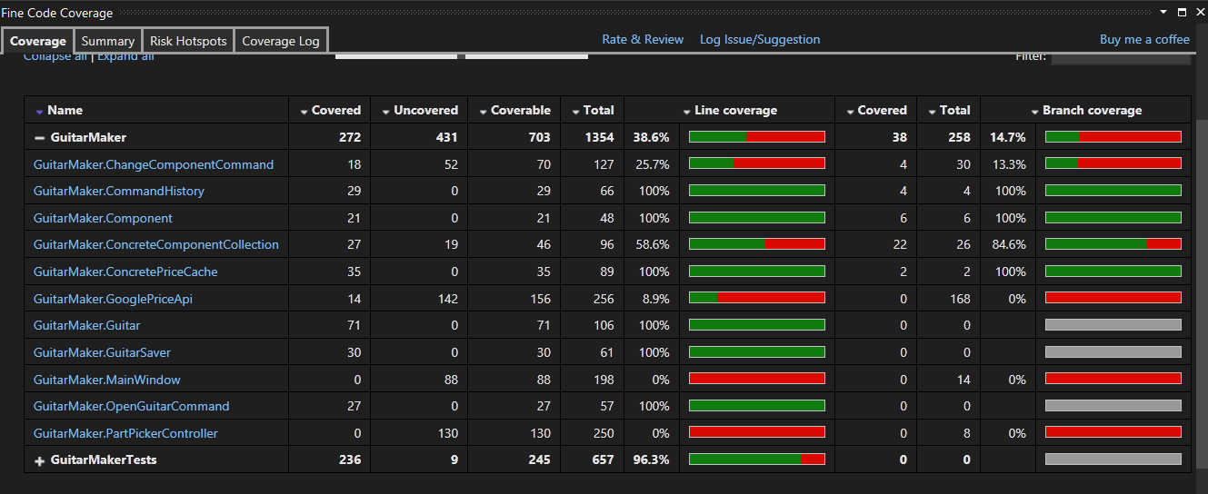

ChangeComponentCommand – Did not test every single ComponentType because every component type is treated the same way and testing every single one would be extremely redundant.

ConcreteComponentCollection – Do not have tests for UpdatePriceAsync method because it has to do with the API.

GooglePriceApi – Did not test methods involving the API.

MainWindow and PartPickerController – Did not write test cases for the GUI. GUI was instead tested manually.