# Release Information

|  |  |
| --- | --- |
| Release | 2 |
| Leader | Josh Wood |
| Git Revision Number | e223ca8c |

For this iteration, we continued to add parts and formatting them to be displayed on the guitar, improved loading of JSON files, and made the program dynamically load components from the JSON to the GUI.

# Progress

|  |  |  |  |  |  |
| --- | --- | --- | --- | --- | --- |
| **Stories and spike solutions worked on during this release** | | | | | |
| **Story** | **Task** | **Description** | **% Impl.** | **Notes, plan for completion** |
| 2 | 26 | Create Finalized JSON file | 100 |  |
| 3 | 13 | Set sizing and placement for all images of guitar parts | 70 | A lot of work was done sizing the parts within XAML files, but images still need to modified. |
| 4 | 21 | Start implementing guitar class | 100 |  |
| 7 | 22 | Implement part selection in GUI | 100 | This works properly, however the images for parts being selected need to be resized. |
| 7 | 24 | Redo Design | 100 | Redid design to implement MVC |
| 7 | 28 | Dynamically create GUI Based on JSON file | 100 |  |
| 5 | 29 | Create method to calculate final price of guitar | 100 | This task has been implemented to show the final price of the parts of the guitar and calculate the total price of the guitar parts |
| 6 | 30 | Display part and final prices in the GUI | 80 | The display of the total price is finalized and the display for the parts of the price is remaining. |
| 15 | 25 | Create a price check job using the API | 0 | This task was not accomplished in time, since Josh ended up spending time contributing to Task 26 with Connor, which was not planned for. This task will be moved to Iteration 3 |
| N/A | 31 | Repository Restructure | 100 | Connor restructured the repository so the team could continue working after Josh and EJ made commits that messed up the file structure. |
| 2 | 32 | Data Flow | 100 | We needed to update how JSON files were deserialized so that component objects could be instantiated. |
| 17 | 14 | Implement method to display modular image of guitar | 70 | Finding a way to change images in existing display elements | |

|  |  |  |
| --- | --- | --- |
| **Accomplishments by engineer** | | |
| **Team Member** | **Total Time (hrs)** | **Tasks implemented** |
| Connor Woodward | 14.5 Hours | 26, 21, 31, 32, 14 |
| Josh Wood | 13 hours | 24, 28, 32 |
| Edward Pazdziora | 10 hrs | 13, 22 |
| Mukesh Mani Tripathi | 9 hours | 29, 30 |
| TEAM TOTAL | 46.5 hrs | 26, 21, 31, 32, 24, 28, 32, 29, 30, 14 |

|  |  |
| --- | --- |
| **Document updates** | |
| **Document** | **Changes** |
| ClassDiagram.PNG | Overhauled class diagram to implement MVC  Updated to reflect additional changes to design |

# Issues

Document anything that is not decided yet and needs to be resolved at some point.

|  |  |  |  |  |
| --- | --- | --- | --- | --- |
| **Issue Number** | **Discovery**  **Date** | **Resolution**  **Date (Est.–Act.)** | **Responsible Person** | **Description (Prob / Resolution)** |
| 1 | 4/2 | 4/2 | Josh, EJ | Josh and EJ both made commits to the repository that messed up the file structure. Connor discovered this and fixed the issue so he could continue working that day. |
| 2 | 4/4 | 4/4 | N/A | We discovered our original design for loading JSON files did not allow each component to have a common interface. This caused issues for dynamically loading components to the UI. We needed to update how JSON files were loaded into memory in order to fix this. |

# Screen Shots

Insert screen shots of functionality added for this release along with screen shots from spike solutions. Add short descriptions of all screen shots along with a short list of features illustrated by each. The goal is to convince your instructor that you completed the work documented above.

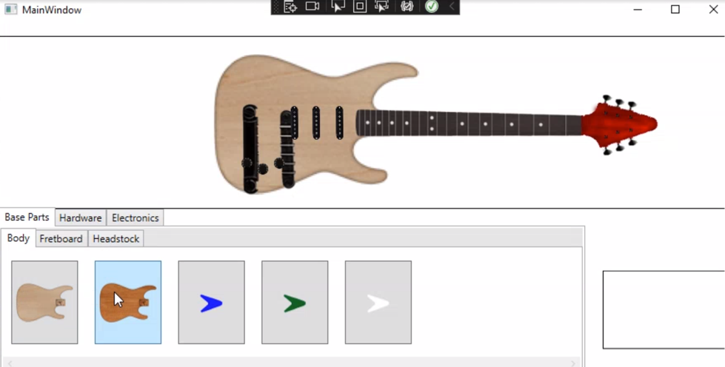

This shows the part selection screen. You can see that all 5 bodies are now displayed as options. The different bodies were loaded in dynamically, based on the contents of a json file (before they were placed manually on the XAML file).

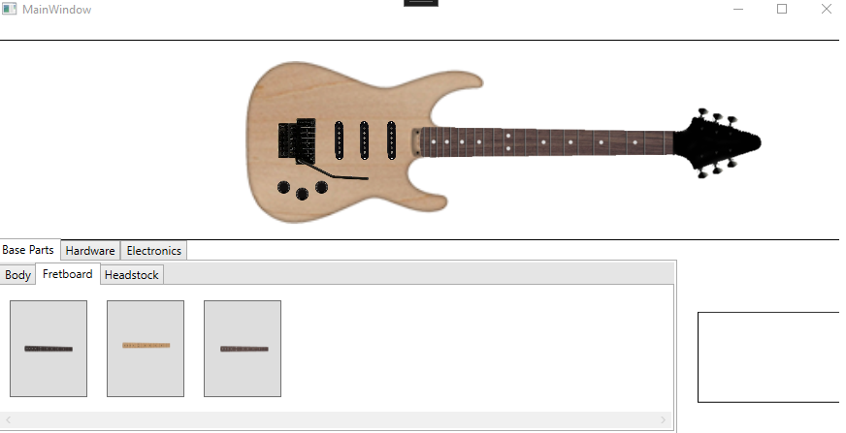

This shows the fretboard options. The fretboard was changed to brown by clicking the brown fretboard button.

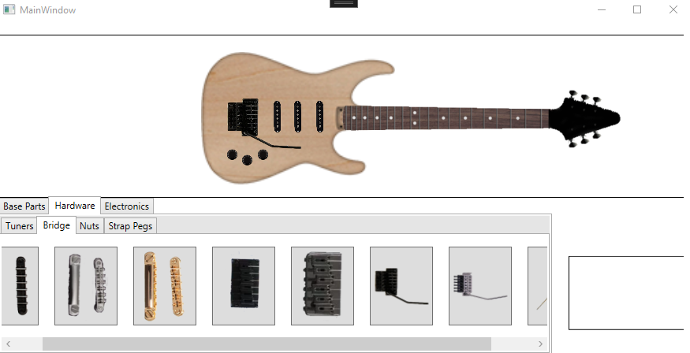

This shows the bridge options. You can see that since there are more options than what can be displayed within the view, a scrollbar appears at the bottom.

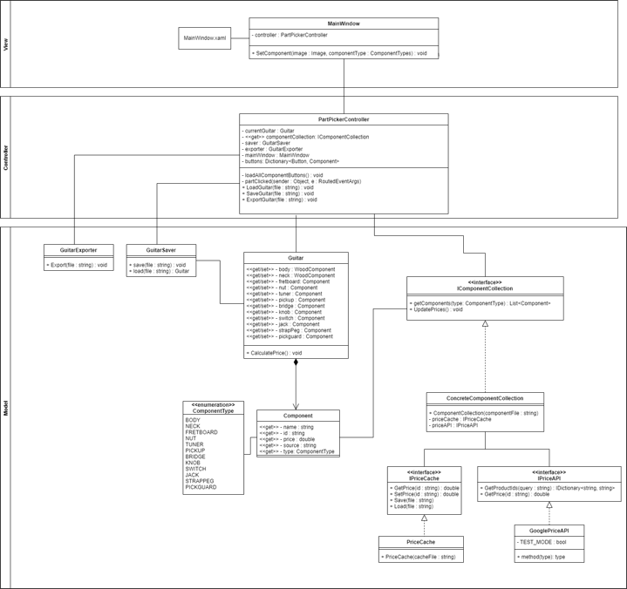

This is our updated class diagram. We spent time reworking our design to implement Model-View-Controller per the project specifications. A larger, readable class diagram can be found on our repository under doc/ClassDiagram.png.