**Functional Block Diagram**

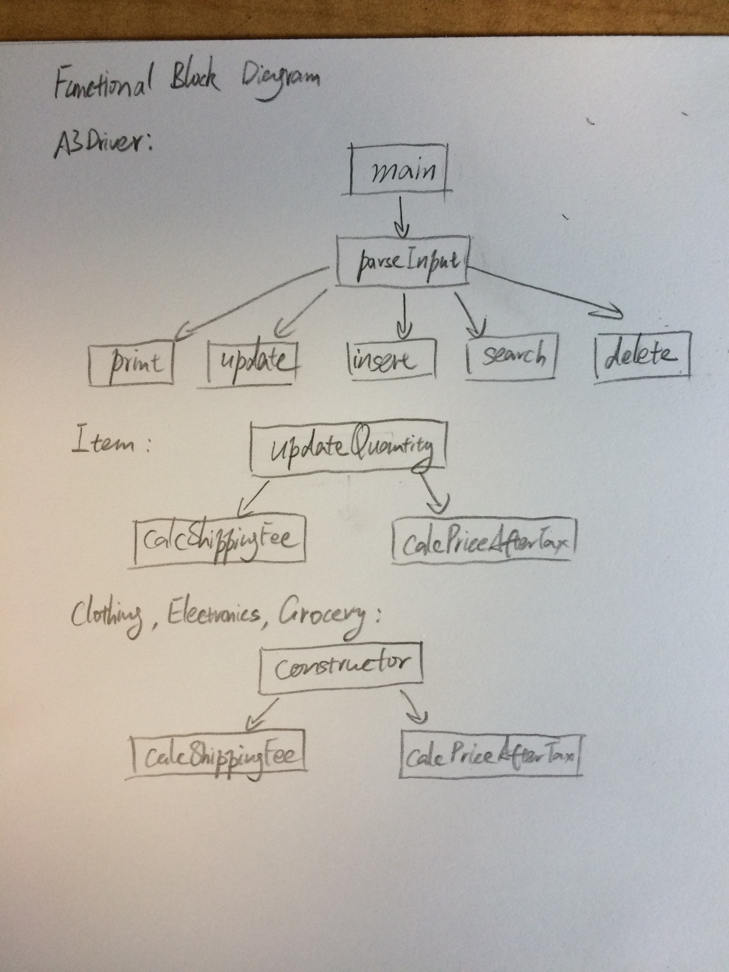

**Pseudocode**

main

read the file

LOOP through each line in the file

parseInput()

parseInput()

split input into an array of String

check the first element in the array, and figure out which operation is it

then direct to the corresponding method

insert()

check the second element in the array to identity the category

read the rest of the input and construct object of that category

and add the objects into ArrayList shoppingCart

search()

LOOP through the shoppingCart and check if the object.name is equal to the

String suggested by the input

IF yes then count += object.quantity

print the statement showing how the count

delete()

make a copy of shoppingCart

LOOP through the copy and check if the object.name is equal to the

String suggested by the input

IF yes then count += object.quantity and remove it from the shoppingCart

print the statement showing how many were deleted

update()

read in the name of the item to be updated and the new quantity

LOOP through shoppingCart and find the Item by name

call object.updateQuantity(new quantity) to update the quantity and the

shipping fee and price after tax

print the statement that quantity has been updated

break

print the statement that no matching item in the shoppingCart

print()

make a copy of ShoppingCart

use Collections.sort(copy) to sort the ArrayList into the desired order

the specific sorting rules are specified by compareTo method in class Item

Loop through copy

print each attribute of each item

print the total cost in the shopping cart