MIT WORLD PEACE UNIVERSITY, PUNE
School of Computer Science and Engineering

MINI PROJECT REPORT
Foundations of Programming – CSE10010

2048 Game in C with SDL2 GUI

Submitted by:
Sriyash Ghodke – PRN: 1262251822
Shiv Mudgal – PRN: 1262250528
Shravya Bhatt – PRN: 1262251996
Priyanka Gupta – PRN: 1262251588
Rayyan Ansari – PRN: 1262252914

Project Guide: Kajal Vatekar, Professor

Submission Date: February 2026

Acknowledgment

We want to say thank you much to our project guide Prof. Kajal Vatekar for the help that the project guide provided. The project guide was always telling us what to do. The project guide was encouraging us all the time. We really liked the feedback that we got from the project guide. This feedback was really helpful when we had problems. The ideas that the project guide gave us made our project work better.

We are also very thankful to the Department of Computer Science and Engineering at MIT World Peace University in Pune. They gave us this platform that we needed to finish our project. We got the guidance that we needed. We also got a good place to work on our project. This really helped us to finish our project on time.

We thank our friends and colleagues too. They took the time to look at our work. They gave us some really good ideas. We are very grateful to our families for supporting us and, for making us feel motivated to do our work.We want to thank them for all the help that they gave us.

Abstract

This project is about the 2048 puzzle game. We made the 2048 game using the C programming language. The 2048 game has a graphical user interface. It uses the SDL2 library.

The 2048 game is a puzzle where you slide tiles. You try to combine tiles to get the 2048 tile. The game is, on a 4x4 grid. You can move tiles up down left and right. After each move a new tile appears.

We made the project in two parts: game.c and main.c. The game.c file has the core game logic. This includes setting up the board moving tiles adding tiles calculating the score and checking if the game is over. The main.c file handles the graphical user interface. It uses SDL2 for rendering, event handling and the user interface.

We used programming ideas like arrays, functions and modular programming. We also used event-driven programming. The 2048 game works on Windows. We used SDL2 libraries to compile and test it. This project shows that we can apply programming skills to make software. The 2048 game is an example of this.

Table of Contents

1. Title Page 1
2. Acknowledgment 2
3. Abstract 3
4. Table of Contents 4
5. List of Figures and Tables 5
6. Introduction 6
7. Literature Review 7
8. System Design / Methodology 9
9. Implementation 12
10. Results and Discussion 16
11. Conclusion 17
12. Future Scope 18
13. References 19

List of Figures and Tables

Figure 1: System Architecture / Flowchart of 2048 Game
Figure 2: SDL2 Rendering Pipeline
Figure 3: Game Screenshots – Initial State, Mid-Game, Game Over Screen

Table 1: Literature Review – Summary of Research Papers
Table 2: Functions in game.c and their descriptions
Table 3: Test Cases

Introduction

6.1 Problem Statement
This project consists of the implementation of the 2048 puzzle (a well-known sliding block game) in C language and using the SDL2 library to create a graphical user interface (GUI). This project provides an example of how to practically apply the fundamental programming concepts that you've learned in the Foundations of Programming course.

6.2 Background / Context
Gabriele Cirulli developed 2048 as a single-player sliding block puzzle in March 2014, and since then, it has grown to become one of the most popular games. With its simple rules yet highly strategic gameplay, many players who are familiar with puzzle games will find it easy to pick up and play this game.

SDL2 (Simple DirectMedia Layer 2) is a cross-platform software library that provides basic access to the various hardware components (audio, keyboard, mouse, display) of your computer. It is implemented as a C library through which you interact with OpenGL and/or Direct3D depending on the platform your game runs on. An additional library called SDL2_ttf (on Windows, and SDL_TTF on all other operating systems) allows you to draw and render TrueType fonts, which we use throughout the project to display tile numbers and the score on the screen.

6.3 Objectives
You will have to allow the user to slide tiles downward and combine them.

Then you will have to verify that there are no legitimate moves available to the player.

* The user interface will be developed with SDL2_ttf library.

This will allow the player to see the state of the board including the colour of the tile and the final score.

To accomplish this the game's logic will be developed in separate files (files where the logic resides will be contained in the game.c and game.h).

The game's display and input processing will be developed in main.c.

* You will need to apply programming techniques, such as the following:

* Arrays, Functions, Random number creation, Event processing,

The final product should allow the user to easily control the game with keyboard input.

You will be able to control the game using the keyboard as follows:

Down arrow or W/S keys or left/right arrow or A/D keys will allow you to slide the tiles.

System Design / Methodology

8.1 Overview of the Approach
The 2048 game is made up of two parts: the game logic part and the presentation part. The game logic part is where we do all the thinking for the 2048 game like moving tiles and checking if the game is won or lost. This is done in the game.c and game.h files. The presentation part is where we make the 2048 game look nice and get input from the user. This is done in the file and we use something called SDL2 to make the game look good and to get keyboard input, from the user who is playing the 2048 game.

8.2 System Flowchart
The following describes the game flow:

START
|
v
Initialize Board (4x4 zeros)
|
v
Add 2 Random Tiles
|
v
Render Board via SDL2
|
v
Wait for Keypress (W/A/S/D)
|
v
Process Move (Left/Right/Up/Down)
|
v
Move Changed Board? --No--> Loop Back
|Yes
v
Add Random Tile (2 or 4)
|
v
Game Over? --No--> Loop Back to Render
|Yes
v
Show GAME OVER Overlay
|
v
END

8.3 Components / Modules

File | Module/Function | Description
game.h | Header file | Declares all function prototypes for the game logic
game.c | initialize_board() | Fills the 4x4 board with zeros
game.c | add_random_tile() | Places a 2 or 4 on a random empty cell
game.c | move_left/right/up/down() | Slides and merges tiles in the given direction, returns 1 if the board changed
game.c | is_game_over() | Returns 1 if no empty cells and no adjacent equal tiles exist
game.c | score() | Returns sum of all tile values as current score
main.c | set_tile_color() | Maps tile values to specific RGB colors for rendering
main.c | render_board() | Draws the grid, tiles, numbers, and score using SDL2
main.c | main() | Initializes SDL2, runs the game loop, handles events

8.4 Algorithms and Techniques

The Tile Sliding Algorithm is really simple. It does things in three steps when you make a move. First it pushes all the numbers to one side. Then it combines the numbers that're the same and next to each other. Finally it pushes all the numbers to one side again. This way the Tile Sliding Algorithm works just like it is supposed to.

The Random Tile Placement is also easy to understand. The add_random_tile function looks at all the spaces and puts them in a list. Then it picks one of these spaces at random. The value of the tile which is either 2 or 4 is chosen by chance.

The Game Over Detection is important to know when the game is finished. The is_game_over function checks two things. First it looks to see if there are any spaces left. Then it checks if there are any tiles next to each other either up and down or side, by side that have the value. If neither of these things is true then the Game Over Detection says the game is over. The Tile Sliding Algorithm and the Game Over Detection work together to make the game work right.

Implementation

9.1 Development Environment
- Programming Language: C
- Compiler: GCC via MinGW (Windows)
- Graphics Library: SDL2 and SDL2_ttf
- Font: Arial (arial.ttf from Windows system fonts)
- IDE / Editor: Visual Studio Code / Code::Blocks
- OS: Windows 10/11
- Build Command: gcc main.c game.c -o game.exe -lSDL2 -lSDL2_ttf

9.2 Key Code Snippets

Board Initialization:
void initialize_board(int x[4][4]) {
for(int i = 0; i < 4; i++)
for(int j = 0; j < 4; j++)
x[i][j] = 0;
}

Move Left Logic (core of all directional moves):
int move_left(int x[4][4]) {
int changed = 0;
for(int i = 0; i < 4; i++) {
// Step 1: Compact non-zeros to left
int temp[4] = {0,0,0,0}; int k = 0;
for(int j = 0; j < 4; j++)
if(x[i][j] != 0) temp[k++] = x[i][j];
// Step 2: Merge adjacent equal values
for(int j = 0; j < 3; j++)
if(temp[j] != 0 && temp[j] == temp[j+1])
{ temp[j] *= 2; temp[j+1] = 0; }
// Step 3: Compact again into final
int final[4] = {0,0,0,0}; k = 0;
for(int j = 0; j < 4; j++)
if(temp[j] != 0) final[k++] = temp[j];
for(int j = 0; j < 4; j++) {
x[i][j] = final[j];
if(x[i][j] != /* original */ final[j]) changed = 1;
}
}
return changed;
}

SDL2 Rendering Loop (main.c excerpt):
while(running) {
while(SDL_PollEvent(&event)) {
if(event.type == SDL_QUIT) running = 0;
if(event.type == SDL_KEYDOWN) {
int moved = 0;
switch(event.key.keysym.sym) {
case SDLK_w: moved = move_up(board); break;
case SDLK_a: moved = move_left(board); break;
case SDLK_s: moved = move_down(board); break;
case SDLK_d: moved = move_right(board); break;
}
if(moved) add_random_tile(board);
}
}
render_board(renderer, board, font);
SDL_RenderPresent(renderer);
}

9.3 Testing

# | Test Case | Expected Result | Actual Result
1 | Move left with mergeable tiles | Tiles merge and count increases | Pass
2 | Move with no valid change | Board unchanged, no new tile added | Pass
3 | Board full, no adjacent equals | Game over returns 1 | Pass
4 | Board full but has adjacent equals | Game over returns 0 | Pass
5 | Random tile always in empty cell | New tile appears only in zero cell | Pass
6 | Score = sum of all tile values | Score matches manual sum | Pass
7 | SDL window renders correctly | 900x800 window displayed | Pass
8 | Game over overlay appears | Semi-transparent GAME OVER shown | Pass

Results and Discussion

10.1 Output

We made a 2048 game that you can play. The game screen has colors. The window size is 900x800 pixels. In the middle you see a 4x4 grid with tiles. Your score is shown at the top. It updates after each move.

Here are some things we found out when we tested the game:

• When you start the game the board has two tiles with 2 or 4 on them.

• When you make a move the tiles. Merge correctly. They only merge when they should.

• After you make a move a new tile with 2 or 4 appears in an empty spot.

• The game knows when its over. It shows a 'GAME OVER' message on the screen.

• Your score is always correct. It shows the value of all the tiles, on the 2048 game board.

10.2 Screenshots / Figures
[Figure 3a: Screenshot of the initial game board with two starting tiles]
[Figure 3b: Screenshot of a mid-game board showing merged tiles]
[Figure 3c: Screenshot of the Game Over overlay]

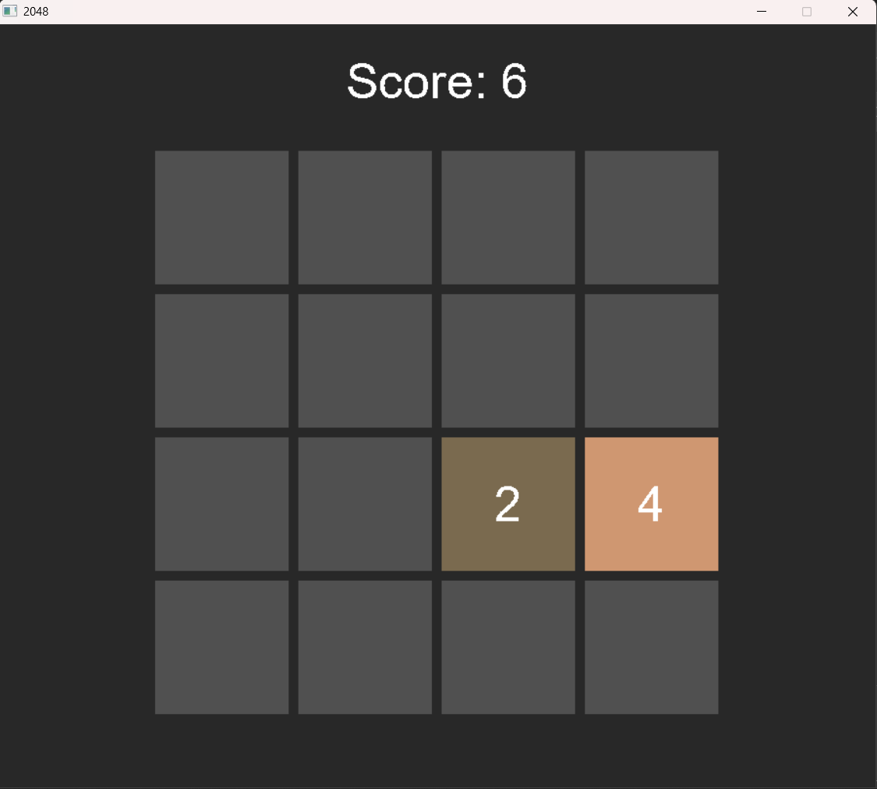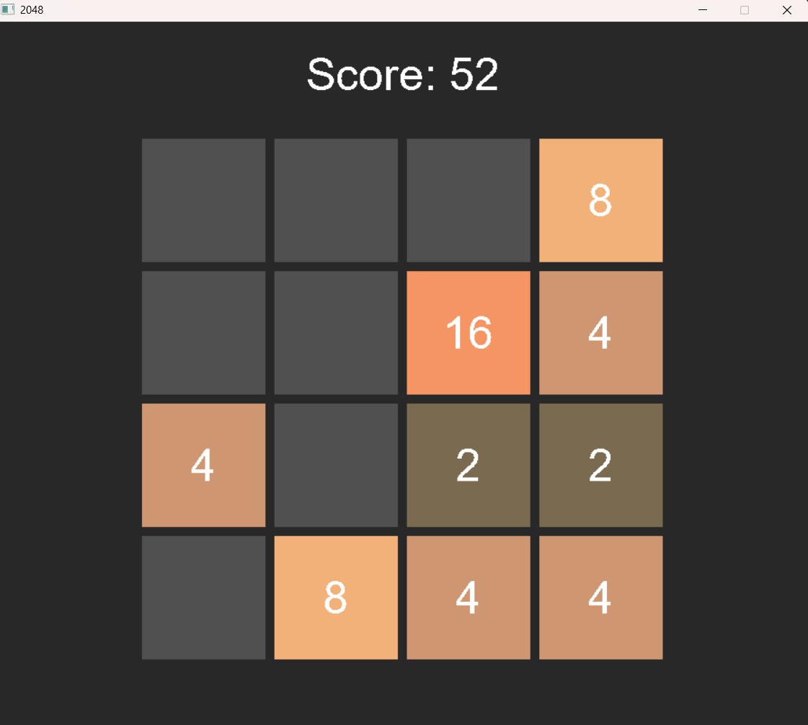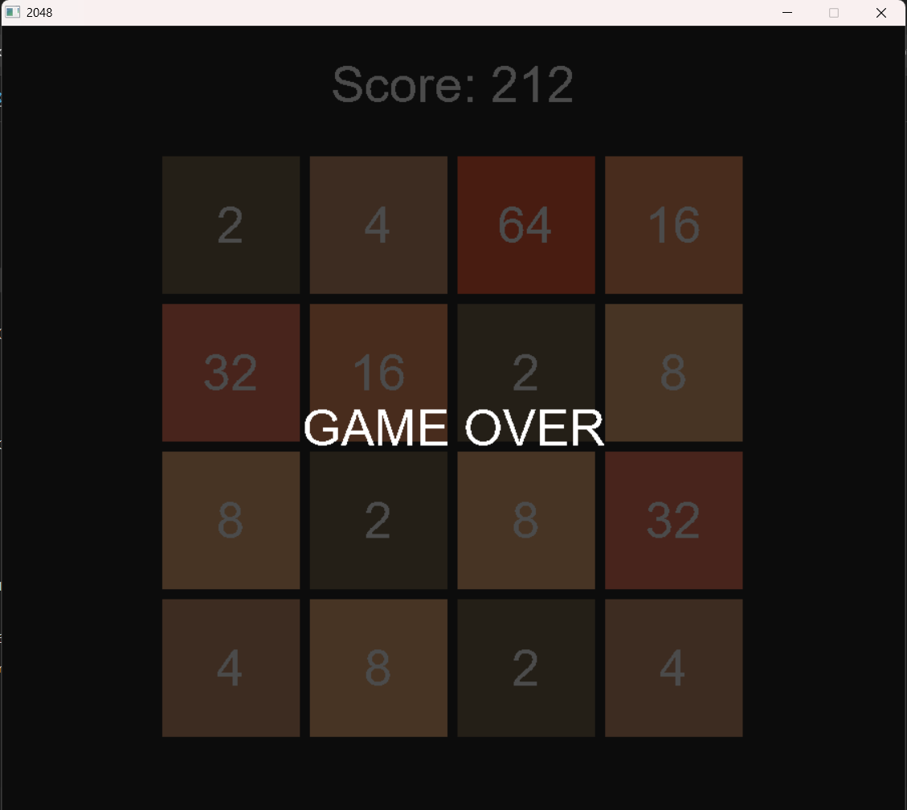

10.3 Analysis

The results are what we were looking for. We made the game logic and rendering code separate. This worked really well. When we made changes to the way things look we did not have to change the game logic and the way around. The way we color the tiles using SDL_SetRenderDrawColor() helps the player see how big the tiles are. The score function is simple. It just adds up all the tiles. This is a way to see how the player is doing even though it is not a perfect scoring system.

One thing we noticed is that the score function just adds up all the tiles of keeping track of points earned when tiles are merged. This is a way of doing things and it could be made better to match the way the original 2048 game scores points, where only the values of merged tiles are added to the score. The 2048 game scoring system is an example of how we could improve our score function the 2048 scoring system is what we are trying to match with our game the 2048 game is what we based our game on.
Conclusion :

This project was a success. It showed that we can make the 2048 game using C and SDL2. We achieved all our goals. The game logic works correctly. It has moves, in all directions random tiles, score tracking and game-over detection. The game board looks good. It has colored tiles with numbers. Shows the score in real-time. We used SDL2 and TrueType fonts for this.

The project helped us learn things from the Foundations of Programming course. We learned about 2D arrays, small functions and header files. We also learned about logic, loops and programming with events. Using the library was helpful. We learned how to use libraries and understand the game loop.

Overall the project is complete. Works well. It is an example of basic programming skills used in interactive software. The 2048 game works as expected. We used C and SDL2 to make it. The game logic and graphics are good. We achieved our goals.

Future Scope

There are some things that we can do to make the project better in the future.

The project needs to be improved. This can be done in a few ways.

Here are some ideas for the project:

•Proper Scoring System: The project needs a scoring system where you get points for the tiles that you merge in the project like the one in the 2048 game. The project scoring system is similar to the 2048 game scoring system. The project will have a scoring system that is like the 2048 game.

•Undo Feature: It would be great if you could undo your move in the project this can be done by saving what the board looked like before you made your move in the project so you can go back to the state of the project.

The project can also have some features, like

•High Score Persistence: The project should be able to save your score in the project and load it when you play the project again so your highest score in the project will not be lost when you stop playing the project.

•Animations: The project can have animations when the tiles move and merge in the project this will make the project look better the project will be more fun to play because the project will have animations.

•Sound Effects: The project can also have effects when the tiles merge in the project and when the project game is over this will make the project more fun to play.

•Difficulty Modes: The project can have levels of difficulty in the project this means that the project game can be made easier or harder by changing how often a 4-tile or a 2-tile appears in the project. The project will be more fun for people who play the project and also, for people who play the 2048 game.

References

[1] G. Cirulli, "2048," Online game, 2014. [Online]. Available: https://gabrielecirulli.github.io/2048/
[2] SDL Development Team, "SDL2 Documentation," libsdl.org, 2023. [Online]. Available: https://wiki.libsdl.org/SDL2/FrontPage
[3] SDL_ttf Development Team, "SDL2_ttf Documentation." [Online]. Available: https://wiki.libsdl.org/SDL2_ttf/FrontPage
[4] MinGW Project, "Minimalist GNU for Windows." [Online]. Available: https://www.mingw-w64.org/

Appendix

A. Full Source Code Listing

game.h – Function Declarations:
#ifndef GAME_H
#define GAME_H
void initialize_board(int x[4][4]);
void add_random_tile(int x[4][4]);
int move_left(int x[4][4]);
int move_right(int x[4][4]);
int move_up(int x[4][4]);
int move_down(int x[4][4]);
int is_game_over(int x[4][4]);
int score(int x[4][4]);
#endif

(Full source code of game.c and main.c is provided as separate attachments.)

B. Compilation Instructions
# Install SDL2 and SDL2_ttf (MinGW on Windows)
# Place SDL2.dll and SDL2_ttf.dll in the same directory as game.exe

# Compile command:
gcc main.c game.c -o game.exe -lSDL2 -lSDL2_ttf -IC:/SDL2/include -LC:/SDL2/lib

# Run:
game.exe

