Combitrack
Combinations of tracks from an hiking routes network
release 5 – February 2025
Bernard Houssais – FF Randonnée 35 – bh35@orange.fr
* * *

Abstract
From a local network of hiking routes, coded in the OpenStreetMap representation, combitrack builds combinations of route sections, starting from a given point and in a fixed range of lengths.

Motivation

Official marked circuits do not always meet the needs of hikers, particularly in terms of their length. However, routes in the same area often have common parts, or can be connected by paths of interest or short passages on the road. This set of usable routes constitutes a network of paths: for example, network of the circuits of Acigné (a city near Rennes known for its many routes).

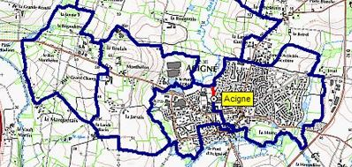
By selecting sections of this network, it is possible to build combinations close to the desired length, and of acceptable quality. Such combined circuits, with varied (or even absent) markings can be materialized by a digital trace, and easily followed on the ground with the help of geolocation.
When the paths in the network are numerous enough, the number of possible combinations becomes enormous. Their manual construction by cutting and trial and error is tedious, without guaranteeing a route of the best quality.
A map such as OpenStreetMap (OSM) contains a large part of the paths and routes located in a given area. Tools can extract these paths from the map, with their paths and properties (category, nature of the surface, etc.). It is possible to select some of these paths, for example those used by a route, or those that would make interesting junctions. This selection results in the construction of a network, and is translated concretely by the production of an OSM data file (suffix .osm), for example Acigne.osm. It then becomes possible to automate the construction of combinations, based on the sections of this network.
This is the purpose of our software combitrack.py.
The network on the chosen area is provided as input to the program. The simple user does not need to know OSM: he can simply view the network that has been built. He chooses one of the predefined starting points, as well as a desired length interval. The combinations are calculated automatically, and output as GPX track files.

Instructions for use

Create a folder specific to each network, and load its OSM representation into it: for example Acigne.osm. Start the combitrack software:

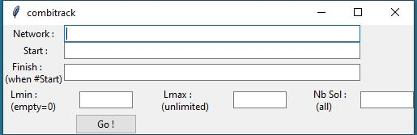
First enter the name of the network: Acigne (without accent), then click on Go! The network is analyzed, with a search for possible anomalies. The starting points defined in the network are listed.

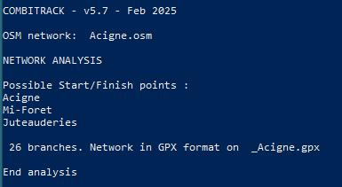
A GPX version of the network _Acigne.gpx is also produced: it could allow you to visualize it, or to manually build a combination, by juxtaposition of some of the 26 branches constructed . We can now start calculating combined circuits, from a starting point to be chosen in the network (starting points recalled during the analysis). Restart the program (the name of the network has been memorized), and add the name of a starting point (or only its beginning).

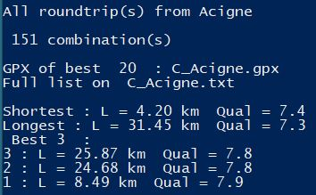
The program found 151 combinations. The one with the best quality measures 8,49 km. The complete list of solutions is produced in the text file C_Acigne.txt and the GPX tracks of the 20 best in C_Acigne.gpx . For each of them, a "quality" calculation was carried out, producing a "score" between 0 and 10. Its calculation method (necessarily subjective!) will be detailed elsewhere. It is based on the nature of the sections of paths as it appears in OSM: natural path, footway, dirt or stone track, small or large road, etc. The GPX tracks are produced in the reverse order of quality. In mapping software, the best ones are thus "above" the others.
The values after Lmin and Lmax make it possible to reduce the number of combinations, by limiting them to those whose length is between Lmin and Lmax. Example: Lmin=9.5 Lmax=11 to obtain combinations between 9.5 km and 11 km. The number Nb_Sol also limits the number of combinations (the best Nb_Sol).
The name of a starting point can be abbreviated in the command line, by giving only its beginning. Capital letters and special characters are not significant, and Saint can be abbreviated to St. Thus a starting point called Sainte-Marie can be written "ste m". Be careful, no accented letter in this name.
Behind Finish can be indicated another point of the network, which will be an end point. We are then no longer looking for circuits but for linear routes between the start and the finish.
If a desired starting (or finishing) point is not predefined, it can be provided in the form of coordinates (latitude, longitude) in decimal degrees: Start: (48.1322,-1.5347) for a start from the church of Acigné.

Quality of a route

With the most common networks, the number of combinations produced can be considerable (sometimes thousands!). Even if the length interval is reduced, the choice of the results to be retained can be difficult. A quality criterion for a combination has therefore been introduced, allowing a ranking of the solutions, by retaining only the N best.
A network is made up of a set of OSM routes, defined by the highway attribute. A highway=path is a fairly narrow path, a footway is a pedestrian path, a track is a farm track, an unclassified a small, little-used road, etc. A quality rating (necessarily subjective) can be associated with each of these supports: a path is often pleasant and will have a maximum rating of 10/10. A small tarmac road will only have 2/10, and we will even put 0 for a busy road. Farm tracks, common on routes, have very variable qualities: OSM generally adds a tracktype attribute, whose value ranges from grade1 (tarmac path) to grade5 (natural state, earth, grass, etc.). A track is considered pleasant from grade3 (stoned with grass), with a suggested rating of 7/10.
The chosen rating for each of the highway values can be found in the first lines of the program. To evaluate a route, each of the tracks that compose it sees its rating calculated, then weighted by its length. Thus, a route consisting of 2/3 dirt tracks (rated 9/10), and 1/3 small road (2/10) will have an overall score of (2/3)*9 + (1/3)*2 = 6.7 This rating is of course rather summary, forgetting the landscape, the natural environment, the relief, the season, etc. It has the merit of being automated, and more precise than the simple percentage of tarmac. Its interest is first of all to allow a classification of the solutions.

Remarks and advice

1: Each launch of the program produces files C_Acigne.txt and C_Acigne.gpx, which overwrite previous versions of these files. Remember to rename them beforehand to keep the results of a previous execution
2: Predefined paths can be traveled back and forth. These paths are set when building the network, and appear in red on the network GPX file _Acigne.gpx (and subsequent map _Acigne.jpg). They are most often junctions between a starting point located away from the main circuits of the rest of the network. In the _Acigne.gpx file, the branches that can be used back and forth are distinguished by their final number starting with 0, such as Acign006.
3: A point of interest (chapel, panorama, etc.) can be connected to the rest of the network by a dead-end path, which must be traveled back and forth (and indicated as such in the network). This access will be present in certain combinations. A dead-end path, not defined as “back and forth”, is considered an anomaly, and deleted by the software
4: The program can produce hundreds of combinations, but the number of GPX tracks produced has been limited to the 20 best. On the other hand, the list of solutions in the C_Acigne.txt file is only limited by the requested Nb Sol. Examine this list to get an idea of the possibilities, then reduce the interval of desired lengths.
5: Conversely, do not be satisfied with the best calculated solution: the quality calculation is only indicative: you may want to visit a tourist site, or prefer a less tortuous route! Limit the number of solutions (about ten?), then examine the tracks produced in a mapping software that accepts multi-track GPX files (VisuGPX). Examine them with your criteria, and only save the track that suits you best.
6: The construction of a new network is done using the JOSM software, used to update the OpenStreetMap map. It therefore requires some practice in contributing to this collaborative map. See the separate documentation on this construction of a network.
7: For simple users, a library of combined circuits can be built using a variant of combitrack called combibase. It produces for each network a large sample of routes of different lengths. See separate notice for this software.

