Starting the tour
1) Make sure robot is physically near the starting position

2) Unplug Roberto from the charger

3) Make sure the emergency stop is depressed so that Roberto doesn't run away.

4) Close the circuit breaker to power on Roberto. This is done by moving a small lever on the breaker's underside as shown in the picture.

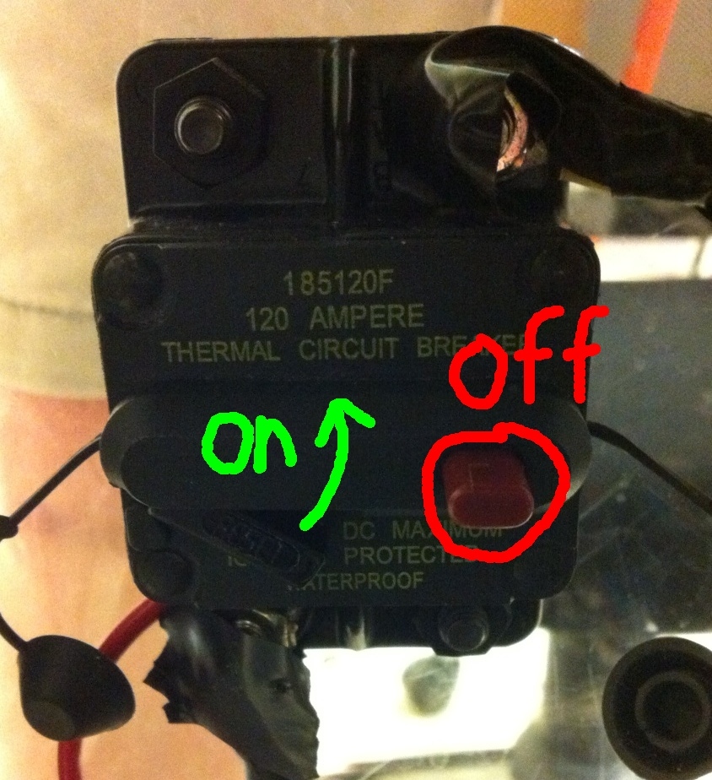

When the power is on, the computer will automatically start up.

5) Open a terminal (ctrl-alt-t)

6) Change directories (you can pres tab to autocomplete this)
$ roscd cwru_tour_guide

7) Run the tour software (again, you can press tab to autocomplete)
$ ./roberto_bk_nav_launch.sh

A window called “rviz” should come up. If it doesn't, press ctrl-c in the terminal to quit, and try to run it again.

If the robot appears to be in the wrong position, click on “2D Pose Estimate” in rviz, and click on where the robot actually is within the map. Drag to set orientation.
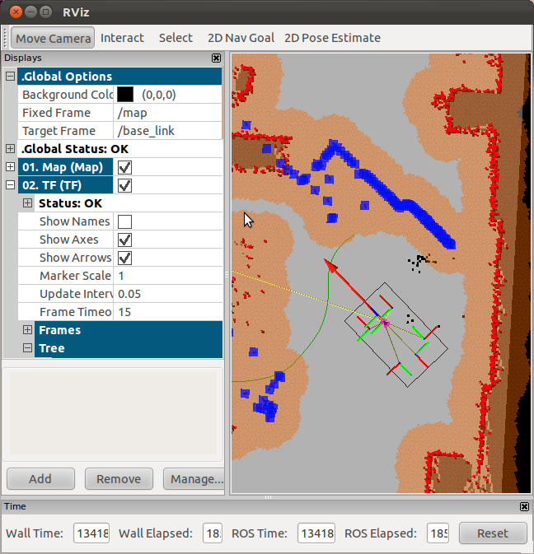
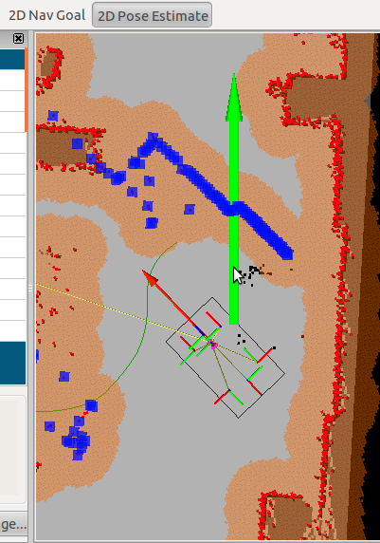
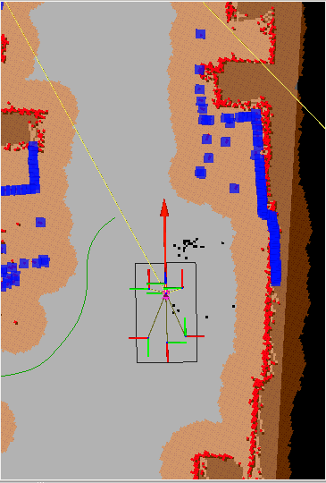

Left: “rviz” window showing robot with incorrect localization
Middle: giving the robot its correct pose
Right” Robot with correct localization (blue laser pings align with map)

8) After ensuring that the robot knows correctly where it is, release the emergency stop. The robot should automatically move.

During the tour
If the robot seems to get stuck, a new goal can be given manually. In rviz, click on “2D Nav Goal” and click where on the map you want the robot to go. Only goals within several meters are allowed. The tour script will automatically resume when the robot is within 1m of its originally-intended goal.

Sometimes, the robot may get stuck with an obstacle at close range. In this case, depress the emergency stop and manually pull the robot backward about a foot. Ensure that the robot's localization is good, and release the emergency stop. A new goal may need to be given manually.

Sometimes, it may be desirable to run the tour without the script for troubleshooting. In this case, edit the file ~/dev/cwru-ros-pkg/cwru_tour_guide/tour_guide_executive/start_executive.launch and set the parameter “skip_sounds” to “true”.

After running
1) Pres ctrl-c in the terminal to shut down the software
2) Power down the computer (the icon in the upper right corner of the screen.)
3) Turn off the circuit breaker (press the red button.)
4) Plug in the battery charger

