Da Vinci Operation Procedures

A: A Da Vinci Anatomical Primer
Computers
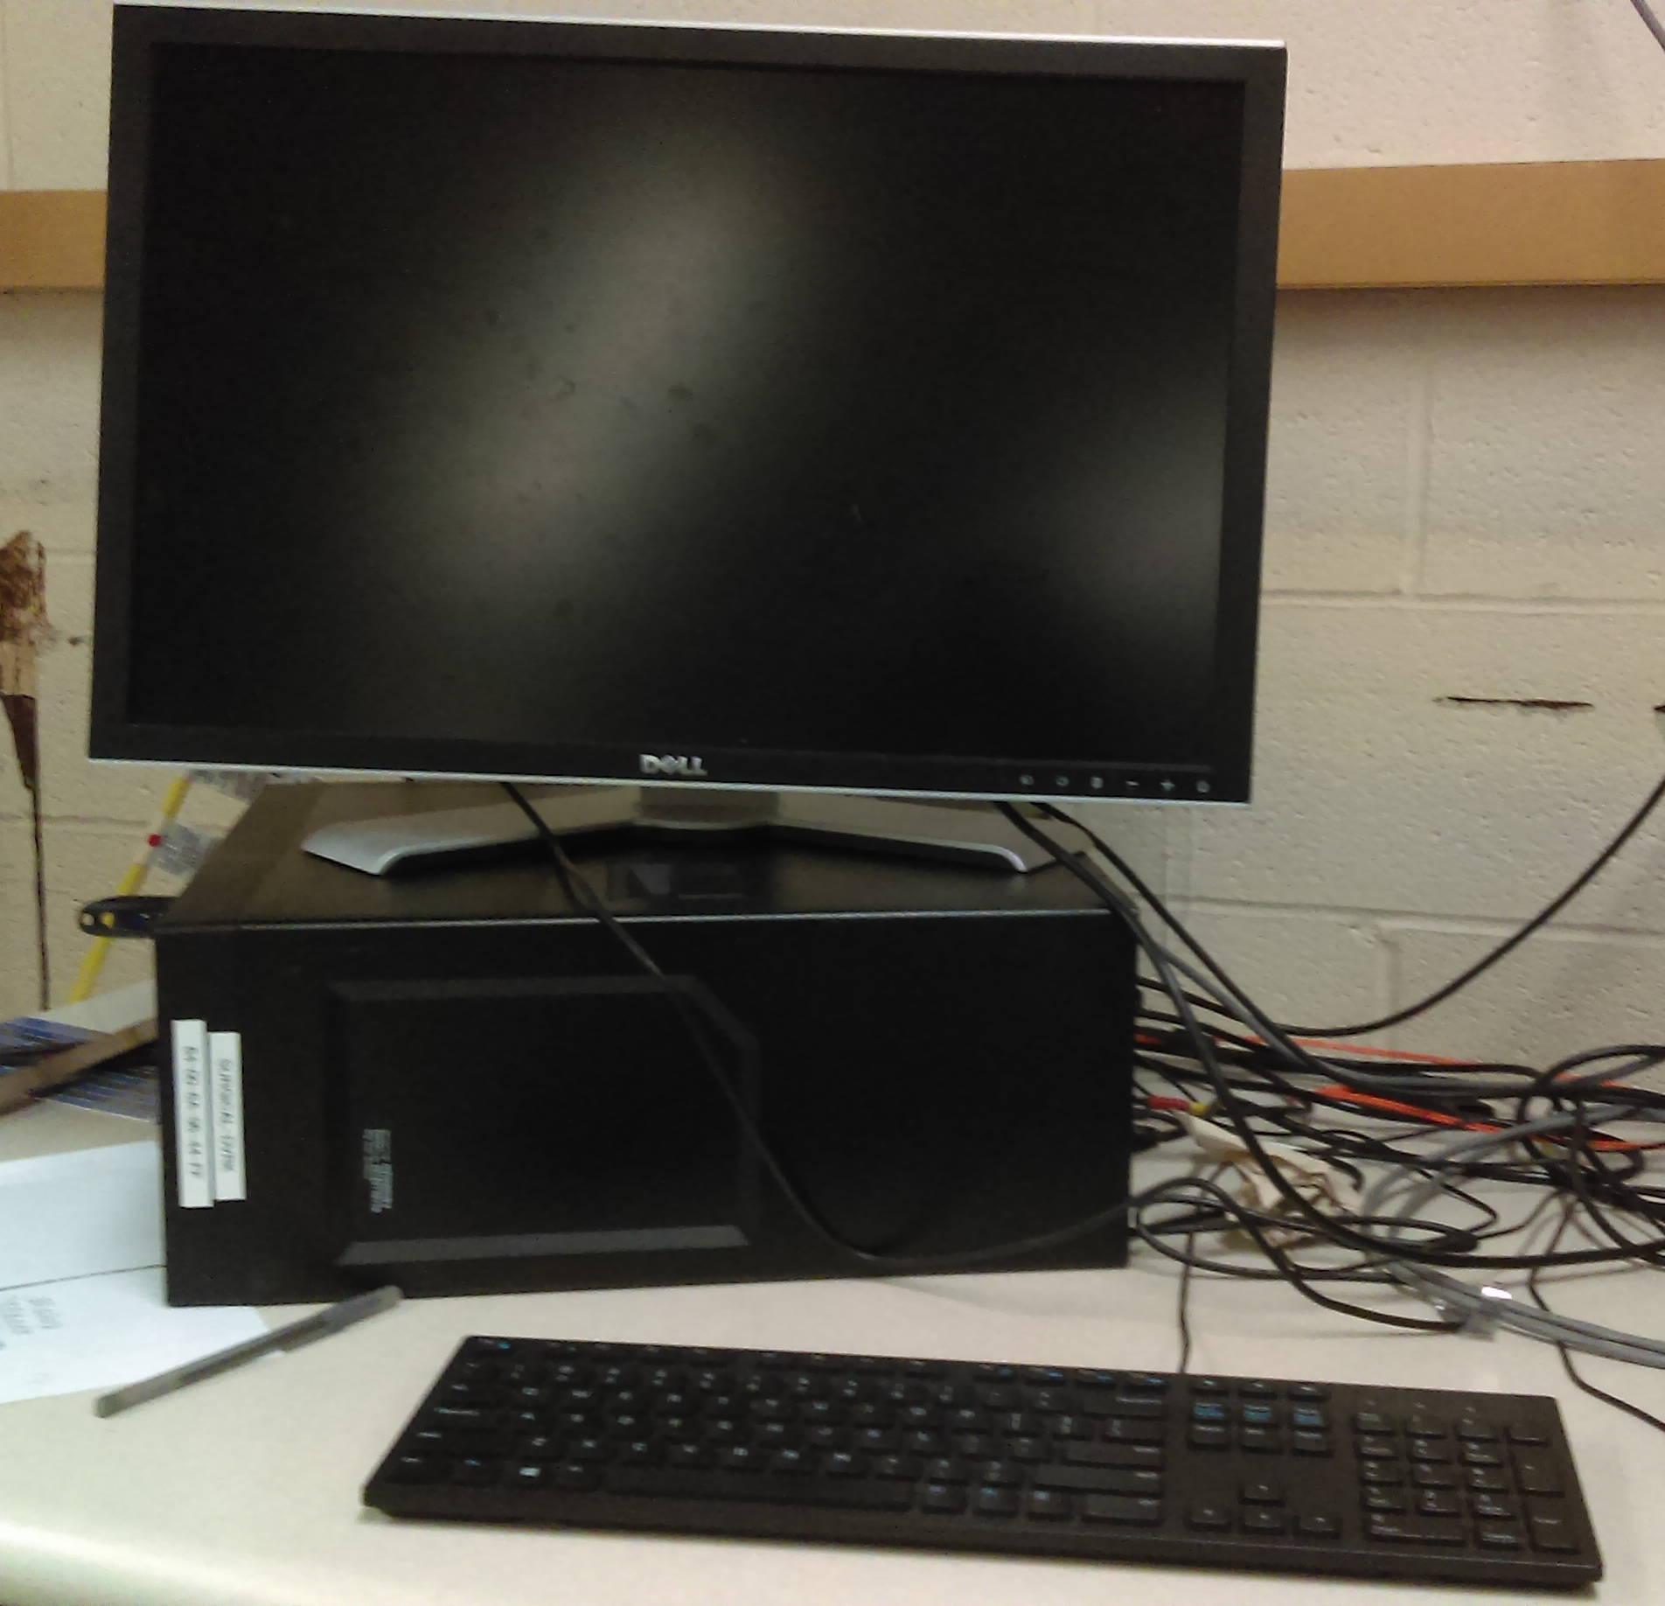
The DVRK control software runs on a Linux computer at a desk next to the Da Vinci robot, which has been tagged with the name SURGICAL-DVRK (the “control computer”).
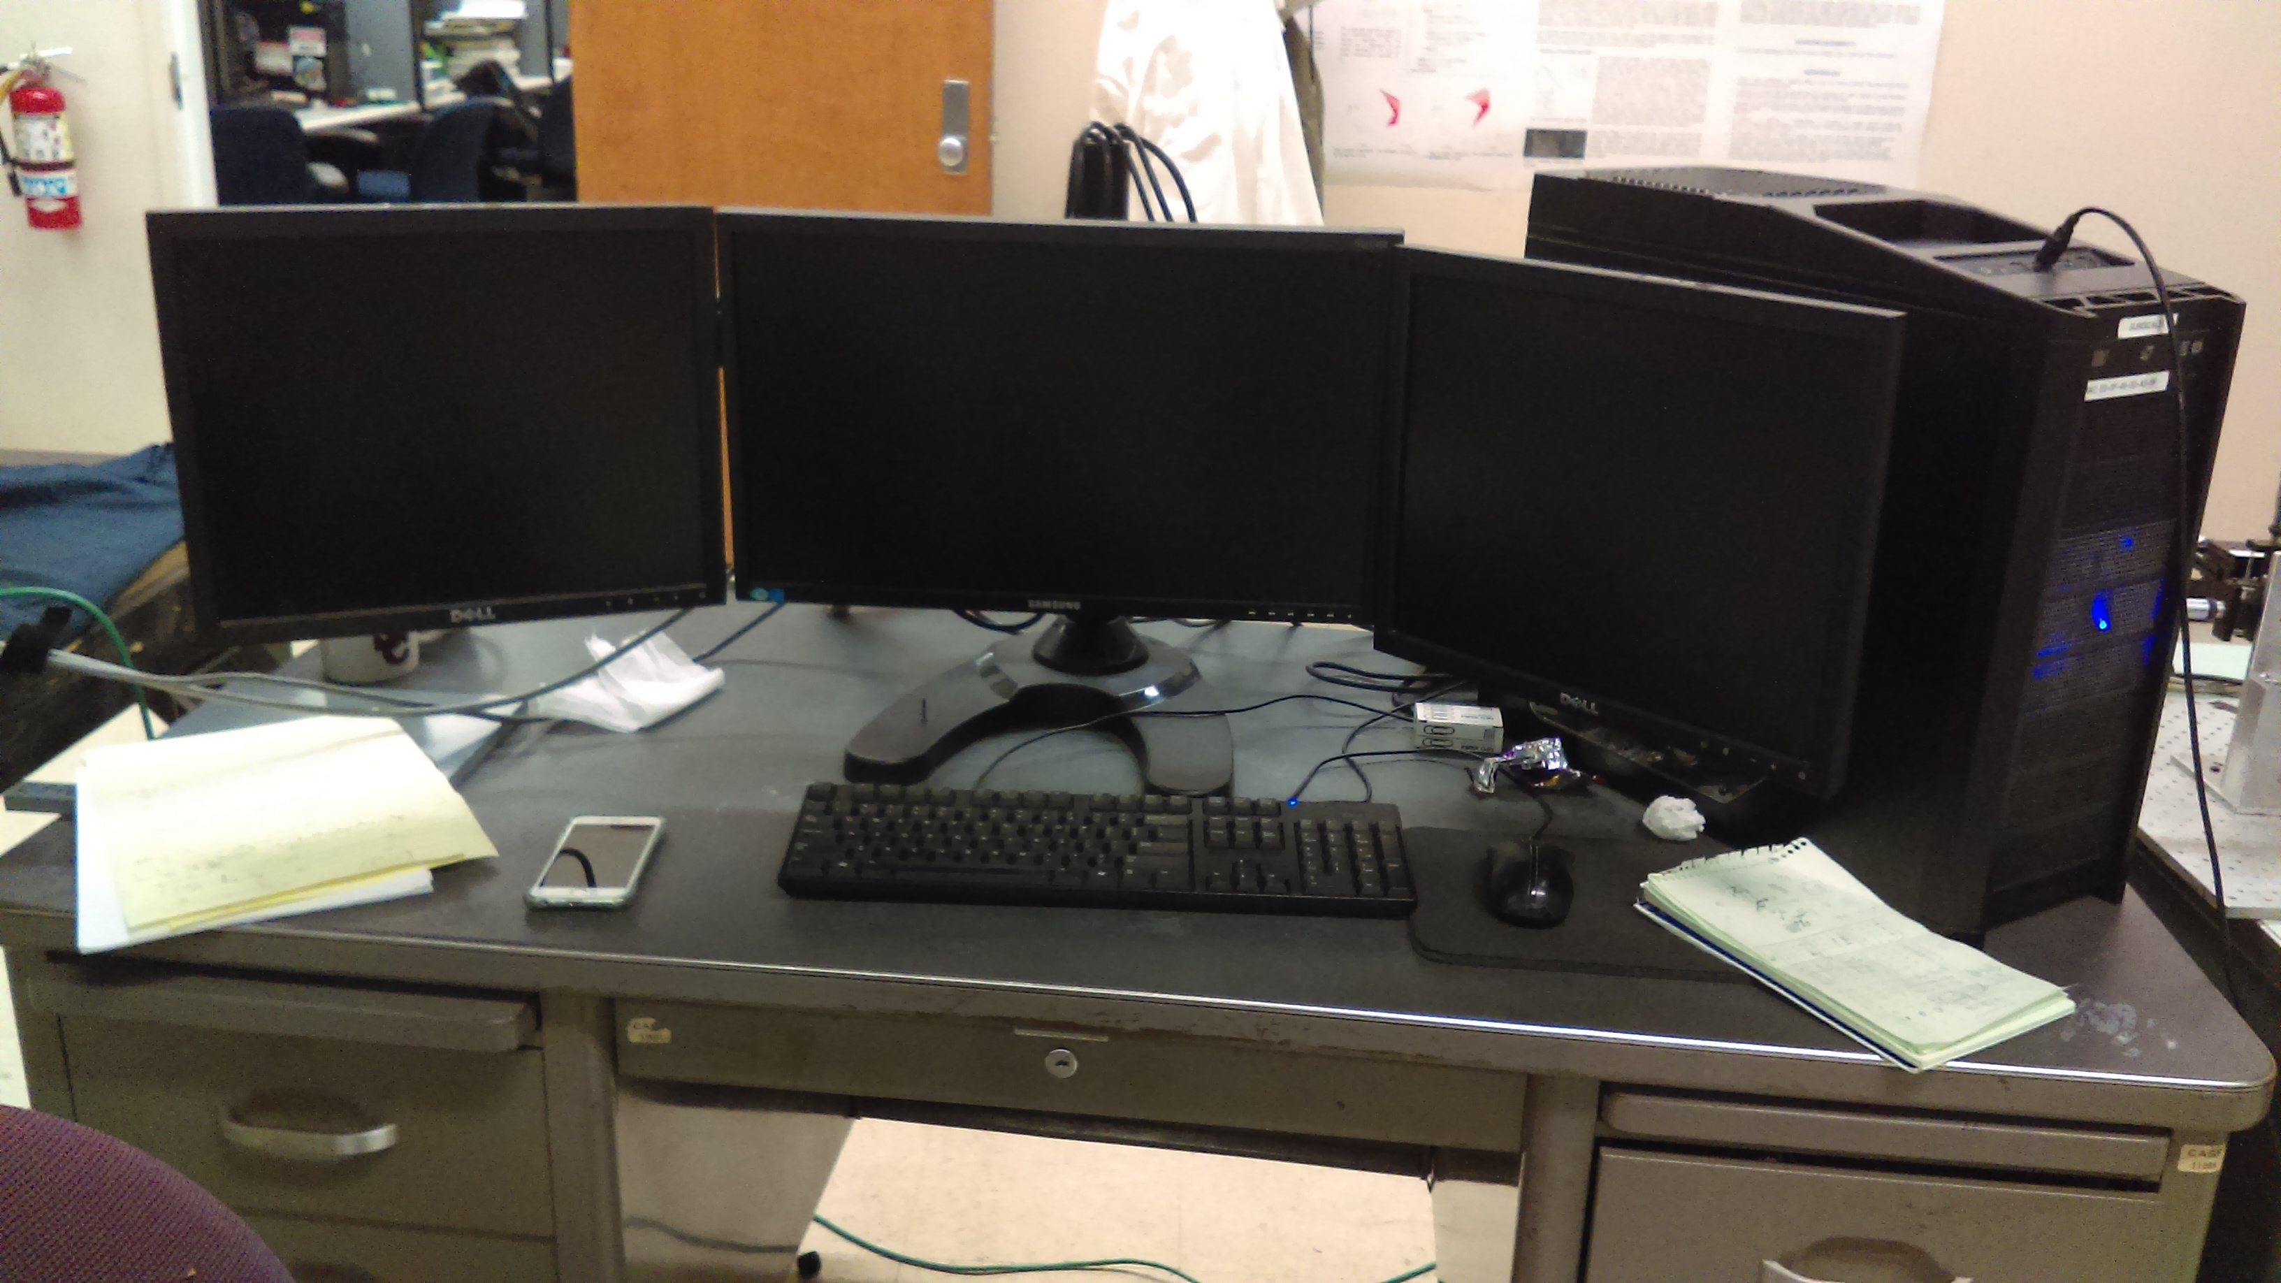
Vision and image processing are done at the computer on the gray desk facing the offices, tagged as SURGICAL31 (the “vision computer”).
Each is connected to unique hardware: it is not possible to control the Da Vinci’s movement from the vision computer or receive camera images on the control computer. Ros topics, however, pass freely from one to the other.

Da Vinci Research Kit (DVRK)
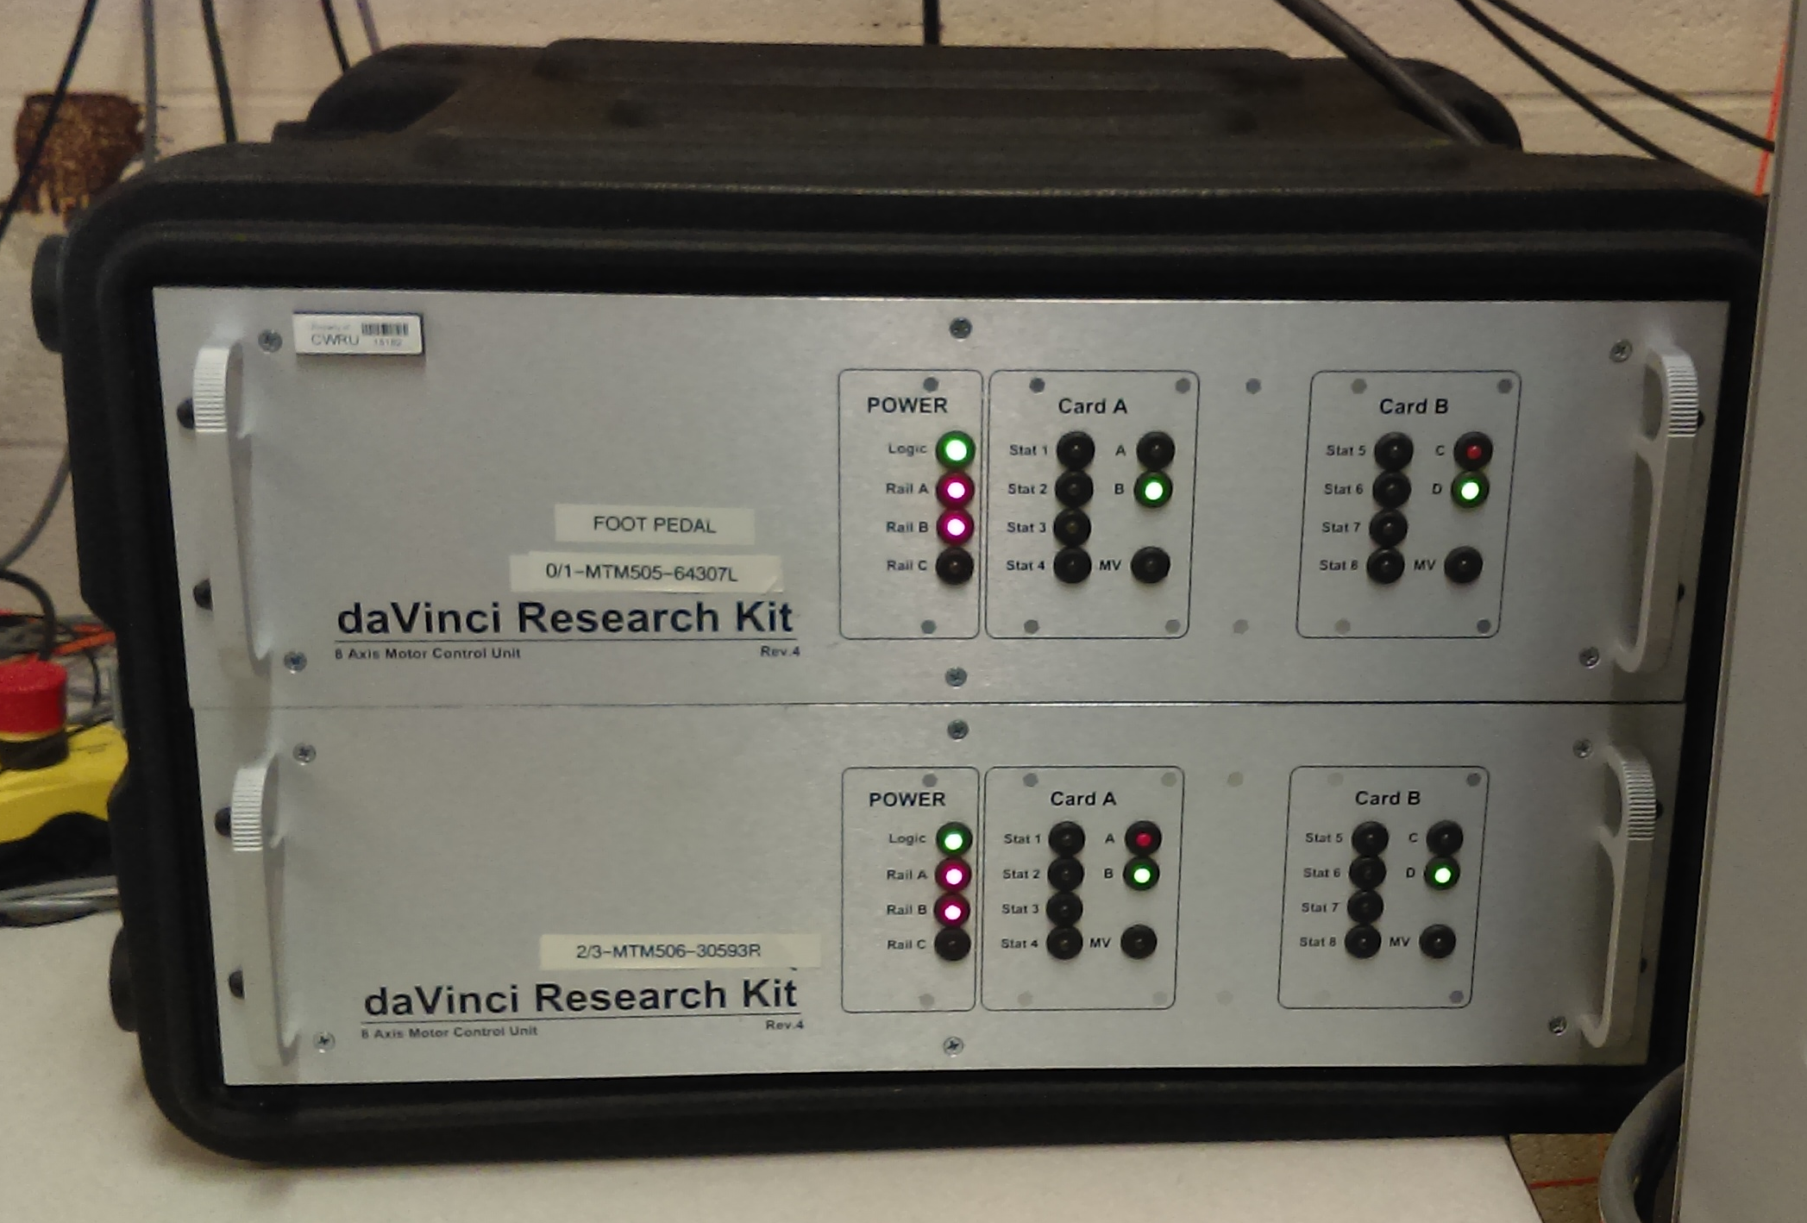
Often just called the “DVRK boxes” to differentiate them from the software used to interact with them, these devices serve as an intermediary between the control computer and the Da Vinci robot itself. They are needed to move the robot, but not to receive images through the endoscope camera.

Main Interface
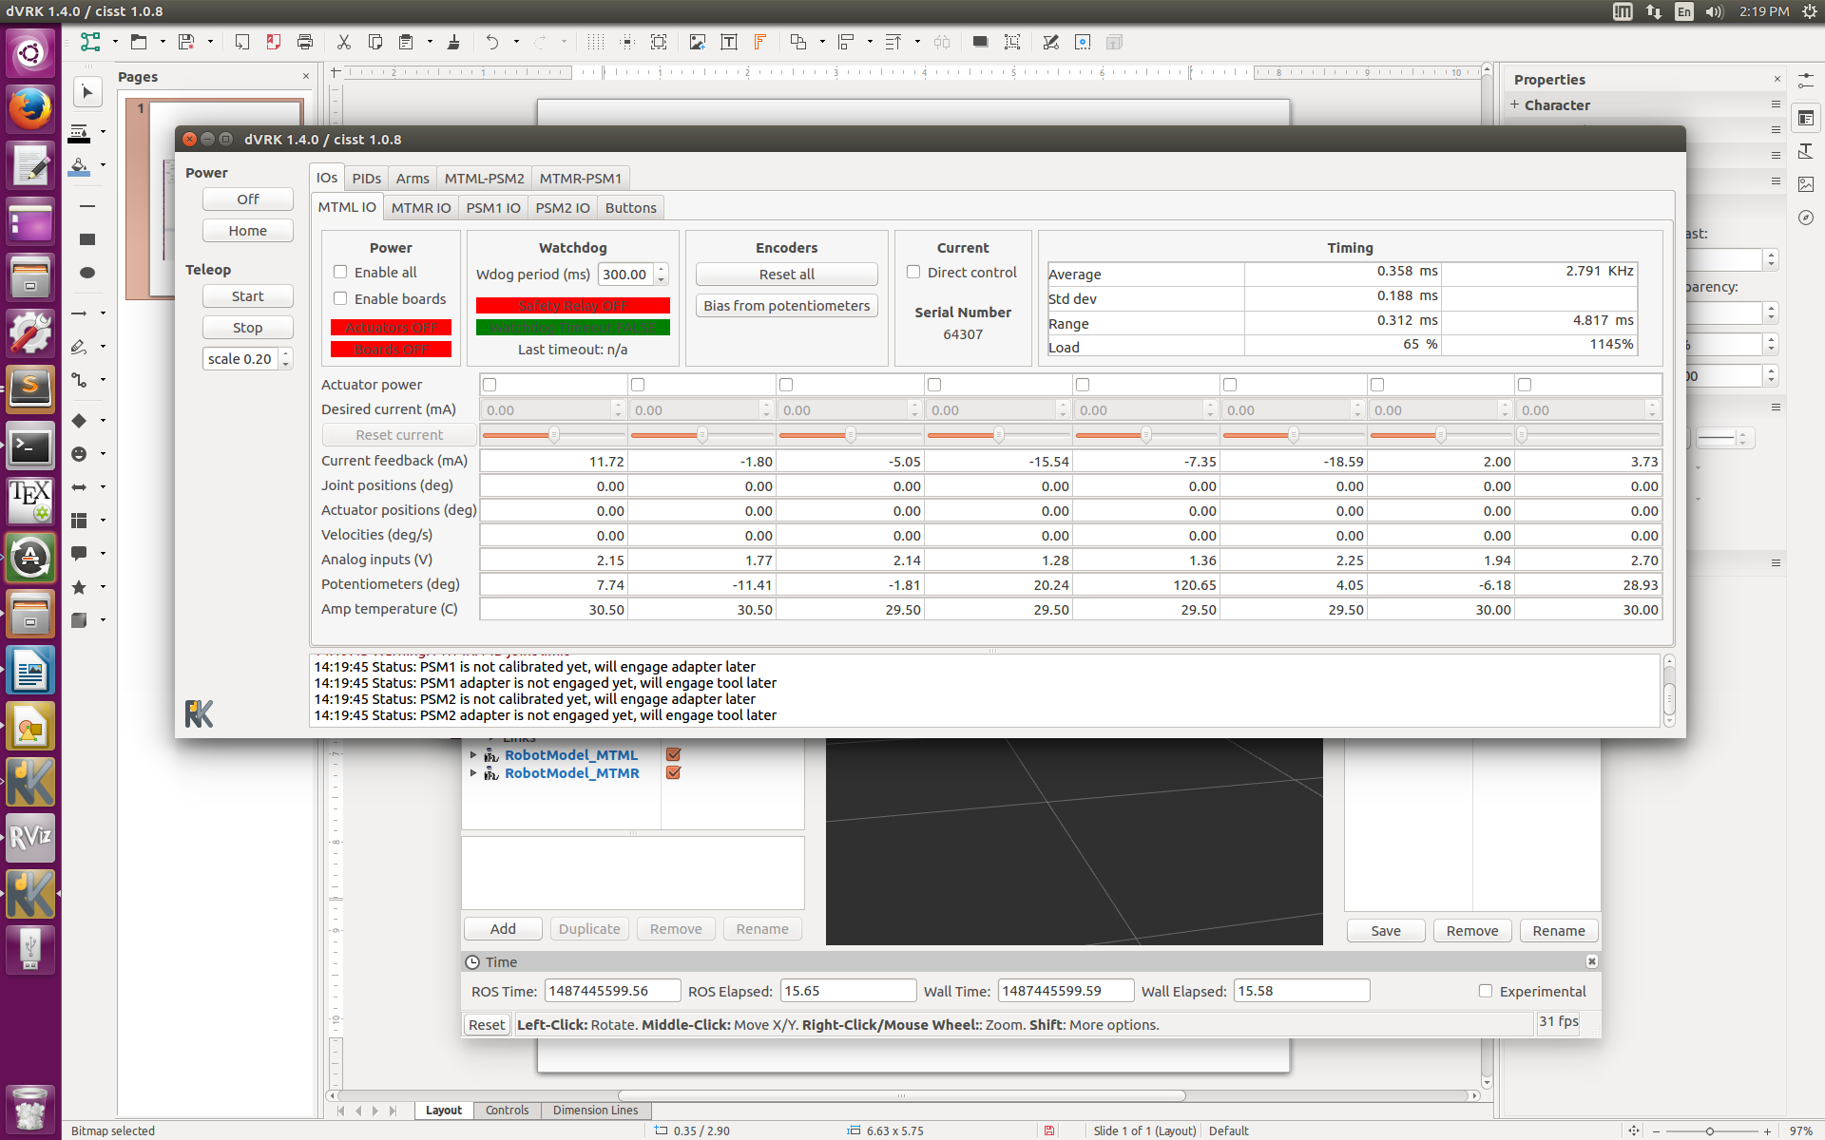
This program acts as a GUI frontend for the DVRK software. It runs on the control computer.

Endoscope
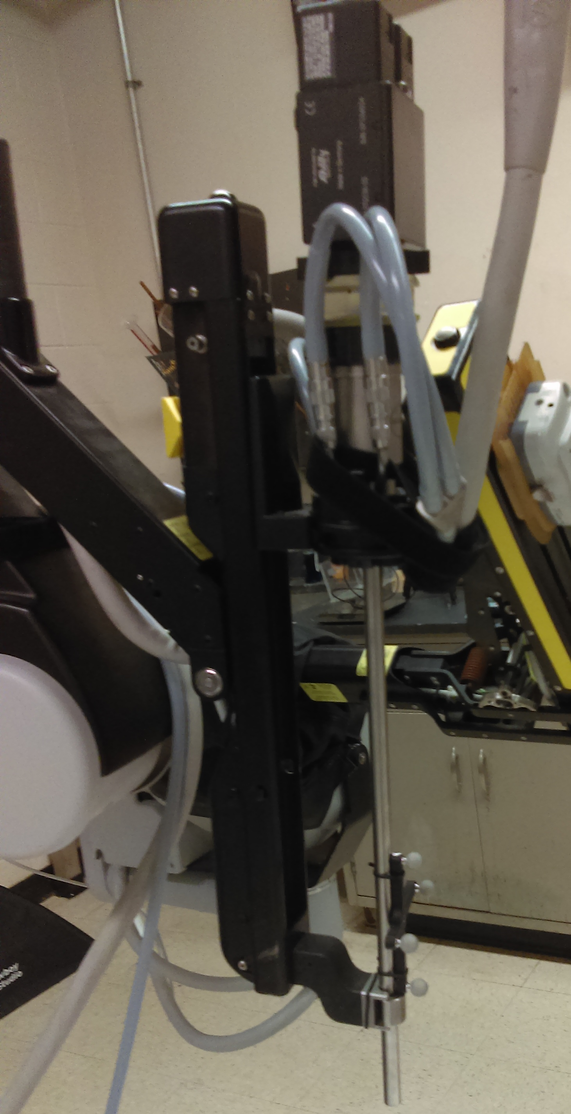
The endoscope contains the Da Vinci’s binocular cameras (hence why it is often referred to as the ‘endoscope camera’ or just ‘camera’). Its field of view is effectively confined to the table underneath it.
Eyepiece
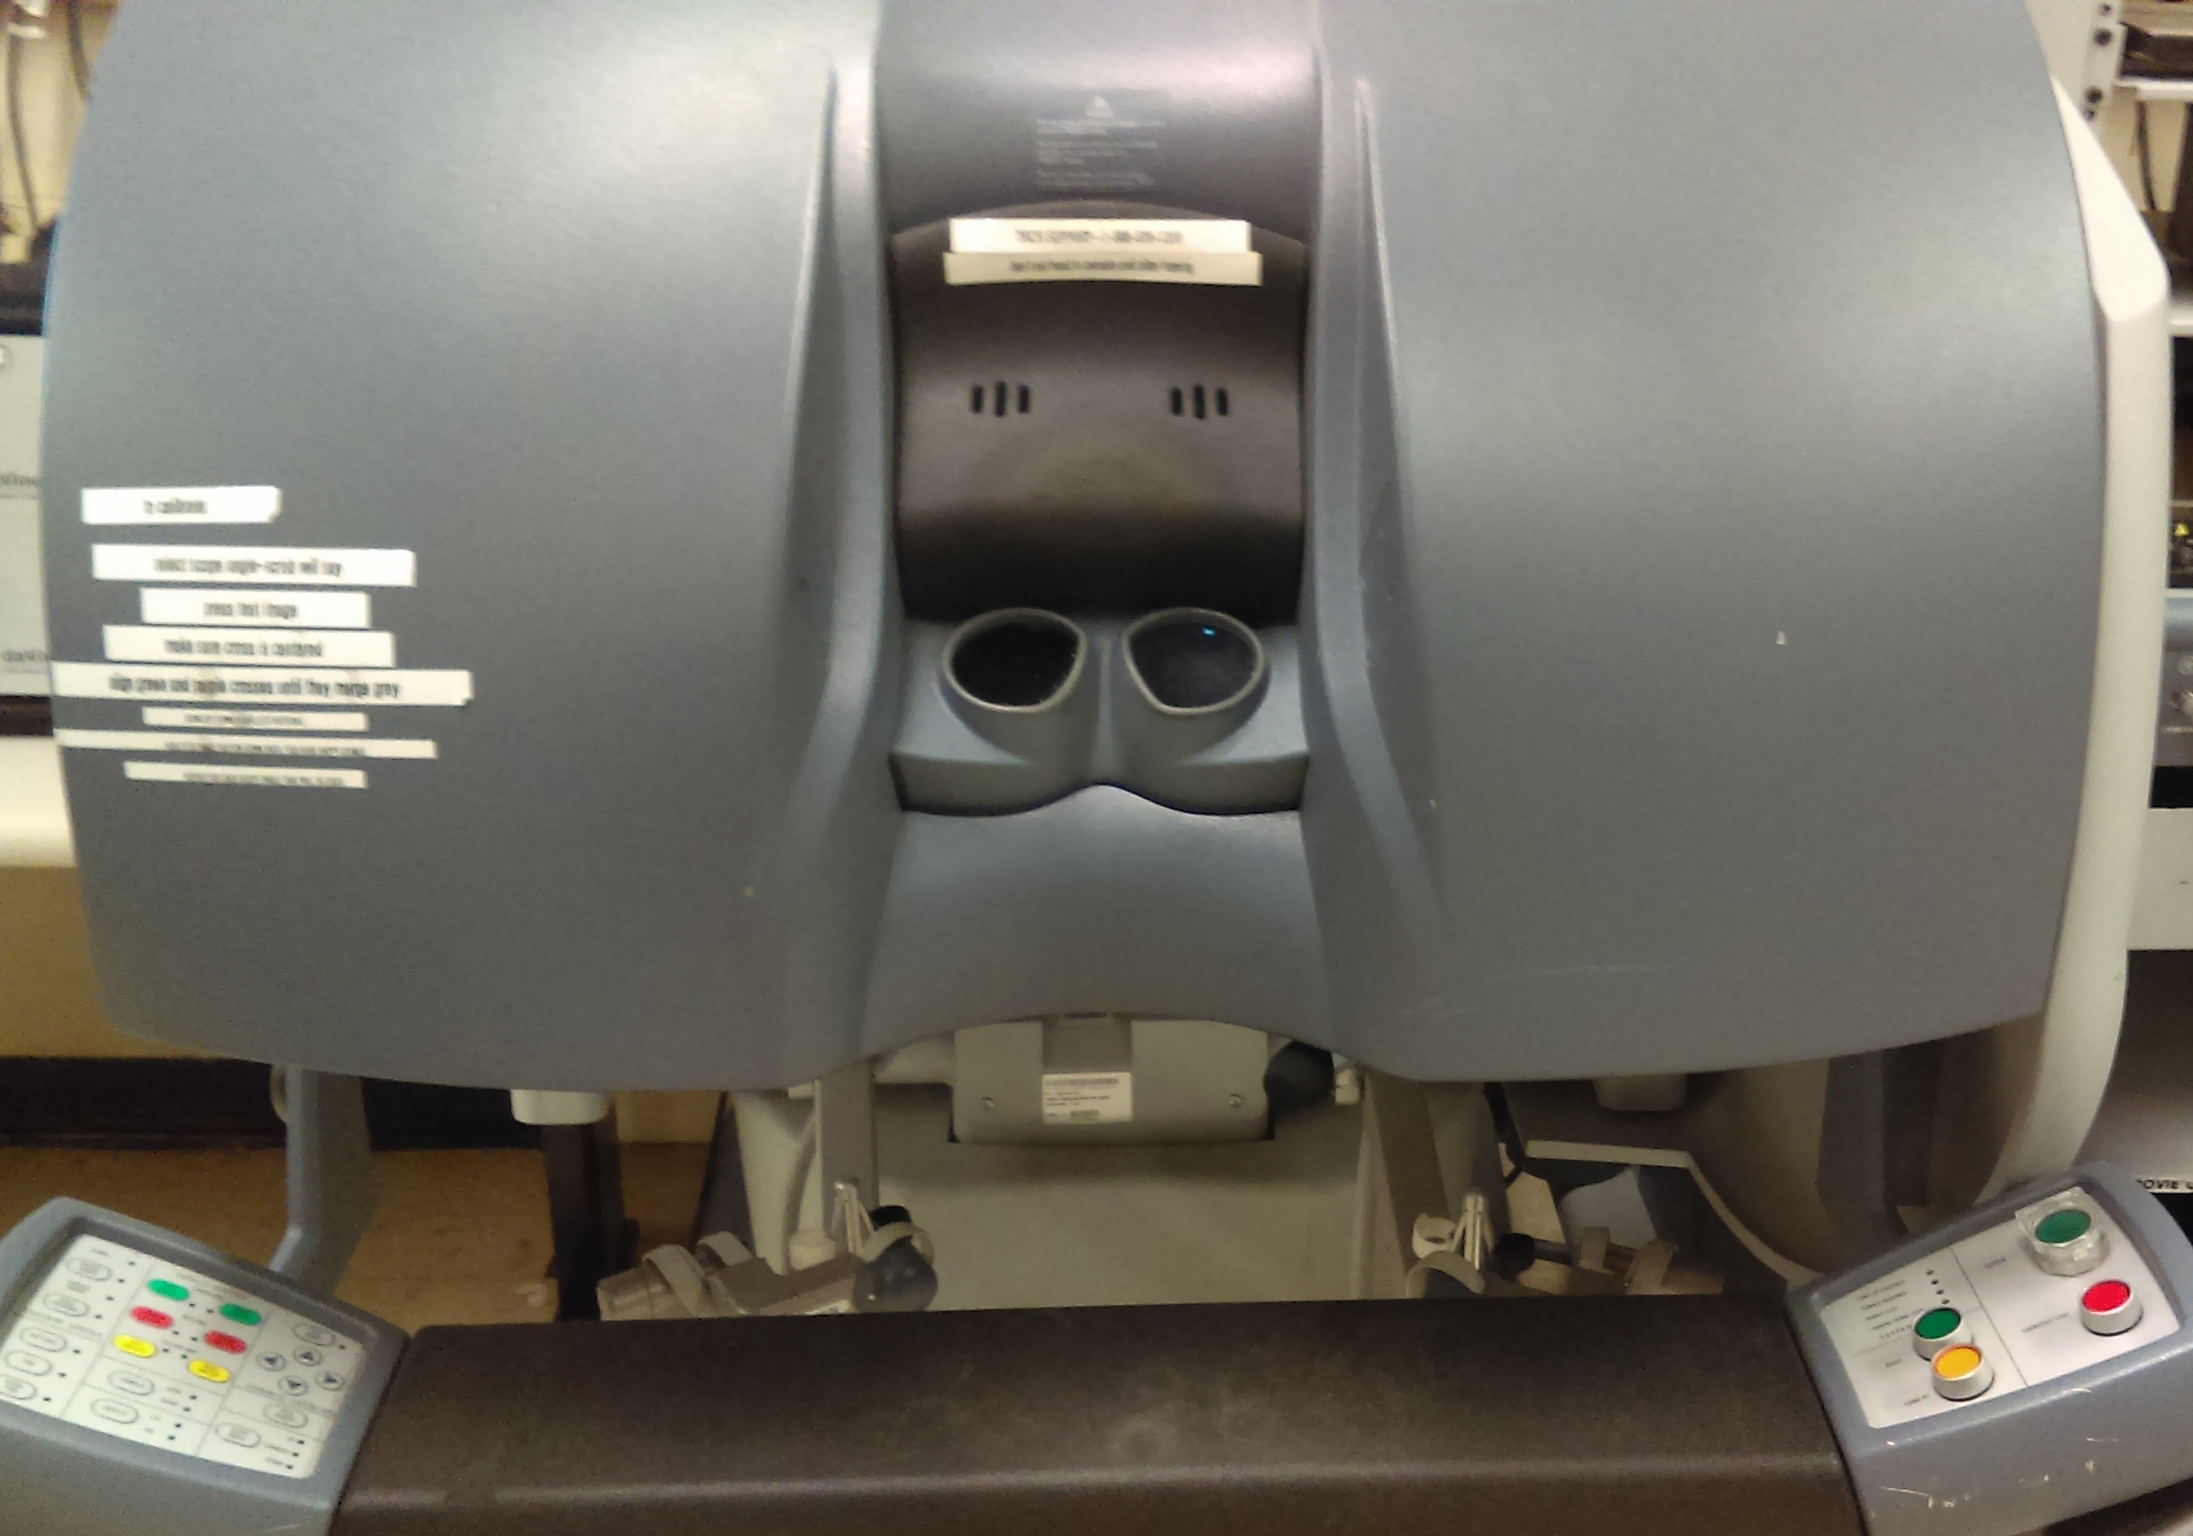
The eyepiece displays the view through the endoscope, if both it and the camera are powered. Although it and the MTMs are physically part of the same device, they are electrically completely separate systems. The controls on the armrest, where they function at all, pertain to the eyepiece and not the MTMs.

Master Manipulators (MTMs)
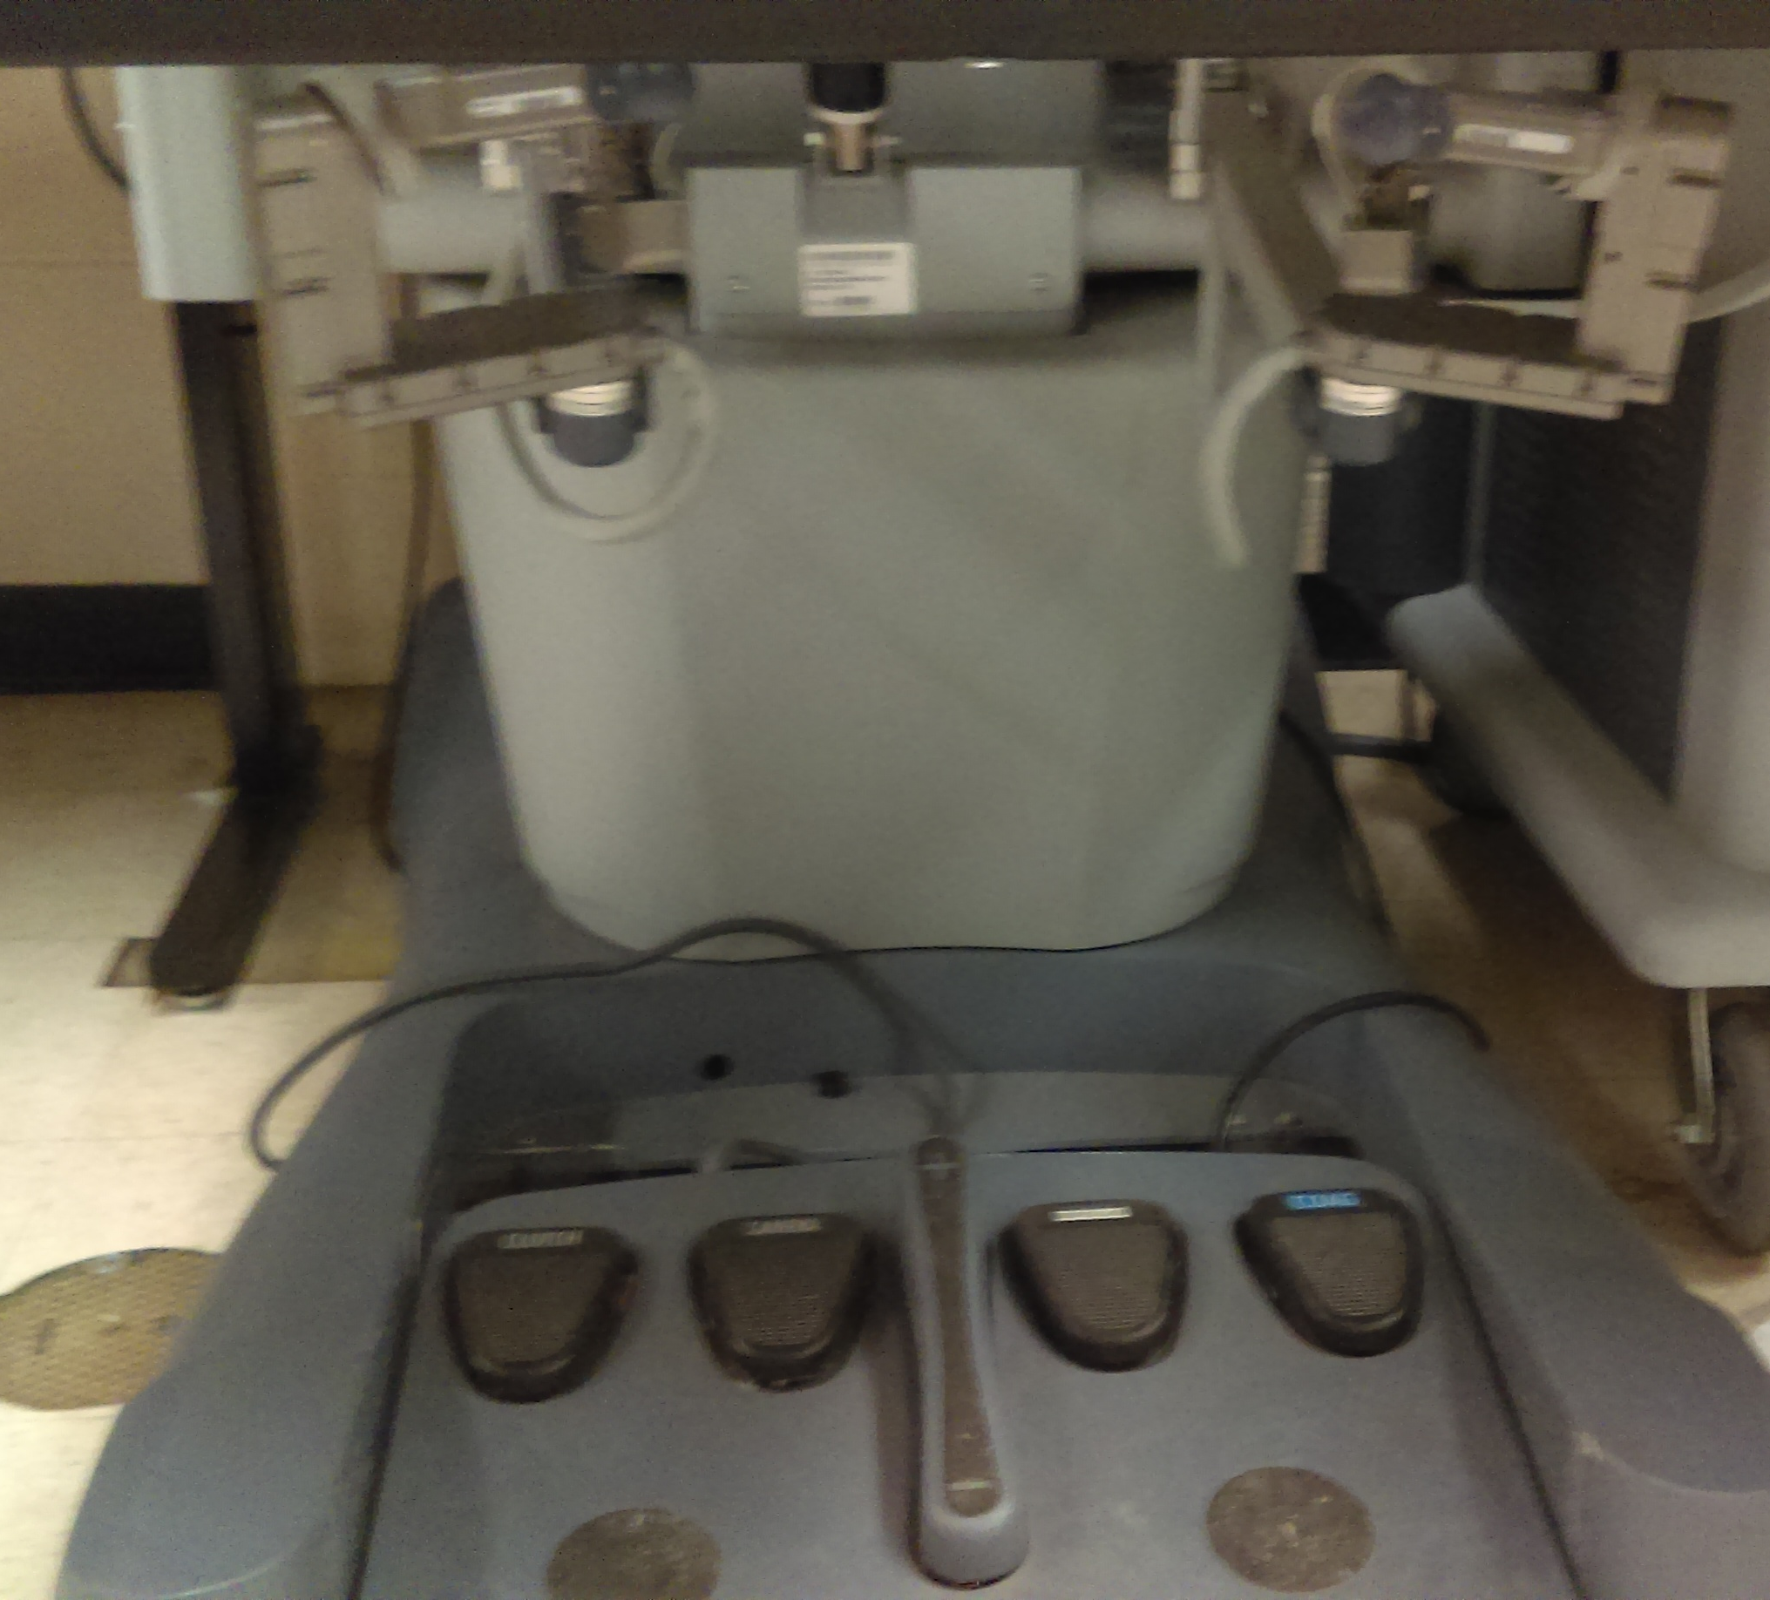
The armature-like devices beneath the eyepiece allow users to directly control the robot through teleoperation. Although they and the eyepiece are physically part of the same device, they are electrically completely separate systems. The MTM system is comprised only of the armatures themselves and the footpedals underneath.

Power Cart
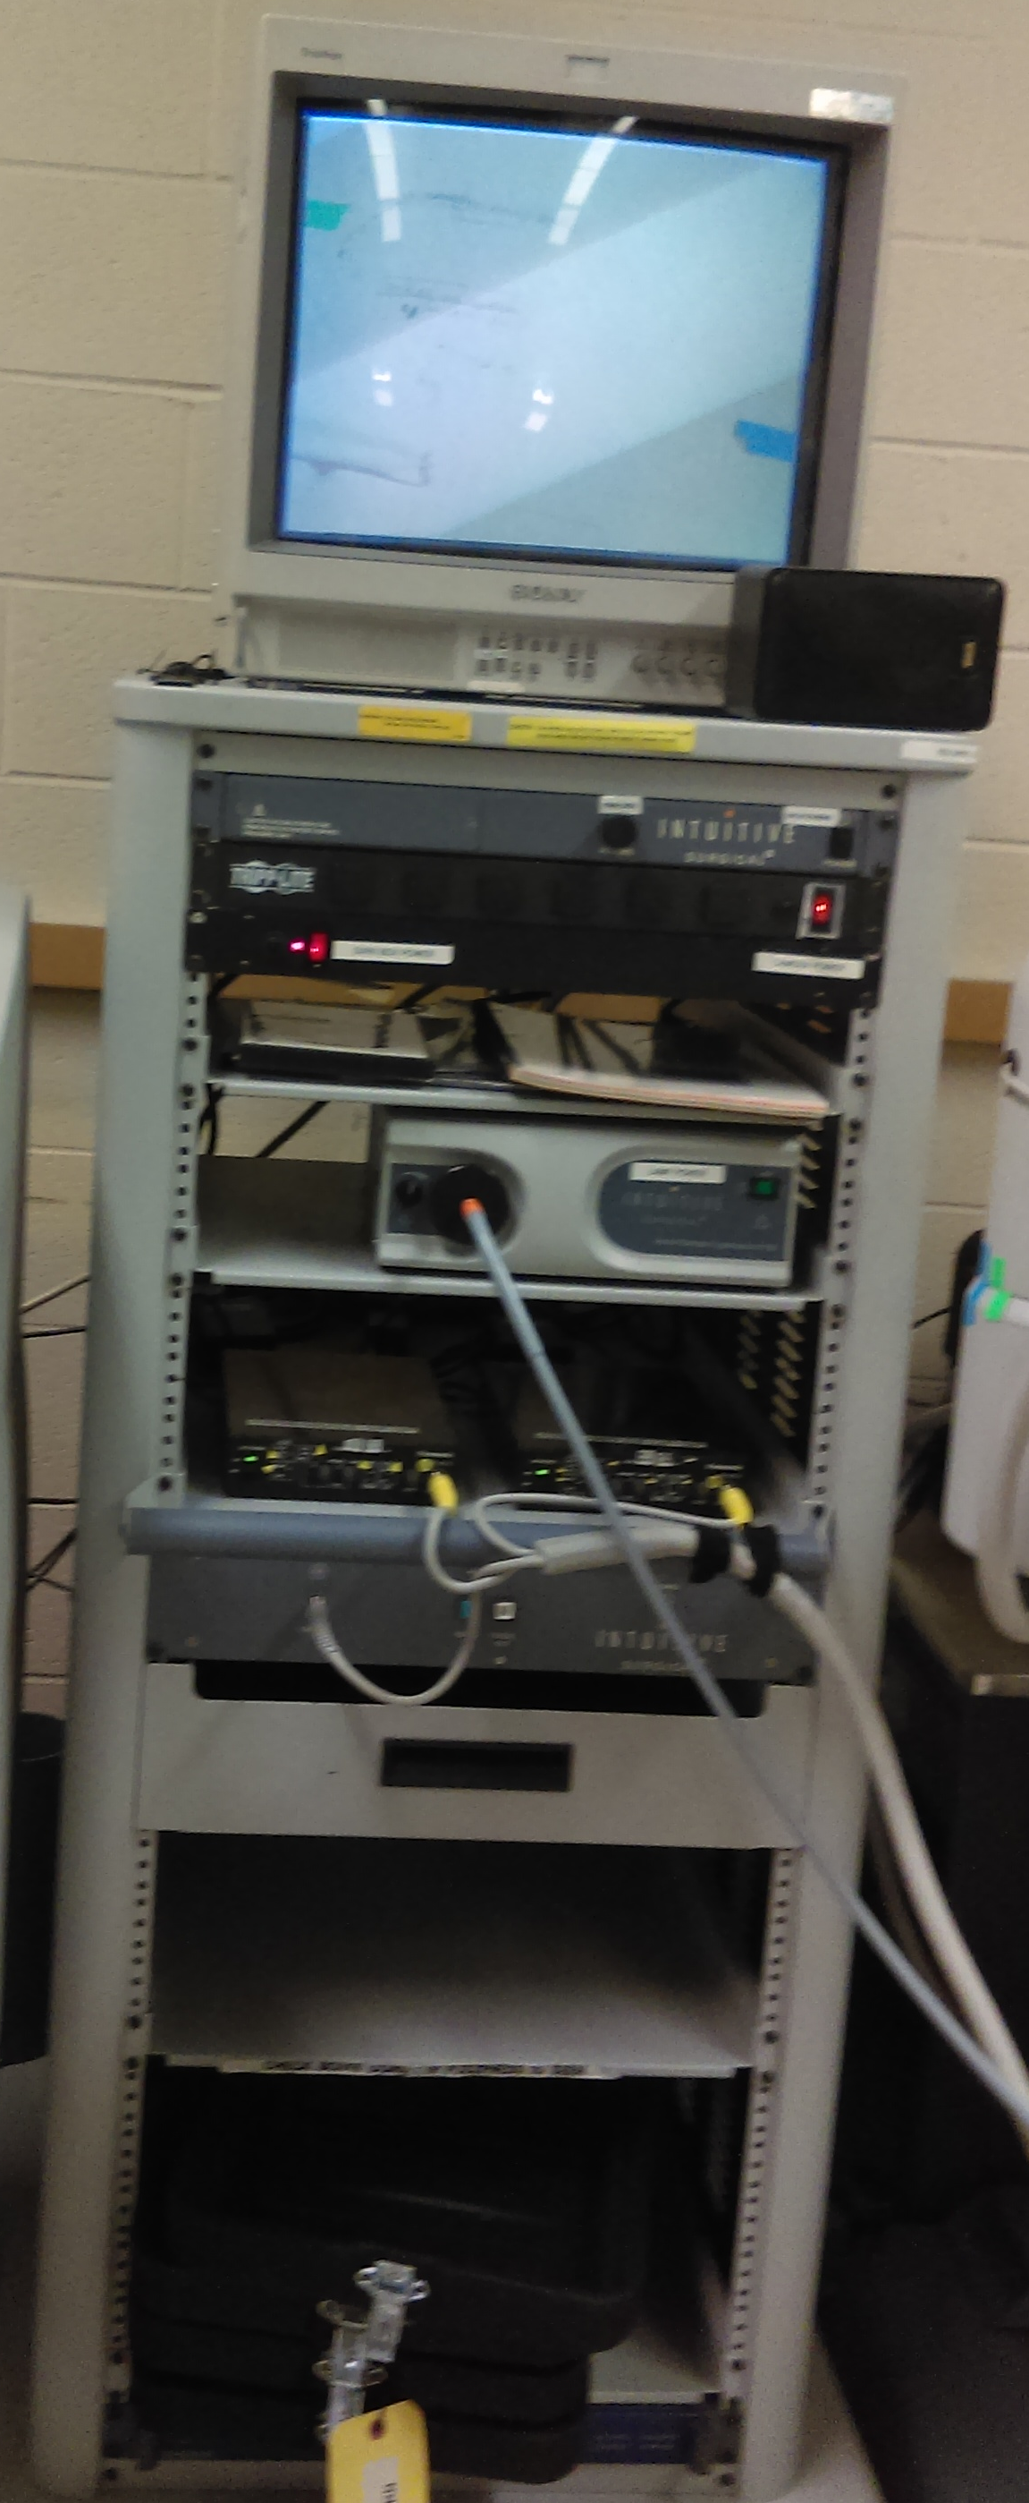
The power cart provides on-off switches for most of the functionality of the DaVinci system with the exception of the two connected computers. It also includes a CRT monitor that will display the output of the endoscope camera, if powered.

Patient-Side Manipulators (PSMs)
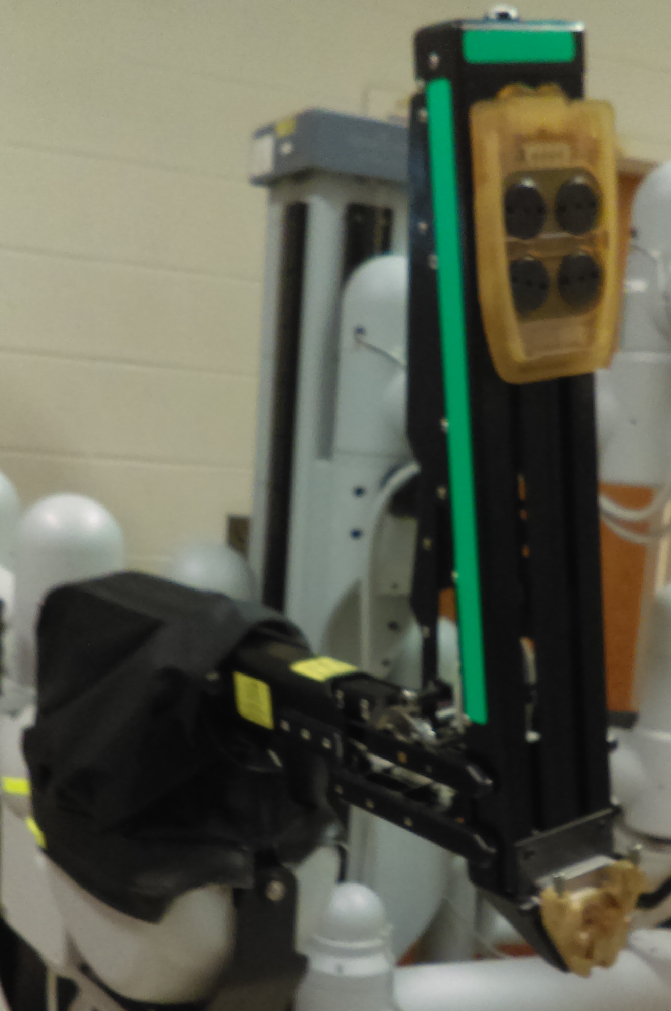
The PSMs are the Da Vinci surgical unit’s main powered components. They are differentiated from the unpowered passive joints by being made of black metal instead of gray plastic. The green arm is labeled PSM1 and is referred to by convention as the right arm; the yellow is labeled PSM2 and is referred to by convention as the left. They are fully backdrivable when not powered; when powered they are quite strong but will revert to an unpowered state when subjected to excessive force.

Passive Joints
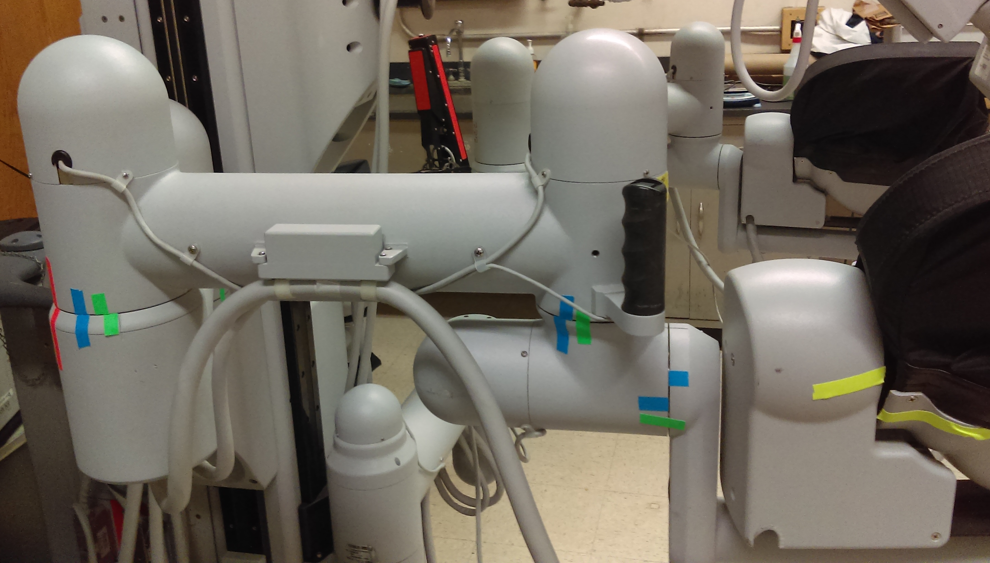
The large, gray joints further back from the PSMs and endoscope are not powered and (for the foreseeable future) do not interact with the DVRK software in any way. They can be moved around by hand whether the system is powered or not (although common sense should be used in not repositioning things when the robot is in motion). Some joints may be stiff or make loud noises when moved- this is normal. The joints cannot be reliably returned to a specific position if moved away from it- there can be differences as great as 10 cm.

Tools
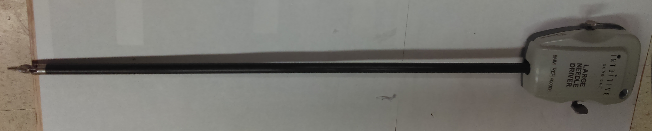
The Da Vinci robot supports multiple interchangeable tools, which can be snapped onto the yellow docking stations on each PSM. Currently only the “Large Needle Driver” and “De Bakey Forceps” tools are fully supported; others have slightly different kinematics and may move strangely under teleoperation or playfile control.

Cannulas
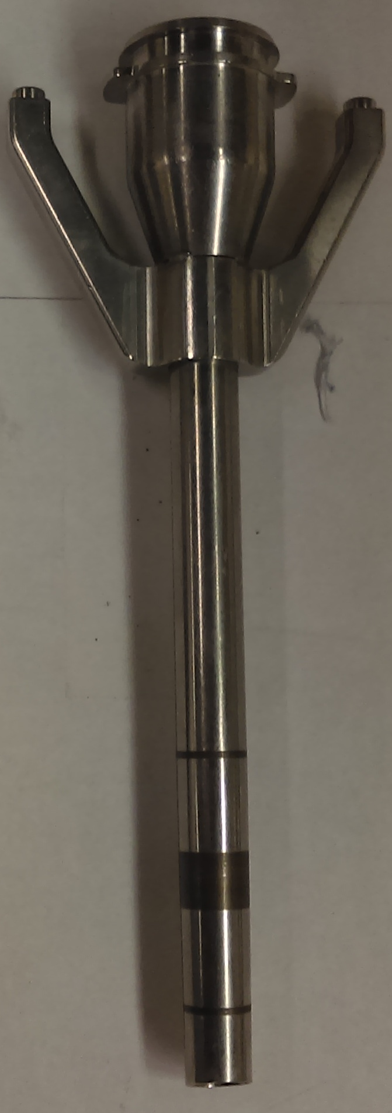
The large metal rods on each arm would be where the robot is inserted into the patient during an actual procedure. They can be removed or reattached using the two screws on top. Whether to run them or not depends on the specifics of a given project- they help steady the tool attachments somewhat, but the range of motion of the grippers is restricted if the tools are retracted fully inside of them.

B: Starting Up The Arms And Controllers
This process is necessary in order to use any of the motor functionality of the DVRK and the Da Vinci- this includes teleoperation, playfiles, and direct control. It is again worth noting that the motion-related elements of the Da Vinci (MTMs, PSMs, and the DVRK boxes themselves) are a completely separate system from the vision related systems (endoscope camera and eyepiece).

- Find the E-stop and identify a safety operator. Make sure E-stop is in the upward (disengaged) position before you power up.
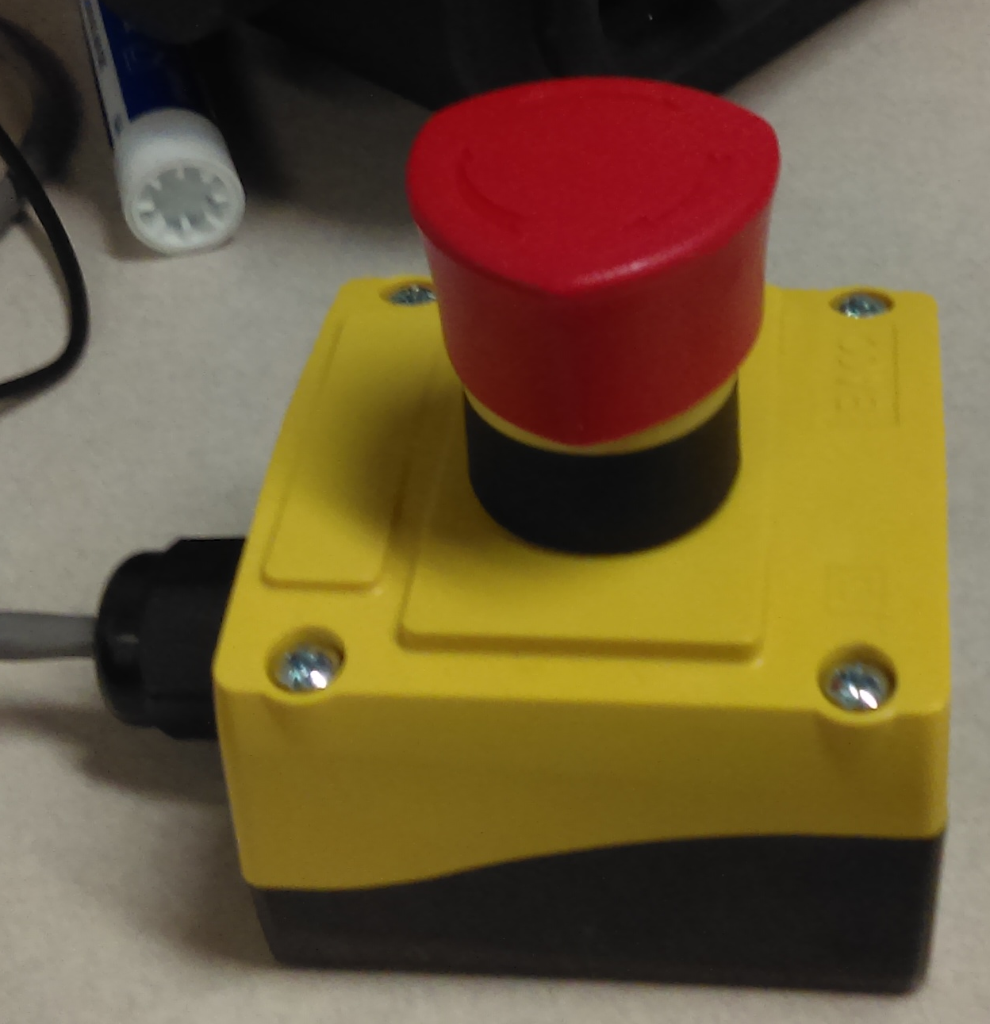

- Make sure the grippers are installed.

- Flip the red switch below the "tripp-lite" logo on the power cabinet (it will light up if the system is powered).
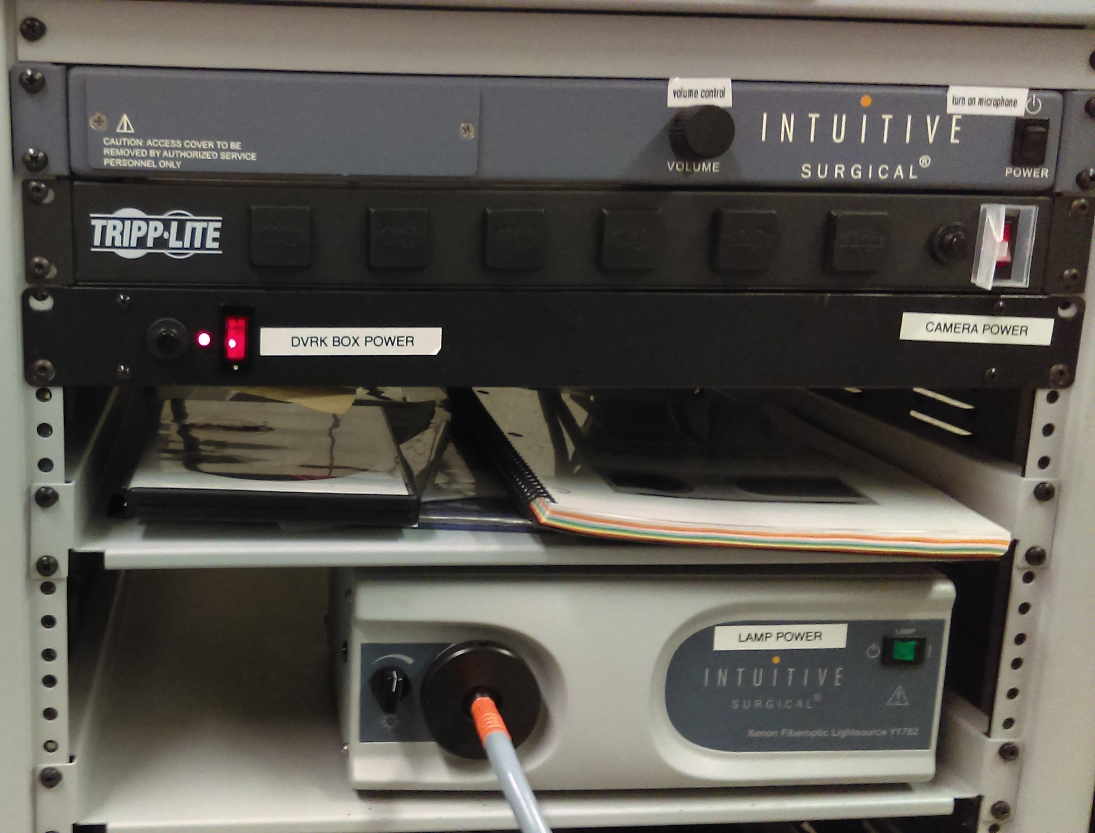

- Wait for the DVRK boxes to begin pulsing red, green, and yellow. Two lights each on “Card A” and “Card B” will do so (true for all 4 boxes).

- Unplug the DRVK-computer Firewire cable and plug it back in. (We’ve marked the appropriate cable with electrical tape).

- In a terminal on the control computer, run
qladisp

- Repeat steps 5 and 6 until qladisp returns a list of eight working nodes. If qladisp hangs, unplug the cable again and it will exit.
This is a successful output:
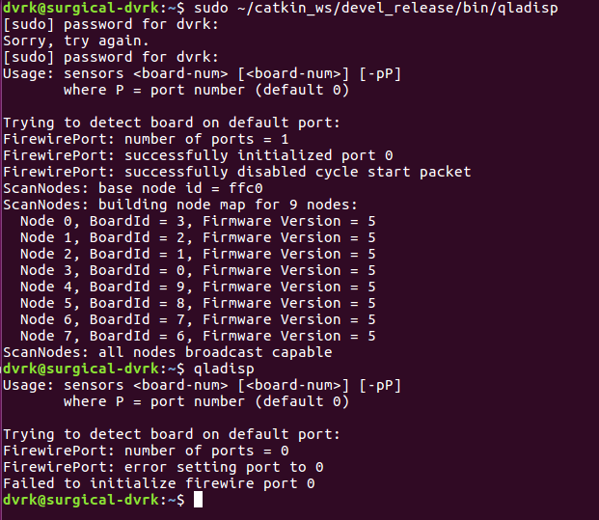
This is an unsuccessful output:
It typically takes two or three cycles of this for the system to fully start.
- Run roslaunch cwru_davinci_launch davinci_launcher_basic.launch This should cause a number of windows to open, one of which will look like this:
This will block the terminal it is in. Keep it running for as long as you are using the Da Vinci.

- Make sure the tools you want to use are attached to the PSMs.

- Click the “home” button. The robot and MTMs may or may not move into new positions.

- Open a new terminal. Run rosrun cwru_davinci_traj_streamer davinci_traj_interpolator_as It will produce a message reading ‘NODE LINKS LATCHED’ and block the terminal. Keep it running for as long as you are using the Da Vinci.

C: Starting Up The Camera And Viewer
Flip the red switch on the power cabinet labeled ‘camera power’. It is enclosed in a small translucent box on the top right (if the box is closed, the latch is on the left side- don’t attempt to force it). It will light up when the system is powered. This will turn on the camera and display the output to both the vision computer and the CRT on top of the power cabinet.

To activate the eyepiece viewer (convenient if you are trying to teleoperate the robot) press the green “SYSTEM” button under the transparent safety cover on the right control pad. The machine will take a few seconds to boot up, and display a warning message reading “System cable fault (151): Shut down system and chack pins and connections”. This is normal. The viewer can be turned off by pressing the green button again.

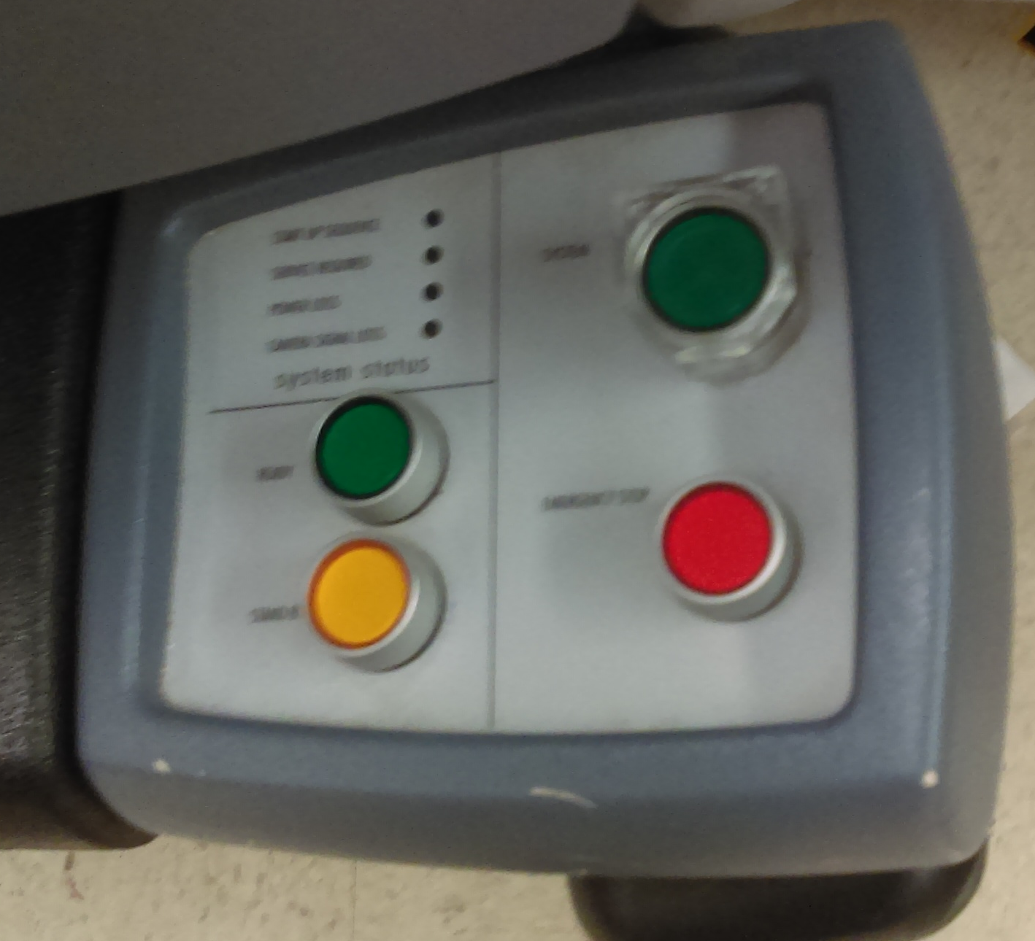

IMPORTANT NOTE:
The DaVinci comes with a xenon fiber-optic light source that shines out of the bottom of the endoscope, controlled by a green switch on the power cart. This lamp has a limited operational life and cannot easily be replaced once it expires. It should only be used in vision-related experiments where it is absolutely necessary to duplicate the lighting conditions of a real surgical operation. If you find the camera view to be too dark during normal operation, use the studio lights near the sink.

D: Running A Jointspace Playfile
- Make sure teleoperation and direct control modes are disabled (see Steps G6 and H5), and press the “home” button on the main interface.

- In an open terminal, run the jointspace playfile reader. It has two modes.

rosrun cwru_playfile_reader playfile_jointspace [PLAYFILE_PATH] will find a playfile on a direct or relative path from wherever you currently are in the terminal. For instance,
cd ~/catkin_ws/src/motion_control/playfile_reader/play/jsp ;
rosrun playfile_reader playfile_jointspace example_all_zero.jsp
and
rosrun playfile_reader playfile_jointspace ~/catkin_ws/src/motion_control/playfile_reader/play/jsp/example_all_zero.jsp
will both find a playfile in ~/catkin_ws/src/motion_control/playfile_reader/play/jsp/example_all_zero.jsp

rosrun cwru_playfile_reader playfile_jointspace [PACKAGE_PATH] [PLAYFILE_PATH] will find a playfile in a specific ROS package. For instance,
rosrun playfile_reader playfile_jointspace motion_control /play/jsp/example_all_zero.jsp
will find a playfile in the play/jsp/example_all_zero.jsp directory of the motion_control package.

Be careful not to confuse this with the cartesian playfile reader. The jointspace reader accepts .jsp playfiles.

E: Running A Cartesian Playfile
- Make sure teleoperation and direct control modes are disabled (see Steps G6 and H5), and press the “home” button on the main interface.

- In an open terminal, run the cartspace playfile reader. It has two modes.

rosrun cwru_playfile_reader playfile_cartspace [PLAYFILE_PATH] will find a playfile on a direct or relative path from wherever you currently are in the terminal. For instance,
cd ~/catkin_ws/src/motion_control/playfile_reader/play/psp ;
rosrun playfile_reader playfile_cartspace example_all_zero.psp
and
rosrun playfile_reader playfile_cartspace ~/catkin_ws/src/motion_control/playfile_reader/play/psp/example_all_zero.psp
will both find a playfile in ~/catkin_ws/src/motion_control/playfile_reader/play/psp/example_all_zero.psp

rosrun cwru_playfile_reader playfile_cartspace [PACKAGE_PATH] [PLAYFILE_PATH] will find a playfile in a specific ROS package. For instance,
rosrun playfile_reader playfile_cartspace motion_control /play/psp/example_all_zero.psp
will find a playfile in the play/psp/example_all_zero.psp directory of the motion_control package.

Be careful not to confuse this with the jointspace playfile reader. The cartesian reader accepts .psp playfiles.

F: Recording A Playfile
- In a new terminal window, run rosrun cwru_playfile_writer playfile_writer [DIR] where [DIR] is the directory you want the playfile to be placed.

- When you are ready to record, press 1.

- Make the Da Vinci do some kind of motion, via direct control, teleoperation, or a playfile (although why you would want to record a playfile into a playfile is a mystery).

- Press Ctrl-C when you are done recording.

G: Controlling The Arms Manually
- Make sure the Da Vinci is not currently running a playfile or in teleop mode (see Step H5), and press the “home” button on the main interface.

- On the main control window, select the “PIDs” tab.

- Select “PSM1 PID” for the green arm, or “PSM2 PID” for the yellow.
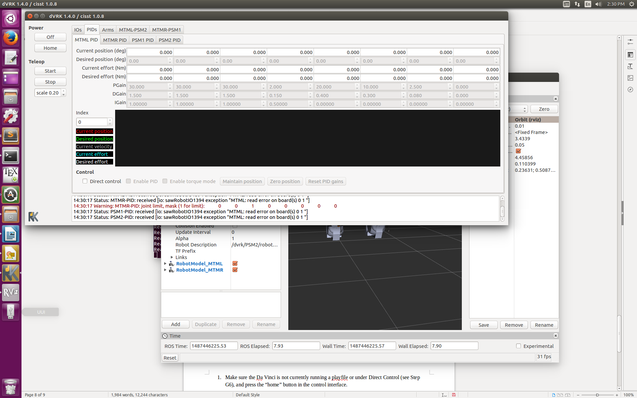

- Click the “direct control” checkbox at the bottom of the window.

- Seven numerical input boxes with the label “desired position (deg)” will become active. These control the seven joints of the arm in question. Don’t try to enter numerical values into them- this will cause the robot to power itself down trying to move its joints an extreme distance in zero time. Instead, select the box you want and use the arrow keys.
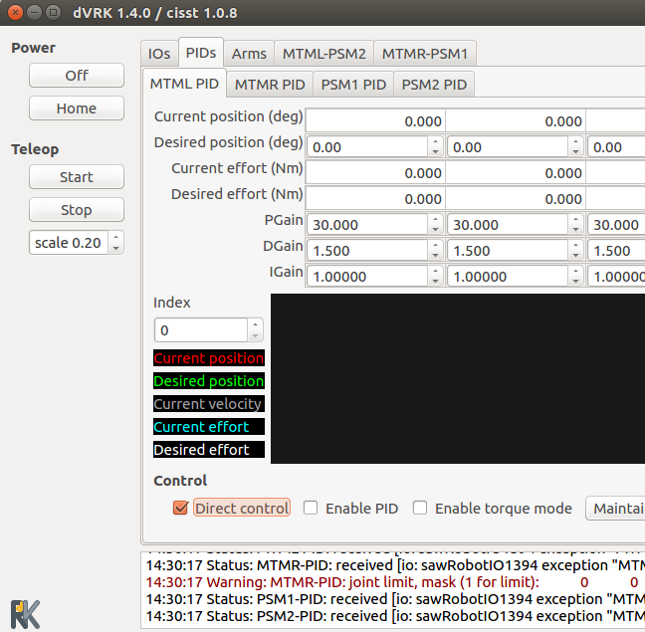

- Be sure to disable the “direct control” checkboxes when you are done.

H: Teleoperating The Da Vinci
- Make sure the Da Vinci is not currently running a playfile or under Direct Control (see Step G6), and press the “home” button in the control interface.

- Press the “start” button under the “teleop” header in the control interface. The MTMs will move.

- Put your fingers in the MTM holsters. It is heavily advised that you have the viewer and camera powered (see Section C) so that you can see what you are doing. The MTMs will be rigid- do not attempt to force them.

- Press the blue footpedal labeled “COAG” to free the MTMs. Any movement you make while the pedal is down will be copied by the robot.

- When you are done, be sure to click the “stop” button under the “teleop” header in the control interface to release teleop control.

I: Back-Driving The Da Vinci
- To safely back-drive the Da Vinci, click the “off” button in the main control window. Be ready for the arms to lose gravity compensation.

- When you are done, click “home” on the main interface to restore power.

J: Shutting down the Da Vinci
- Click the “off” button in the main control window. Be ready for the arms to lose gravity compensation.

- Close the main control window, as well as the Rviz windows it spawned.

- Close all active terminals. This will kill the trajectory interpolator and DVRK software back-end.

- Turn the main “tripp-lite” power switch back off.

