„ S.A.W.Z.E.“

“The Super Awesome Wheelchair Zombie Escape”

Projectarbeit 1.Semester, Games Academy Berlin

**STAND: 15.11.2014**

Team: S.A.W.Z.E.

* Tobias Paul – Art and Animation
* Amon Kalagin – Art and Animation
* Daniel Pochert – Programming and Scripting
* Robert Lücke – Game and Level Design
* Andrea Schelling - Art
* Toma Komitski – Game Design and Production

1. High Concept:

In S.A.W.Z.E. (The Super Awesome Wheelchair Zombie Escape) steuert der Spieler ein pensionierten Kriegsveteran im Rollstuhl mit kaputten Bremsen in orthographische top-down Perspektive durch Zombie verseuchten Labyrinthen in einem hektischen Verfolgungsjagd mit der Hilfe von spezielle Items, um eine Gruppe von überlebenden zu schützen und zu versorgen.

In S.A.W.Z.E. the player steers a wheelchair bound hero, whose wheelchair has broken brakes, through a zombie-infested labyrinth in a hectic chase, with the aim of protecting and caring for a group of survivors.

1. Vision

The game S.A.W.Z.E. is inspired by the old school arcade legend “Pacman” and it aims to bring out the hectic and dynamic game play into a modern theme with more complex mechanics. The main goal of S.A.W.Z.E. is to add diverse features like collectable power up items or different opponent types, as well as to add level objectives for the player to accomplish, while keeping simple and dynamic gameplay.

Signature game mechanics of pacman such as the constant motion of the character who can be navigated by the player in all 4 directions, but cannot stop, the collection of point-giving items at each step, as well as the one screen top-down view perspective over the level will be discovered in the mechanics of S.A.W.Z.E., however all of them will have a special and unique twist on them, thus adding to and expanding the classic game feeling and atmosphere without just being a blank copy of it.

1. USP’s

* Level Objectives  
  It is not enough just to escape from the level in order to be successful in SAWZE. Before the escape, the player needs to accomplish a task and by doing so the level exit is activated. These tasks will be always shortly communicated in the form of a level briefing and will be orientated in the context of supporting and protecting a group of survivors. This way the player will have a feeling of purpose when navigating through the levels, but will not be distracted by cut scenes or story telling elements.
* Dynamic Gameplay  
  The fact that the player cannot stop, but only determine the direction of movement, the Virus clouds draining the oxygen bar, the limited oxygen packs placed on the level and the constant danger of the zombies lurking around and no real way of eliminating this danger except of occasional and limited power ups, will provide the payer with a dynamic and hectic game experience and give him the sensation of constant necessity to move and escape.
* Power ups   
  Throughout the levels the player will have the chance to collect and use diverse but limited power up items, which will be of significant aid to him in accomplishing his tasks and escaping each level.

1. Target Group

Age restriction: 6+

Gender: both

Gaming experience: none required

The content of the game allows a brought specter of players as it contains no violence or horror, thus allowing a 6+ age group. The minimum age is set at 6 years as suggested by the USK, due to the considerable pressure to act exerted in action packed sequences.

The genre of the game also reinforces the placement of the player age restriction at 6+ as it is a combination of “arcade” and “jump and run”. The essential aspects of the classic arcade gameplay such as easy to access, simple controls and a clear game task, as well as skill and speed of reaction requirement are characteristic for S.A.W.Z.E., as well some major jump and run gameplay aspects, such as the comical figures controlled by the player, who seek to run their way through various levels whilst overcoming a range of obstacles. Recent trends in this genre are also represented in the game play of S.A.W.Z.E., which is enhanced with missions, adventure elements and collectable items in 3D environment.

Source: <http://www.usk.de/en/classification/genres/>

The level of difficulty of the game play allows a brought specter of players. The controls are fairly simple and intuitive and the difficulty of the levels increases in small steps adjusted to a general learning curve regarding the game mechanics. The idea behind the level progression is “easy to learn, difficult to master”.

The difficulty of the levels will be defined by the following components and increasing difficulty will be achieved in the level design by adding one of the factors below on top of each next level (or each second level):

* the size of the level (bigger levels allow more “dead-end” paths),
* the quantity of Zombie Opponents,
* the quality of Zombie opponents (additional Zombie types with better Path finding scripts, faster movement or special features such as additional Z-Virus trail behind the Zombie for a number of map tiles)
* the quantity of collectable objective items
* the areas infected from Z-Virus
* the quantity of Oxygen Packs placed on the level
* Box shift

1. Story and Setting

In the middle of a scary zombie virus outbreak a new hero rises. Not the classic fast, strong, charismatic, young action hero, who fights his way through Zombie hordes armed with nothing but his pocket knife and can run through walls, but a rather different hero: Major Tomahawk is a retired, grumpy, old war veteran in a wheelchair, due to an old injury. He lives alone and usually doesn’t favor the company of other people and neither do other people like being in his company.

Never the less, when helpless people need his aid in this scary zombie chaos, Major Tomahawk takes initiative in his hands and rises to any challenge, regardless the limits set to him by age and the wheelchair, which constantly has issues with the brakes.

Soon he finds himself protecting a group of survivors and volunteering for the most difficult of tasks.

(…)

1. Visual Concept
2. Interface and game function  
     
   5.1. What can the player do? Why and How?

In S.A.W.Z.E. each level has objective that needs to be accomplished in order to pass the level. When the objective is achieved the exit of the level will be activated and the player needs to enter the exit area. The different level objectives are defined by the game modus used in the level. The goal is to have at least 3 different game modus in order to bring variety in the challenges between different levels, however for the basic version one game modus will be enough for the game to be playable. *(For more Details on Game Modus, please see chapter 6. Core Features and their mechanics)*

The player can navigate the game hero in all 4 available directions in any level (up-down and left-right) by using the arrow controllers on the keyboard. The character is in constant motion so there is no way to stop. This makes the game play dynamic and the player needs to think quickly and on his feet regarding the directions he takes. This decision needs to take in account the following factors:

* Where is the game objective that the player needs to reach?
* After achieving the level objective: where is the level Exit?
* Where are the Zombie opponents?
* Will there be enough Oxygen to pass through “The Zombie-Virus Clouds”?
* Do I want to attempt to collect and use a “Power up Item”?

All Power up items are activated passively – the player needs only to drive through them and they are automatically activated. They can be of great help for the player but collecting them might put the player in great risk by exposing him to the Zombie opponents and draining the Health bar. This is why collecting these items will be among the critical decisions the player needs to make while playing the game.   
  
. *(For more Details on power up items, please see chapter 6. Core Features and their mechanics)*

5.2. 3-minutes of game play experience

 In S.A.W.Z.E. (The Super Awesome Wheelchair Zombie) the player steers a wheelchair bound hero, whose wheelchair has broken brakes, through a zombie-infested labyrinth in a hectic chase, with the aim of protecting and caring for a group of survivors.

Before the level starts, the player sees a brief explanation of the setting, background as well as targets of the upcoming level on a mission briefing screen. After reading the briefing the player hits any button to start the level.

For example: "Jenny has gone off to search for food and hasn’t returned yet. You have to find her and bring her back to the group!” In addition there is also a picture of the objective and an object navigator icon on the side of the screen guides the player to the location of the objective. After successfully accomplishing the level objective the object navigator icon shows to the player the direction of the level exit.

The player then presses "Start" and is immediately taken to the level screen. The player figure is set in motion straight away (the wheelchair has broken brakes!) and the player navigates in the 4 directions.

Every step allows the player to collect distributed "Antidote Packs" which the hero needs to recover the health bar (located in the top-left hand corner of the screen), which constantly drops slowly as the air is contaminated throughout the whole level. Additional danger is presented by the clouds with concentrated zombie virus which drain the health bar significantly when the player drives straight through them. If the Health bar gets completely empty – the game is lost.

There are zombies lurking in the levels and the player must skilfully avoid any collision with them as this will mean the game is lost.

Due to the constantly dropping health bar, the lurking zombies and the fact that the hero can’t stop his wheelchair, a hectic and fast-paced game ensues.

There are a few "power up items” available to help the player. For details check Power ups

The player has to quickly decide, does he/she want to get a power up and risk low health bar and confronting zombies, or does he/she want to head straight to the level objective.

When the player accomplishes the level objective, the level exit is activated. The player now needs to manoeuvre the hero to reach the level exit quickly. When the hero reaches the level exit with the level has been successfully completed;

Straight away the player sees a message on the "level accomplished screen" with congratulations for a hard-earned success. Clicking any button will start the next level.

1. Core Features and their Mechanics  
     
   The following section provides a detailed list of all planed game features and their game mechanics. It also splits all features in 3 categories based on their priority for the timely completion of the project.   
     
   The first category (**Must Have**) provides a list with all features which are absolutely necessary to completing the project to a status in which the game is playable on 100% and has the components listed in the Vision of the Game.  
   The **Should Have** section contains mainly features related to further game modus options. It is very important to have at least 3 fully functioning game modus in order to bring variety for the player and a more diverse and interesting game experience. The different game modus can be than used as a blue print from the game designers in creating multiple levels with the different Objectives the player needs to accomplish in order to finish the level. For the same reason in the should have section there are also variation of the core features such as further zombie types with different mechanics, as well as variation of power up items all aiming to diversify the game experience.  
   In the **Nice to Have** category there are some features that will heavily impact the game play with their implementation, but are not crucial for achieving the goals set in the Vision. Such features are for example the Save Game option, a point system, High score menu, between Level sections with dialogs etc. Further variations on already existing core features are also listed in the Nice to Have feature section and if implemented will give more variety in the game play as well as heavily increase the potential play duration as more interesting levels will be added.

* 1. Must Have
* The Hero:   
  Is controlled via the keyboard arrows in all 4 directions; the use of an active item (for example the gun) is triggered by hitting the spacebar button. Passive items are activated as he drives on them on the map. If he collides with a zombie the game is over.
* Zombie type 1:  
  Is the basic opponent and main obstacle for the player. The zombie moves across the map based on a script (…)
* Game Objective 1 “Collect all the items”:  
  In this game modus the goal is to collect a special item of importance for the survivor group, like for example food, medication or fuel; in the “Must Have” feature selection this item will be Medic-kit.
* Medic-kit  
  Level Objective Item on the map. By reaching and driving on the Medic-kit on the game map the player activates the Level Exit.
* Start Menu Screen  
  A screen with the game logo and a “Click Enter to Start Game” button. By clicking Enter on the keyboard the Loading screen appears.
* Level Loading Screen   
  Contains a short description of the goal of the level; after (n-time) it changes to the game screen.
* Level Exit with Level Objective condition  
  When the level objective is achieved the Level Exit is activated, thus visually changing slightly (bright color on the Exit field and/or around it); when the player reaches the Exit level field the level is successfully accomplished.
* Level obstacles – walls type 1   
  The labyrinth, of which the level is designed, they have collision block so that they are impassable
* Oxygen bar   
  Every step of the Hero through areas with Zombie Virus Cloud triggers an algorithm which decreases the Oxygen bar placed on the left side of the screen. When the Oxygen bar gets fully depleted the game is over;
* Oxygen packs  
  Are placed all over the level map and when the hero drives through them they are collected and add a small portion oxygen in the oxygen bar, thus increasing the limit of movement through the Zombie Virus Clouds
* Zombie Virus Cloud   
  drains the Oxygen Bar;
* GUI   
  Oxygen bar (left) and power up bar (right)
* Power Up 1 – Nitro Pack  
  Passive item; increases the speed of the hero by ?? %
* Power Up 2 – Gun   
  Active Item; when triggered it shoots out one projectile in the direction of movement; If the projectile collides with a Zombie, the Zombie disappears from the level.
  1. Should Have
* Game Objective 2 “Save the Trapped Survivor”
* Trapped Survivor
* Game Objective 3 “Clear the perimeter”
* Power Up3 – Machine gun
* Zombie type 2
* Collectable items for Game Objective 2; additional types : Food, Fuel, Water
* Sound
* (…)
  1. Nice to Have
* Save game option
* Points system
* High Score
* Power Up n+
* Zombie type n+
* Trapped Survivor n+
* Between Level Sections with Dialogs
* Pictures for the Loading screens
* Multiple Playable Characters

(…)

1. Critical Success factors

Pacman+  
The game experience should be associated with the game experience in pacman. The core features of pacman should be represented but adjusted. The changes on these core features should not be too big and afar from the original – they should remind the player of the pacman game experience. At the same time the game should also have its unique traits.

Visual Components  
*2D – 3D and will it all fit in the one screen level?!?!?!?!?!?!*

Level Balance  
The level design and the balancing of level objects it a major critical success factor. All levels will be in one size and with a fixed top-down camera, which means that the various obstacles and features of a level are limited to one-screen view. A very balanced and smart placement of all level components and their balance is critical for the entertaining effect of the game. Poorly designed levels may end up being too easy to win or absolutely impossible to pass.

1. Monetization   
     
   Target Market  
   S.A.W.Z.E. has simple and very intuitive game play and has short levels (2 to 5 minutes game play for the first basic levels). This opens a wide range of potential players in regards of gender, age or experience with games. If placed on a web platform and playable over Facebook as an Example, a very wide range of potential players can be reached.   
   Revenue Generation  
   All thoughts expressed below will require big quantity of levels (>20 playable levels) in order to be attractive for a player to make a purchase. The Level Design of additional levels can follow the blue print available from the basic 3 (ideally more than 3) Game modus options. The can repeat each other across multiple levels and so create variety in the game experience as each 3 levels in a role will have a different level objective.  
   S.A.W.Z.E. can be distributed as a free-to-play game in a basic version limited to (for Example) 3 to 4 levels and containing 2 possible power ups. Further Levels and additional power up items unlock can be a chargeable DLC. The Story communicated in-between the first few levels can be a motivation for the player to purchase further levels.  
   Another possibility for revenue generation within the free-to-play model would be limited lives per hour/day and the possibility of purchasing extra lives as well as extra power ups regardless the items embedded in the levels.
2. Platform and Technical Requirements

**Platform:** S.A.W.Z.E. will be developed for PC at first. Later adjustment on other platforms will be possible.  
  
**Engine:** Unity3D  
  
**Audio:** SFXR  
  
**Graphics:** Maya; Blender; Max; ZBrush; Photoshop; After Fix; dDo; Knald; nDo²

1. Team Structure  
     
   Tobias Paul – Art and Animation

* Amon Kalagin – Art and Animation
* Daniel Pochert – Programming
* Robert Lücke – Game Design
* Toma Komitski – Game Design and Production

1. Development Time line and Deadlines

The planning and work organization of the project is structured on 3 levels in order to give maximum overview to the team at any time given regarding the status of the project and the current tasks. Those 3 levels are:

Goals and Task brake down

All Ziele sind in einem Excel Sheet aufgelistet und nach den folgenden Kriterien aufgeteilt:

* Hauptziel (= Features)
* Task (Zwischenschritte um ein Ziel zu erreichen)
* Priorität (A = Must Have, B = Should Have, C = Nice to Have)
* Status (wurde es schon abgeschlossen oder nicht)
* Teammitglieder der die Aufgabe erledigen soll
* Tage um die Aufgabe abzuschließen
* User Story **(**damit jeder eine Ahnung darüber bekommt, was der jeweilige Komponente bei dem Spieler ermöglicht)

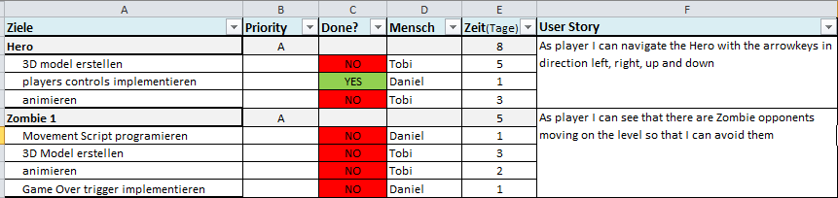

Strategic time line and deadlines overview

Stellt ein strategisches Überblick auf das gesammte Project dar.

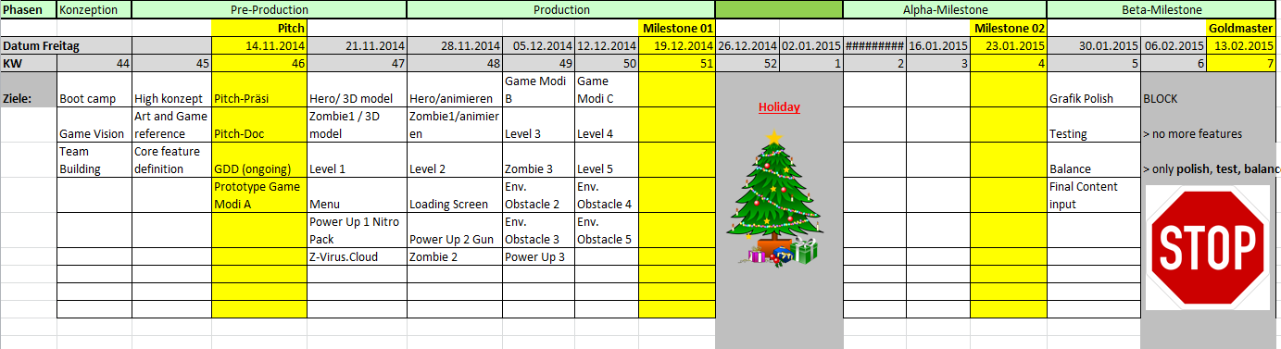

Operative brake down on week level (Trello)

Wird in Trello ausgeführt <https://trello.com>   
Dieser Zeitplan gibt die detaillierte Zeiteinteilung der Wochen wider und stellt die spezialisierten Aufgaben dar, die in einer bestimmten Woche erledigt werden müssen. Jede Aufgabe wird einem bestimmten Teammitglied zugeordnet und hat die Funktion Kommentare zu speichern, um die operative Kommunikation und deren Dokumentation zu erleichtern. Verschiedene Dateien können für eine Aufgabe auch hochgeladen werden. Alle Aufgaben sind in 3 Kategorien bezüglich des Status, in dem diese sich befinden, aufgeteilt und dazwischen verschoben (TO – DO, in Progress und DONE):

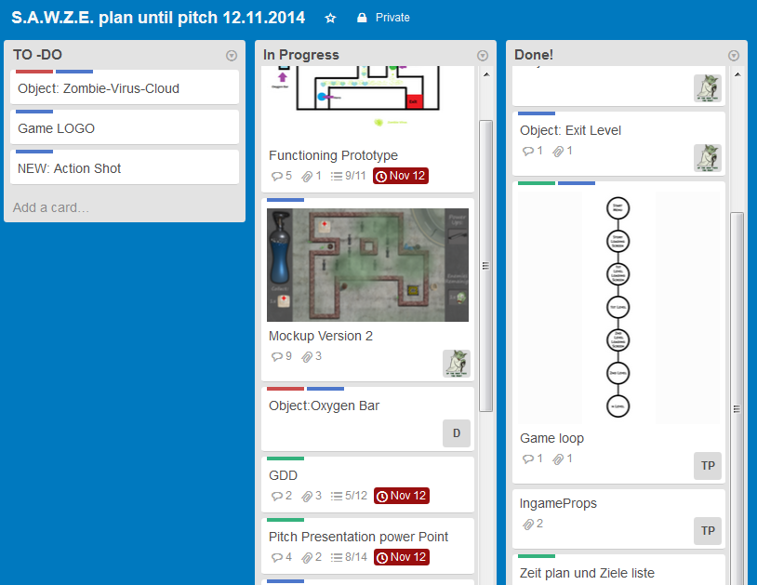

1. Appendix

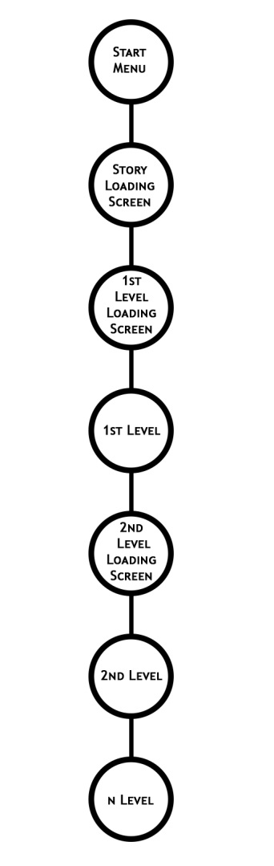

Das gleiche Abwechseln zwischen Level und Loading Scr

1. Game Loop

een mit Gratulation und Erklärung für der nächsten Level bleibt für alle weiteren Level.

Wenn der erste Level erfolgreich abgeschlossen wurde, kommt der Loading Screen für den zweiten Level. Zuerst wird der Spieler für sein Erfolg gratuliert und danach wird es kurz erklärt was und warum muss man im nächsten Level machen.

Der Spieler kann durch das zweite Level Spielen

Der Spieler kann durch das erste Lvel spielen.

Be idem ersten Start wird ein Loading screen angezeigt auf dem die Story und der Stetting in paar Sätze erklärt werden.

Als erstes beim Hochfahren von dem Spiel wird das „Start Menu“ angezeigt. Es beinhaltet: Game Logo, Background Picture (Action Shot), Start Game button.

Vor dem Ersten Level wird in einem Level Loading Screen kurz darüber berichtet was der Spieler in dem Level erledigen soll und warum.