„ S.A.W.Z.E.“

“The Super Awesome Wheelchair Zombie Escape”

Project Arbeit 1.Semester, Games Academy Berlin

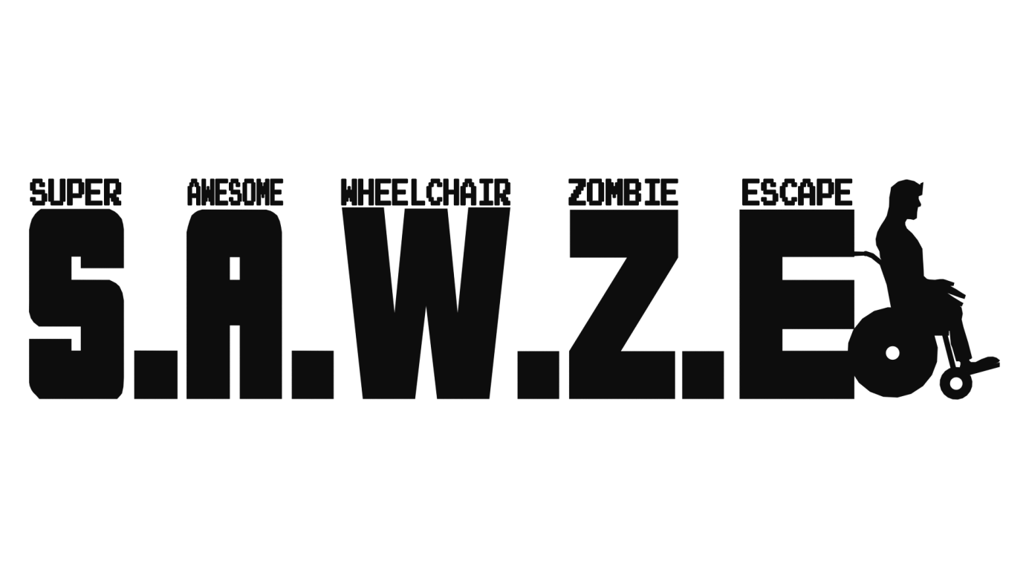

Inhalt

1. Vision statement 3

2. USPs 3

3. Story and setting 4

4. Game play and player tasks 4

5. Game play summary and overview 5

6. Visual presentation 6

7. Features 6

7.1 Controls and basic obstacles 6

7.2 Health bar, Contamination and Antidotes 7

7.3 Game Objectives 8

7.4 Opponent Types 10

7.5 Power Ups 11

8. GUI 14

8.1 Briefing and tutorial boxes 14

8.2 In-Game GUI 15

9. Target group, genre and difficulty level 17

10. Critical success factors 17

11. Team Structure and Tasks 18

12. Tools and Platform 19

13. Development Stages 19

# Vision statement

The game S.A.W.Z.E. is inspired by the old school arcade legend “Pac-man” and it aims to bring out the hectic and dynamic game play into a modern theme with more complex mechanics. The main goal of S.A.W.Z.E. is to add diverse features like collectable power up items or different opponent types, as well as to add level objectives for the player to accomplish, while keeping simple and dynamic gameplay.

Signature game mechanics of pac-man such as the constant motion of the character who can be navigated by the player in all 4 directions, but cannot stop, the collection of point-giving items at each step, as well as the top-down view perspective over the level will be discovered in the mechanics of S.A.W.Z.E., however all of them will have a special and unique twist on them, thus adding to and expanding the classic game feeling and atmosphere without just being a blank copy of it.

# USPs

* **Level Objectives**

It is not enough just to escape from the level in order to be successful in SAWZE. Before the escape, the player needs to accomplish a task and by doing so the level exit is activated. These tasks will be always shortly communicated in the form of a level briefing and will be orientated in the context of supporting and protecting a group of survivors. This way the player will have a feeling of purpose when navigating through the levels, but will not be distracted by cut scenes or story telling elements.

* **Dynamic Gameplay**

The fact that the player cannot stop, but only determine the direction of movement, the Virus clouds draining the health bar, the limited antidotes placed on the level, which recover the health of the player and the constant danger of the zombies lurking around, combined with the limited possibility of eliminating these dangers, provided only by occasional and limited power ups, will provide the payer with a dynamic and hectic game experience and give him/her the sensation of constant necessity to move and escape.

* **Power ups**

Throughout the levels the player will have the chance to collect and use diverse but limited power up items, which will be of significant aid to him in accomplishing his tasks and escaping each level.

* **Art Stile**

SAWZE will bring the player in a well-rounded and smooth cartoony environment, defined by bright and strong colors and simple, clear but organic shapes of assets and characters. Goal is to create a game world with abstract designs, which give the player a feeling of being in a comic book or a cartoon, but remain close to realistic objects and items that are easy to recognize and identify with. Such effect is to be achieved by the choice, balance and contrast of colors, dark outlines and smooth, round, low detail in both environment objects and characters.

* **Fun Gameplay and visual presentation**

The main USP of SAWZE is the combination of the dynamic but intuitive game play and the fun cartoon stile of the game. It is very easy for the player to interact with the game and achieve a feeling of flow already in the first minutes. The level design and art of the game are communicating a goofy fun experience for a wide potential target group of players and even losing the game is not provoking negative feelings and frustration, but is rather a teaser for the player to give it just one more try.

# Story and setting

In the middle of a scary zombie virus outbreak a new hero rises. Not the classic fast, strong, charismatic, young action hero, who fights his way through Zombie hordes armed with nothing but his pocket knife and can run through walls, but a rather different hero: Major Tomahawk is a retired, old war veteran in a wheelchair, due to an old injury. He lives alone and usually doesn’t favor the company of other people and neither do other people like being in his company.

Never the less, when helpless people need his aid in this scary zombie chaos, Major Tomahawk takes initiative in his hands and rises to any challenge, regardless the limits set to him by age and the wheelchair, which constantly has issues with the brakes.

Soon he finds himself protecting a group of survivors and volunteering for the most difficult of tasks.

# Game play and player tasks

*What can the player do? Why and How?*

In S.A.W.Z.E. each level has objective that needs to be accomplished in order to pass the level. When the objective is achieved the exit of the level will be activated and the player needs to enter the exit area. The different level objectives are defined by the game modus used in the level. The goal is to have at least 2 different game modus in order to bring variety in the challenges between different levels.  
*(For more Details on power up items, please see chapter 7. Features, Game Objectives)*

The player can navigate the game hero in all 4 available directions in any level (up-down and left-right) by using the arrow controllers or WASD on the keyboard, or play with controller. The character is in constant motion so there is no way to stop. This makes the game play dynamic and the player needs to think quickly and on his feet regarding the directions he takes. This decision needs to take in account the following factors:

* Where is the game objective that the player needs to reach?
* After achieving the level objective: where is the level Exit and how to get there?
* Where are the Zombie opponents?
* Will the player have enough health to pass through “The Zombie-Virus Clouds”?
* Will the player have enough health to pass through an area that has no antidotes left?
* Does the player want to attempt to collect and use a “Power up Item”? Or is it too risky?

All Power up items are activated passively – the player needs only to drive through them and they are automatically activated. They can be of great help for the player but collecting them might put the player in great risk by exposing him to the Zombie opponents and draining the Health bar. This is why collecting these items will be among the critical decisions the player needs to make while playing the game.   
  
*(For more Details on power up items, please see chapter 7. Features, Power Ups)*

# Game play summary and overview

*Game loop overview:*

Before the level starts, the player sees a brief explanation of the setting background as well as the targets of the upcoming level on a mission briefing screen. After reading the briefing the player hits any button to start the level.

For example the level briefing might be something like this: "Jenny has gone off to search for food and hasn’t returned yet. You have to find her and bring her back to the group!” In addition there is also a picture of the objective (in this case a picture of Jenny). Also there is an object navigator icon on the side of the screen, which guides the player to the location of the objective by showing him the direction he/she needs to take. After successfully accomplishing the level objective the object navigator icon shows to the player the direction of the level exit.

The player then presses any button, he/she is immediately taken to the level screen. The player figure is set in motion straight away (the wheelchair has broken brakes!) and the player navigates in the 4 directions.

Every step allows the player to collect distributed "Antidote Packs" which the hero needs to recover the health bar (located in the top-left hand corner of the screen), which constantly drops slowly, as the air is contaminated throughout the whole level. Additional danger is presented by the clouds with concentrated zombie virus which drain the health bar significantly when the player drives straight through them. If the Health bar gets completely empty – the game is lost.

There are zombies lurking in the levels and the player must skilfully avoid any collision with them as this will mean the game is lost.

Due to the constantly dropping health bar, the lurking zombies and the fact that the hero can’t stop his wheelchair, a hectic and fast-paced game ensues.

There are a few "power up items” available to help the player. The player has to quickly decide, does he/she want to get a power up and risk low health bar and confronting zombies, or does he/she want to head straight to the level objective.

When the player accomplishes the level objective, the level exit is activated. The player now needs to manoeuvre the hero to reach the level exit quickly. When the hero reaches the level exit with the level has been successfully completed;

Straight away the player sees a message on the "level accomplished screen" with congratulations for a hard-earned success. Clicking any button will start the next level.

# Visual presentation

All information on Graphic Stile as well as Art and Game references are to be found in the “Art bible” document.

See enclosed art bible:  
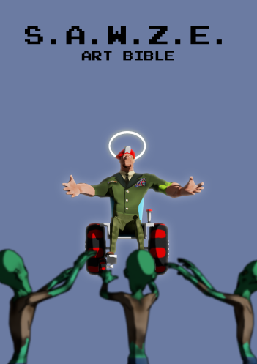

# Features

# 7.1 Controls and basic obstacles

SAWZE offers to the player simple and intuitive control mechanics. Playing the game requires only 4 buttons/commands as input for the directions available to the player. All power ups are activated passively without any input required from the player and the hero figure never stops so all the player needs to do is give in the direction. Though simple this input is enough to create the hectic and dynamic game play which characterizes SAWZE and the level design and variety delivers a challenge to the player both on motoric as well as on tactical level.

The player moves with constant speed, except in the case of the **Nitro Pack** and **Super Awesome Antidote** power ups (which increases the speed) and the **broken glass** on the floor (which decreases the speed). The fun and cartoony stile of the game has impact even on the navigation: the hero will shove his head and shoulders left and right when taking turns, he will leap forwards when hitting a wall or other obstacle and he will leap backwards when speeding up with the nitro pack.

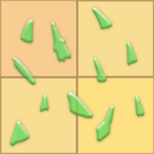

*Picture N; Broken Glass*

# 7.2 Health bar, Contamination and Antidotes

To reinforce the hectic feeling of the game play on top of the constant motion of the payer, there is also an additional stress factor which pushes the player to fast decisions and constant hectic movement through the levels. This factor is the **contamination**. Because of the zombie virus outbreak every level is contaminated and the plyer loses health (4% per second) even outside of the **concentrated zombie virus cloud**. This contamination delivers however a significantly lower penalty to the health bar than driving through concentrated zombie virus cloud, which has a major health penalty of 20% per second spent in the cloud.

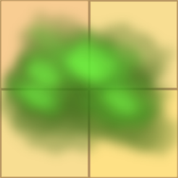

*Picture N; Concentrated zombie virus cloud*

The player can monitor how much health he/she has left on the **health bar** positioned on the top left corner of the screen. An additional feedback is provided by a little pop up, which appears next to the health bar when the player is in a concentrated zombie virus cloud.

 

*Picture N; Health bar (left) and concentrated zombie virus cloud pop up (right)*

Collecting **Antidotes** is the only tool the player has available to recover health. Collecting an antidote recovers immediately 10% health. This makes collecting those a constant necessity and pushes the player to take alternative routes if possible in order to avoid passing through an area twice, because though the contamination is constant and the concentrated zombie virus clouds are permanent too, the antidotes disappear after being collected. Therefor it is usually not recommended to go back the same way.

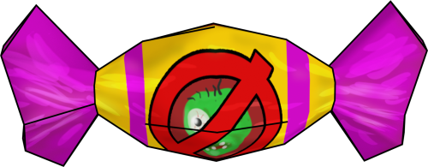

*Picture N; Antidote*

This constellation and game play balance between antidotes and strongly contaminated areas is a great tool for the level design, allowing wide variety of strategies and paths for each level, thus bringing a new challenge for the player for every level. It also gives the opportunity to create “dead ends” and “trap areas” on the levels. So the player not only has few possible paths to complete the level, but also few paths that will lead him to certain fail.

# 7.3 Game Objectives

One of the USPs of SAWZE is introducing to the player objectives to complete for every level before escaping. This gives more purpose to the gameplay and is essential to the hectic but fun game play.

In SAWZE there are 2 possible Game Options as features with multiple content variations of them in order to avoid repetitiveness:

* **Collect Item**

This Game Option challenges the player to find and collect a specific item of importance. There are two variations in content for this Game Objective option: Medi pack and/or Food Supplies. The different levels can have multiple collectable items – the more the player needs to collect, the higher the difficulty of the level. After collecting all the level exit is activated and the player can escape the level. The object navigator shows the direction in which the player will find the collectables and when they are close and within the players screen view they will stick out from the environment because they are rotating, thus giving an extra feedback to the player.

 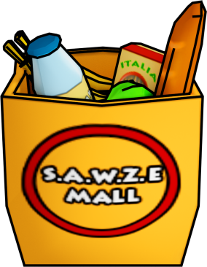

*Picture N; Medi Pack Picture N; Shopping bag*

* **Save the trapped survivor**

In this Game Objective Option the collectable is not a thing but a person (or an animal). In content variation SAWZE has 6 different types of trapped survivors: older woman, older man, younger woman, younger man, a dog and a cat.

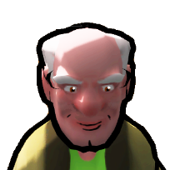 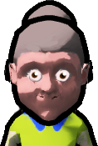 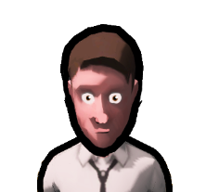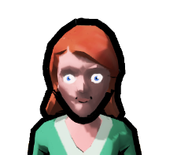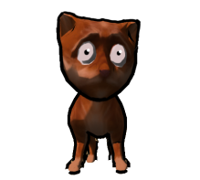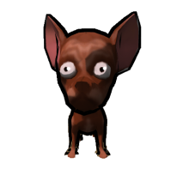

*Picture N; trapped Survivors (old man, old woman, young man, young woman, cat, dog)*

In general they function similar to the collectable items with one significant difference: after “collecting” them, the trapped survivors follow the player until he reaches the level exit. If a trapped survivor collides with a zombie, the player fails the level as if he/she was caught by the zombie themselves. This makes the “save the trapped survivor” game objective significantly harder and more challenging than collecting items. A level can have more than one trapped survivor as objective, so by the end all survivors will follow the moving hero in a tail behind him – the more they are, the harder it gets to avoid zombies.

The object navigator shows the direction in which the player will find the trapped survivors and when they are close and within the players screen view there is an arrow floating and rotating above them, thus giving an extra feedback to the player.  
  
 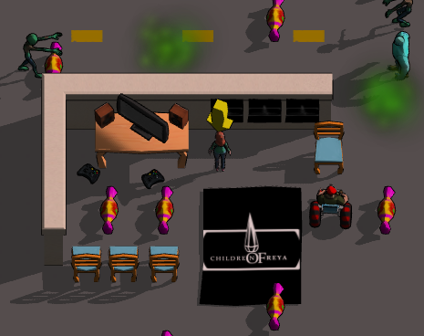

*Picture N; Arrow for pointing out the trapped survivor in game*

The two game objectives can be used together, for example: “save the trapped cat and get some food on the way out!” This on its own is in a way a third game objective from the perspective of the player.

# 7.4 Opponent Types

In SAWZE there are two zombie types that the player needs to avoid: Evil Scary Zombie and Hunter Zombie. If they catch the player or a following trapped survivor the level is failed.

* **Evil Scary Zombie**

The Evil Scary Zombie is the simpler basic opponent type. It follows a pattern between multiple points on the level, given to it by the level designer and always keeps a constant speed which is slightly slower than this of the player. Alone in a big room this opponent isn’t much of a threat to the player, but in greater numbers or in tight corridors the Evil Scary Zombie a foe to reckon with.

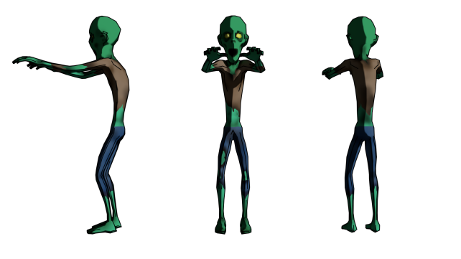

*Picture N; Evil Scary Zombie*

* **Hunter Zombie**

The Hunter Zombie is the more advanced opponent in the game and significantly bigger threat to the player. Similar to the Evil Scary Zombie the Hunter patrols between predefined areas on the level and his speed is even slower than the speed of the normal zombie, however if the Hunter Zombie finds himself facing the player in a direct line with the player (no obstacles in-between) he will charge with increased speed in the direction of the player and will even follow him behind one corner. If the player manages to secure distance from the Hunter Zombie behind minimum of two corners, the Hunter Zombie will leave the chase and will resume his predefined path.

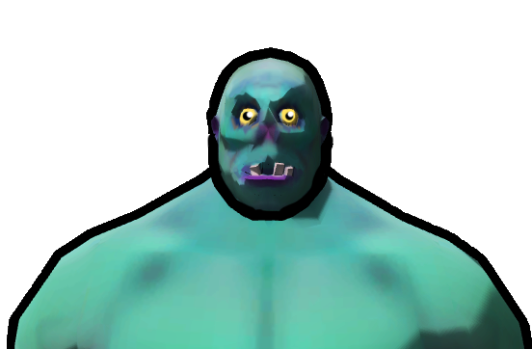

*Picture N; Hunter Zombie*

# 7.5 Power Ups

There are 3 power up items available to the player in SAWZE: the **Nitro Pack**, the **Alarm** and the **Super Awesome Antidote**. They are all activated passively straight after being collected by the player and their effects are, in the spirit of the game, all absolutely nonviolent and cartoony. Generally all 3 power ups have great positive effect for the player, however all of them can turn into a disadvantage based on their placement on the level or based on the decision from the player on when to collect them and where to go after collecting them.

* **Nitro Pack**

The Nitro Pack increases significantly the speed of the player when collected. This increased speed is limited to 5 seconds and is visualized with a flame coming behind the hero to give better feedback to the player. If the Nitro Pack is collected while trapped survivors are following the hero, the speed increase doesn’t apply to them. This leads to increased distance between player and his followers and might turn into a disadvantage if this distance grows too big and thus increases the danger of the survivors being caught by zombies.

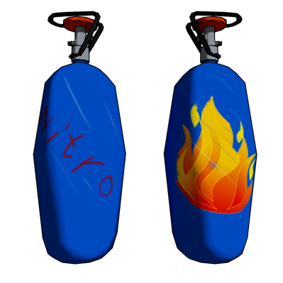

*Picture N; Nitro Pack*

* **Alarm**

This power up has two parts positioned separately on the map and affects all Zombie opponents on the level. The first part is the trigger platform which is activated by the player by driving over it. When activated the second part, which is the actual alarm will sound a signal that will attract all zombies around it for a limited time. While the alarm is active, a particle effect pulsing around it will signal the player that it is on.

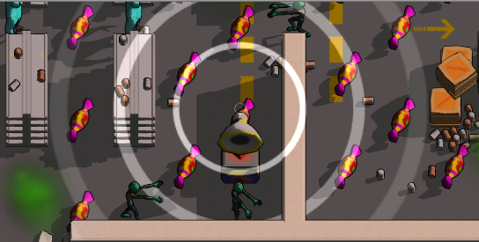

*Picture N; Alarm- on*

When the alarm switches itself off in couple of seconds, all zombies will resume their predefined patterns. This makes this power up extremely useful when the player wishes to clear a path from opponents in order to reach a target, however if the player moves towards the activated alarm instead, he/she is committing a great mistake as he/she will find themselves surrounded by zombies. For the level design this features also opens an interesting option of placing it in advantage or disadvantage for the player depending on where will the alarm summon the zombies – if used as a disadvantage, the alarm maybe placed on the way of the player to his goal, thus making it very complicated for him/her to maneuver around the there-gathered opponents.

 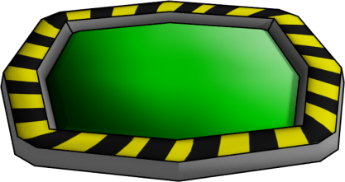

*Picture N; Alarm Picture N; Alarm trigger platform*

* **Super Awesome Antidote**

This is the ultimate power up in the game. For several seconds it slightly increases the speed of the hero, it makes him invulnerable and when colliding with zombie opponents it actually turns them back to normal humans permanently which then follow the hero like normal saved trapped survivors until the end of the level. A particle effect around the hero during the positive effect of the super awesome antidote, gives feedback to the player how long is this positive effect lasting. Also if there are trapped survivors already following the player, the effect of this power up will apply to them as well. This means that zombies, colliding with the tail of trapped survivors while the effects are lasting, will also turn in normal humans and follow the hero.



*Picture N; Super Awesome Antidote*

This ultimate strength of the super awesome antidote can also turn into a disadvantage for the player as the more zombies are turned back to humans, the longer will the tail of survivors behind the player grow, which again might turn into great difficulty if the player is facing more zombie opponents after the positive effect expires.

So the level designer will place the super awesome antidote around the end of a level, if the aim is to project only advantage with low/no risk; or he will place the power up mid or beginning of level to create potentially disadvantage. At the end it is off course the choice of the player if he will collect it or not, so this power up, same as the other two, places the player in front of a tactical decision for every level.

# GUI

The main goal in creating the user interface for SAWZE is to reinforce the simple and intuitive game play. The stile is simple and in line with the cartoony and funny look of the whole game. The main aspects are the briefing and tutorial boxes, alongside with the in-game elements such as health bar, level objective counter and navigator.

# 8.1 Briefing and tutorial boxes

Every level starts with a short level briefing, which explains to the player what his /her objective in the current level is. It also contains visual material of the objective. The first 5 levels contain short tutorial messages communicating to the player all mechanics and all features of the game. The first level is purely tutorial and after being through with it, the player will be aware of the core mechanics in SAWZE. The mock-up below illustrates and example for a level briefing with its main components:

- Level name/number  
- Short description on what and why needs to be done  
- Picture of the Objective(s)

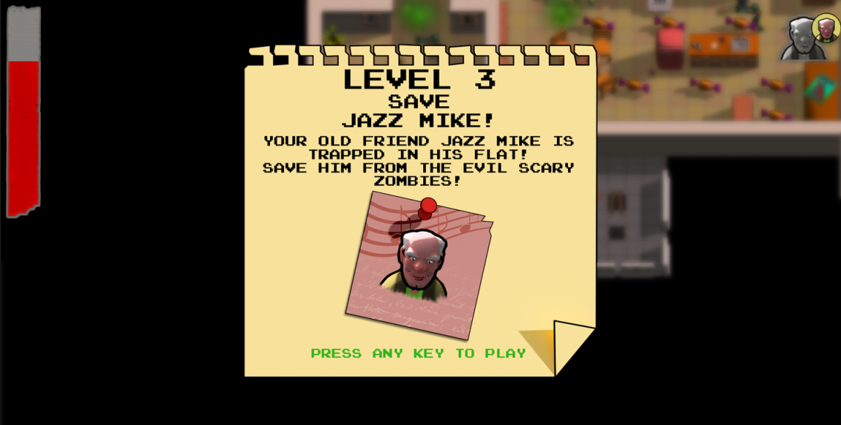

*Picture N; Mock up Level Briefing*

# 8.2 In-Game GUI

The In-Game GUI has 3 elements serving the player for orientation but also as a feedback system regarding the interactions between him and the game:

* + The **Health Bar**, which is placed on the top-left corner of the screen, indicates how much health does the player have left. When the bar reaches a critical minimum of 30% a vignette is activated to alarm the player that antidotes need to be collect urgently. An additional feedback is activated at any time the player goes through a cloud of concentrated zombie virus and a green cloud in the form of a comic speech bubble containing an exclamation mark pops out next to the health bar. If the bar is completely depleted the level is failed.
  + The **Level Objective Counter** is positioned on the top-right side of the screen. It indicates the collectable level objective(s). In the beginning this icon is transparent and grey, but when the objective is achieved (item collected or survivor saved) it changes to solid and colored, thus indicating to the player that this objective is accomplished. In addition to the visual feedback there is a sound effect indicating this.

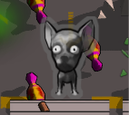

*Picture N; Level objective counter (objective not achieved)*

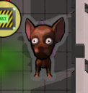

*Picture N; Level objective counter (objective achieved)*

* + The **Level Objective Navigator** is always on the very rear of the screen but not fixed – it moves on the rear of the screen depending on the current position of the player towards the objective on the level. This is a great indicator for the general direction the player should take, without being too detailed and showing the exact path. When all objectives are achieved, the Level Objective Navigator shows the direction towards the level exit.

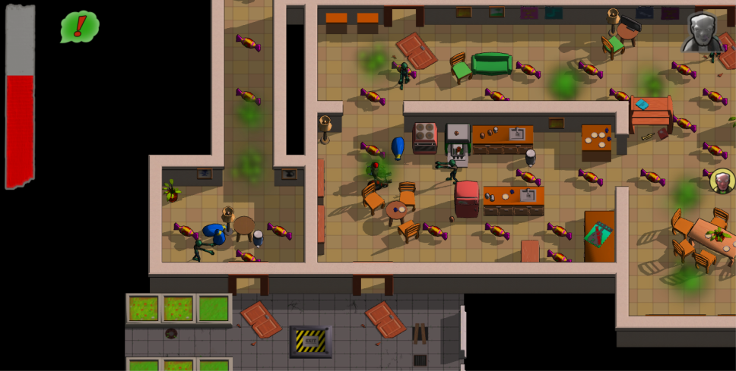

*Picture N; Mock up In-Game GUI*

# Target group, genre and difficulty level

The content of the game allows a brought specter of players as it contains no violence or horror, thus allowing a 7+ age group. The minimum age is set at 7 years as suggested by the USK, due to the considerable pressure to act exerted in action packed sequences.

Age restriction: 7+

Gender: both

Gaming experience: none required

The genre of the game also reinforces the placement of the player age restriction at 7+ as it is a combination of “arcade” and “jump and run”. The essential aspects of the classic arcade gameplay such as easy to access, simple controls and a clear game task, as well as skill and speed of reaction requirement are characteristic for S.A.W.Z.E. Some major jump and run gameplay aspects, such as the comical figures controlled by the player, who seek to run their way through various levels whilst overcoming a range of obstacles is the second key flavor of the game. Recent trends in this genre are also represented in the game play of S.A.W.Z.E., which is enhanced with missions, adventure elements and collectable items in 3D environment.

Source: <http://www.usk.de/en/classification/genres/>

The level of difficulty of the game play allows a brought specter of players. The controls are simple and intuitive and the difficulty of the levels increases in small steps adjusted to a general learning curve regarding the game mechanics. The idea behind the level progression is “easy to learn, difficult to master”.

The difficulty of the levels will be defined by the following components and increasing difficulty will be achieved in the level design by adding one of the factors below on top of each next level (or each second level):

* the size of the level (bigger levels allow more “dead-end” paths),
* the quantity of Zombie opponents,
* the quality of Zombie opponents
* the quantity of collectable objective items
* the game modi – collect items or save survivors, or both
* the areas infected from Z-Virus
* the quantity of Antidotes placed on the level

# 10. Critical success factors

**Pacman+**

The game experience should be associated with the game experience in pac-man. The core features of pac-man should be represented but adjusted. The changes on these core features should not be too big and afar from the original – they should remind the player of the pac-man game experience. At the same time the game should also have its unique traits. The balance of innovation and maintaining pac-man flavor is critical and challenging to achieve.

**Visual Presentation**

The art style of the game is one of the main USPs and achieving a goofy, funny cartoon style is a hard task. The whole asset palate was completely changed/ adjusted 3 times during the production phase until the desired appearance was achieved. The final result at the end was worth the effort.

**Fun Game play**

Even harder than the art stile, was to achieve comedy in the game play. The whole concept of SAWZE is driven by harmless joke with the zombie setting and every feature is driven by this joke aspect. All the power ups have not only comic appearance but a comic effect on the game play. The zombies and their behavior as well as the objectives and settings themselves aim to create the feeling of being in a cartoon and distance the player from resemblance to reality.

**Level Balance**

The level design and the balancing of level objects is a major critical success factor. A very balanced and smart placement of all level components is critical for the entertaining effect of the game. Poorly designed levels may end up being too easy to win or absolutely impossible to pass. The increasing game difficulty with each next level is a delicate matter as well. The aim is to give a brought specter of player a balanced challenge.

# 11. Team Structure and Tasks

Team: S.A.W.Z.E.

Tobias Paul – Character Art and Animation

Amon Kalagin – Setting, Environment Art and modelling

Daniel Pochert – Programming

Robert Lücke – Game Design

Andrea Schelling - Setting, Environment Art and modelling

Toma Komitski – Game Design and Production

External member:

[Markus Zierhofer](https://www.facebook.com/markus.zierhofer?fref=nf) - Music and Sound effects

# 12. Tools and Platform

**Platform:** S.A.W.Z.E. will be developed for PC at first. Later adjustment on other platforms will be possible.  
  
**Engine:** Unity3D  
  
**Audio:** SFXR  
  
**Graphics:** Maya; Blender; Max; ZBrush; Photoshop; After Fix; dDo; Knald; nDo²

# 13. Development Stages

