Neon data

Pre-requisite :

* Download all the required data from <https://data.neonscience.org/data-products/explore> and place it in a directory.
* Download the script from the GitHub page :
* Place the downloaded script in a directory which you can access using your python IDE.

This tutorial is aimed at Performing the following functions :

* Iterates through all the files in a single directory.
* Iterates through all the zipped files in the directory
* Temporarily unzips all the excel files in the directory
* Script runs through all the data in a directory and calculates the daily averages for a given site.
* Concatenates all the files into a single file named “*FinalDataTALL2018-2020.xlsx*”
* The FinalData file contains the daily data of 5 different sites in 5 different sheets.
* The data is indexed based on StartDateTime variable.
* Fills the missing values with -999.

Open the required python script in a python IDE .

Various parts of the script need to be changed to suite your needs :

* 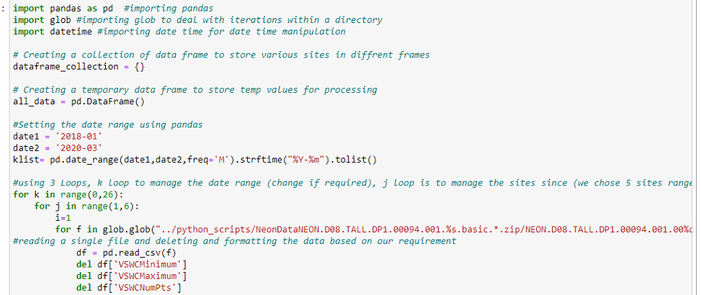

Change the directory location based on where your Neon Data files are located.

Note: you generally do not need to change the name at the end of the path.

Change the date1,date 2 variables based on your start date and time

Run the script chose the directory where the Neon Data files are located, it creates a “*FinalDataTALL2018-2020.xlsx*” file in the same directory where the script is located. The script generally takes about 5-10 mins to process the various components.