Connor Watson  
Last HW CS 636  
Neural Network Portion

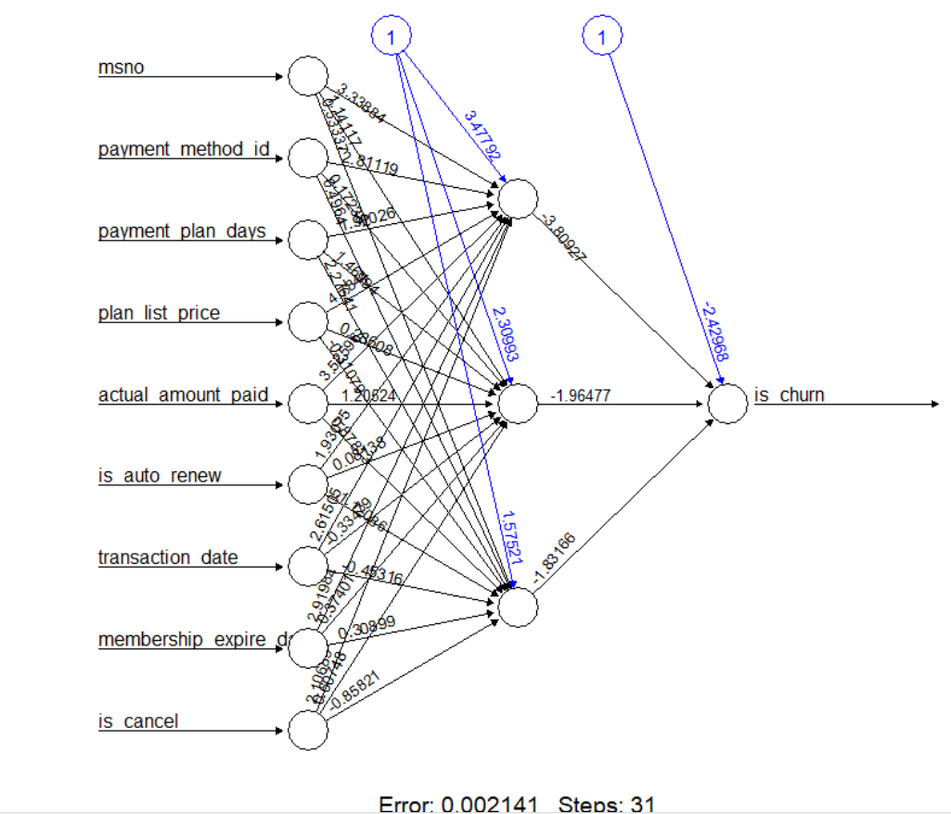

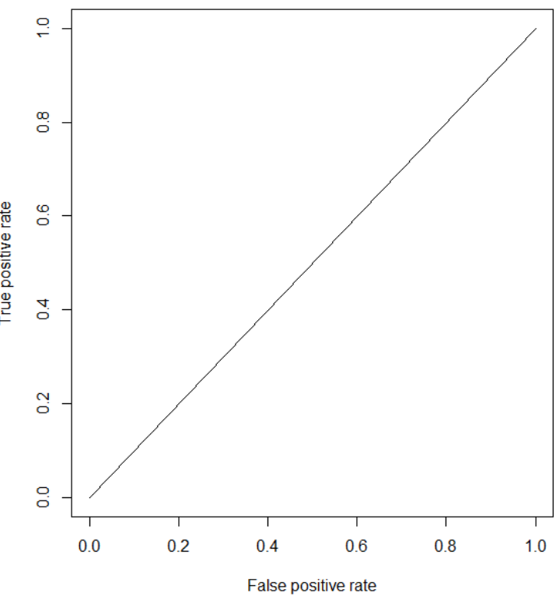

area under curve is 0.5

#Connor Watson

#Lab9 Codes

train_data = read.csv('/Users/watson/Documents/cs636/kkbox/train_v2.csv', header = T)

trans_data = read.csv('/Users/watson/Documents/cs636/kkbox/transactions_v2.csv', header = T)

merged <- merge(train_data, trans_data, by="msno")

sample_data <- merged

sample_data$is_churn <- as.numeric(sample_data$is_churn)

sample_data$msno <- as.numeric(sample_data$msno)

data <- (sample_data - min(sample_data, na.rm=TRUE))/(max(sample_data,na.rm=TRUE) -

min(sample_data, na.rm=TRUE))

set.seed(17)

ind <- sample(2, nrow(data), replace =T, prob = c(0.7,0.3))

train_1 <-data[ind==1,]

test_1 <- data[ind==2,]

library(neuralnet)

names <- names(train_1)

formula <- as.formula(paste("is_churn ~", paste(names[!names %in% "is_churn"], collapse = " + ")))

nmodel <- neuralnet(formula, data=train_1, hidden=3,

linear.output = FALSE)

plot(nmodel)

p <- nmodel$net.result[[1]]

pred <- compute(nmodel,train_1[,-1])

p_res <- pred$net.result

p_res <- ifelse(p_res>0.5,1,0)

tab_res <- table(predicted=p_res, Actual = train_1$is_churn)

tab_res

(1- sum(diag(tab_res)/sum(tab_res))) * 100

(sum(diag(tab_res)/sum(tab_res))) * 100

pred <- compute(nmodel,test_1[,-1])

p_res_2 <- pred$net.result

p_res_2 <- ifelse(p_res_2>0.5,1,0)

tab_res_2 <- table(predicted=p_res_2, Actual = test_1$is_churn)

tab_res_2

(1- sum(diag(tab_res_2)/sum(tab_res_2))) * 100

(sum(diag(tab_res_2)/sum(tab_res_2))) * 100

detach(package:neuralnet, unload = T)

library(ROCR)

nn.pred = prediction(p_res_2, test_1$is_churn)

pref <- performance(nn.pred, "tpr", "fpr")

plot(pref)

auc.perf = performance(nn.pred, measure = "auc")

auc.perf@y.values #area is 0.5

rm(list = ls())

detach(package:ROCR, unload = T)

Random Forest Portion

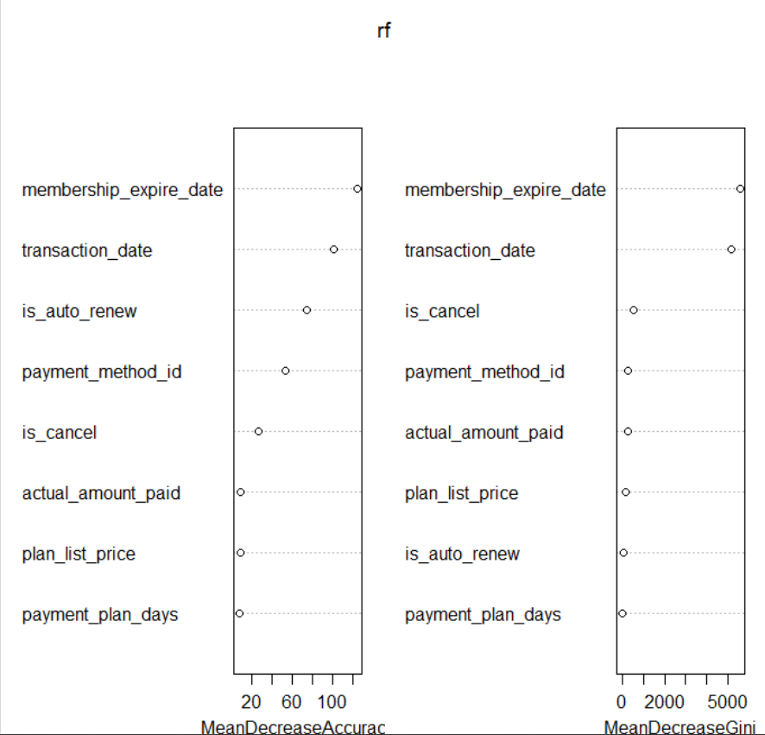

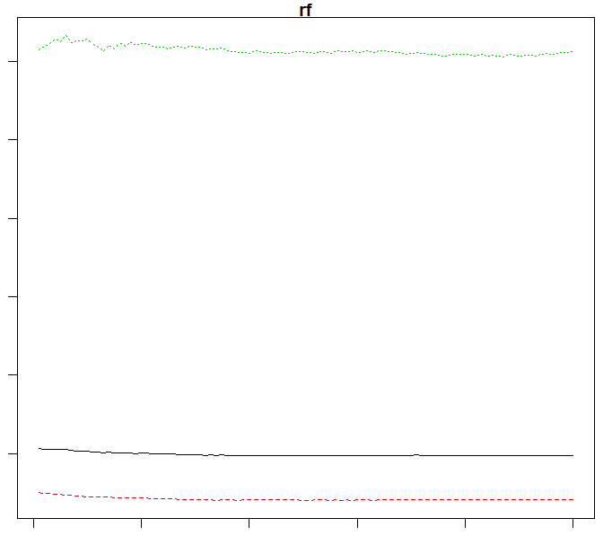

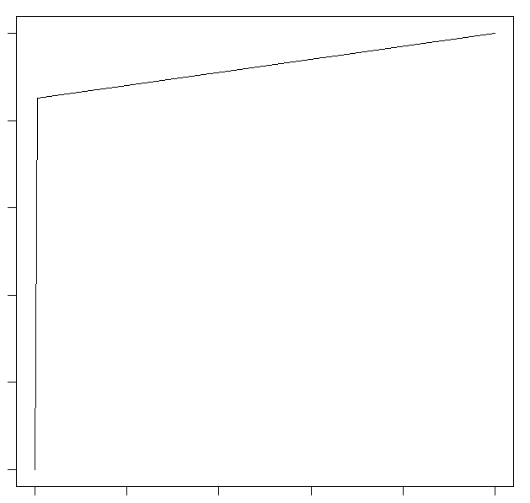 Train Plot area = 0.923212683

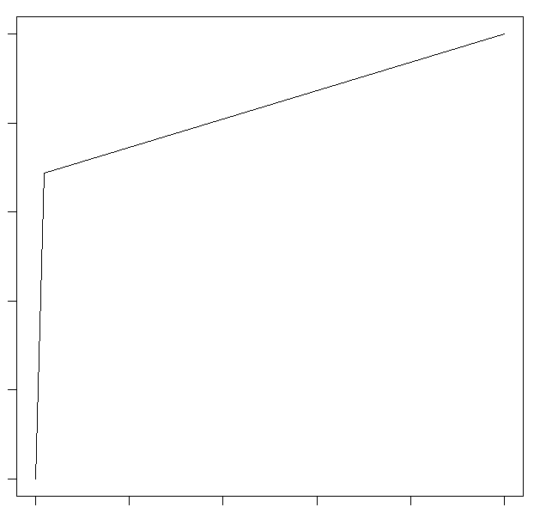Test Plot area = 0.8346216455

train_data = read.csv('/Users/watson/Documents/cs636/kkbox/train_v2.csv', header = T)

trans_data = read.csv('/Users/watson/Documents/cs636/kkbox/transactions_v2.csv', header = T)

merged <- merge(train_data, trans_data, by="msno")

set.seed(17)

ind <- sample(2, nrow(merged), replace = T, prob = c(0.1, 0.9))

sample_data <- merged[ind == 1,]

data <- sample_data

data$is_churn <- as.factor(data$is_churn)

set.seed(17)

ind <- sample(2, nrow(data), replace = T, prob = c(0.7, 0.3))

train_2 <- data[ind==1,]

test_2 <- data[ind==2,]

#install.packages("randomForest")

library(randomForest)

rf <- randomForest(is_churn ~ + payment_method_id + payment_plan_days + plan_list_price + actual_amount_paid +

is_auto_renew + transaction_date + membership_expire_date + is_cancel, train_2,

importance = T, ntree = 100, mtry = 8)

rf

#install.packages('e1071', dependencies=TRUE)

library(caret)

library(ROCR)

library(pROC)

pred_1 <- predict(rf, train_2)

confusionMatrix(pred_1, train_2$is_churn)

pred1_ints <- ifelse(as.numeric(pred_1)==1,0,1)

pred1_ints

train_pred <- prediction(pred1_ints, train_2$is_churn)

train_perf <- performance(train_pred, 'tpr', 'fpr')

plot(train_perf)

auc.perf_1 = performance(train_pred, measure = "auc")

auc.perf_1@y.values

pred_2 <- predict(rf, test_2)

confusionMatrix(pred_2, test_2$is_churn)

pred2_ints <- ifelse(as.numeric(pred_2)==1,0,1)

pred2_ints

test_pred <- prediction(pred2_ints, test_2$is_churn)

test_perf <- performance(test_pred, 'tpr', 'fpr')

plot(test_perf)

auc.perf_2 = performance(test_pred, measure = "auc")

auc.perf_2@y.values

varImpPlot(rf)

plot(rf)