# UE5_Lyra学习指南_084_讲解GA_Melee

本文章仅为小刚-B站课堂-虚幻引擎视频课程Lyra-精讲的演讲手稿.
本套课程链接:
[UE5]虚幻引擎游戏案例Lyra精讲
https://www.bilibili.com/cheese/play/ss112001159
前置课程链接:
[UE5]虚幻引擎UEC++从基础到进阶
https://www.bilibili.com/cheese/play/ss28043
文章内容由小刚撰写,采用了以下多种方式:
1.口述转文字
2.AI重构
3.参考引擎源码
4.Lyra工程源码
5.结合社区论坛各位大佬的解析

概述
本节讲解单手攻击.
因为上下文联系比较多.所以使用Word方便截图

能力的注册

(Ability="/Script/Engine.BlueprintGeneratedClass'/ShooterCore/Game/Melee/GA_Melee.GA_Melee_C'",AbilityLevel=1,InputTag=(TagName="InputTag.Ability.Melee"))

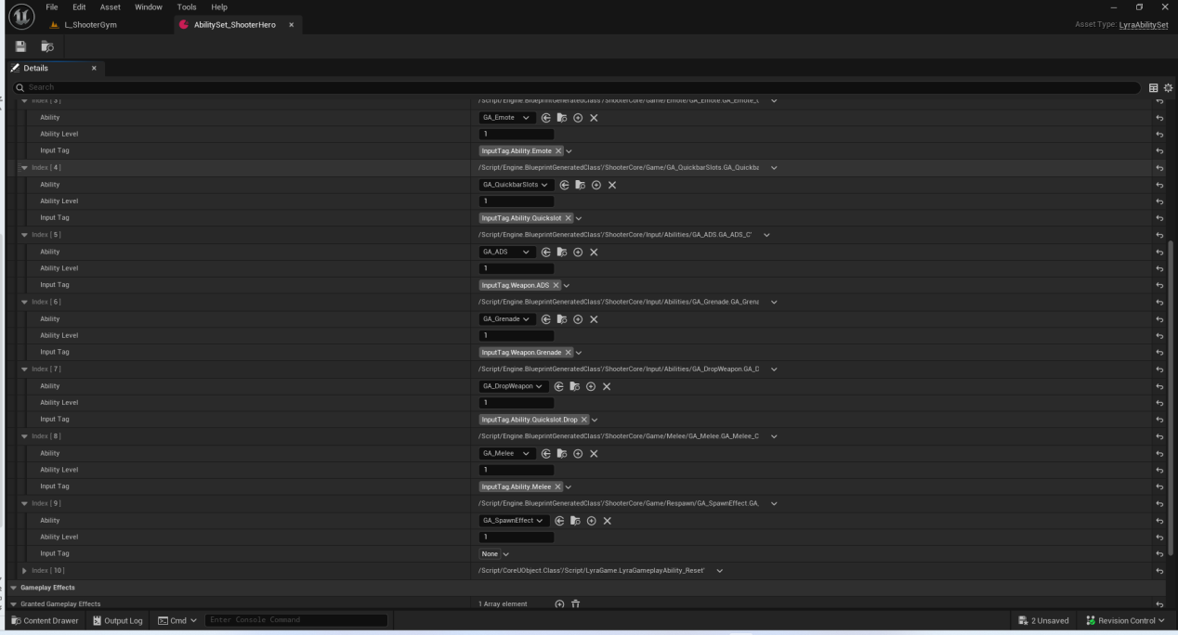

近战的动画选择
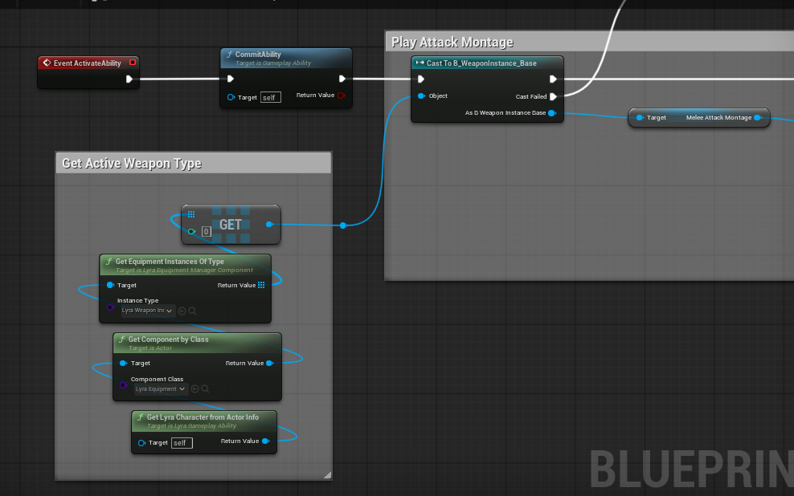

近战胶囊体射线检测
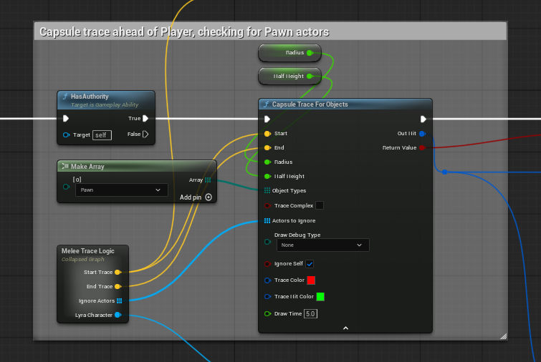

核对友伤
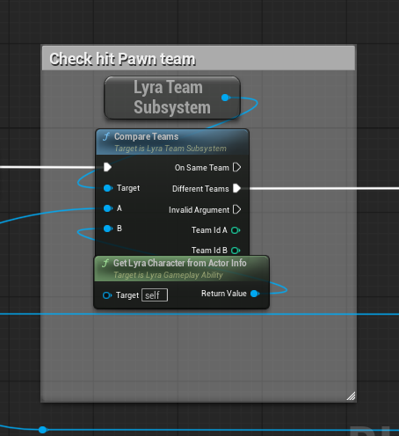
注意这个写法很有意思
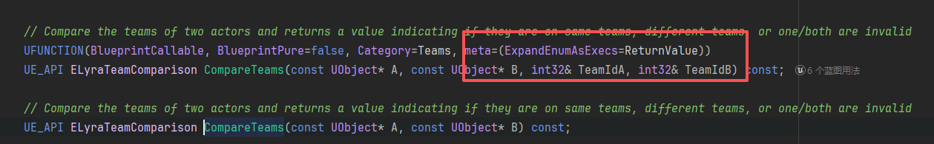
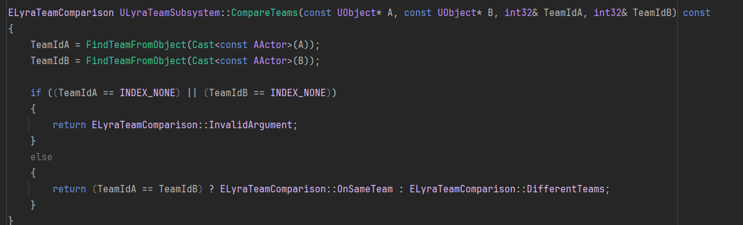
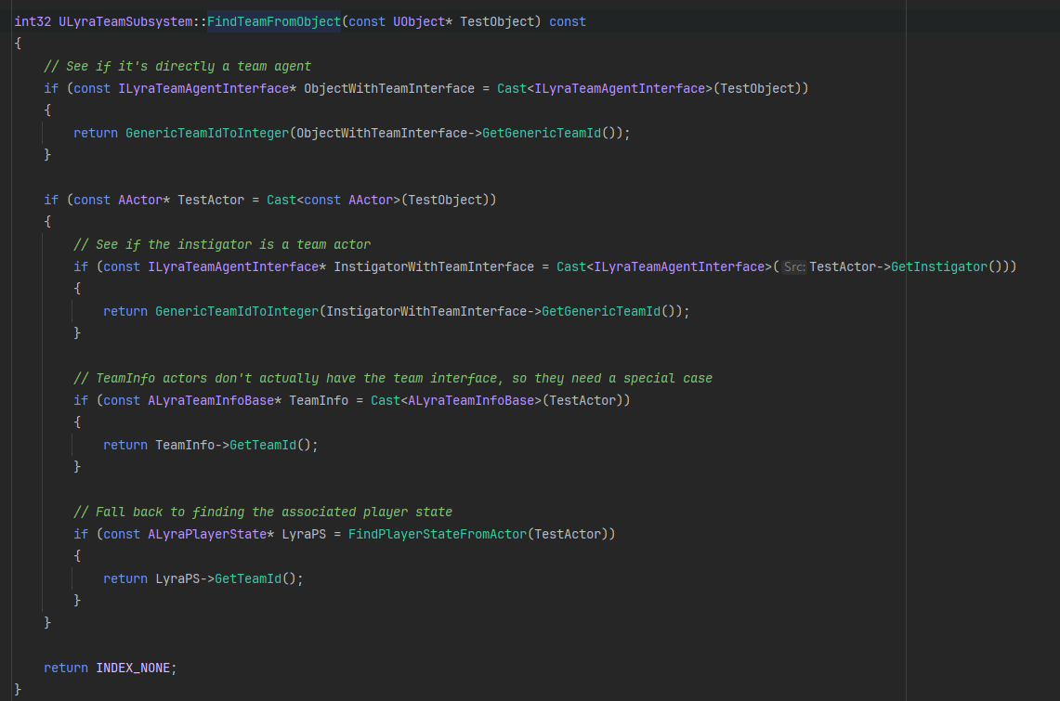

核对遮挡性
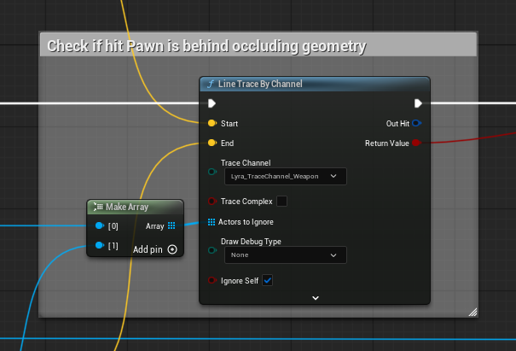

添加冲刺效果
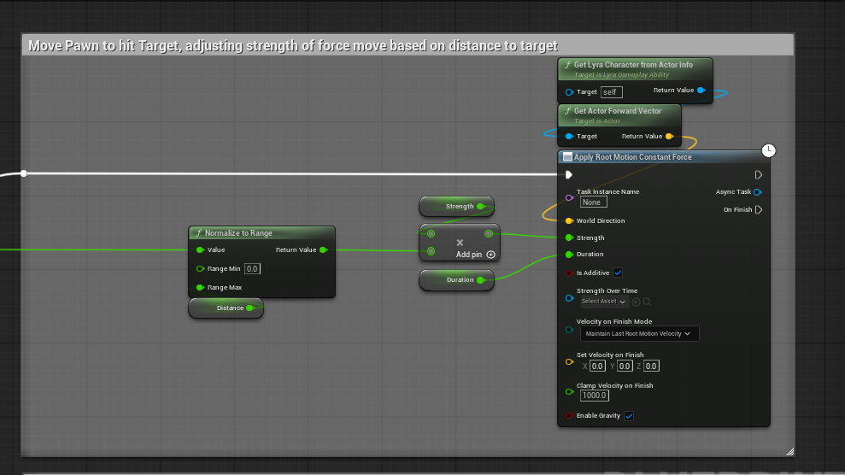

施加挥集效果
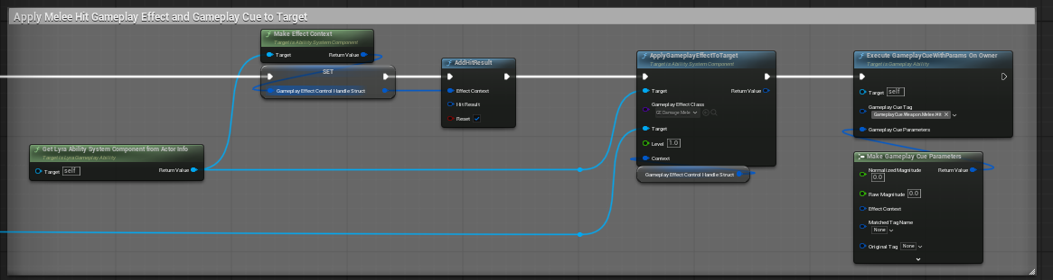

背景音效的改变
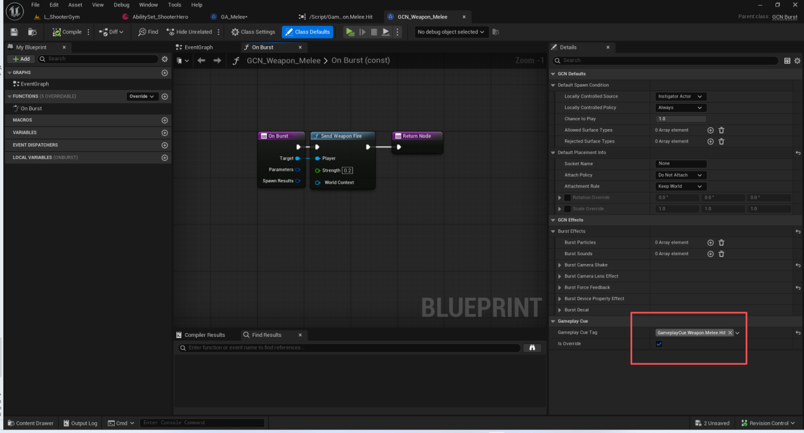

GE命中效果
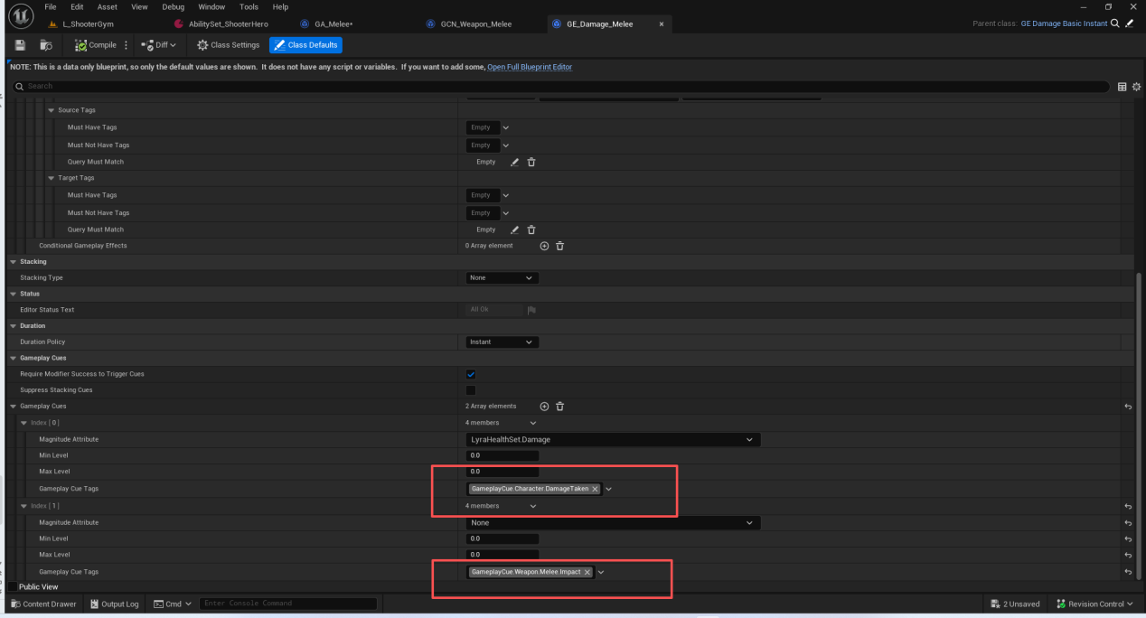

伤害计算
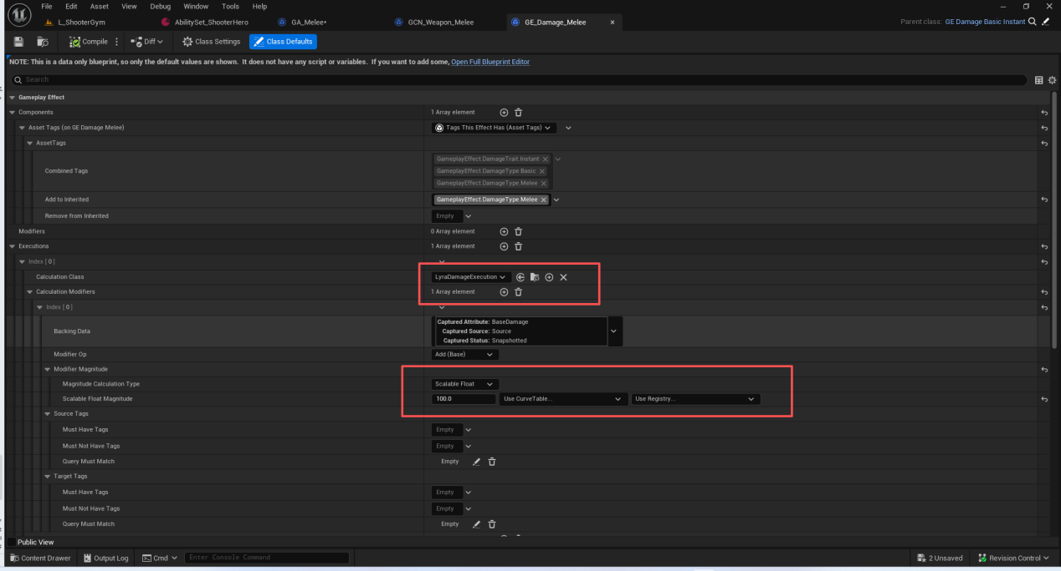
GEEC的代码较长.不在此处截图.同时涉及到属性的修改.

ULyraDamageExecution::Execute_Implementation(const FGameplayEffectCustomExecutionParameters &, FGameplayEffectCustomExecutionOutput &) LyraDamageExecution.cpp:45
FActiveGameplayEffectsContainer::ExecuteActiveEffectsFrom(FGameplayEffectSpec &, FPredictionKey) GameplayEffect.cpp:3138
UAbilitySystemComponent::ExecuteGameplayEffect(FGameplayEffectSpec &, FPredictionKey) AbilitySystemComponent.cpp:1022
UAbilitySystemComponent::ApplyGameplayEffectSpecToSelf(const FGameplayEffectSpec &, FPredictionKey) AbilitySystemComponent.cpp:953
UAbilitySystemComponent::ApplyGameplayEffectSpecToTarget(const FGameplayEffectSpec &, UAbilitySystemComponent *, FPredictionKey) AbilitySystemComponent.cpp:792
FGameplayAbilityTargetData::ApplyGameplayEffectSpec(FGameplayEffectSpec &, FPredictionKey) GameplayAbilityTargetTypes.cpp:47
UGameplayAbility::ApplyGameplayEffectSpecToTarget(FGameplayAbilitySpecHandle, const FGameplayAbilityActorInfo *, FGameplayAbilityActivationInfo, FGameplayEffectSpecHandle, const FGameplayAbilityTargetDataHandle &) GameplayAbility.cpp:2111
UGameplayAbility::ApplyGameplayEffectToTarget(FGameplayAbilitySpecHandle, const FGameplayAbilityActorInfo *, FGameplayAbilityActivationInfo, const FGameplayAbilityTargetDataHandle &, TSubclassOf<…>, float, int) GameplayAbility.cpp:2084
UGameplayAbility::BP_ApplyGameplayEffectToTarget(FGameplayAbilityTargetDataHandle, TSubclassOf<…>, int, int) GameplayAbility.cpp:2052
UFunction::Invoke(UObject *, FFrame &, void *const) Class.cpp:7460
UObject::CallFunction(FFrame &, void *const, UFunction *) ScriptCore.cpp:1175
[内联] FFrame::Step(UObject *, void *const) ScriptCore.cpp:509
UObject::execLet(UObject *, FFrame &, void *const) ScriptCore.cpp:2893
[内联] FFrame::Step(UObject *, void *const) ScriptCore.cpp:509
[蓝图] GA_Weapon_Fire: PlayMontageAndWait Event Graph
ProcessLocalScriptFunction(UObject *, FFrame &, void *const) ScriptCore.cpp:1275
ProcessScriptFunction<…>(UObject *, UFunction *, FFrame &, void *const, void (*)(UObject *, FFrame &, void *)) ScriptCore.cpp:1067
`ProcessLocalFunction'::`2'::<lambda_1>::operator()() ScriptCore.cpp:1320
ProcessLocalFunction(UObject *, UFunction *, FFrame &, void *const) ScriptCore.cpp:1337
[内联] FFrame::Step(UObject *, void *const) ScriptCore.cpp:509
[蓝图] GA_Weapon_Fire: Event OnRangedWeaponTargetDataReady Function /Game/Weapons/GA_Weapon_Fire.GA_Weapon_Fire_C:OnRangedWeaponTargetDataReady
ProcessLocalScriptFunction(UObject *, FFrame &, void *const) ScriptCore.cpp:1275
UObject::ProcessInternal(UObject *, FFrame &, void *const) ScriptCore.cpp:1364
UFunction::Invoke(UObject *, FFrame &, void *const) Class.cpp:7460
UObject::ProcessEvent(UFunction *, void *) ScriptCore.cpp:2209
ULyraGameplayAbility_RangedWeapon::OnTargetDataReadyCallback(const FGameplayAbilityTargetDataHandle &, FGameplayTag) LyraGameplayAbility_RangedWeapon.cpp:539
TBaseUObjectMethodDelegateInstance::ExecuteIfSafe(const FGameplayAbilityTargetDataHandle &, FGameplayTag) DelegateInstancesImpl.h:689
[内联] TMulticastDelegateBase::Broadcast(const FGameplayAbilityTargetDataHandle &, FGameplayTag) MulticastDelegateBase.h:258
TMulticastDelegate<void __cdecl(FGameplayAbilityTargetDataHandle const & __ptr64,FGameplayTag),FDefaultDelegateUserPolicy>::Broadcast(const FGameplayAbilityTargetDataHandle &,FGameplayTag) DelegateSignatureImpl.inl:1080
UAbilitySystemComponent::ServerSetReplicatedTargetData_Implementation(FGameplayAbilitySpecHandle, FPredictionKey, const FGameplayAbilityTargetDataHandle &, FGameplayTag, FPredictionKey) AbilitySystemComponent_Abilities.cpp:3968
UFunction::Invoke(UObject *, FFrame &, void *const) Class.cpp:7460
[蓝图] AbilitySystemComponent: ServerSetReplicatedTargetData Function /Script/GameplayAbilities.AbilitySystemComponent:ServerSetReplicatedTargetData
UObject::ProcessEvent(UFunction *, void *) ScriptCore.cpp:2209
FObjectReplicator::ReceivedRPC(FNetBitReader &, const FReplicationFlags &, const FFieldNetCache *, const bool, bool &, TSet<…> &) DataReplication.cpp:1402
FObjectReplicator::ReceivedBunch(FNetBitReader &, const FReplicationFlags &, const bool, bool &) DataReplication.cpp:1178
UActorChannel::ProcessBunchInternal(FInBunch &) DataChannel.cpp:3436
[内联] UActorChannel::ProcessBunch(FInBunch &) DataChannel.cpp:3528
UActorChannel::ReceivedBunch(FInBunch &) DataChannel.cpp:3243
UChannel::ReceivedSequencedBunch(FInBunch &) DataChannel.cpp:576
UChannel::ReceivedNextBunch(FInBunch &, bool &) DataChannel.cpp:1081
UChannel::ReceivedRawBunch(FInBunch &, bool &) DataChannel.cpp:697
UNetConnection::DispatchPacket(FBitReader &, int, bool &, bool &) NetConnection.cpp:3926
UNetConnection::ReceivedPacket(FBitReader &, bool, bool) NetConnection.cpp:3294
[内联] UNetConnection::ReinjectDelayedPackets() NetConnection.cpp:2270
UNetConnection::PostTickDispatch() NetConnection.cpp:2183
UNetDriver::PostTickDispatch() NetDriver.cpp:2625
[内联] Invoke(void (UNetDriver::*)(), UNetDriver *&) Invoke.h:66
[内联] UE::Core::Private::Tuple::TTupleBase::ApplyAfter(void (UNetDriver::*&)(), UNetDriver *&) Tuple.h:320
V::TBaseUObjectMethodDelegateInstance::ExecuteIfSafe() DelegateInstancesImpl.h:689
[内联] TMulticastDelegateBase::Broadcast() MulticastDelegateBase.h:258
TMulticastDelegate::Broadcast() DelegateSignatureImpl.inl:1080
UWorld::Tick(ELevelTick, float) LevelTick.cpp:1336
UEditorEngine::Tick(float, bool) EditorEngine.cpp:2149
UUnrealEdEngine::Tick(float, bool) UnrealEdEngine.cpp:530
ULyraEditorEngine::Tick(float, bool) LyraEditorEngine.cpp:37
FEngineLoop::Tick() LaunchEngineLoop.cpp:5619
[内联] EngineTick() Launch.cpp:60
GuardedMain(const wchar_t *) Launch.cpp:189
LaunchWindowsStartup(HINSTANCE__ *, HINSTANCE__ *, char *, int, const wchar_t *) LaunchWindows.cpp:271
WinMain(HINSTANCE__ *, HINSTANCE__ *, char *, int) LaunchWindows.cpp:339

此处贴出堆栈.
点出核心代码调用.
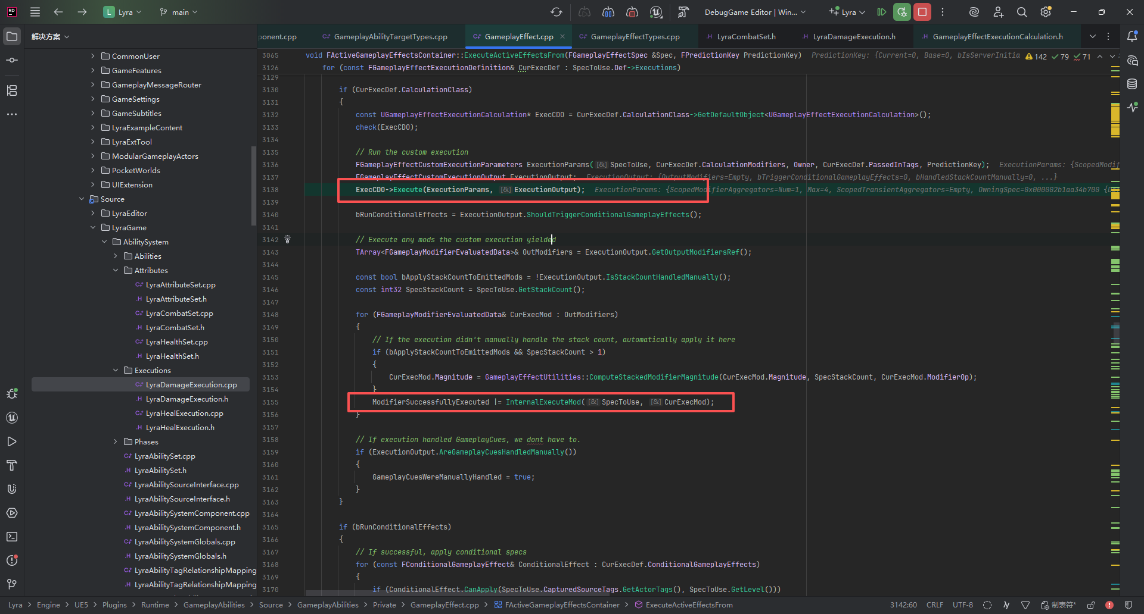
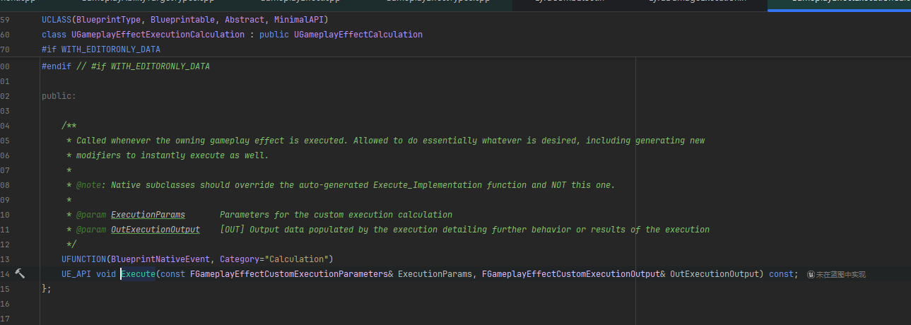
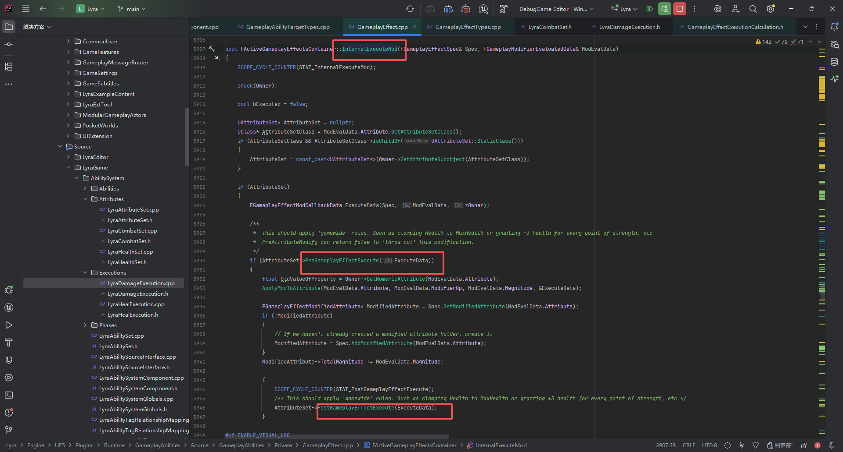

伤害冲击音效
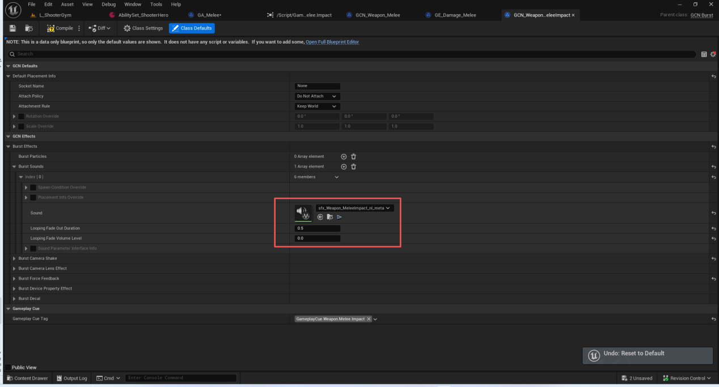

人物受击效果
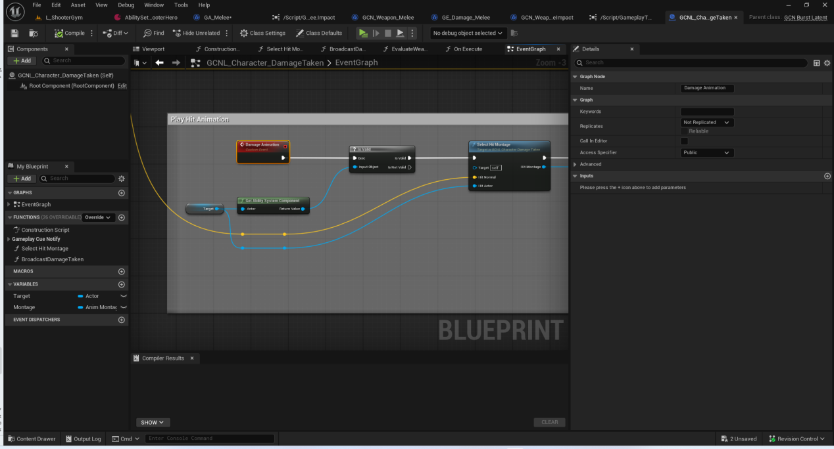
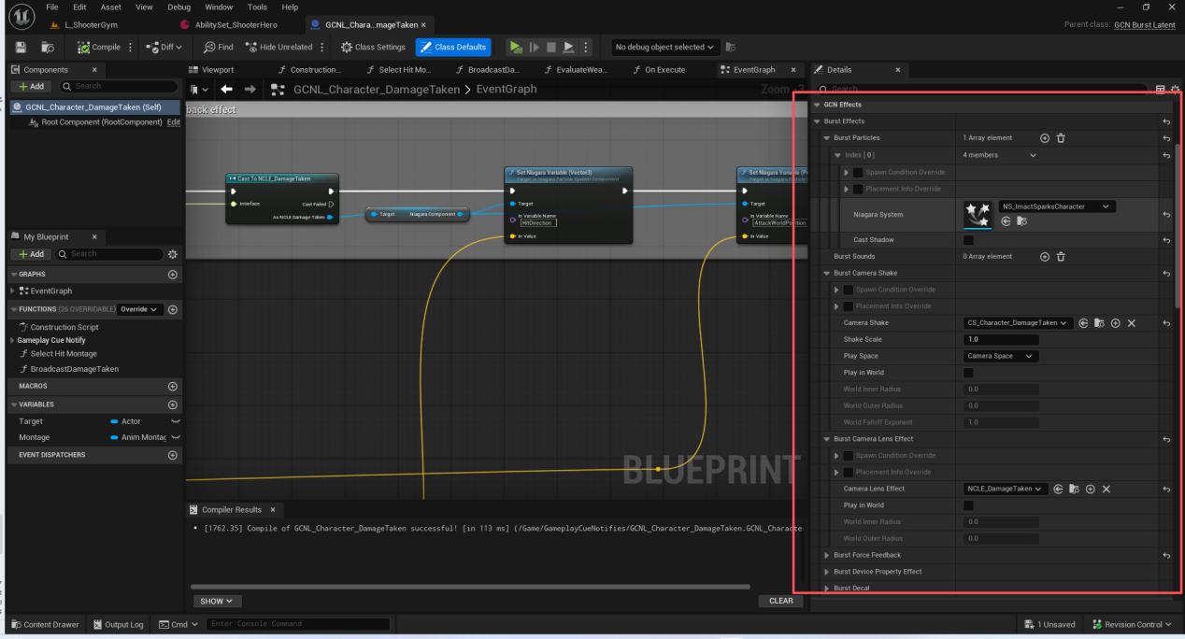

武器挥动的音效
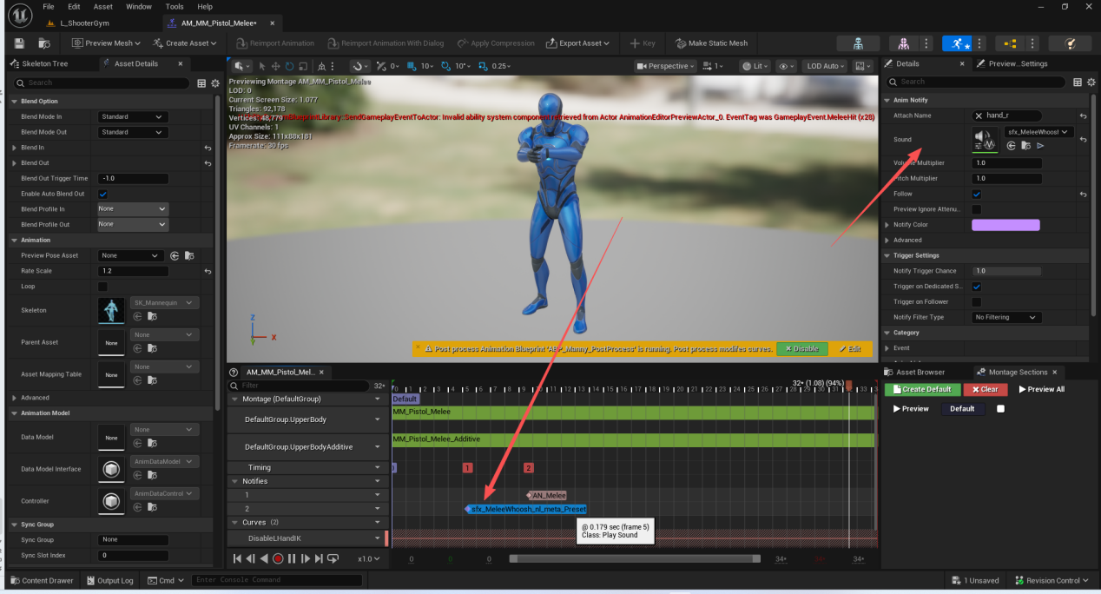
注意这个AN_Melee目前没有进行设计.应当设计

总结

