Melzi Resuscitation
by WirelessguyNY

Before we get in to the low level details here allow me to take a moment to discuss how your device works and why you would or would not want to update the firmware on your TRONXY to begin with.

Before we Begin:

Firstly, the firmware is the brains and logic behind what makes your steppers move, heat bed heat up and extruder heat up and push/pull at your plastic filament. I DO NOT suggest messing with the firmware unless you feel you have a true need. The TRONXY uses an older version of the Marlin firmware and the latest copy online will not even fit on the Melzi's memory anymore. So, why was it that I was interested in updating my device? I had three reasons I thought were fairly good.

a) My TRONXY came with an inductive Auto Level sensor and it was not functioning well. I found that mounting it in a different location (next to my fan) yielded better results for me. However, moving the default location of the sensor meant that my sensor to nozzle offset distance had changed. This modification is not exposed wihtin the EEPROM config so Repetier, Cura, Pronterface, etc... can not be used to alter that.

b) EEPROM Chitchat is disabled in TRONYXY's shipped firmware. OK, so this was a bit disappointing to me. I had been making manual adjustments within the EEPROM settings on Repetier but found that things were not getting saved to my device. I was doing a combination of PC saves and direct 3D printer changes and saves and couldn't figure out what was wrong till I showed the code to an experienced Prusa builder at a local makerspace.

c) The guy at the makerspace also told me about a nifty feature (also left disabled) called BABYSTEPPING; which can be found in the configuration_adv.h file. This feature will allow you to make micro adjustments during your printing. [Note: This feature is only available when printing off the SD card. After starting your print the menu will add a 'Tune' function. I personally dial the Z distance to where the extruder clicks a bit because I can not let out filament and then back it off a touch so that the plastic lays down cleanly without any over extrusion or round blobs on the bed.

For completeness, all three of my tweaks above were for the purpose of setting my Z distance so that I got a nice clean flat bead running across my first layer. I do believe this is a critical key component to getting nice solid prints on your machine. To me, those are worthy reasons for trying to re-flash your firmware.

Main Event:

For some reason my Melzi board did not want to communicate with my PC correctly and I think that my firmware flashing via the Arduino IDE only partially took. I began to have sporadic issues with what got displayed on my LCD screen and eventually when I went to turn my TRONXY P802 on all I got was an LCD white an all white display (BRICKED!)

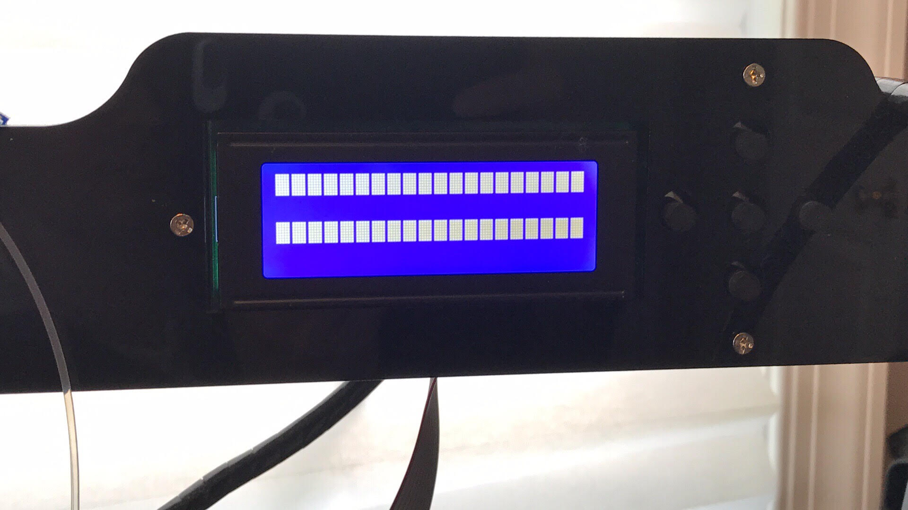

My understanding is that when this happens you have likely lost the low level code called the bootloader; which tells you device what part of memory to start reading in order to load up marlin (or your other firmware) to run the machine. Once this occurs there is only one way to bring your device back to life again. The USB port is inaccessible because the software that runs it is not yet loaded up. At the factory, companies do not use USB. Every device still has a good old serial connection for flashing. The Melzi board has 6 pins on the bottom left. (Arduinos have similar pins too. Even devices like your wifi router have serial tabs, though the company may not put pins on).

I have been told that you can actually use and Arduino and hook up some of its pins to the Melzi and use it as a serial controller but I'm not really that advanced when it comes to these devices. Instead, I took the route of purchaing a devices called an USBasp AVR Programmer. (I got mine form Amazon for $8.50) https://www.amazon.com/gp/product/B01H82F8FY/ref=oh_aui_detailpage_o00_s00?ie=UTF8&psc=1

It looks like this:
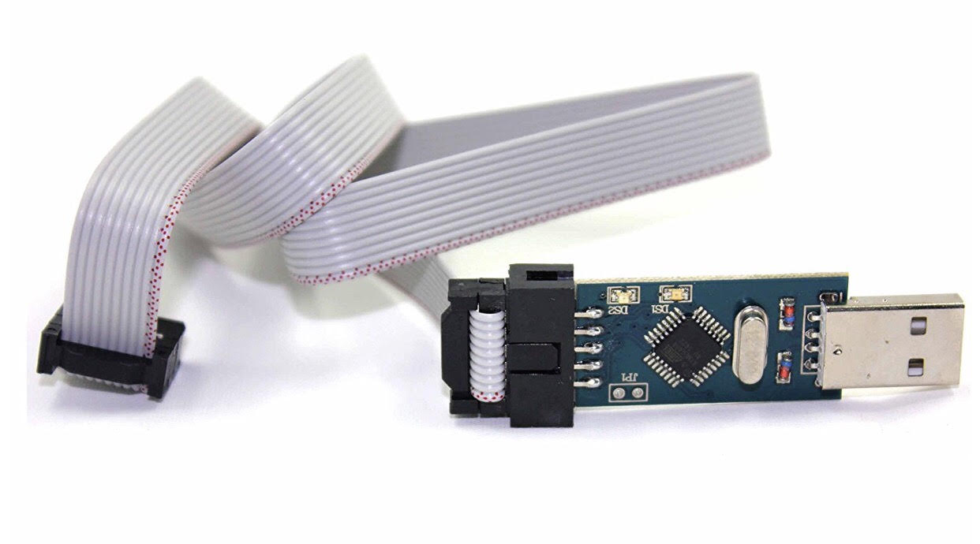
and mine even included a 10 pin to 6 pin converter:
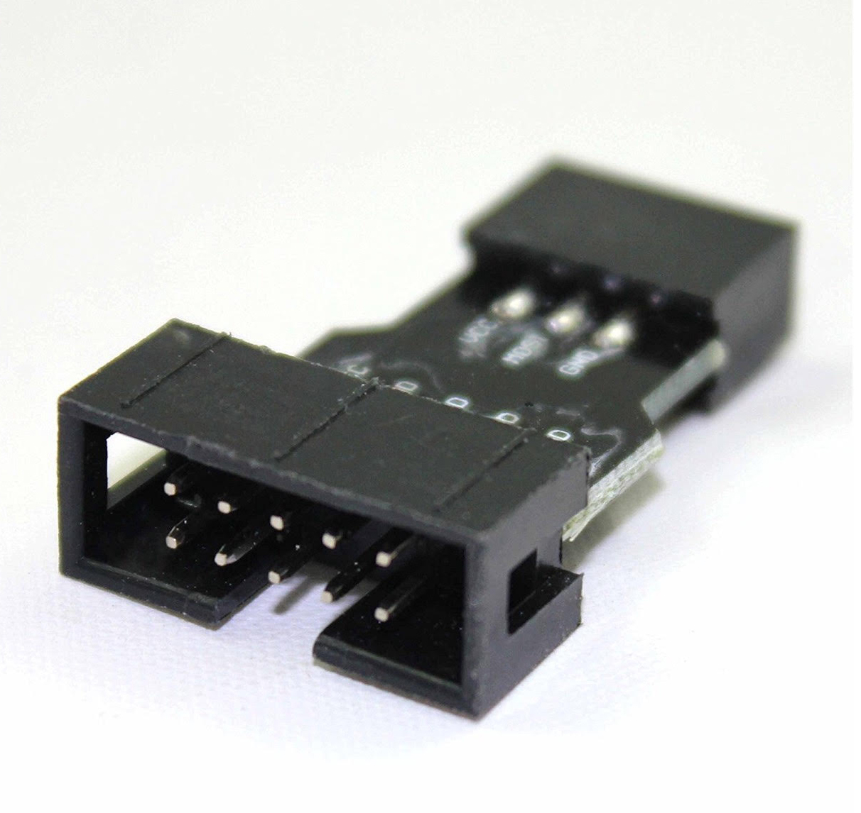
The six pin side of the converter has a small tab. This faces the top of the Melzi board. [I'ts pretty easy to figure out since the bottom of that connector says gnd | mosi | vcc and the same ground is at the bottom of the melzi board.

The next piece is a bit tricky since the programmer does not come with any pc software and you're on your own for figuring this out. The drivers for this device are unsigned so you would likely have issues installing the device against a modern windows 7/8/10 machine. This is an easy workaround; which is in part why I'm writing this article to begin with.

The following website has an app called Zadig and wlil allow you to install libusb on your PC without issue. Just follow the instructions there. http://zadig.akeo.ie/

Once installed you should bb able to use Device Manager on your windows machine ot figure out what com port your programmer is on. From there all you need to do is open the Adruino IDE tools menu and setup your proper Board type: Sanguino Processor: ATMEGA 1284 and com port. Next select the Programmer: USPasp.

You can then try the last line item Burn Bootloader.
With any luck your Melzi will be alive again.
At this point you can take your functioning marlin.ino and try Menu item Sketch > Upload using Programmer

With any luck you'll be back in action.

****

I should also note one anomaly I haven't been able to explain.

The Arduino IDE and Repetier had issues seeing my devices (Melzi and a RAMPS 1.4 board) because of baud rate settings. Cura seemed unbothered. Here's the scoop: Your board firmware and the Arduino or Repetier should match. You can use 250000 or other similar settings BUT...

if you go in to your Device Manager settings for the COM port do not set this number!! I had mine matching the others and nothing worked. The Device Manager Com speed MUST be set to 9600 baud.

Yes, I realize this make no sense but it is the only thing that worked for me. If I used any other setting my Melzi and Ramps boards would turn on initially and then go into reset mode about 10 seconds later; again and again. It took me days to troubleshoot this so I hope the info is useful to someone.

Happy Printing

