Software Requirements Specification
for
Opinion Trivia Game
Version 1.0 approved
Prepared by Alesander Romero, Brian Schwartz,
Eric Gjerde, Laercio Catao, Ruth Moths
Organization of Programming Students OPS
October 2, 2015
Table of Contents
Table of Contents ii
Revision History ii
1. Introduction 1
1.1 Purpose 1
1.2 References 1
2. Overall Description 1
2.1 User Classes and Characteristics 1
2.2 Operating Environment 1
2.3 Design and Implementation Constraints 2
2.4 Assumptions and Dependencies 2
3. External Interface Requirements 2
3.1 User Interfaces 2
3.2 Hardware Interfaces 3
3.3 Software Interfaces 3
3.4 Communications Interfaces 3
4. System Use Cases 3
4.1 Use case name and identifier 4
4.2 Withdraw money from ATM (U2) 4
4.3 Deposit money into ATM (U3) 5
5. Other Nonfunctional Requirements 5
5.1 Performance Requirements 5
5.2 Safety Requirements 5
5.3 Security Requirements 5
5.4 Software Quality Attributes 6
6. Other Requirements 6
7. System Requirements Chart 6
Appendix A: Analysis Models 6
Appendix B: To Be Determined List 6

Revision History
Name | Date | Reason For Changes | Version
Original | 10/2/15 | Creation | 1.0
Revision | 10/9/15 | Added 6. System Req.– 3.1.7 | 1.1

Introduction

Purpose
Opinion based trivia game, where one player selects a question from a list. Then different players should input a word that best answers the previous question. The leader then selects the answer he prefers, and points will be given to the winner. Scores will be kept and shown in the leaderboards screen.

References
None

User Classes and Characteristics
Administrator
- The game manager.
- Approves of the proposed questions by the players.

Players
- Causal friends coming together as to play a fun party game
- A leader will select a question.
- The other player will answer the question.
- The leader will pick a winner.

Operating Environment
Windows PC computer with internet connection

Design and Implementation Constraints
Time constraint –deadline is December 18, 2015.
Software Constraint—the software provided on the school platform.

Assumptions and Dependencies
Windows
.Net

External Interface Requirements
SKIP ALL OF SECTION 3 for the SRS… We’ll do this as part of the GUI Prototype

User Interfaces
<Describe the logical characteristics of each interface between the software product and the users. This may include sample screen images, any GUI standards or product family style guides that are to be followed, screen layout constraints, standard buttons and functions (e.g., help) that will appear on every screen, keyboard shortcuts, error message display standards, and so on. Define the software components for which a user interface is needed. Details of the user interface design should be documented in a separate user interface specification.>

Think about this in terms of standards, not specific features. For example,
- all buttons will have a black border
- all fonts will be Arial
- Draw a screen template showing “main area”, “menu here”, “status bar” and describe each component. If you have multiple screen layouts depending on the user’s current task/settings, describe them
- What screen resolutions will you support?
- Will you be Section 508 compliant? Are there any other standards you support?
- etc…

Hardware Interfaces
<Describe the logical and physical characteristics of each interface between the software product and the hardware components of the system. This may include the supported device types, the nature of the data and control interactions between the software and the hardware, and communication protocols to be used.>

If you system doesn’t include hardware, then you’ll have none. If it has hardware components, then you should describe (at a high level) how you interface with that hardware.

Software Interfaces
<Describe the connections between this product and other specific software components (name and version), including databases, operating systems, tools, libraries, and integrated commercial components. Identify the data items or messages coming into the system and going out and describe the purpose of each. Describe the services needed and the nature of communications. Refer to documents that describe detailed application programming interface protocols. Identify data that will be shared across software components. If the data sharing mechanism must be implemented in a specific way (for example, use of a global data area in a multitasking operating system), specify this as an implementation constraint.>

These are internal connections to things like databases, web servers. You mainly need to explain that you have them, but (for CS421) I don’t expect detailed information about how you actually connect to them and use them. Just explain that you do connect to them and use them for storage of customer information, or to process incoming web requests, etc… These are internal components of your system.

Communications Interfaces
<Describe the requirements associated with any communications functions required by this product, including e-mail, web browser, network server communications protocols, electronic forms, and so on. Define any pertinent message formatting. Identify any communication standards that will be used, such as FTP or HTTP. Specify any communication security or encryption issues, data transfer rates, and synchronization mechanisms.>

These are external communication mechanisms. Do you connect to a bank computer to verify credit card information? That is NOT part of your system, so it is an external communication you have. Describe it here. Do you have other systems connecting in to yours to perform some function? That would also go here.

System Use Cases

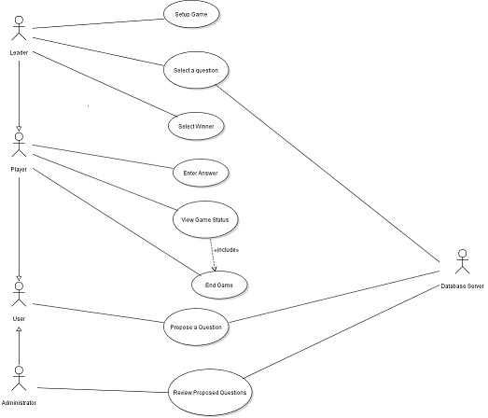

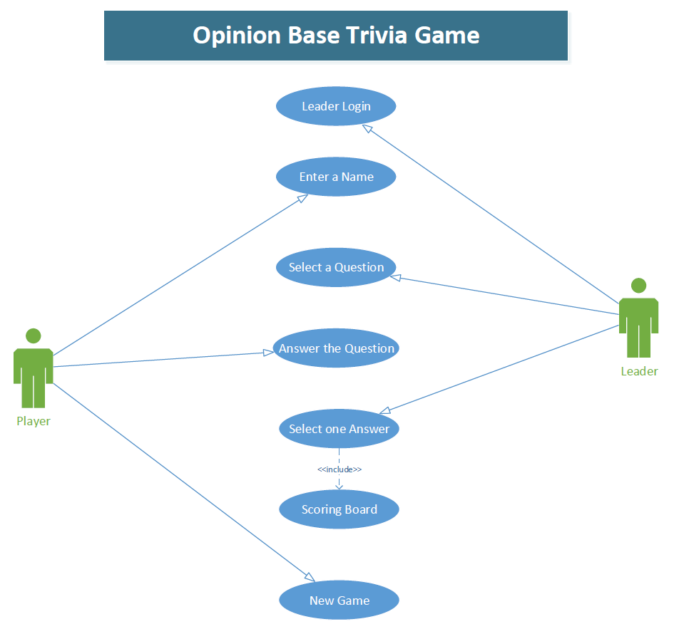

3.1 Setup Game (U1)
- U1
- Objective – A group of player initialize setting and enter names for a new game.
- Priority – High
- Source – Grieg Carson (party game player).
- Actors - Players
- Flow of Events
6.1 Basic Flow
6.1.1. Player selects game length, number of players, and chooses what subjects to draw questions from during the game.
6.1.2. The system takes the users selection and creates a new game.
6.1.3. Based on the number of players selected by the player/user, the system will prompt player to enter a name for each player, and store it
6.1.4 The system randomly selects one of the players as a leader.
6.1.5 The system selects the leader as the active player and is sent to begin round.
6.2 Alternative Flow 1 -- At step 6.1.3. A player’s name is not entered.
6.2.1 System prompts player to enter name.
6.2.1 Return to step 6.1.3.
6.4 Exception Flow(s) -- None
- Includes - None
- Preconditions – The player/group of players are ready to set up and begin playing a game.
- Post conditions – Player chose conditions of game, data is sent to begin round..
- Notes/Issues - Begin round must accept data as parameters

3.2 Selects a Question (U2)
- U2
- Objective – The Leader selects a question.
- Priority – High
- Source – Harry Potter (party game player).
- Actors - Leader
- Flow of Events
6.1 Basic Flow
6.1.1. Leader will select a question from a pre-defined list.
6.1.2. Leader confirms selection.
6.1.3. System posts the selected question to all players.
6.2 Alternative Flow 1 -- At step 6.1.1 the Leader fails to select a question within a designated time.
6.2.1 The system randomly selects a question for the Leader.
6.2.2 Return to step 6.1.2
6.3 Exception Flow(s) -- None
- Includes - None
- Preconditions – A game has been started.
- Post conditions – All the players know the question selected by the Leader.
- Notes/Issues - None

3.3 Enter answers (U3)
- U3
- Objective – Each player enters his answer to a question selected by the leader.
- Priority – High
- Source – Mary Sue Johnson (party game player).
- Actors - Players
- Flow of Events
6.1 Basic Flow
6.1.1. Players reads the lead player’s question.
6.1.2. A player selects his answer from a list provided by the system.
6.1.3. That same player confirms his answer.
6.1.4. Steps 6.1.2 and 6.1.3 is repeated for each additional player.
6.2 Alternative Flow 1 -- At step 6.1.2 a player fails to enter an answer.
6.2.1 Lead player enters in “no answer”.
6.2.1 Lead player confirms “no answer”.
6.2.1 Return to step 6.1.4.
6.3 Exception Flow(s) -- None
- Includes - None
- Preconditions – Lead player has selected a question.
- Post conditions – All the players answers to the lead players question has been answered.
- Notes/Issues - None

3.4 Select an answer/winner (U4)
- U4
- Objective – The leader of the round selects the answer he chooses to be the winning one from the answers the other users wrote.
- Priority – High
- Source – Mary Sue Johnson (party game player).
- Actors - Leader
- Flow of Events
6.1 Basic Flow
6.1.1. Each of the player’s answers are displayed on the screen simultaneously.
6.1.2. The leader selects the answer he chooses to be the winning one by clicking on it.
6.1.3. Points are awarded to the player that wrote that answer.
6.2 Alternative Flow-- None.
6.4 Exception Flow(s) -- None
- Includes - None
- Preconditions – The players have enter their answers.
- Post conditions – Points are awarded to the winning player of that round.
- Notes/Issues - None

3.5 View the game status (U5)
- U5
- Objective – The game updates players on the game’s current status.
- Priority – High
- Source – Tom Brady (party game player).
- Actors – Leader, Players
- Flow of Events
6.1 Basic Flow
6.1.1 System checks the game state.
6.1.2 Game state sent to player (if in networked mode).
6.1.3 Game displays status screen.
6.1.4 Status screen is updated based on game state.
6.1.5Status screen remains until closed by player.
6.1.6 If round is over, go to start of next round.
6.2 Alternative Flow-- None.
6.3 Exception Flow(s) -- None
- Includes - None
- Preconditions – Game is in progress, round is over or player selects view status option.
- Post conditions – Return to normal gameplay, proceed to next round if appropriate.
- Notes/Issues - None

3.6 Player proposes a question (U6)

- U6
- Objective – User creates a new question to be added to the database after system approval.
- Priority – Lower
- Source – Bob Hope (party game player)
- Actors – Player, Database Server
- Flow of Events
6.1 Basic Flow
    - Display question entry screen.
    - User selects question category.
    - User enters the question’s content.
    - User selects the submit option.
6.1.5 User verifies the question and selects the confirm option.
6.1.6. Question is added to appropriate unapproved database table.
6.2 Alternative Flow 1 –
6.2.1. Display question entry screen.
6.2.2. At any point, user selects the cancel option.
- Includes
  - None.
- Preconditions – User selects enter question option from main menu.
9. Post conditions – Entered question is in the database if not cancelled, user returned to main menu.
10. Notes/Issues - None

3.7 End the game (U7)

- U8
- Objective – The players decide to end the game.
- Priority – High
- Source – Jack Plack (party game player)
- Actors – Leader and Player
- Flow of Events
6.1 Basic Flow
    - At the beginning of the game, the players decide how many rounds they want.
    - At the end of the last round, the final scores are shown
    - The game ends automatically
6.2 Alternative Flow 1
6.2.1 At the beginning of the game, the players selected “unlimited rounds” option.
6.2.2 Players play until they want to stop.
6.2.3 Players confirm to stop game by selecting “end game” option.
6.2.4 Return to step 6.1.2.
- Includes –
  - U7 – End of game.
- Preconditions – At least one round of the game has to be played before deciding to end the game.
- Post conditions – The game is ended without keeping any of the player’s information.
- Notes/Issues - None

3.8 Review proposed questions (U8)

- U8
- Objective – The Administrator reviews a question proposed by a player. Then decides if question will be added the database of questions.
- Priority – Lower
- Source – Jerry Kippler (game manager)
- Actors – Administrator, game database
- Flow of Events
6.1 Basic Flow
    - Administrator retrieves proposed questions from the database.
    - Reviews a question.
    - Administrator decides the question does qualify.
    - Administrator enters qualify question, the proposing player’s name and date to the database.
6.1.5 Steps 6.1.2 through 6.1.4 is repeated for each proposed question.
6.2 Alternative Flow 1 – At step 6.1.3 Administrator decides the question does not qualify.
6.2.1. The proposed question is discarded.
6.2.2. Return to step 6.1.5.
6.3 Exception Flow 1 –
6.3.1 Database is locked due to backup in progress. System executes use case U5
- Includes
  - U5 – Exception occurs
- Preconditions – At least one player has entered a proposed question.
- Post conditions – Qualify proposed questions are entered in the database.
- Notes/Issues - None

Other Nonfunctional Requirements

Performance Requirements
See section 7 requirements 23-27

Safety Requirements

See section 7 requirements 25-32

Security Requirements
See section 7 requirements 35-42

Software Quality Attributes
See section 7 requirements 55-62

Other Requirements
<Define any other requirements not covered elsewhere in the SRS. This might include database requirements, internationalization requirements, legal requirements, reuse objectives for the project, and so on. Add any new sections that are pertinent to the project.>

None

System Requirements Chart

These requirements should match up with your use case description.
ID | Priority | Type  N= Functional  NF= Non  Functional | Source | Contained in Use Case(s) | Description
3.1.1 | High | F |  | U1 | The system shall require at least 3 players to function properly
3.1.2 | High | F |  | U1 | The system shall require user to make selection for number of players
3.1.3 | High | F |  | U1 | The system shall require user to make selection for game length
3.1.4 | High | F |  | U1 | The system shall require user to make selection for question subject matter
3.1.5 | High | F |  | U1 | The system shall require all players to enter a name
3.1.6 | High | F |  | U1 | The system shall store game and player information
3.1.7 | High | F |  | U1 | The system randomly selects one of the players as a leader.
3.2.1 | High | F |  | U2 | The system will provide a pre-defined list
3.2.2 | High | F |  | U2 | The system shall require the leader to select one question in a certain time period
3.2.3 | High | F |  | U2 | The system will post the selected question by the leader to the player(s) or select randomly one if overtime.
3.3.1 | High | F |  | U3 | The system will provided the player with a list to choose his answer from.
3.4.1 | High | F |  | U4 | The system shall require user to choose one answer between different answers displayed
3.4.2 | High | F |  | U4 | The system shall keep track of the points
3.5.1 | High | F |  | U5 | The system will track the current round number
3.5.2 | High | F |  | U5 | The system will track each player’s name and score
3.6.1 | Lower | F |  | U6 | The system will store proposed, unapproved questions and categories
3.6.2 | Lower | F |  | U6 | The system will store approved questions and categories
3.7.1 | High | F |  | U7 | The system will show the final scores
3.7..2 | High | F |  | U7 | The system has to provide an option to end the game
3.8.1 | High | F |  | U8 | The system shall require the administrator to decide if the question qualifies

Appendix A: Analysis Models
<Optionally, include any pertinent analysis models, such as data flow diagrams, class diagrams, state-transition diagrams, or entity-relationship diagrams.>

Don’t do any of these for CS421 SRS. You will create these models during the high level design deliverable.
Appendix B: To Be Determined List
<Collect a numbered list of the TBD (to be determined) references that remain in the SRS so they can be tracked to closure.>

List here any open questions or things you know still need to be done to the SRS, but haven’t been addressed yet. (It’s okay to have things like that, especially in this project because we don’t have time to do everything.)

