SendDataToClient ，SendRequestLocal和SendOperationLocal 的区别

enum{

ProtoTypeNotify=0, // 提醒通知

ProtoTypeProxy, // 代理模式

ProtoTypeRequest, // 请求资源

ProtoTypeOperation, // 操作请求

};

SendDataToClient ProtoHead->dwProtoType = ProtoTypeProxy

SendRequestLocal ProtoHead->dwProtoType = ProtoTypeRequest

SendOperationLocal ProtoHead->dwProtoType = ProtoTypeOperation

发送的数据 数据 头+ 数据包

LPINTER_PROTO_HEAD ProtoHead=(LPINTER_PROTO_HEAD)xBuffer;

ProtoHead->dwClientAddr=dwClientAddr; //客户端IP

ProtoHead->dwCommandId=dwCommandId; //命令ID

ProtoHead->dwDataLen=dwBufferLen; //数据包长度

ProtoHead->dwProtoType=dwProtoType; //发送消息类型

RtlCopyMemory(xBuffer+sizeof(INTER_PROTO_HEAD),Buffer,dwBufferLen );

// 与服务交互

//获取配置信息

SendRequestLocal(0, REQUEST_QUERY_SERVER_CONFIG);//请求获取配置信息

//接受的返回消息包

REQUEST_QUERY_SERVER_CONFIG,//查询服务器设置

typedef

struct _ServerSetConfigInfo

{

DWORD dwDataPort;

DWORD dwCommandPort;

WCHAR szClientPassword[21];

}ServerSetConfigInfo, *PServerSetConfigInfo;

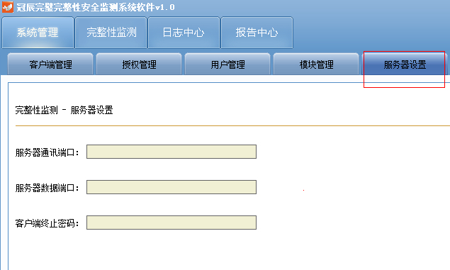

SendRequestLocal(0, REQUEST_CLIENT_IS_ONLINE, &ip, sizeof(ip));

REQUEST_CLIENT_IS_ONLINE,//查询客户端是否在线

typedef

struct _ClientIP

{

DWORD dwClientIP;

}ClientIP, *PClientIP;

//接受的返回数据包

typedef

struct _ClientConnStatus

{

DWORD dwClientIP;

DWORD dwIPStatus;

}ClientConnStatus, *PClientConnStatus;

//发送运行策略前，检测客户端是否在线

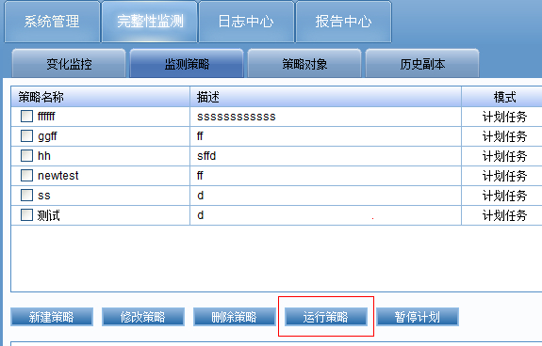

//获取客户端目录前 检测客户端是否在线

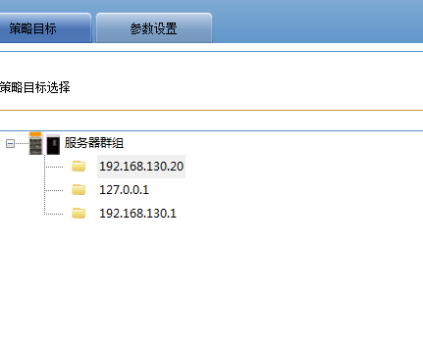

SendOperationLocal(0, OPERATION_SET_SERVER_CONFIG, &SConfig, sizeof(SConfig));

OPERATION_SET_SERVER_CONFIG,//更改服务器设置

typedef

struct _ServerSetConfigInfo

{

DWORD dwDataPort;

DWORD dwCommandPort;

WCHAR szClientPassword[21];

}ServerSetConfigInfo, *PServerSetConfigInfo;

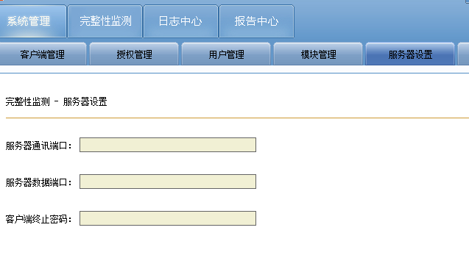

SendOperationLocal(0, SERVER_START_RESTORE, &copyinfo, sizeof(copyinfo));

SERVER_START_RESTORE,//开始还原

typedef

struct _CopyInfo

{

DWORD dwClientIP;//客户端IP

WCHAR szStrategyName[64];//策略名

WCHAR szCopyFilePath[MAX_PATH];

}CopyInfo, *PCopyInfo;

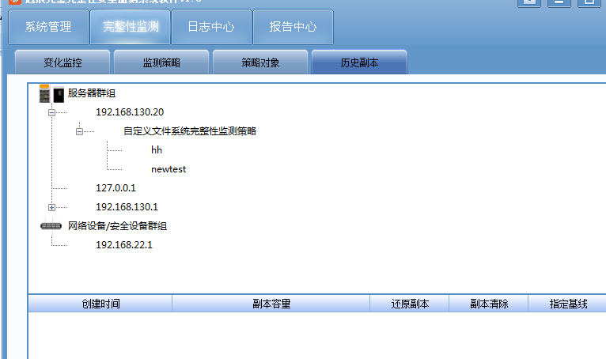

SendOperationLocal(0, OPERATION_CONNECT_CLIENT, &clientip, sizeof(clientip));

OPERATION_CONNECT_CLIENT,//连接客户端

typedef

struct _ClientIP

{

DWORD dwClientIP;

}ClientIP, *PClientIP;

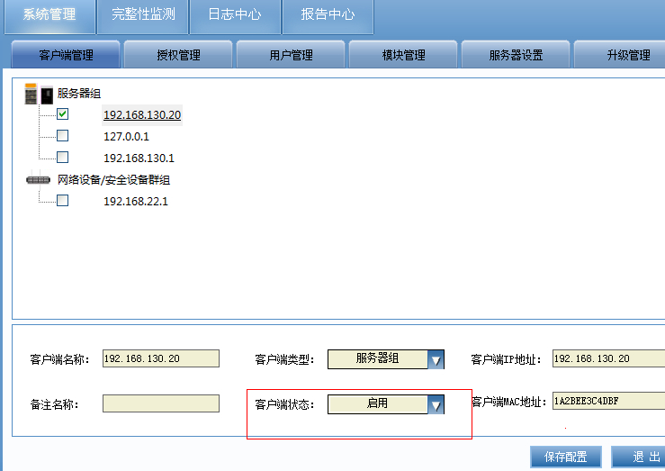

SendOperationLocal(0, OPERATION_DISCONNECT_CLIENT, &clientip, sizeof(clientip));

OPERATION_DISCONNECT_CLIENT,//断开客户端

typedef

struct _ClientIP

{

DWORD dwClientIP;

}ClientIP, *PClientIP;

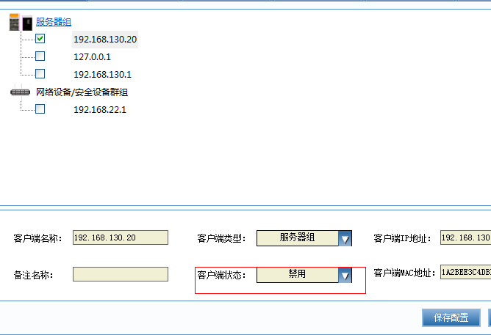

// 与客户端交互

// 公用

SendDataToClient(inet_addr(W2A(m_csIP.GetBuffer())), SERVER_LIST_DRIVE);

SERVER_LIST_DRIVE, //列出盘符

****没有数据包*****

//点击客户端IP 获取客户端盘符

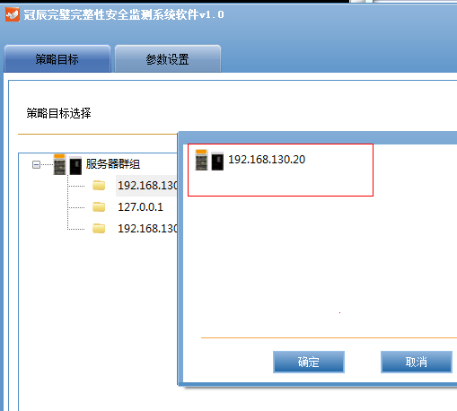

//客户端返回数据包

头文件 +数据包

//SendDataToClient(ProtoTypeProxy,dwCommandId,RemoteAddr,Buffer,dwBufferLen);

头文件的dwProtoType = ProtoTypeProxy

<DriverInfo>

<Item Dir="252" />

</DriverInfo>

SERVER_LIST_FILEDIRECTORY, //列出目录下所有文件和文件夹

SendDataToClient(0, SERVER_LIST_DIRECTORY, &dir, sizeof(dir));

****没有数据包*****

//客户端返回数据包

头文件 +数据包

头文件的dwProtoType = ProtoTypeProxy

//NAME 目录名

<FileDirInfo>

<Item Name="20130725" IsDir="1" />

<Item Name="360Downloads" IsDir="1" />

<Item Name="淘宝" IsDir="1" />

<Item Name="签名目录" IsDir="1" />

<Item Name="送检前程序" IsDir="1" />

</FileDirInfo>

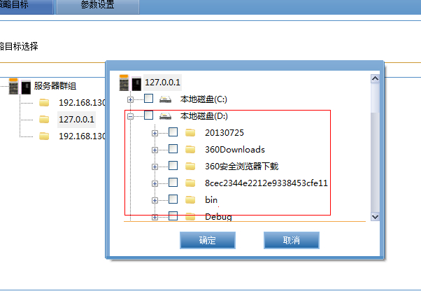

//因为之前的结构数据太大了，调整了服务的实现，策略消息统一用数据包统一用STRATEGY_BUFFERDATA

typedef struct _STRATEGY_BUFFERDATA

{

//策略名称

WCHAR StrategyName[64];

}STRATEGY_BUFFERDATA,*LPSTRATEGY_BUFFERDATA;

SendOperationLocal(0, SERVER_STRATEGYGUARD_ADD,&strategyBufferData,sizeof(STRATEGY_BUFFERDATA))

SERVER_STRATEGYGUARD_START, //运行策略

SERVER_STRATEGYGUARD_PAUSE, //暂停策略

SERVER_STRATEGYGUARD_STOP, //停止策略

SERVER_STRATEGYGUARD_ADD, //新增策略 （新加）

SERVER_STRATEGYGUARD_DELETE, //删除策略

SERVER_STRATEGYGUARD_MODIFY, //修改策略

