

**PREDICTIVE ANALYTICS PROJECT**

**REPORT on**

Personalized Fire Detection System

**Submitted By:**

|  |  |  |  |
| --- | --- | --- | --- |
| **S.No.** | **Name** | **Course** | **Sap ID** |
| 1. | Anusha Sharma | B.Tech-CSE-AIML-hons | 500108267 |
| 2. | Sujal Sinha | B.Tech-CSE-AIML-hons | 500108589 |
| 3. | Dhananjay Jaykumar | B.Tech-CSE-AIML-hons | 500108687 |

**Under the guidance of**

Prof. Achala Shakya

# 

**School of Computer Science**

University of Petroleum & Energy Studies, Dehradun

**Index**

| **Sr. No.** | **Contents** | **PageNo.** |
| --- | --- | --- |
| 1 | Project Title |  |
| 2 | Abstract |  |
| 3 | Introduction |  |
| 4 | Literature Review |  |
| 5 | Problem Statement |  |
| 6 | Objectives |  |
| 7 | Methodology |  |
| 8 | Implementation |  |
| 9 | Result |  |
| 10 | Conclusion and future scope |  |

# 1. Project Title

Fire Detection System Using Machine Learning Algorithms

# 2. Abstract

The Personalized Fire Detection System is an innovative machine learning-powered system designed to provide individuals with enhanced detection capabilities and resources to manage their mental wellbeing. Leveraging advanced natural language processing and machine learning algorithms, the assistant engages users in conversational interactions to assess their fire risk needs, identify patterns and triggers, and offer personalized recommendations for improvement. By integrating with wearable devices, environmental data sources, and other data sources, the assistant creates a comprehensive profile of each user's fire risk journey, enabling targeted interventions and timely support.

The ultimate goal of the Personalized Fire Detection System is to enable early fire detection to take control of their fire risk, reduce fire-related damage, and improve overall safety of life and property. By providing accessible, stigma-free support, the platform aims to bridge the gap between fire risk resources and those who need them most. With its user-centered design and evidence-based approach, the Personalized Fire Detection System has the potential to revolutionize the way we approach fire risk care, making it more effective, efficient, and compassionate.

The Fire Detection System is a machine learning-powered solution designed to identify fire risks using data collected from Wireless Sensor Networks (WSNs). By analyzing environmental parameters such as temperature, humidity, and gas concentrations, the system predicts fire occurrences with high accuracy. Utilizing advanced ML models, it ensures early detection, reducing potential damage and safeguarding life and property.

Key features include:

Real-time analysis of sensor data.

Accurate fire risk prediction using algorithms such as Random Forest, SVM, and Logistic Regression.

Deployment flexibility across forested and industrial areas.

The project demonstrates how machine learning can enhance traditional fire detection systems, making them smarter, faster, and more reliable.

# 3. Introduction

Fires are among the most destructive natural disasters, with significant environmental, economic, and societal consequences. Forest fires, in particular, destroy ecosystems, threaten wildlife, and pose risks to nearby communities.

Traditional fire detection methods, such as watchtowers and satellite imaging, are often too slow or limited in scope to mitigate fire damage effectively. The need for an advanced, scalable, and accurate fire detection system has led to the integration of Wireless Sensor Networks (WSNs) and Machine Learning (ML) technologies.

Wireless Sensor Networks are distributed systems capable of real-time environmental monitoring, while Machine Learning leverages data patterns to predict fire risks accurately. This combination empowers authorities to respond promptly and efficiently to potential fire threats.

**4. Problem statement**

# Early detection of fires is critical for minimizing damage. However, existing systems face limitations, such as:

# Delayed response times: Manual monitoring and satellite imaging often result in delayed detection.

# False alarms: Environmental factors like sunlight or human activities can trigger false positives.

# Limited scalability: Traditional systems cannot easily cover vast or remote areas.

# This project addresses these challenges by utilizing machine learning algorithms to process data from Wireless Sensor Networks, ensuring faster and more accurate fire detection.

# 5. Objectives

1. **Develop an Intelligent Detection System:** Use ML algorithms to analyze sensor data for fire detection.
2. **Minimize False Alarms:** Employ robust models to distinguish between fire indicators and false triggers.
3. **Real-time Monitoring:** Enable instant identification and reporting of fire risks.
4. **Deployability:** Ensure the system is scalable and adaptable to different environments, including forests and industrial zones.

.

# Methodology

**1. Data Collection**

* **Sources:** Temperature, humidity, CO, and CO2 levels gathered from WSNs.
* **Dataset:** Utilized forest fire datasets from the UCI Machine Learning Repository, containing 517 instances and 13 attributes.

**2. Preprocessing**

* Cleaned and normalized data to remove noise.
* Applied feature scaling to enhance model compatibility.
* Encoded categorical variables where necessary.

**3. Machine Learning Algorithms**

* **Logistic Regression:** Predicts fire risks based on linear relationships.
* **K-Nearest Neighbors (KNN):** Classifies data points based on similarity.
* **Support Vector Machines (SVM):** Creates hyperplanes for precise classification.
* **Decision Trees:** Splits data hierarchically for interpretable predictions.
* **Random Forest:** Combines multiple trees for higher accuracy.

# Implementation

**1. System Architecture**

* **Wireless Sensor Networks (WSNs):** Sensors are deployed in fire-prone areas to collect environmental data (e.g., temperature, humidity, CO, and CO2 levels).
* **Central Processing Unit (CPU):** Receives data from WSNs and processes it using Machine Learning models.
* **Decision-making Module:** Classifies input data into fire or no-fire events and sends alerts if necessary.

**2. Workflow**

* **Data Input:** Sensors collect environmental parameters.
* **Preprocessing:** Noise removal, scaling, and encoding to prepare data for ML algorithms.
* **ML Model Execution:** Data is fed into trained ML models for prediction.
* **Output:** Results are classified as "fire" or "no fire" with associated probabilities.
* **Alert Generation:** In case of fire detection, notifications are sent to relevant authorities.

**3. Algorithm Training and Testing**

* Data is split into **training (80%)** and **testing (20%)** subsets.
* Models are trained and evaluated using metrics such as **accuracy, precision, recall,** and **F1-score.**

# Results

**1. Accuracy Analysis**

Machine Learning algorithms were tested for their performance using the "Forest-fires.csv" dataset. Below are the results:

|  |  |  |  |
| --- | --- | --- | --- |
| Algorithm | Accuracy | Precision | Recall |
| Logistic Regression | 58.6% | 61.9% | 67.2% |
| KNN | 50% | 56% | 55% |
| SVM | 61% | 60% | 87% |
| Decision Tree | 52% | 57% | 58% |
| Random Forest | 55% | 61% | 51% |
| Naïve Bayes | 48% | 58% | 22% |

**2. Observations**

Random Forest and SVM showed the highest accuracy and robustness.

KNN and Logistic Regression performed well but are more sensitive to data noise.

Decision Trees are interpretable but prone to overfitting without pruning.

* 1. **Logistic regression**

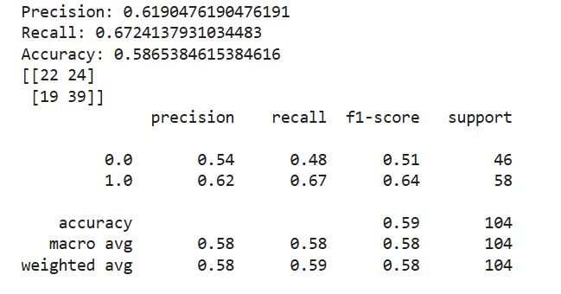

Prediction:

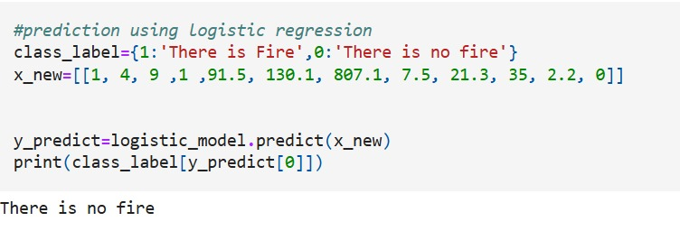

* 1. **KNN Classification**

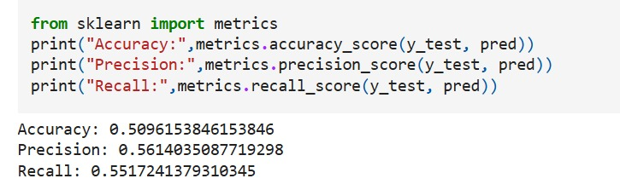

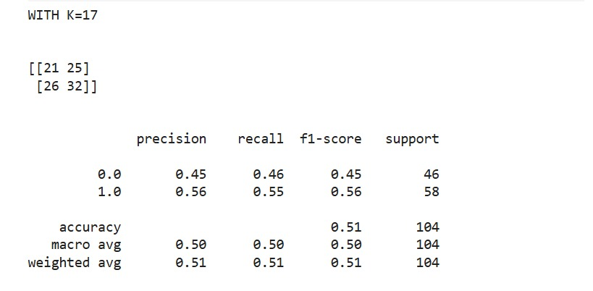



Prediction

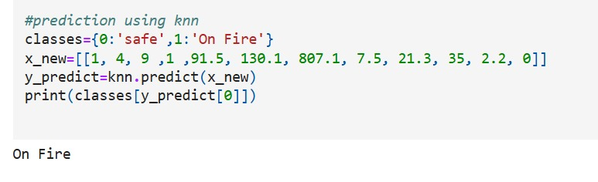

* 1. **Support vector machine**

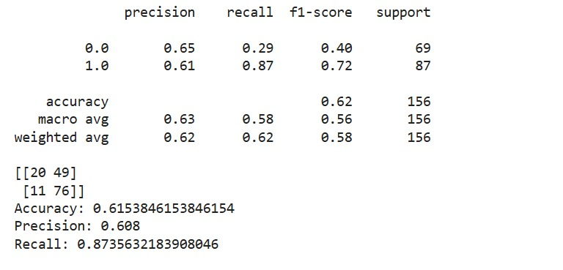

Prediction

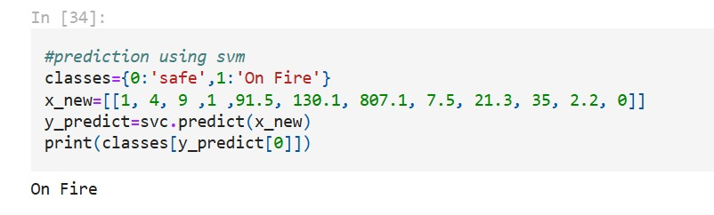

* 1. **Decision tree**

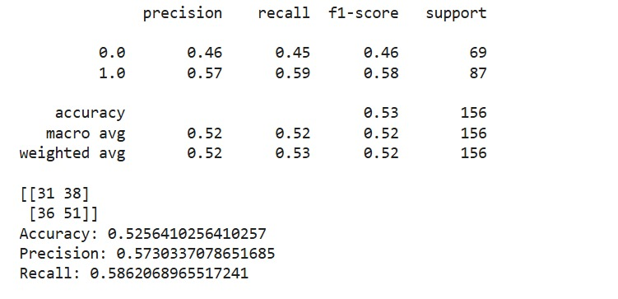

Prediction

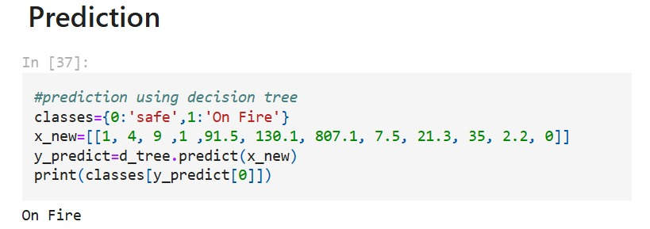

* 1. **Naïve Bayes**

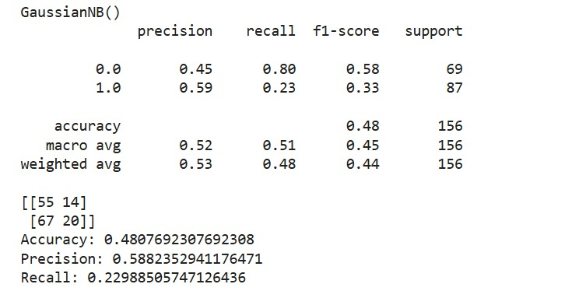

Prediction

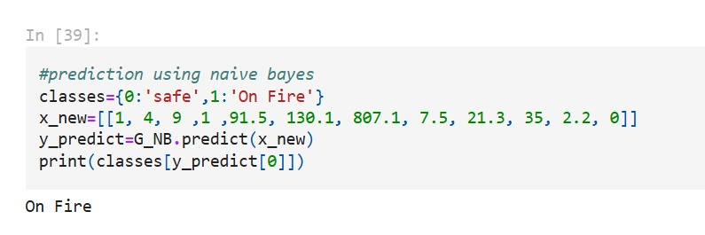

* 1. **Random forest**

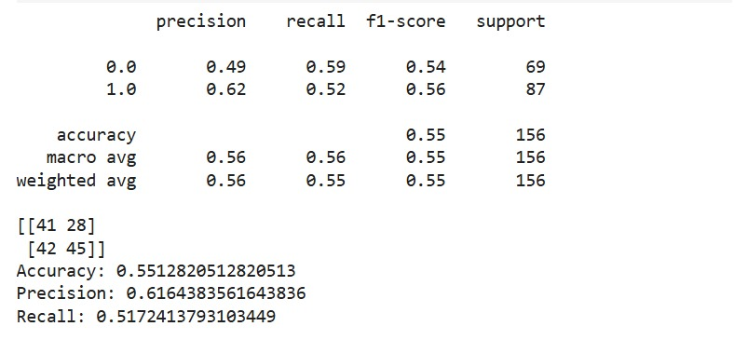

Prediction

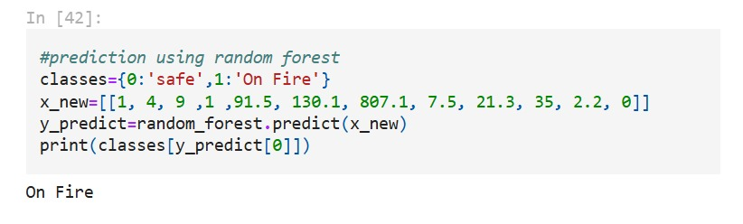

# Conclusion and future scope

Wireless sensor networks are helpful in detecting events. In the case of forest fire detection wireless network sensor nodes remove the difficulty faced in traditional methods like man standing on a tower and monitoring the environment. Now with the use of WSN we can put sensor nodes in each and every part of forest and mostly in the region where the risk is high. All the data collected by sensor nodes have to be aggregated to reach the result so it is done by using tree based and cluster-based methods.

The machine learning techniques add enhancement to the security of wireless sensor networks. With the use of machine learning techniques, the problem of faulty nodes is minimized. With the use of regression algorithm network lifetime is enhanced and with the use of decision tree algorithm network lifetime is enhanced as well as accuracy. SVM and neural network give better results.

**Future Scope**

We will be finding a method based on machine learning which will be

• Accurate in prediction

• Fault Tolerant

• Robust

and then finding its space and time complexity and will try to optimise it.