**3.1**

**#1**

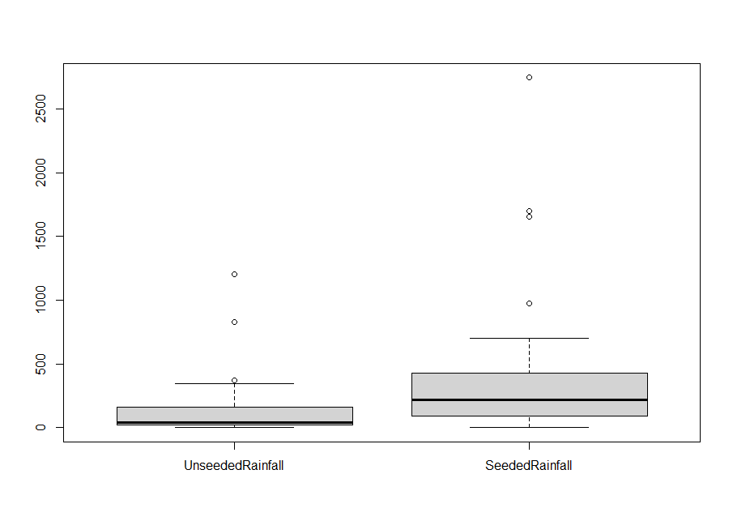

Most rainfall is lower than 500 for both unseeded rainfall and Seeded. However, the average value and the median of seeded rainfall are both higher than unseeded one.

**#2**

Since the two data set are not normally distributed, so I took log to them.

Then I run the t test for them.

t = -2.5456, df = 49.965, p-value = 0.01404

So it has an obvious effect on rainfall in this experiment.

The mean difference between them is 277.4

**3.2**

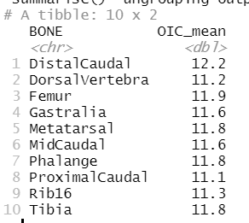

It looks like the means of OIC are nearly the same, ANOVA is need to test.

The result of ANOVA does not support that the Tyrannosaurus rex is warm-blooded, but look at the pairwise comparison, most of the pairs are not statistical different, even some are nearly the same.

So I think it’s because the amount of data is too small so that the ANOVA is not accurate enough.

Finally, I prefer it is warm-blooded

**3.3**

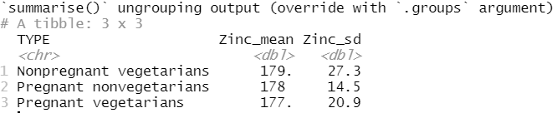

The means are nearly the same. Run the ANOVA test:

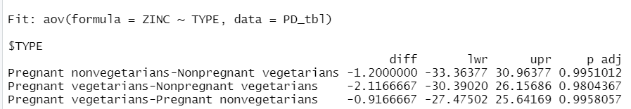

The p values are almost equal to 1, means there is not statistical difference between them. So, the theory is not true.

**3.4**

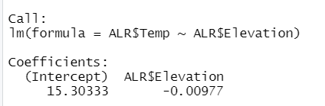

The slope of linear regression is -0.00977 degrees C m-1 , approximately equals to 9.8 degrees C km-1

So, they made it.

**3.5**

#1

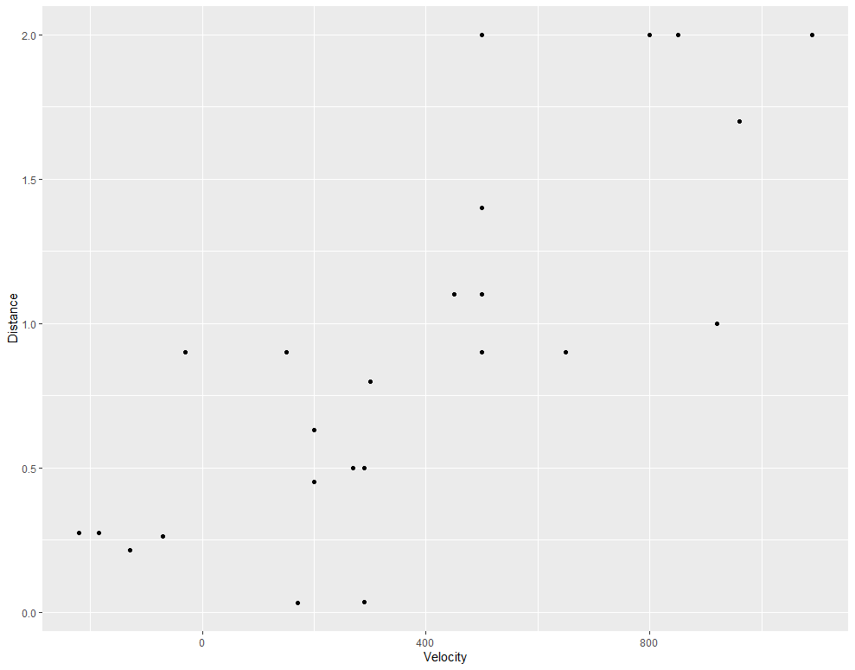

#2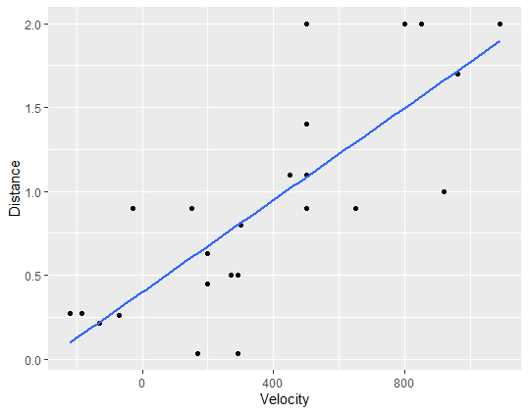

#3

Since the Big Bang is started at one point, the velocity should be 0 at the very beginning.

From the Big Bang, the Nebulas goes away as different velocity, time times the velocity is the distance, so the slope is the Universe age.

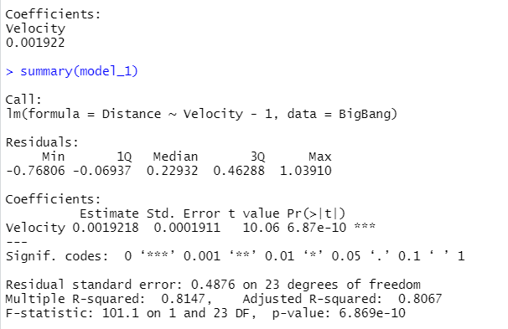

The age is 1.88*10e+10 years

#4

The data we got now is not precise enough, like there are 4 points has the same velocity, but the distance is not same, which make the regression lower or higher than the truth.

**3.6**

#1

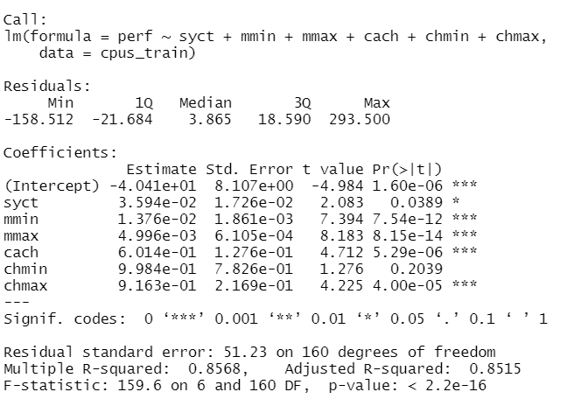

#2

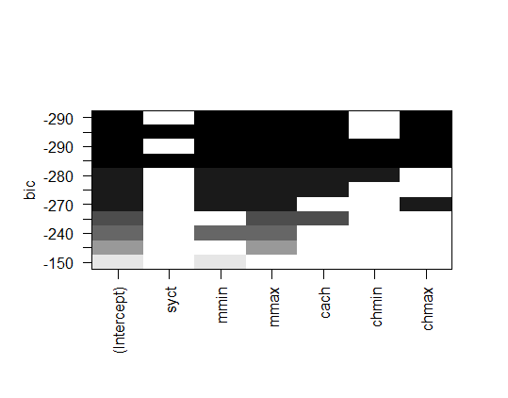

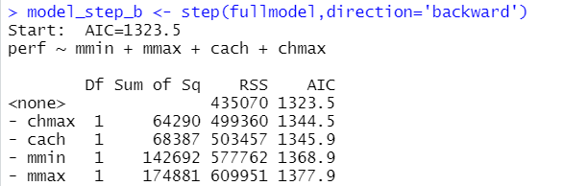

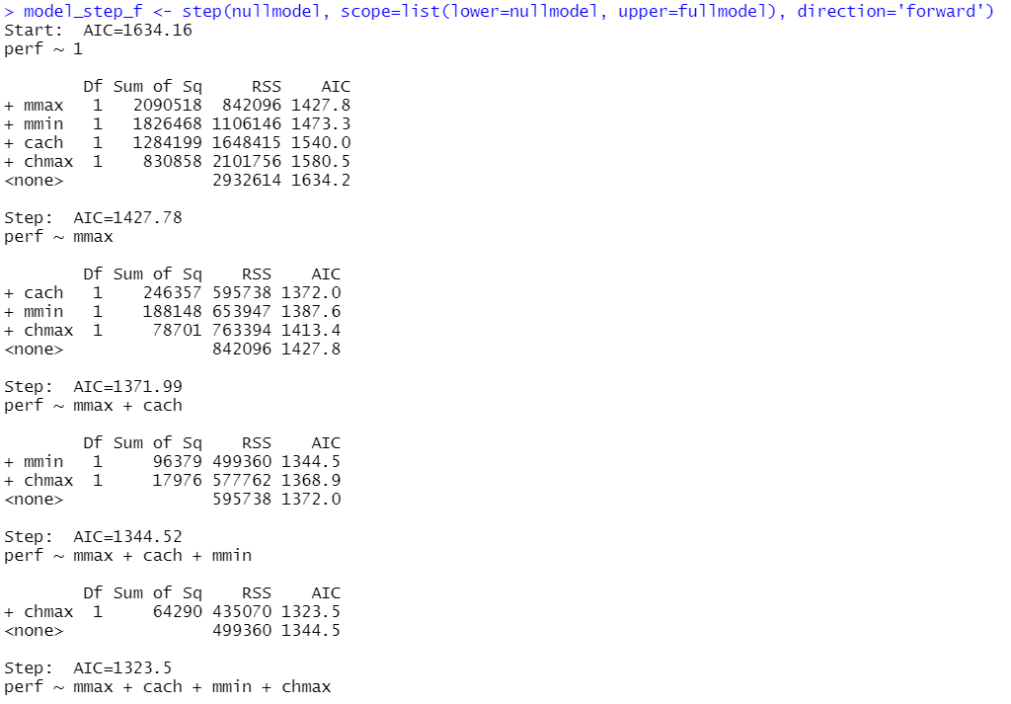

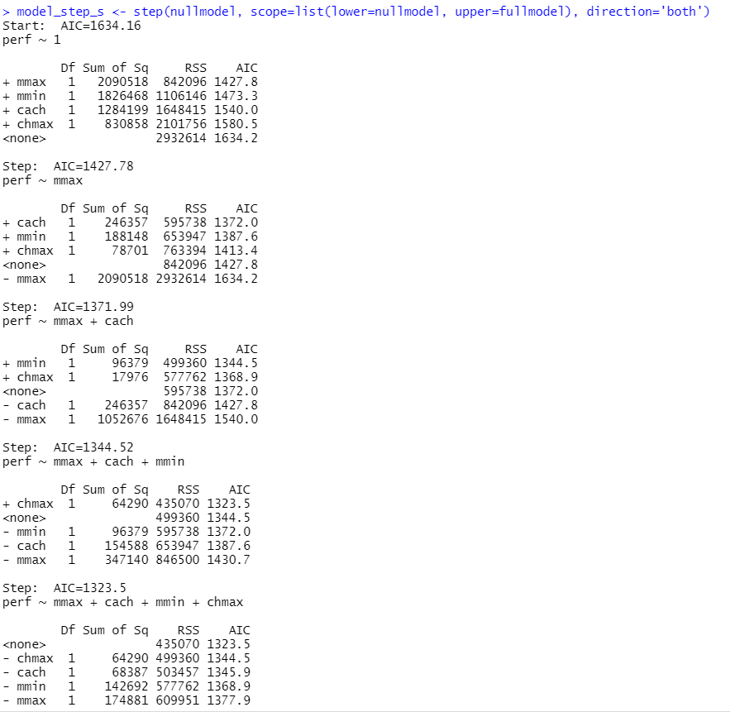

**3.7**