**5.1**

**#1 I read all the data, then take the average of them.**

**#2**

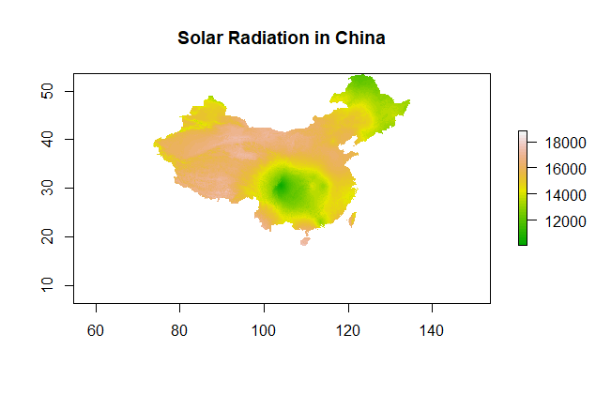

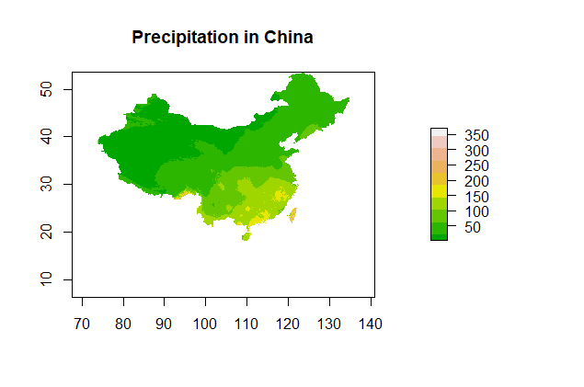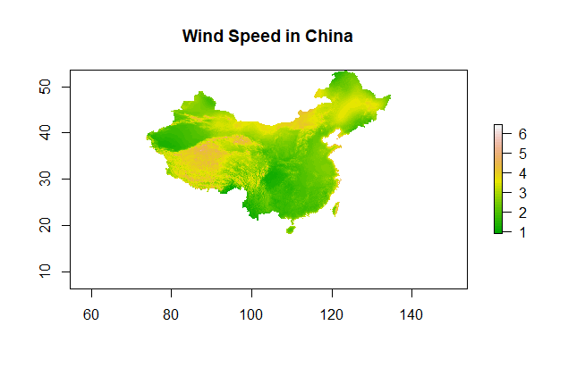

**#3 According to the Wind Speed in China, we can find out that the obvious divide value is around 3, so the threshold is 3.**

**My favorite spots is Inner Mongolia, since it’s near to the densely populated area.**

**#4 Xinjiang is the favorite of mine, because its solar radiation is pretty high while the precipitation is quite small.**

**5.2**

**#1**

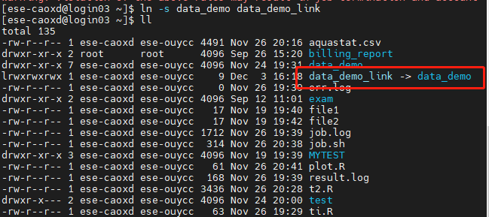

**#2**

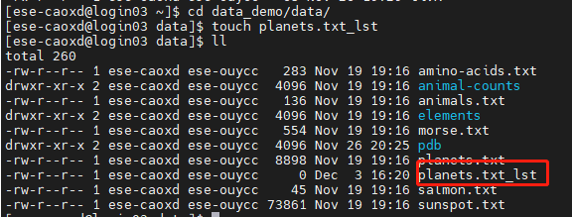

**#3**



**#4**



**#5**

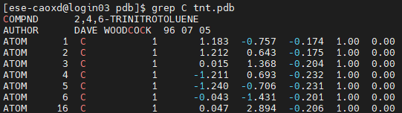

**#6**

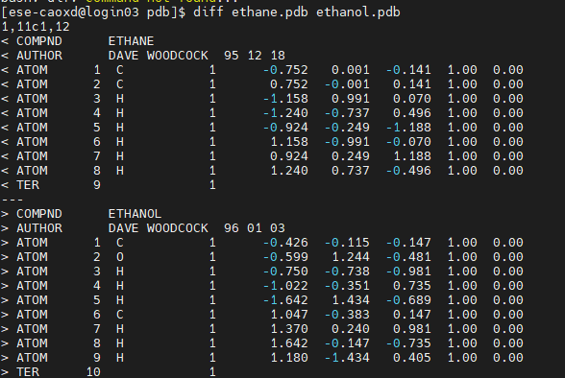

**#7**

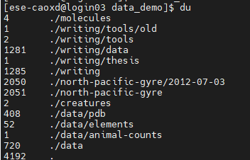

**#8**



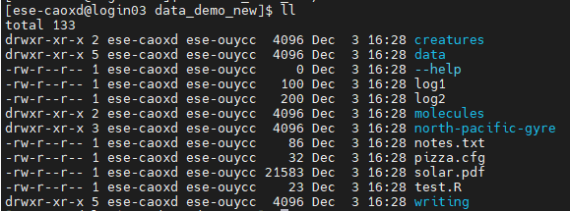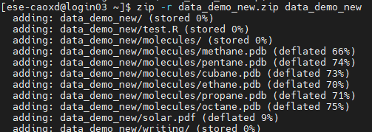

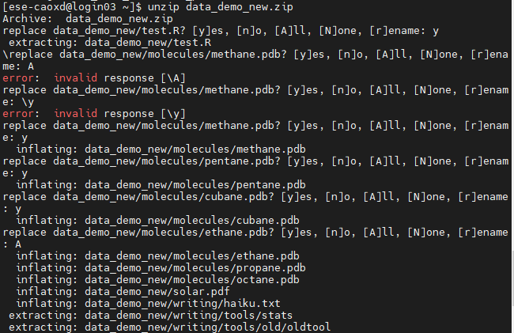

**#9**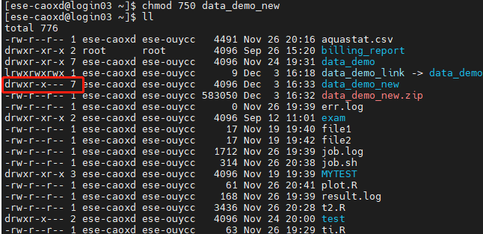

**#10**

