一、背景绪论

二、数据处理

1、数据预览

船舶图像：（19万张左右）

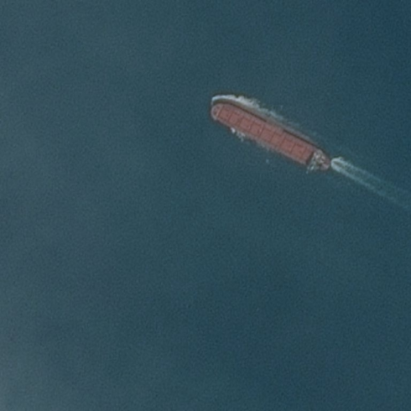

数据目标：（保存在csv表格中）

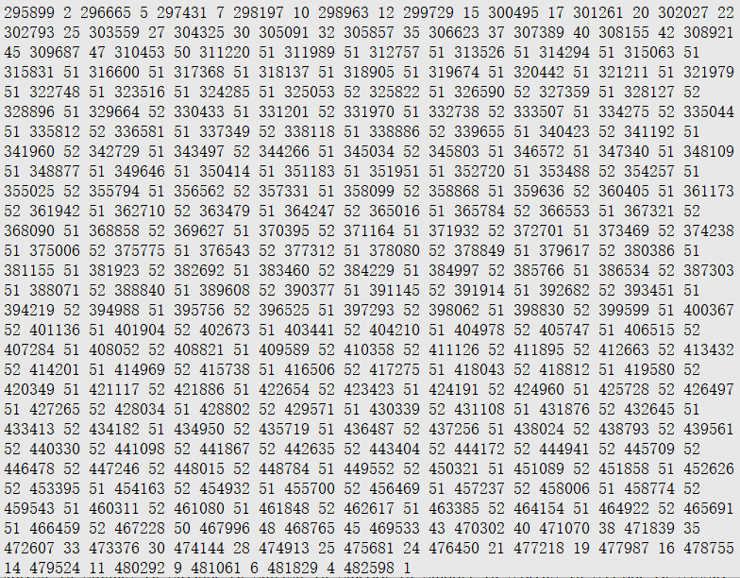

这是所得数据的rle编码，解码效果如下：

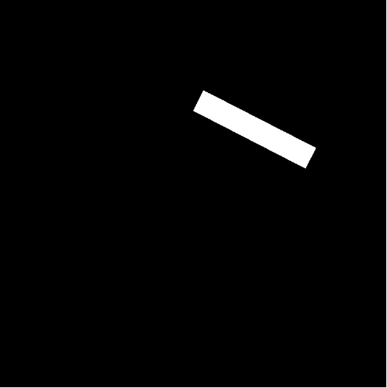

1. 数据解码

Rle编码（Run Length Encoding），它的原理是通过检测统计数据流中重复的位或字符序列，并用它们出现的次数和每次出现的个数形成新的代码。从而达到数据压缩的目的。

例如，“5 3 10 4”表示，目标所在位置包括：第5个像素点开始连续的3个像素点和第10个像素点开始连续的4个像素点。

Rle解码算法：

新建一张全0图像，对其修改对应的目标像素为1。

Rle解码代码如下：

|  |
| --- |
| **def** rle_to_array(img, rles):  l, w = img.shape[0], img.shape[1]  x = np.asarray(img).reshape((l, w, 3))  y = np.zeros(l * w, dtype=np.uint8)   **for** rle **in** rles.values:  **if** rle **is** np.nan:  **break** rle = rle.split(**' '**)  starts, lengths = [np.asarray(x, dtype=int) **for** x **in** (rle[0:][::2], rle[1:][::2])]  starts -= 1  ends = starts + lengths  **for** s, e **in** zip(starts, ends):  y[s:e] = 1   y = y.reshape((l, w)).T.reshape((l, w, 1))  **return** x, y |

1. 数据清洗

删除数据中的残缺图像、模糊图像、重复图像。

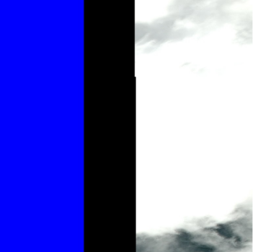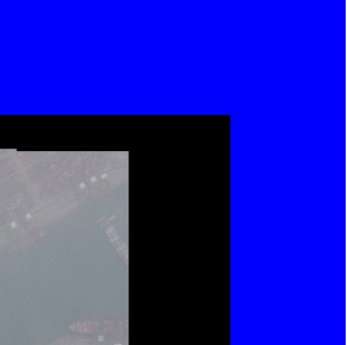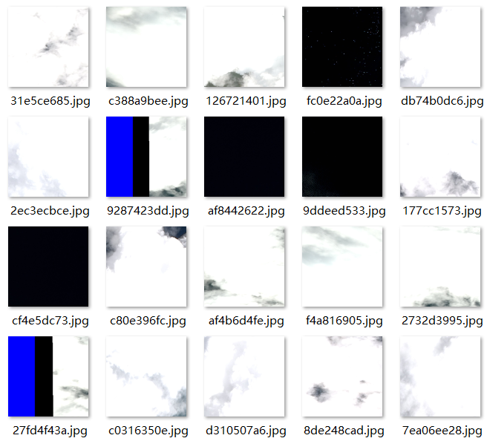

对粘连的小船舶数据，实行部分舍弃或合并。

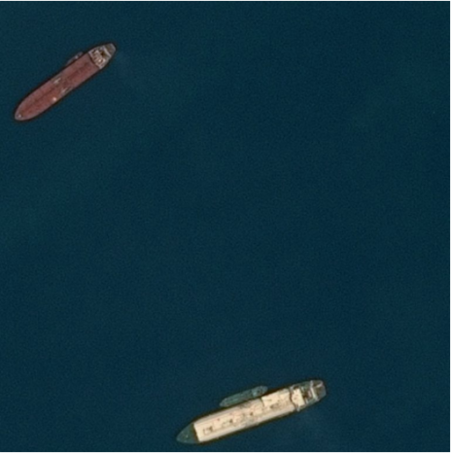

1. 数据平衡

由于图像中的船只数量并不固定，因此我们将其分类：

1. 、先按照有无船只分类

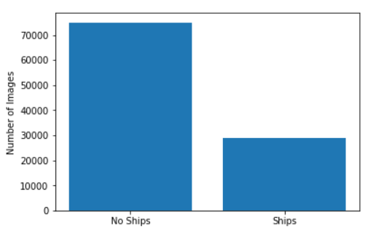

无船图像大概有15万张，有船图像大概有4万张。



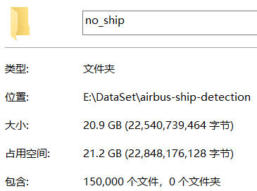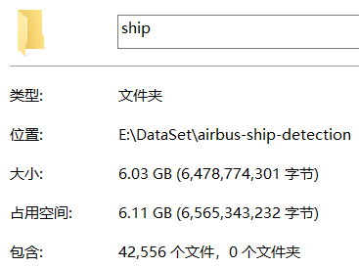

1. 、再根据船只数量分类

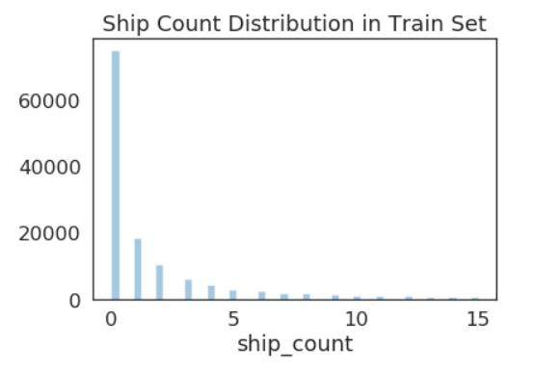

特点为：图像中船只数量越多，图像数量越少。

1. 、将不同船只数量的图像按比例结合

将每种图像都取出一部分放入预准备数据中，使各种数据比例大致相同，得到一个平衡的预准备数据。（无船图像数据中包含内容较少，不取）

1. 数据生成

由于原始数据是RGB图像数据，所占内存较大，为了防止内存溢出，制作一个数据生成器。

定义一个循环，不断地用随机数选择图像数据，选择后将目标数据进行解码处理得到L图像数据，最后将RGB图像和L图像抛出。

代码如下：

|  |
| --- |
| **def** generator(imgs, results, batch_size, seed=**None**):  **if** seed:  np.random.seed(seed)  ImageId, EncodedPixels = results[**"ImageId"**], results[**"EncodedPixels"**]  **while True**:  samples = np.random.choice(imgs, size=batch_size)  X, Y = [], []  **for** s **in** samples:  img = Image.open(img_path)  rles = EncodedPixels[ImageId == s]  x, y = rle_to_array(img, rles)  X.append(x)  Y.append(y)  X, Y = np.asarray(X) / 255, np.asarray(Y)  **yield** (X, Y) |

1. 数据增强

使用keras库的ImageDataGenerator，设置多种参数使图像进行各种变换而产生更多的数据。

常用参数设置：

Rotation_range：图像随即旋转的角度范围。

width_shift/height_shift：图像在水平或垂直方向上的平移范围。

Shear_range：随机错切变换的范围。

Zoom_range：图像随机缩放的范围。

Horizontal_flip：随机将一半图像水平翻转。

Fill_mode：用于填充新创建像素的方法。

例：

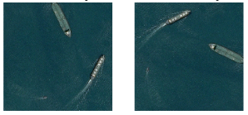

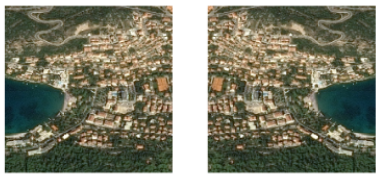

1. 模型建立
2. U-net简介

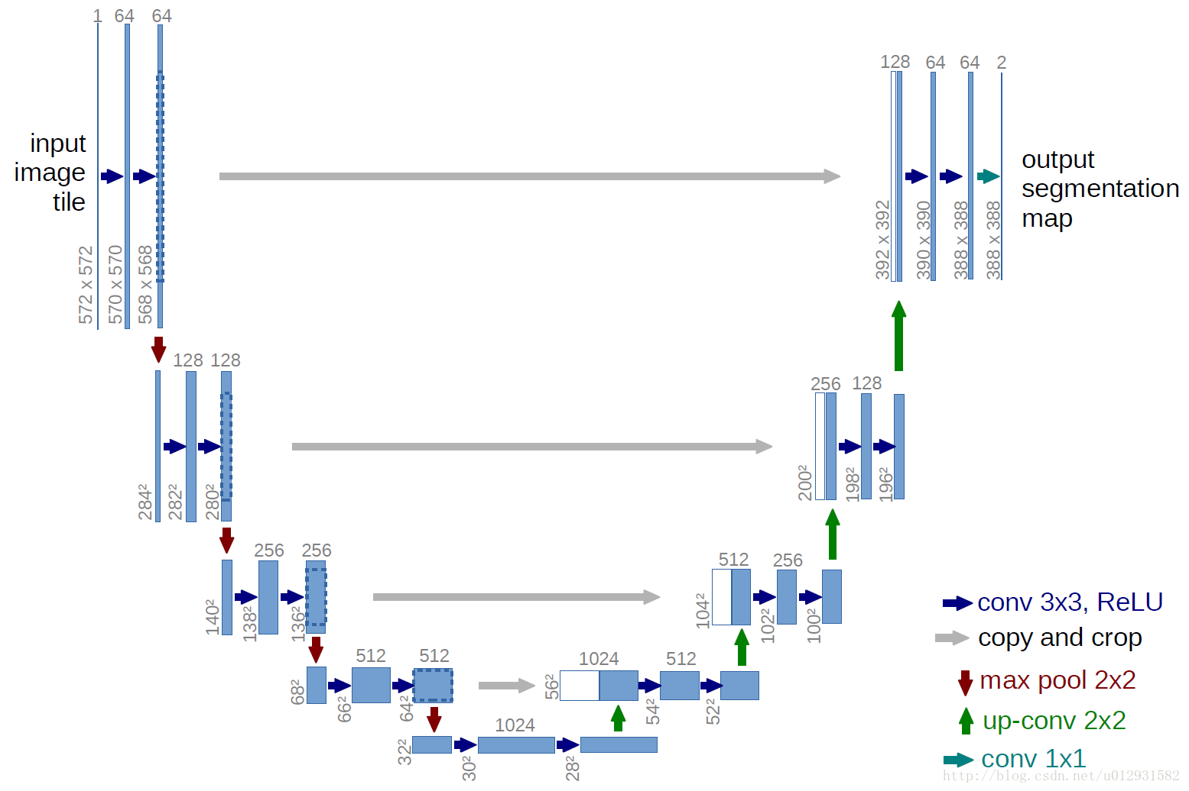

模型的结构十分的对称，左边为一系列连续地卷积池化，而右边则相反，为一系列连续地上采样卷积，而图中灰色箭头则是残差连接，将浅层特征与深层特征结合，避免了特征的损失，此模型因结构形似“U”形，而被称为U-net。

1. 模型搭建
2. 、卷积池化

|  |
| --- |
| c = Conv2D(8, (3, 3), activation=**'relu'**, padding=**'same'**)(x) c = Conv2D(8, (3, 3), activation=**'relu'**, padding=**'same'**)(c) p = MaxPooling2D((2, 2))(c) |

1. 、拼接+反卷积

|  |
| --- |
| c2 = Conv2DTranspose(8, (2, 2), strides=(2, 2), padding=**'same'**)(c) m = concatenate([c1, c2], axis=3) c = Conv2D(8, (3, 3), activation=**'relu'**, padding=**'same'**)(m) c = Conv2D(8, (3, 3), activation=**'relu'**, padding=**'same'**)(c) |

Conv2DTranspose可用UpSampling2D+Conv2D代替。

1. 、添加批标准化层

|  |
| --- |
| c = BatchNormalization()(c) |

统一分布，加强网络的泛化能力；

使用更高的学习率，加快训练速度；

充当Dropout，防止过拟合。

1. 、优化器与损失

optimizer使用Adam优化器，loss取(1-IoU)，IoU是预测图像与真实图像的重合率，IoU越大，loss越小。

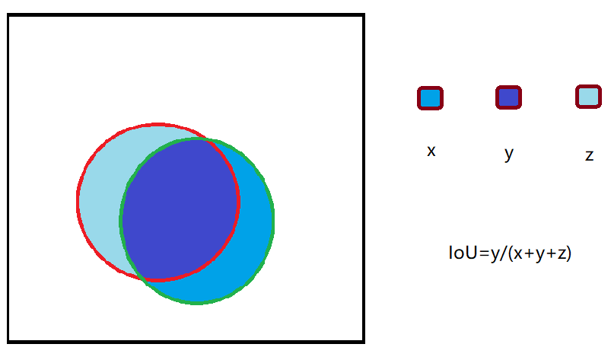

1. 、输入输出

|  |
| --- |
| input = Input((512, 512, 3))  output = Conv2D(1, (1, 1), activation=**'sigmoid'**)(c) |

输入RGB图像，输出01图像，实质是像素点矩阵。

1. 、模型结果

|  |
| --- |
| __________________________________________________________________________________________________  Layer (type) Output Shape Param # Connected to  ==================================================================================================  input_1 (InputLayer) (None, 512, 512, 3) 0  __________________________________________________________________________________________________  conv2d_1 (Conv2D) (None, 512, 512, 8) 224 input_1[0][0]  __________________________________________________________________________________________________  batch_normalization_1 (BatchNor (None, 512, 512, 8) 32 conv2d_1[0][0]  __________________________________________________________________________________________________  conv2d_2 (Conv2D) (None, 512, 512, 8) 584 batch_normalization_1[0][0]  __________________________________________________________________________________________________  batch_normalization_2 (BatchNor (None, 512, 512, 8) 32 conv2d_2[0][0]  __________________________________________________________________________________________________  max_pooling2d_1 (MaxPooling2D) (None, 256, 256, 8) 0 batch_normalization_2[0][0]  __________________________________________________________________________________________________  conv2d_3 (Conv2D) (None, 256, 256, 16) 1168 max_pooling2d_1[0][0]  __________________________________________________________________________________________________  batch_normalization_3 (BatchNor (None, 256, 256, 16) 64 conv2d_3[0][0]  __________________________________________________________________________________________________  conv2d_4 (Conv2D) (None, 256, 256, 16) 2320 batch_normalization_3[0][0]  __________________________________________________________________________________________________  batch_normalization_4 (BatchNor (None, 256, 256, 16) 64 conv2d_4[0][0]  __________________________________________________________________________________________________  max_pooling2d_2 (MaxPooling2D) (None, 128, 128, 16) 0 batch_normalization_4[0][0]  __________________________________________________________________________________________________  conv2d_5 (Conv2D) (None, 128, 128, 32) 4640 max_pooling2d_2[0][0]  __________________________________________________________________________________________________  batch_normalization_5 (BatchNor (None, 128, 128, 32) 128 conv2d_5[0][0]  __________________________________________________________________________________________________  conv2d_6 (Conv2D) (None, 128, 128, 32) 9248 batch_normalization_5[0][0]  __________________________________________________________________________________________________  batch_normalization_6 (BatchNor (None, 128, 128, 32) 128 conv2d_6[0][0]  __________________________________________________________________________________________________  max_pooling2d_3 (MaxPooling2D) (None, 64, 64, 32) 0 batch_normalization_6[0][0]  __________________________________________________________________________________________________  conv2d_7 (Conv2D) (None, 64, 64, 64) 18496 max_pooling2d_3[0][0]  __________________________________________________________________________________________________  batch_normalization_7 (BatchNor (None, 64, 64, 64) 256 conv2d_7[0][0]  __________________________________________________________________________________________________  conv2d_8 (Conv2D) (None, 64, 64, 64) 36928 batch_normalization_7[0][0]  __________________________________________________________________________________________________  batch_normalization_8 (BatchNor (None, 64, 64, 64) 256 conv2d_8[0][0]  __________________________________________________________________________________________________  max_pooling2d_4 (MaxPooling2D) (None, 32, 32, 64) 0 batch_normalization_8[0][0]  __________________________________________________________________________________________________  conv2d_9 (Conv2D) (None, 32, 32, 128) 73856 max_pooling2d_4[0][0]  __________________________________________________________________________________________________  batch_normalization_9 (BatchNor (None, 32, 32, 128) 512 conv2d_9[0][0]  __________________________________________________________________________________________________  conv2d_10 (Conv2D) (None, 32, 32, 128) 147584 batch_normalization_9[0][0]  __________________________________________________________________________________________________  batch_normalization_10 (BatchNo (None, 32, 32, 128) 512 conv2d_10[0][0]  __________________________________________________________________________________________________  conv2d_transpose_1 (Conv2DTrans (None, 64, 64, 64) 32832 batch_normalization_10[0][0]  __________________________________________________________________________________________________  concatenate_1 (Concatenate) (None, 64, 64, 128) 0 batch_normalization_8[0][0]  conv2d_transpose_1[0][0]  __________________________________________________________________________________________________  conv2d_11 (Conv2D) (None, 64, 64, 64) 73792 concatenate_1[0][0]  __________________________________________________________________________________________________  conv2d_12 (Conv2D) (None, 64, 64, 64) 36928 conv2d_11[0][0]  __________________________________________________________________________________________________  conv2d_transpose_2 (Conv2DTrans (None, 128, 128, 32) 8224 conv2d_12[0][0]  __________________________________________________________________________________________________  concatenate_2 (Concatenate) (None, 128, 128, 64) 0 batch_normalization_6[0][0]  conv2d_transpose_2[0][0]  __________________________________________________________________________________________________  conv2d_13 (Conv2D) (None, 128, 128, 32) 18464 concatenate_2[0][0]  __________________________________________________________________________________________________  conv2d_14 (Conv2D) (None, 128, 128, 32) 9248 conv2d_13[0][0]  __________________________________________________________________________________________________  conv2d_transpose_3 (Conv2DTrans (None, 256, 256, 16) 2064 conv2d_14[0][0]  __________________________________________________________________________________________________  concatenate_3 (Concatenate) (None, 256, 256, 32) 0 batch_normalization_4[0][0]  conv2d_transpose_3[0][0]  __________________________________________________________________________________________________  conv2d_15 (Conv2D) (None, 256, 256, 16) 4624 concatenate_3[0][0]  __________________________________________________________________________________________________  conv2d_16 (Conv2D) (None, 256, 256, 16) 2320 conv2d_15[0][0]  __________________________________________________________________________________________________  conv2d_transpose_4 (Conv2DTrans (None, 512, 512, 8) 520 conv2d_16[0][0]  __________________________________________________________________________________________________  concatenate_4 (Concatenate) (None, 512, 512, 16) 0 batch_normalization_2[0][0]  conv2d_transpose_4[0][0]  __________________________________________________________________________________________________  conv2d_17 (Conv2D) (None, 512, 512, 8) 1160 concatenate_4[0][0]  __________________________________________________________________________________________________  conv2d_18 (Conv2D) (None, 512, 512, 8) 584 conv2d_17[0][0]  __________________________________________________________________________________________________  conv2d_19 (Conv2D) (None, 512, 512, 1) 9 conv2d_18[0][0]  ================================================================================================== |

1. 参数调优

由于模型较为复杂，常用的GridSearch与RandomSearch需要耗费大量时间，所有我们打算手动调参。

主要参数：轮数初始为10，次数初始为32，个数初始为2。

1. 、选择轮数（对全部数据训练的轮数）

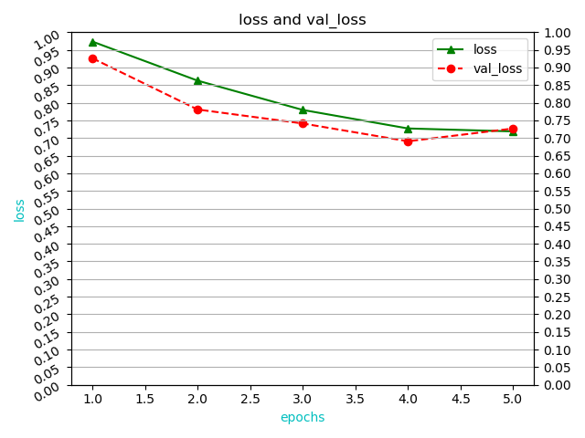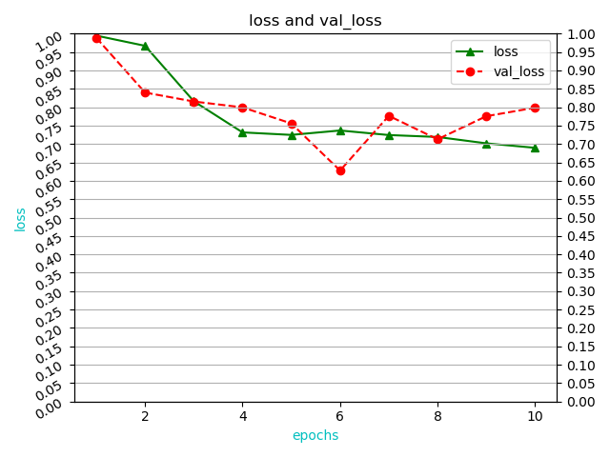

轮数：由loss图像所得，设置为5。

1. 、选择次数（一轮中训练的次数）

次数：次数=样本数/个数。

1. 、选择个数（一次训练的样本数）

个数：由于16张图片内存过大，而2张图片效果较差，所以设置为4。