WyStack Lesson Plan #2

Lesson Title: Circuits, Circuits, Circuits

Grade Band and Class: 7/8 STEAM

Duration: 7-8 class periods of 50 minutes each

Prior Knowledge: block coding skills

Overview: Students will work together in groups of 2-3 to build, debug, and run a variety of circuits both in TinkerCad and IRL on an Arduino and breadboard. Each assignment will be progressively harder and build on the knowledge of previous assignments. Students will receive game points (not related to the assignment grade) for completing the tasks first. Each project is worth more points than the last and the object is to have the most points at the end to win a prize (in this case, lunch at my expense). Each day, teacher will review circuit components and what we learned that works well.

Materials: Arduino Uno (or comparable), breadboard, LED’s, various sensors, wires, resistors, an incredible amount of coffee and patience, a TinkerCad teacher account and a class for students to join, a computer that can run the Arduino app for download.

Breakdown:

- Day 1- For the first day, students work individually to ensure that all participants can successfully build a simple circuit.
  - Begin by asking students what they know about circuits, e.g. positive and negative, completing a circuit, power and resistors.
  - Show students how to build a simple circuit on TinkerCad circuits. This circuit includes one LED that blinks and leaves out the resistor to make a point.
  - Show students how to code using blocks and how that translates to text. I use the block + text function in TinkerCad so that they can copy and paste the written code into Arduino.
  - Run the circuit virtually, show how the LED explodes so that we do not do this IRL. Then add the resistor to show how that works correctly.
  - Play with the code to show how to make the light blink with different durations and pauses. Talk about how the pin in the code must coincide with the pin you have chosen on the circuit.
  - Share this template and code to students using the activity function in TinkerCad Class. Students can make a copy of this and tinker it. Have students build a circuit in TinkerCad using 3 LED’s and make them light up individually and then all at once.
  - I made this a competition with the 5 points to the person who successfully completed the circuit first, 4 to the second and third places, and 3 points to all others who complete. This is distinct from the assignment points and counts toward a final prize.
- Day 2- Divide students into groups. Within groups, they decide who will debug the virtual model and code and who will build the IRL circuit.
  - Teacher shares assignment on Tinkercad with a virtual circuit including 3 LED’s, a RGB LED, and a sound buzzer. This model has errors related to the LED’s and code.
  - Students may use their resources (the example saved on TinkerCad from the previous class) to debug the virtual model and build circuit IRL. Both the virtual and IRL circuits must have the LED’s flash like a stoplight (green, yellow, red), sound the buzzer, and then make the RGB run red, white, blue (like a cop car).
  - The first team to successfully run the model both virtually and IRL receives 6 points, second and third receive 5 pts, all other teams receive 3 pts completion of both or partial points for some elements.
Assignment description example:
For this project, you must follow the instructions exactly.
- Decide who in your group will build the circuit IRL and who will build the circuit and code in TinkerCad and Arduino. You may consult, but not change roles.
- Go to TinkerCad and open the activities tab. Find the activity labeled Basic Circuits. This is a project you need to build and debug. Make a copy and start editing.
- The coding person will program the circuit to do EXACTLY these things in this order:
  - Flash the LED's in the order Green, Yellow, Red
  - Sound the buzzer for 3 seconds
  - Flash the RGB the colors Red, Blue, White
- The IRL builders must build the circuit to do the same. You then upload the code from TinkerCad to Arduino and run it on the real breadboard.
The first team to successfully build the whole project gets 6 points. All other teams get 3 points for the entire build, or 1 point for each successful portion. These points build to an in-class reward, not the actual grade.

HINTS-Look for errors with positive and negative wiring, wire placement, and PIN numbers. The RGB code portion is correct.

- Day 3-Divide students into groups. Within groups, they decide who will debug the virtual model and code and who will build the IRL circuit. You may switch or keep groups depending on how students work together. If a student is missing their partner they may opt to build alone or to assist me for points.
  - Teacher shares assignment on Tinkercad with a virtual circuit including ultrasonic sensor, RGB, and buzzer. This model has errors related to the LED’s and code. Students are using block code and seeing how it translates to text by using the block + text function in TinkerCad.

Assignment Description Example:
For this project, you must follow the instructions exactly.
- Decide who in your group will build the circuit IRL and who will build the circuit and code in TinkerCad and Arduino. You may consult, but not change roles.
- Go to TinkerCadd and open the activities tab. Find the activity labeled Sound the Alarm. This is a project you need to build and debug. Make a copy and start editing.
- The coding person will program the circuit to do EXACTLY these things in this order:
  - Set the ultrasonic sensor to read the distance of the object and print it to the serial monitor.
  - If the object is beyond 50 cm, the buzzer will not sound and the RGB can be blank or glow green.
  - If the object comes within 50 cm, sound the buzzer at 120 tone for 3 seconds and make the RGB glow yellow.
  - If the object comes within 25 cm, sound the buzzer at 60 tone for 3 seconds and make the RGB glow red.
  - The color and buzzer should change as the distance moves back and forth.
- The IRL builders must build the circuit to do the same. You then upload the code from TinkerCad to Arduino and run it on the real breadboard.
The first team to successfully build the whole project gets 8 points. All other teams get 4 points for the entire build, or 1 point for each successful portion. These points build to an in-class reward, not the actual grade.

HINTS-Look for errors with positive and negative wiring, wire placement, and PIN numbers. The Ultrasonic wiring and coding for the reading is correct. You may want to check the output to the buzzer and the RGB.
- Day 4- This day is different as the teacher introduces new sensors only. Students are given a picture of the circuit and the exact text code to copy and paste. There is still a virtual and IRL component, but no debugging as we are using new elements.
Assignment Description Example:
For this project, you must follow the instructions exactly.
- Decide who in your group will build the circuit IRL and who will build the circuit and code in TinkerCad and Arduino. You may consult, but not change roles.
- This assignment is different in that there is no template in Tinker Cad. You will build the circuit below in both TinkerCad and IRL. There is nothing wrong with the circuit, or with the code. Once it is done, you will copy the code below and run it on TinkerCad and IRL. Your group must do both to successfully complete the assignment.
Circuit:
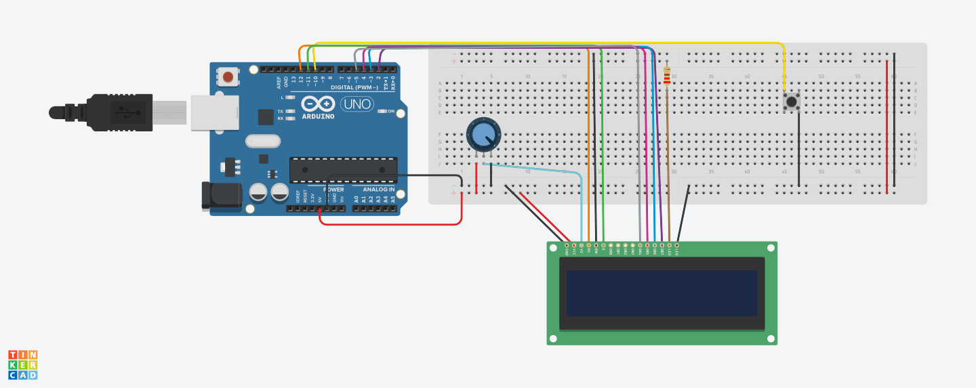
Code:
// C++ code
//
#include<LiquidCrystal.h>
int rs = 12;
int en = 11;
int d4 = 5;
int d5 = 4;
int d6 = 3;
int d7 = 2;
LiquidCrystal lcd(rs, en, d4, d5, d6, d7);
void setup()
{
pinMode(10, INPUT_PULLUP);
lcd.begin(16, 2);
}
void loop()
{
if(digitalRead(10)==LOW)
{
lcd.setCursor(0, 0);
lcd.print("Hello World");
lcd.setCursor(0, 1);
lcd.print("How are you?");
}
}
The first team to successfully build the whole project gets 10 points. All other teams get 5 points for the entire build, or 1 point for each successful portion. These points build to an in class reward, not the actual grade.
- Day 5-Final Build. Students can choose to either debug an existing template or create from scratch with pictures and the correct code. Teacher creates two different assignments in Canvas and assigned students based on their choice. This allows you to control who sees the assignment so there is no peeking!!!
Assignment Description Examples:
For this project, you must follow the instructions exactly.
- Decide who in your group will build the circuit IRL and who will build the circuit and code in TinkerCad and Arduino. You may consult, but not change roles.
- Go to TinkerCad and open the activities tab. Find the activity labeled Heating up. This is a project you need to build and debug. Make a copy and start editing.
- The coding person will program the circuit to do EXACTLY these things:
  - Set the light sensor to read the light range and print it to the serial monitor.
  - The brighter the light, the brighter the LED will glow.
  - Set the temperature sensor to read the temperature in Fahrenheit.
  - If the temperature goes over 70 F, set the RGB color to red. It is below 70, set it to blue or purple.
- The IRL builders must build the circuit to do the same. You then upload the code from TinkerCad to Arduino and run it on the real breadboard.
The first team to successfully build the whole project gets 12 points. All other teams get 6 points for the entire build, or 1 point for each successful portion. These points build to an in-class reward, not the actual grade.

HINTS-Look for errors with positive and negative wiring, wire placement, and PIN numbers. The sensor wiring and coding for the reading is correct. You may want to check the output pints to the LED and the RGB.

Second example:
For this project, you must follow the instructions exactly.
- Decide who in your group will build the circuit IRL and who will build the circuit and code in TinkerCad and Arduino. You may consult, but not change roles.
- This assignment is different in that there is no template in Tinker Cad. You will build the circuit below in both TinkerCad and IRL. There is nothing wrong with the circuit, or with the code. Once it is done, you will copy the code below and run it on TinkerCad and IRL. Your group must do both to successfully complete the assignment.
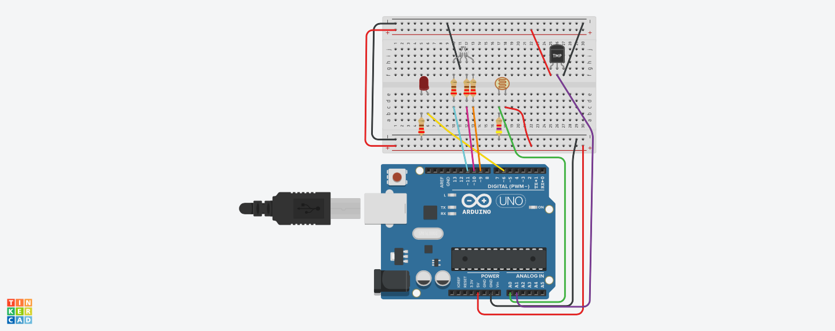
Code:
// C++ code
//
int sensorValue = 0;
int temperatureValue = 0;
void setup()
{
pinMode(A0, INPUT);
Serial.begin(9600);
pinMode(6, OUTPUT);
pinMode(A1, INPUT);
pinMode(11, OUTPUT);
pinMode(10, OUTPUT);
pinMode(9, OUTPUT);
}
void loop()
{
// read the value from the sensor
sensorValue = analogRead(A0);
// print the sensor reading so you know its range
Serial.println(sensorValue);
// map the sensor reading to a range for the LED
analogWrite(6, map(sensorValue, 0, 1023, 0, 255));
delay(100); // Wait for 100 millisecond(s)
// read the value from the sensor
temperatureValue = (-40 + 0.878679 * (analogRead(A1) - 20));
if (temperatureValue < 70) {
analogWrite(11, 51);
analogWrite(10, 204);
analogWrite(9, 0);
} else {
analogWrite(11, 255);
analogWrite(10, 0);
analogWrite(9, 0);
}
analogRead(A1);
}
The first team to successfully build the whole project gets 12 points. All other teams get 6 points for the entire build, or 1 point for each successful portion. These points build to an in class reward, not the actual grade.

