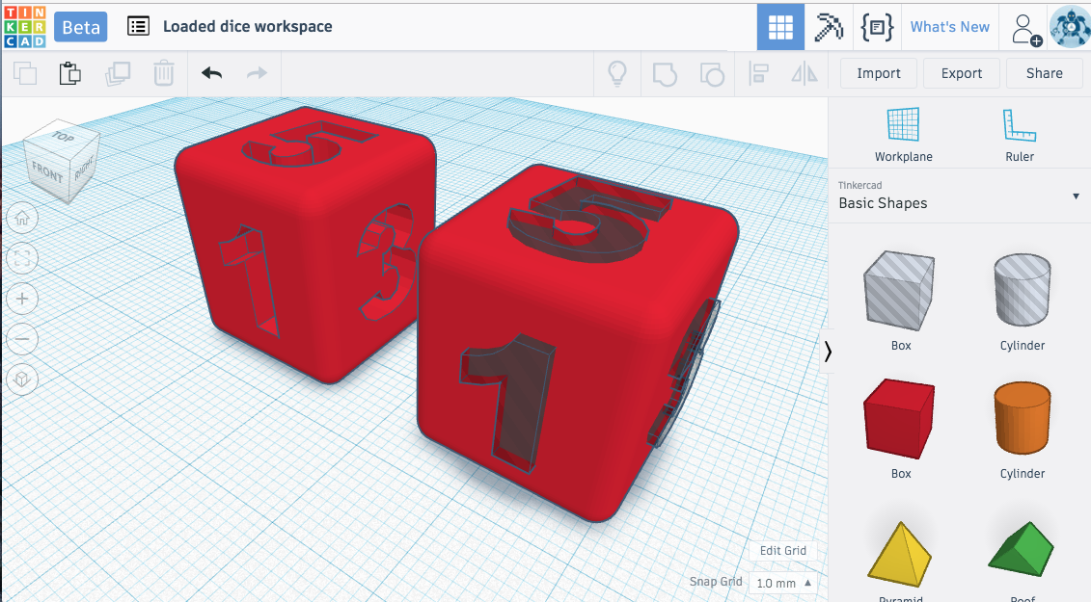
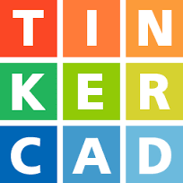
Introduction to 3D Design
& Print with TinkerCad
Pre-class activities: 12 minutes
Face-to-face presentation: 10 min
Face-to-face activities: 70 min

Activities & Instructions
- Introductory slides, or view the Recorded Presentation Video (if you are working through the workshop on your own)
- Keychain activity

Learning outcomes - using tinkercad
Participants will be able to do the following by the end of this workshop:
- Be able to add shapes and text to the TinkerCad workplace.
- Be able to move around by: Turning, Zooming, Panning, Reset view, Move, and Undo.
- Be able to resize and rotate objects using object sliders.
- Be able to extrude from objects, or make holes in them.
- Be able to bevel or round object edges.
- Be able to group objects together into one object.
- Know how to use the ruler and align tools.
- Be able to duplicate objects, including repeating patterns.
- Be able to a personalized keychain design by the end of the unit.
- Export to STL format for 3D printing.
- Find previously designed models they are interested in on Thingiverse and Sketchfab.

Learning outcomes - data analysis
Students will collect data on 3D printing times.
- Students will find the estimated print time and record it in a table.
- Students will record the actual print time and record it in the same table in a new column.
- Students will add an equation to determine the percent change between estimated and actual print time and record in new column.
- Students will add an equation and find the average between the percent change.
- Students will construct a graph and add relevant data and follow proper graph construction.

Learning Outcomes - 3D printing
- Students will make a 3D print.
- Students will look at ways to change 3D printing settings to:
  - Add strength
  - Reduce filament use
  - Reduce print time
- Students will understand supports

Step 1: Pre-Class Videos, Readings, & Exercises
25 minutes or less.
- [A, B] What is 3D printing and how does it work? (2 min) -
- Setup an account at http://tinkercad.com & follow along with at least the 2nd through 4th videos.
- [A, B, C, D] Introduction to TinkerCad (just watch, don’t try to follow along) (3 min) - https://www.youtube.com/watch?v=MwjWT-EvKSU
- [A, B] How to move around in TinkerCad (1 min) - https://www.youtube.com/watch?v=wa37nrj0pH0
- [C] Move objects & change the grid (2 min) - https://www.youtube.com/watch?v=Prpjk8dgf9I
- [C] Resize and Rotate objects (4 min) - https://www.youtube.com/watch?v=o-bGROLcrMg
- [F,H] Copy, Paste, and Group (3 min) - https://www.youtube.com/watch?v=rSjP0c7rLSU
- [G] Align and Flip (2 min) - https://www.youtube.com/watch?v=rgnvNXCh-mw

Step 2: Pre-Lab Questions
- Can you produce a dimensionally accurate key chain through tinkercad? What are issues that you anticipate can be found in the project? How do you anticipate correcting them?
- What data points are needed to construct a graph? Where does each variable need to go on the x y coordinate plane? What do you anticipate your data will show?
- What material is important to share in your conclusions? Why do we share our findings?

Step 3: In-Class Active Learning Activities & Instruction
- Design & Print Tips: http://bit.ly/2Vwp4Vb
- Keychain activity: http://bit.ly/2ZDgT6M
- Importing & Modifying STL files in TinkerCad: https://bit.ly/3a27MU5

Step 4: Post-Lab Assessment & Course Feedback
- Can you produce a dimensionally accurate key chain through tinkercad? Post a screenshot of your design and post a picture of your final project. If there are errors, describe how you would fix them.
- What data points do you need to construct a graph from estimated print time and actual print time? What does your data show or what do you think it should show?
- What material do you think is important to share in your conclusions? What specifically would you share about these findings and why is it important?

