Lesson Plan – Plotting Data
Computer Programming - Python
Instructor: John Lupher

Learning Target: Students will plot the data collected from their drone flight using the Matplotlib library.

Success Criteria:
SC #1: I can read a csv file with Python.
SC #2: I can use the Pandas library to read the data into a dataframe.
SC #3: I can plot data from the dataframes using Matplotlib.

Materials: Computers with Python, Pandas, Matplotlib and CoDrone installed; CoDrone Lite drones with blue tooth adapters.

Lesson Plan:

Introduction (5 minutes)

Explain purpose of lesson: Today we will be learning about reading csv data files into dataframes with Pandas and plotting the data using Matplotlib in Python.

Present learning target and success criteria: The learning target is for students to be able to explain and utilize a file reading techniques and plotting data in Python. The success criteria is for Students to determine how to read data using pandas read_csv method file and determine how to assemble and plot the data from a dataframes.

Guided Practice (15 minutes)

Explain the purpose of reading data from files: CSV files can be read using pandas read_csv method. Using this method you can easily use the dataframes created to plot the data. For today’s exercise we will be using the recorded flight time for the x-axis of our line charts.

Explain how to read files and plot data:
- Demonstrate how pandas read_csv() works.
- Demonstrate how to view dataframes
- Demonstrate how to plot data from dataframes

Demonstrate example: Read CSV files with sample data and plot the data in Python on the classroom large format monitors.
In this lab you will be using the Matplotlib library to plot data for your drone.

To import the Matplotlib module:
import matplotlib.pyplot as plt

To import pandas:
import pandas as pd

Read the file into a dataframe:
df = pd.read_csv("dronedata.csv")

Print the dataframe:
print(df)

To plot columns of data from the dataframe:
plt.plot(df['Time')],df['Battery'])
plt.title("Drone Battery Data -Student Name")
plt.xlabel("Flight Time")
plt.ylabel("Voltage")
plt.show()

Results:
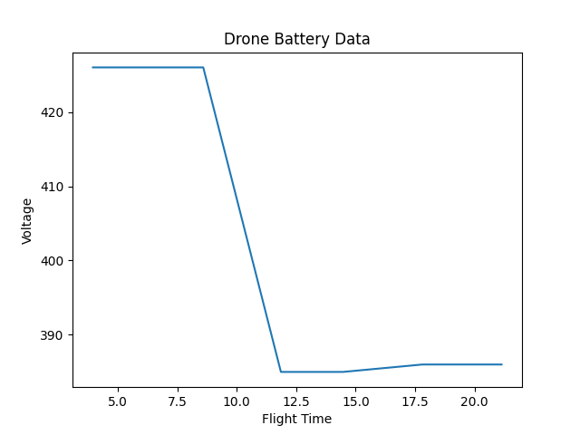

Have students work in pairs to complete exercises: Provide students with exercises to complete and have them work in pairs to practice writing data to files on their computer.

Independent Practice (15 minutes)

Assign exercises for students to complete:

Have your drone complete a mission

Collect the data from the drone

Create a program in Python called DronePlot.py. Make sure to put your name in the title of the chart.

Create a plot of your battery voltage over time.

Save the image as a pdf file called battery.pdf

Create a plot of your flight height over time.

Save the image as a pdf file called height.pdf

Create a plot of your flight Air Pressure over time.

Save the image as pdf file called pressure.pdf

Submit all three charts and your code to this assignment.

Good Luck Pilots!

Conclusion (5 minutes)

Review material: Review the material taught in the lesson.

Check for understanding: (3-2-1 Google Form)

Record 3 things you learned during this lesson.

Record two things you found interesting and would like to know more about.

Record 1 question you still have about the material.

