Joslin/DeFreece Final Project Report
Education:
For this project, students participated in 2 separate lessons. In the first lesson, students engaged with a guest speaker about traffic light programming. Students asked and answered questions and did a light simulation.
For the second lesson, students tried 2 different ways to create a traffic light simulator. Students then had to troubleshoot errors in their coding and set up. Students played around with different timings. For this level, students copied the prewritten code and changed the timings as part of the finite machine. Some kids loved this and others didn’t. It was observed that those students who couldn’t get the code got frustrated and didn’t want to continue. We also had students who were slower looking at the video on their own pace. Overall, students were engaged and worked hard during the lesson.
Overall, we enjoyed teaching a successful and impactful project that not only benefited our students, but also contributed to the improvement of our community's traffic infrastructure.
Education Pictures:
Lesson 1:
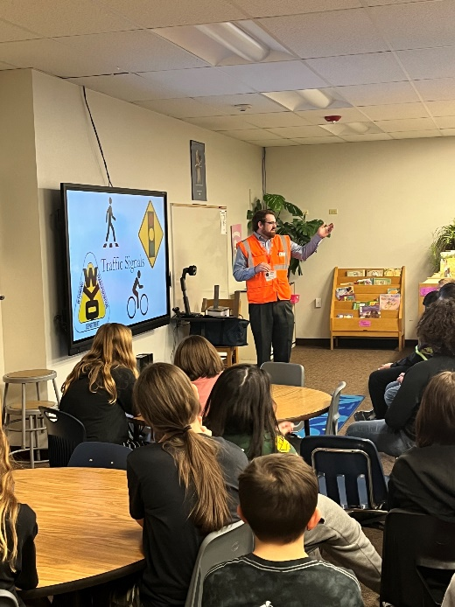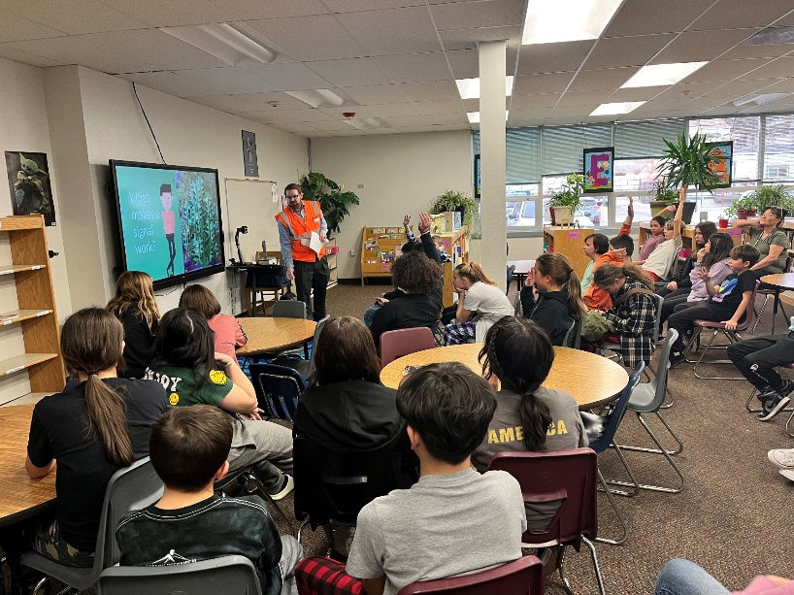
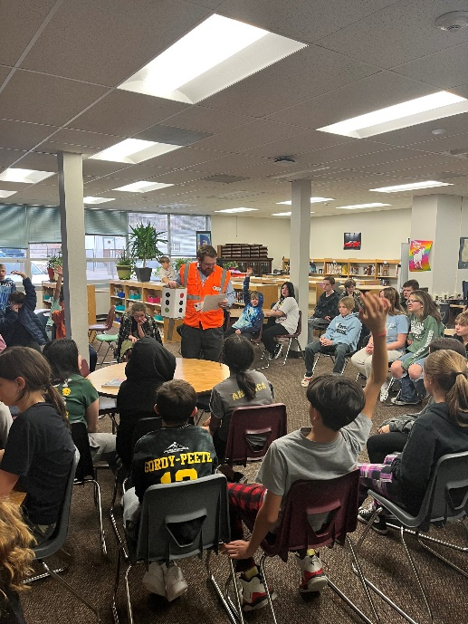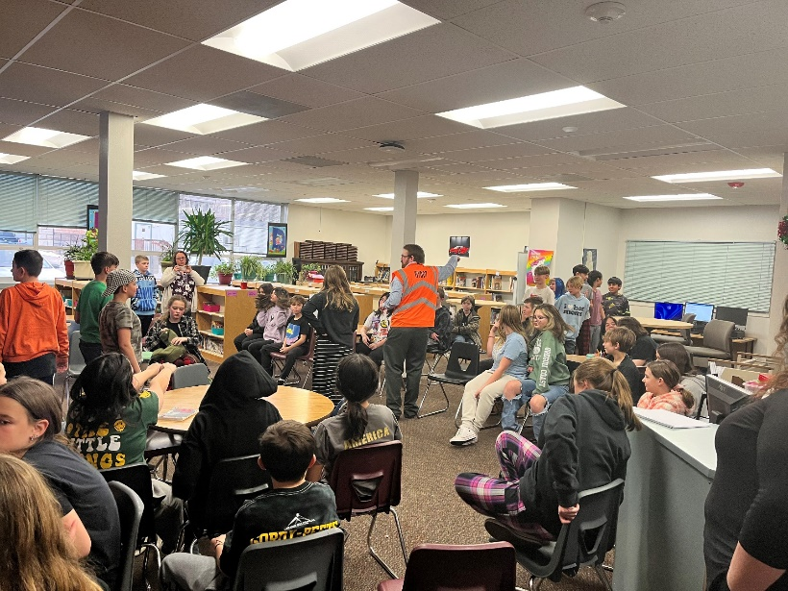
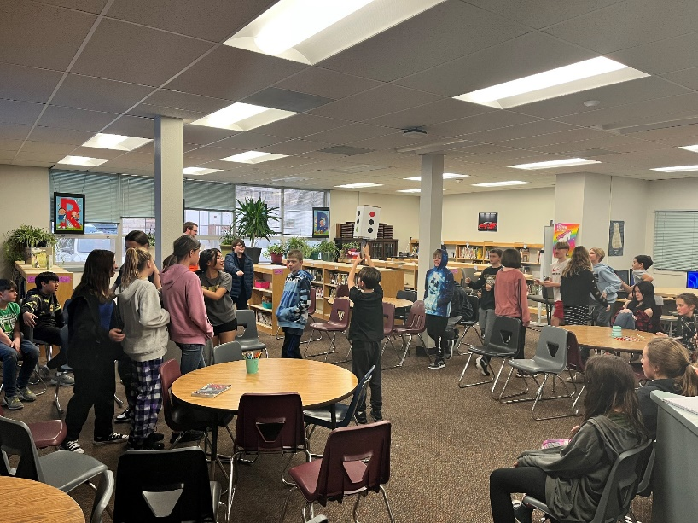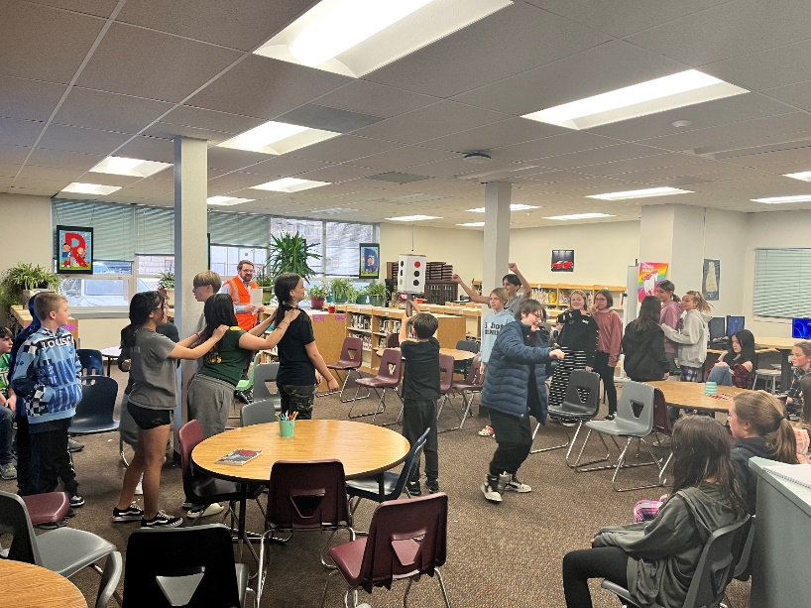

Lesson 2:
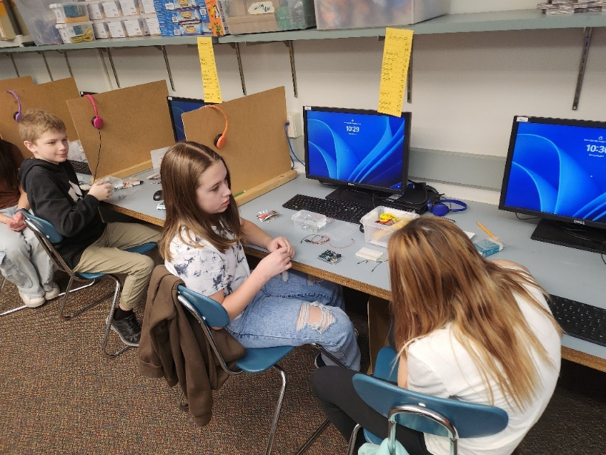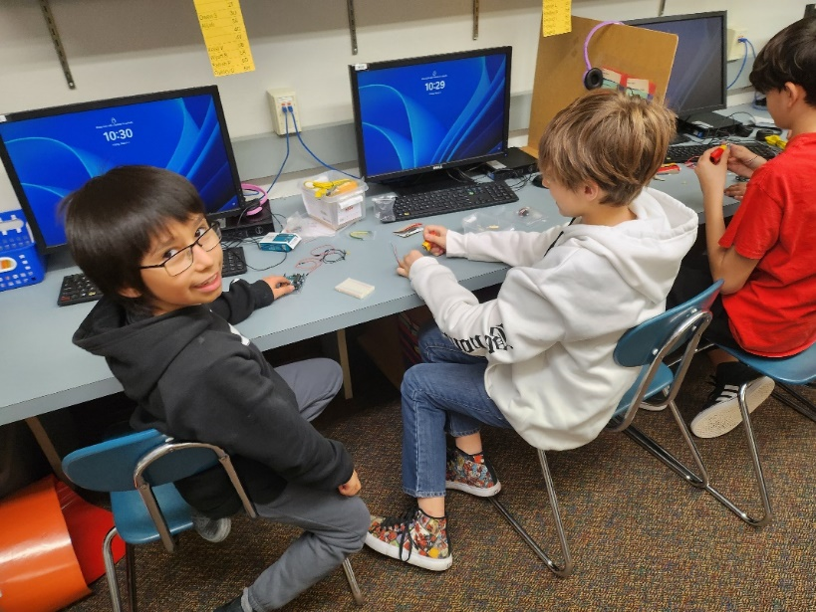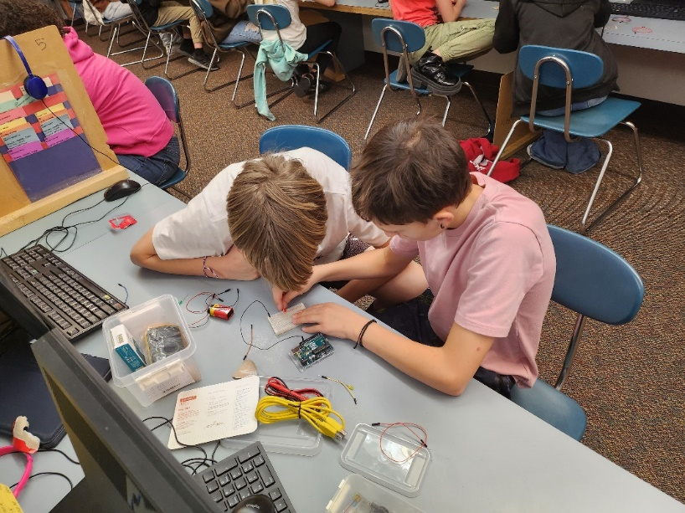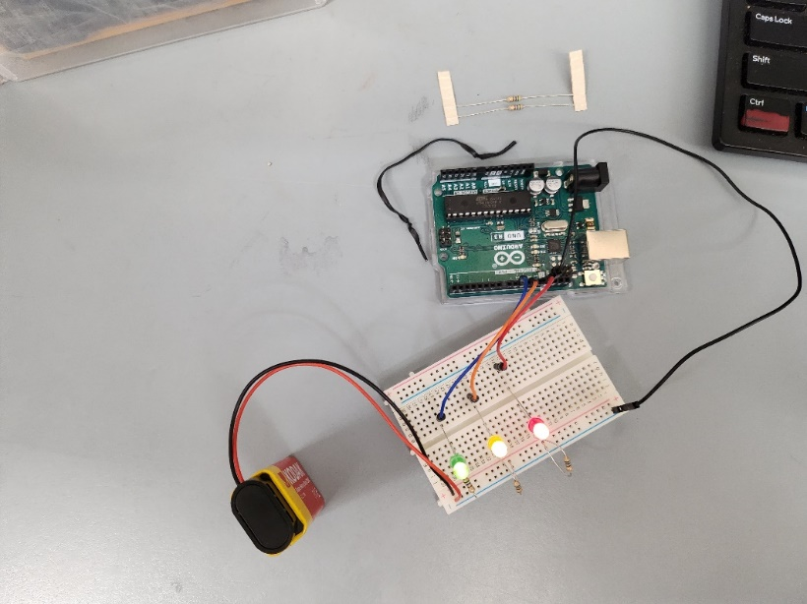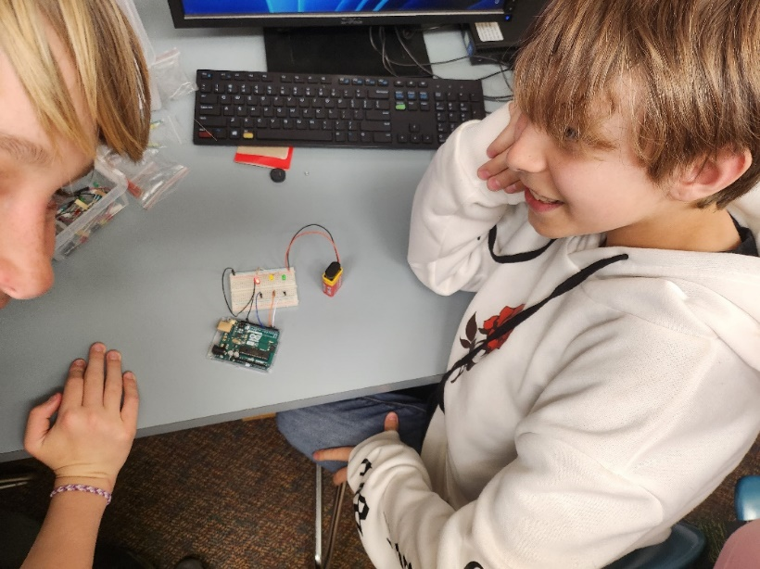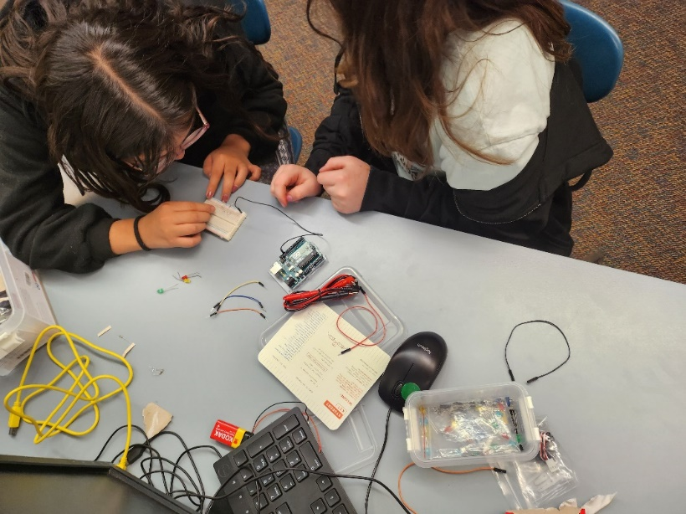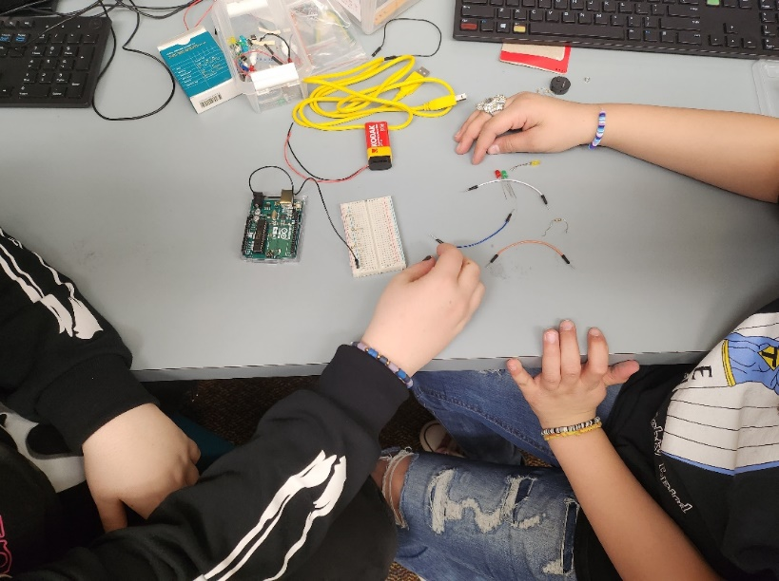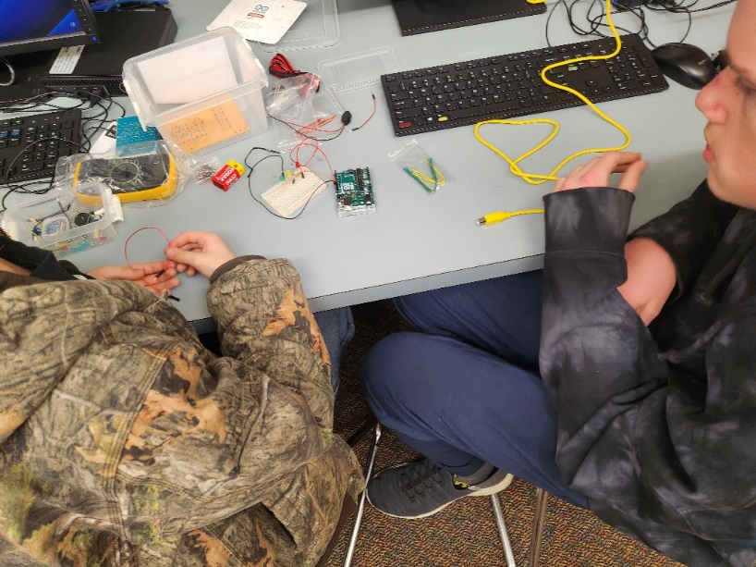

Research:
During the time between our summer project and now, we knew that it would be important to continue this learning experience in order to contribute to our academic growth. We decided to continue focusing our time and resources on the projects in order to complete/teach it successfully. Looking back, we recognized that this opportunity was a great experience that allowed us to further engage our class and make real-life connections for students between the classroom and the real-world. We believe that these lessons were able to be successful through the continuation of work on our summer research project.

