Each area that has been modified to incorporate microbit technology has been highlighted blue.

DRAFT: Lesson 8: How does a cup’s surface affect how light warms up a liquid inside the cup?

Previous Lesson | We considered what we’ve learned about the interactions occurring within the closed cup system to determine other possible explanations for a temperature change in the liquid inside. We developed models that represent how light, heat, or cold (i.e., energy) might be interacting with the system to cause the temperature change, and we determined ways to test our ideas.
This Lesson  Investigation  2 days   | 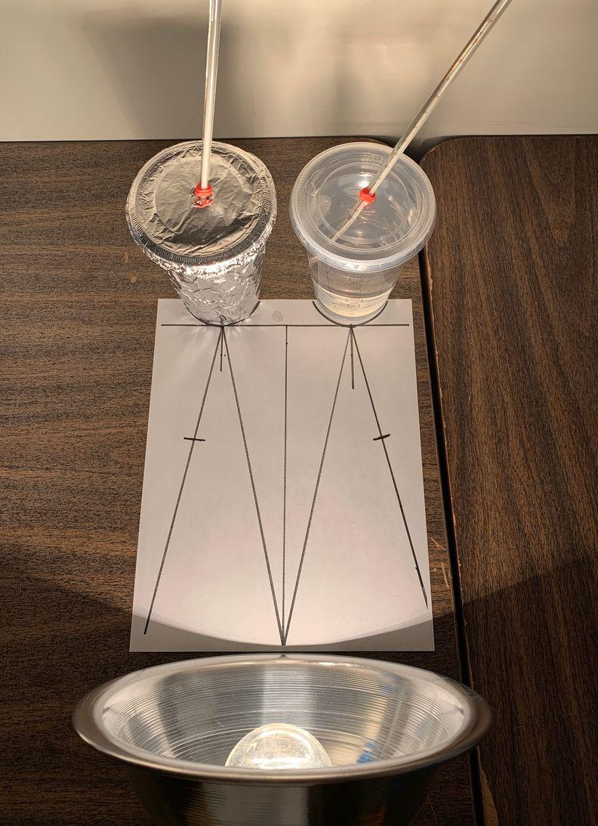 | We carry out an investigation to test the interaction between light and the cup surface in warming up the cold water inside the cups. We shine light on cups with walls of different materials and colors and measure the amount of incoming, reflected, and transmitted light, and we also place some cups in a completely dark condition. We figure out that the water in all the cups warms up, even cups in the dark condition, but it warms up more in the cups in the light conditions. We wonder about additional mechanisms by which the water inside the cups warms up.
Next Lesson | We will carry out an investigation to test whether heat or cold moves into or out of a cup system. We will gather temperature data inside and outside the system to see if the temperature goes up on one side when it goes down on the other side. We will analyze the data to assess the movement of heat or cold through the cup wall and the transfer of energy between the inside and the outside of the cup system.

BUILDING TOWARD NGSS  MS-PS1-4, MS-PS3-3, MS-PS3-4, MS-PS3-5, MS-PS4-2, MS-ETS1-4   | What students will do  Develop and use models to describe how light transmission through, reflection off, and absorption by cup walls causes changes in the temperature (effect) of water inside the cup.  What students will figure out  - Light can transfer energy into a system.  - When light that shines on a surface is not reflected or transmitted, it is absorbed, which warms the matter it shines on.  - Temperature changes in the water can still occur even if light does not transmit through the cup wall and even if there’s no light.

Lesson 8 • Learning Plan Snapshot
Part | Duration | Summary | Slide | Materials
1 | 10 min | NAVIGATION  Prompt students to revisit their ideas from Lesson 7 about how light affects the temperature of water inside a clear plastic cup and how to test their ideas through investigation. | A-B
2 | 15 min | PROGRAM THE MICRO:BITS  Have students sync their MICRO:BITS with their iPads. Have students program a simple light meter. | C-J | micro:bit with battery pack
3 | 20 min | LIGHT AND TEMPERATURE INVESTIGATION CONT.  Monitor students as they conduct an investigation of how light warms up water differently in cups with different surfaces. Place a set of cups in the dark as well. Demonstrate how to take light readings. Collect and record temperature and light measurements |  | calculator, note cards and tape, markers (optional), class Temperature Change table, markers, Light and Temperature Investigation,

End of day 1
3 | 20 min | LIGHT AND TEMPERATURE INVESTIGATION CONT.  Monitor students as they conduct an investigation of how light warms up water differently in cups with different surfaces. Place a set of cups in the dark as well. Demonstrate how to take light readings. Collect and record temperature and light measurements | K | calculator, note cards and tape, markers (optional), class Temperature Change table, markers, Light and Temperature Investigation,
4 | 10 min | ANALYZE DATA FROM LIGHT AND TEMPERATURE INVESTIGATION  Facilitate a Building Understandings Discussion to conclude students’ analysis and interpretation of data from the light and temperature investigation. | L-P | calculator, class Temperature Change table, whiteboard and chart paper, markers
5 | 15 min | DEVELOP MODELS TO EXPLAIN TEMPERATURE CHANGE  Guide students as they draw models to explain how light warmed up water differently in clear versus opaque cups. | Q | Explaining Temperature Changes in Each Cup

End of day 2

Lesson 8 • Materials List
 | per student | per group | per class
Light and Temperature Investigation materials | - Investigating Light’s Effect on Warming Up Water | - Group A’s: 1 lamp with 100-W light bulb 1 Light Measurement Template 2 thermometers 1 500-mL beaker 1 16-oz clear plastic cup and lid 1 16-oz foil-wrapped cup and lid timer (optional)  - Group B’s: 1 lamp with 100-W light bulb 1 Light Measurement Template 2 thermometers 1 500-mL beaker 1 16-oz white-painted cup and lid 1 16-oz black-painted cup and lid timer (optional)  - Dark Group: 4 thermometers 1 500-mL beaker 1 16-oz clear plastic cup and lid 1 16-oz foil-wrapped cup and lid 1 16-oz white-painted cup and lid 1 16-oz black-painted cup and lid access to a dark cabinet or box timer (optional)  - 1 micro:bit with battery pack | - 4 2-L pitchers of cold water chilled to 6℃ (800 mL per Groups A and B and 1200 mL for Dark Groups)  - 1 16-oz clear plastic cup and lid  - 1 16-oz foil-covered cup and lid  - 1 16-oz white-painted cup and lid  - 1 16-oz black-painted cup  - 2 lamps with 100 W light-bulbs  - 1 light meter  - 2 Light Measurement Template
Lesson materials | - science notebook  - calculator  - Explaining Temperature Changes in Each Cup | - note cards and tape  - markers (optional) | - class Temperature Change table  - markers  - whiteboard and chart paper

Materials preparation (60 minutes)

Review teacher guide, slides, and teacher references or keys (if applicable).

Make copies of handouts and ensure sufficient copies of student references, readings, and procedures are available.

Ahead of time, make a class Temperature Change table on chart paper for pooling data across groups. This table can be reused from class to class if students post their data on it with note cards and tape.

Analyze and interpret the class data from day 1 in preparation for the discussion in day 2. See relevant guidance between days 1 and 2 for more information.

[OP.TH.L8.010, 50]Day 1: Light and Temperature Investigation
- Group Size: 3
- Setup: Chill pitchers of water in the refrigerator overnight to 6℃. You will need approximately 800 mL per Groups A and B and 1600 mL for the Dark Group. Use the directions in How to Make the Test Cups for the Light and Temperature Investigation to create the cups for the investigation. Make 1 copy of the handout Investigating Light’s Effect on Warming Up Water for each student. Make 1 copy of the Light Measurement Template for each Group A and Group B (but not the Dark Group). Prepare lab bins for the groups with these investigation materials:
- Group A’s: 1 lamp with 100-W light bulbs, 1 Light Measurement Template, 2 thermometers, 1 500-mL beaker, 1 16-oz clear plastic cup and lid, 1 16-oz foil-wrapped cup and lid, timer (optional), a micro:bit with a battery pack.
- Group B’s: 1 lamp with 100-W light bulbs, 1 Light Measurement Template, 2 thermometers, 1 500-mL beaker, 1 16-oz white-painted cup and lid, 1 16-oz black-painted cup, timer (optional), a micro:bit with a battery pack.
- Dark Group: 4 thermometers, 1 500-mL beaker, 1 16-oz clear plastic cup and lid, 1 16-oz foil-wrapped cup and lid, 1 16-oz white-painted cup, 1 16-oz black-painted cup, access to a dark cabinet or box, timer (optional), , a micro:bit with a battery pack.

Day 1: Class Light Measurement
- Group Size: Whole class
- Setup: Using the Light Measurement Template, set up 2 lamps and 2 light meters with one set of the 4 test cups and lids (clear plastic, black-painted, white-painted, and foil-covered) to demonstrate light measurements at the front of the classroom.
- Notes for during the lab: Darken the room as much as possible by closing shades and turning off floor lamps. Some light from windows is OK. You can leave the classroom lights on until it is time to collect data. Monitor students to make certain they are recording the light measurements appropriately.

Lesson 8 • Where We Are Going and NOT Going

Where We Are Going

In the previous lesson, students used models to consider how light could explain how liquids warmed up inside cups, and they devised ways to test those ideas. Students referred to light as a source of energy that could be transferring into the cup. In this lesson, students carry out an investigation to test light’s role in warming up cold water and observe how various cup surfaces affect this process. Students shine lights on the test cups and measure the amounts of incoming, reflected, and transmitted light. Students also place cups in the dark as a comparison.

Students figure out that when a cup surface transmits light, the water inside warms up more than when the surface reflects light. Students also think about light that is absorbed by the surface of the cup and by the water inside, and they make conclusions about the role of light absorption in causing the water to warm up. Additionally, students observe that the water warms up even in cups in dark conditions. Thus, students realize that light is only part of the explanation and create the need to figure out additional mechanisms beyond light absorption by which the water can warm up. We consider what else might be moving through the cup walls that could lead to temperature changes.

As much as possible, try to reference changes in the water’s temperature as “warming up” (or “cooling down”) rather than “heating up.” Encourage students to think about energy entering the cup systems. “Heating up” involves the word “heat,” which we want to reserve for describing the amount of heat that is moving from one place to another and resulting in a temperature change (Lessons 9 and 14).

Where We Are NOT Going

Students will collect evidence in this investigation to associate the absorption of light with an object’s temperature. However, we are not yet explaining the mechanism by which this occurs or what leads to these changes beyond the absorption of light as an energy transfer at the macroscale. In Lesson 15 students will revisit the absorption of light at the particle scale to explain mechanistically how energy transferred from light leads to an increase in kinetic energy of particles.

In addition, it is not necessary for students to use the term radiation for this type of energy transfer, as this will be articulated after students have constructed their models of energy transfer through conduction later in the unit (Lesson 15). Students may refer to the light as giving energy to the water inside the cup. It is OK for students to use the term energy in a loose way. Students will talk more explicitly about the relationship between changes in temperature, particle motion, and kinetic energy in Lessons 11-12.

LEARNING PLAN for LESSON 8
1 · NAVIGATION | 10 min
MATERIALS: science notebook
Review our ideas about the role of light. Display slide A. Ask 2 students to summarize the ideas that were raised in the last class about how light could affect the temperature of the water inside a clear plastic cup. After students share, emphasize that we are trying to figure out how water inside the cup warms up without matter entering or leaving the cup system. In the previous lesson we settled on the idea that energy from light and heat or cold could change the temperature of the water.  Motivate the need to investigate different cup surfaces. To broaden our understanding of this phenomenon, have students consider how their model for explaining the role of light might apply to cups composed of various materials and surfaces that transmit different amounts of light through the cup wall. Display slide B. Say, So we’ve been thinking about these clear plastic cups and we know that light passes through their walls. When we discussed your models, some of you mentioned blocking the light, so that got me thinking about using cups that could reflect some or all of the light. These types of cups are common, like the cups you can buy for a birthday party. There are other types of plastic cups that are solid colors (hold up/point to an opaque cup). We’ve also thought about metal cups.✱  Say, Do you think light would affect water in an opaque cup in the same way as in the clear plastic cup? What do you think would be similar or different? Ask students to turn to a elbow partner for 2 minutes to discuss their ideas. Encourage students to use the light models they created for the clear plastic cup as the basis for developing their ideas.✱  Elicit students’ predictions. Bring the class together and poll students’ ideas about how the water temperature in an opaque cup would compare to the water temperature in a clear plastic cup if they were left in the light for the same amount of time. Say, Do you think light might affect the water’s temperature differently in the different cups, or not? Have students raise their hand to indicate which statement they agree with: say, Raise your hand if you think that the water in the opaque cup would be warmer than the water in the clear plastic cup … cooler than the water in the clear plastic cup … the same as the water in the clear plastic cup.  Prompt 1-2 students to share their reasoning for each choice. Example prompts are included below.  Suggested prompt Sample student response  For those who thought that the water in the opaque cup would be a different temperature than the water in the clear plastic cup, why do you think so? I think the water in the opaque cup will be cooler because light can’t transmit through the cup. If light can’t get through, it won’t warm it up. I think the water in the opaque cup will be warmer because it absorbs the light and warms up the water like an oven.  For those who thought that the water in the opaque cup would be the same temperature as the water in the clear plastic cup, why do you think so? The same amount of light is going to hit the cup and then warm up the water.  Ask, Do you think that the cup’s color would affect the water’s temperature? Why or why not? Example responses and follow-up questions are listed below.  Suggested prompts Sample student responses Follow-up questions  How do you think the color of the cup’s surface might affect the water’s temperature? The water in lighter-colored cups will be cooler than water in darker-colored cups because some of the light reflects off the cup. So less light will get to the cup. The water in darker-colored cups will be warmer than water in lighter-colored cups because the darker surface absorbs more light and warms up the water. The water in the darker-colored cups will likely be cooler because the surface blocks more light from entering the water. What does it mean for some light to be absorbed? What evidence do you have from your previous experiences that the cup’s color might affect the water’s temperature?  Explain that in the next part of the lesson, we are going to conduct an investigation over two days to test our ideas about light’s role in warming up (or not warming up) the water in a cup and how various cup surfaces might affect how light interacts with the cups. | ✱ ATTENDING TO EQUITY  After describing the types of cups and predicting the amount of light that would transmit through their walls, refer to these objects as transparent and opaque and have students practice using these words throughout this lesson. These terms should already be on your word wall as words earned in the light and matter unit, but continued practice applying them in new context will benefit students’ vocabulary development, particularly for emergent multilingual learners.  ✱ SUPPORTING STUDENTS IN ENGAGING IN DEVELOPING AND USING MODELS  Throughout this conversation, encourage students to look at their science notebooks and use their models for light’s interaction with the clear plastic cup as a starting point to generate predictions about how the interaction would change if the cup’s material (a variable in the system) were to change.

2. · MICRO:BIT PROGRAMMING
MATERIALS: micro:bit with battery pack (per group)
Review our past experiences with micro:bits. Ask students to summarize past experiments with micro:bits. Ask them to predict how we will be using them here. Ask them why we might use them instead of an instrument designed specifically for a single purpose.

Follow syncing steps. Have students follow the simple steps to sync their micro:bit with their iPad.

Have students code to show a light level. This is a simple “MakeCode” action, but students may need to be prompted in the logic. See bellow suggested prompts to drive student work.

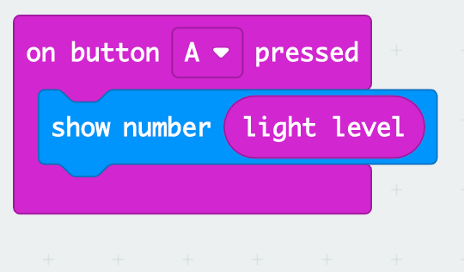

Suggested prompts | Sample student responses
What do you want the micro:bit to show?  How can you que the micro:bit that you need that information. | The level of light when I point it at the experiment.  By turning it on. By pressing a button.
What unit do you think the light level is in?

Explain that in the next part of the lesson, we are going to conduct an investigation over two days to test our ideas about light’s role in warming up (or not warming up) the water in a cup and how various cup surfaces might affect how light interacts with the cups.

End of day 1

3 · NAVIGATION | 3 min
MATERIALS: science notebook, class Temperature Change table
Navigation. Ask students to take out Investigating Light’s Effect on Warming Up Water. Display slide K and ask students to recall the questions that were guiding our investigation. Ask the following questions to help students remember the purpose of the respective controls for the experiment.

Suggested prompt | Sample student response
What was the purpose of testing the cups in the dark? | To compare to water temperature inside the other cups to see whether light leads to changes in the water’s temperature.  To understand whether water can warm up without light.
What was the purpose of testing the cups in the light? | To see how the water warms up inside cups with different surfaces.

4 · ANALYZE DATA FROM LIGHT AND TEMPERATURE INVESTIGATION | 22 min
MATERIALS: calculator, class Temperature Change table, whiteboard and chart paper, markers
Discuss approaches to analyzing and interpreting the class data. Display slide L. Say, We collected a lot of data yesterday. What could we do to help us understand the relationship between the temperature changes in the water and the amounts of reflected and transmitted light? The goal of this discussion is to have students look at patterns in the data rather than individual data points and to be able to identify and account for outliers that might be due to error rather than representing actual phenomena.✱ Use the following prompts to guide the discussion.  Suggested prompts Sample student responses Follow-up questions  What could we do with the data to help us understand the relationship between the temperature changes in the water and the amounts of reflected and transmitted light? Take averages of data. Identify and take out outlier data. Why is calculating averages helpful? Why might identifying outliers be useful when analyzing this data set?  Why is calculating averages helpful? We’re looking at how changing one thing affects another. We want to see if there is a pattern. It makes sure no one measurement is the only thing we use for data. Do we include outliers (if they are present) when calculating averages?  What do you think might have caused some of the variability in our data? Errors with measuring the light. The angle of the lamp. Light coming in from the top of the cup when measuring the light transmitted through the cup wall. Each light bulb might have had a different level of brightness. How did we try to account for these potential sources of error in our experiment?  Average Water Temperature Change vs. Light Measurements (% Incoming Light)  Condition △T Transmitted Reflected  Light Clear +6℃ 81% 14%  Foil +3.5℃ 0% 39%  Black +6℃ 0% 31%  White +4.5℃ 12% 44%  Dark Clear +2℃ 0% 0%  Foil +2℃ 0% 0%  Black +1.5℃ 0% 0%  White +1.5℃ 0% 0%  Calculate average values for each measure. Display slide M. Have students work on their own to record the class data in a combined data table, which is the first question in the Analysis section of the Investigating Light’s Effect on Warming Up Water handout. Give students a minute to quietly scan the data for patterns.  Construct a Notice and Wonder chart. Display slide N. Based on the average data, have students work with a partner to record on their handout what they notice and wonder about the data. When doing so, they should keep in mind the questions we posed in the last class: “Does light warm up the water?” and “How does the cup surface affect how light warms up the water?” Students should continue to use patterns as a lens for making sense of the data.✱  As students analyze the data in the form of a Notice and Wonder chart, they should examine the relationships between cup types and the amounts of reflected and transmitted light and how those amounts contributed to the observed temperature changes.✱  Engage in a Building Understandings Discussion. Reconvene the whole class. Develop a class Notice and Wonder chart on chart paper or a whiteboard space. Have each pair of student partners share at least 1 noticing and wondering from the data.  KEY IDEAS Purpose of the discussion: To identify that the evidence supports that light does lead to warming of the cup surface and the water inside the cup, but to have lingering questions about other mechanisms that warm up the cups and the water inside. Listen for these ideas: - Black and clear cups warmed up the most and reflected the least light. - White and foil cups warmed up the least and reflected the most light. - The water inside the cups in the dark warmed up without light. - Something else happens to light that is not transmitted or reflected; light is absorbed by the cup and the water inside the cup.  Below are sample noticings and wonderings that students might come up with.  Notice Wonder  The temperature of the water increased in all conditions. Temperatures changed in cups where light didn’t transmit through the cup wall. Temperature changed in cups in the dark. The clear plastic cup and the black cup had the greatest temperature change. The foil cup had the least temperature change, followed by the white cup. How does the light cause the water temperature to change if light doesn’t pass through the cup wall? Where did all of the light go that did not transmit through or reflect off the cup surface? How is it possible for the water to warm up without light? Why did the foil cup result in a lower temperature change than the white cup?  Display slide O. Say, Based on our data, it seems that the cup surface does affect how light warms up the water inside. Having a lot of data can seem a little overwhelming. So first, let’s try to figure out how light in general affects how the water warmed up.✱ You may use the following prompts to guide the discussion.  Suggested prompt Sample student response  How does the amount of transmitted light affect the water’s temperature? Transmitted light tends to warm up water more.  How does the amount of reflected light affect the water’s temperature? The more reflected light, the less the temperature goes up.  Display slide P. Say, One of the interesting things you noticed in the data is that the amount of transmitted light and reflected light don’t add up to the whole amount of the incoming light. Where did the rest of the light go? Do you think this light affected the water temperature in some way? The intent of these questions is to guide thinking about how light can be absorbed by the cup wall and then warm up the water, because the amount of transmitted and reflected light cannot explain the increased temperatures. Now is your opportunity to reintroduce the idea of light being absorbed by matter, which was a lingering question for students following the light and matter unit.  Say, Based on our data, we know that light can transmit through the cup wall, reflect off the cup wall, and do something else. We call this something else absorption, because the light energy is being absorbed and transferred to the matter. Using this information, how do you think this absorbed light affects the water’s temperature? Give students a moment to think, and then elicit a few of their initial ideas.  Explain that to help us answer these questions, we’re going to construct models to help us explain how the cup surface affects how light warms up the water.  ADDITIONAL GUIDANCE In the next part of the lesson, we create the space for students to think about the mechanism by which absorbed light warms the water, but we do not talk about this mechanism in terms of conduction until later in the unit (Lessons 12-15). Due to measurement errors and scattering of light, it’s difficult to calculate absorbed light. Students will need to focus on the transmissive and reflective data not adding up to the total incoming light as a proxy for thinking about light absorbed by the matter. | ✱ SUPPORTING STUDENTS IN ENGAGING IN ANALYZING AND INTERPRETING DATA  Reinforce to students what they learned in Lesson 4 about the role of averaging data. Have students apply the concepts of averaging to analyze and characterize data. When collecting data, increasing the number of data points for pattern analysis is important for enhancing the reliability of the stated claims. The identification of outliers is an important skill related to this practice, particularly when figuring out whether high or low points are part of the pattern or due to error. When discussing potential sources of error in this investigation, the presence of an open system that admits ambient light when measuring light transmission through the cup wall will lead to some error. Measurement error could also be due to light bulb variations or lamp or light sensor positioning. We asked students to take each light measurement twice and calculated all measurements in terms of percentage of incoming light. In addition, we minimized error from light reflecting off nearby cups by testing only one cup at a time per lamp and spacing the lamps apart.  ✱ SUPPORTING STUDENTS IN DEVELOPING AND USING PATTERNS  Emphasize to students to focus on patterns as they analyze their data and to avoid getting too focused on a single data point. It is challenging to obtain accurate light sensor measurements, so focusing on single data points may lead students toward problematic conclusions. Focusing on patterns from the light and temperature data, coupled with students’ wealth of related experiences with light warming objects up, will prove more beneficial.  ✱ SUPPORTING STUDENTS IN ENGAGING IN ANALYZING AND INTERPRETING DATA  To support students’ analysis of the data, it might be helpful to have them group the cups by these types to see how differences between those groups might reveal information about the relationship between the cup surface, light, and temperature change:  - cup that is transparent  - colored cups (white and black) that are opaque  - reflective foil-covered cup that is opaque  ✱ SUPPORTING STUDENTS IN DEVELOPING AND USING CAUSE AND EFFECT  Coupling this data analysis with constructing models will help students move beyond identifying surface-level patterns (correlation) to identifying mechanisms (causation). Transition students from thinking about patterns to trying to make sense of the data in terms of mechanisms. Use this opportunity to examine issues related to cause versus correlation. Students may associate transmitted light with temperature changes, but other factors might mediate that effect. For example, opaque objects do not transmit light through them, but they do warm up due to the absorption of energy. Make certain students do not conclude a causal relationship simply from the patterns they identified. In Lesson 15 students will return to light, focusing more on a mechanistic explanation.

5 · DEVELOP MODELS TO EXPLAIN TEMPERATURE CHANGE | 15 min
MATERIALS: science notebook, Explaining Temperature Changes in Each Cup
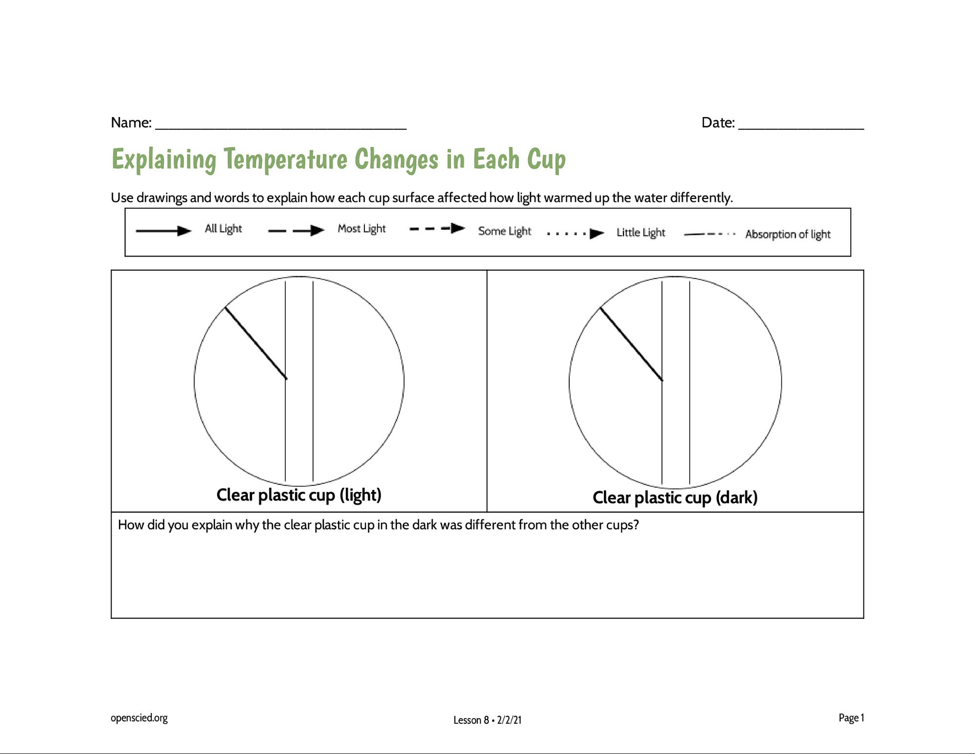  Develop models to explain findings. Display slide Q. Explain that we’re going to draw models to explain how and why the water warmed differently in the various cups. Distribute the handout Explaining Temperature Changes in Each Cup to each student. Explain that the models focus on one area of the cup wall and that the illustrations include a light ray that represents the incoming light that we measured. Students’ models should account for the data collected about how the percentages of reflected and transmitted light differed between the cups and how those differences affected the changes in water temperature.  Remind students to use the representations for different amounts of light that were developed in the previous unit on light and matter. The key is provided on the handout. You may want to discuss the representation of absorption at this time.✱  Give students time to construct models. Ask students to first work individually to represent their ideas about what happens to light as it encounters the cup wall. Give students up to 5 minutes to think about each model and to choose the representation (i.e., dashed arrow) they want to use to show amounts of light doing different things.  Discuss students’ models. Ask students to share their models with a partner seated near them for about 2-3 minutes. Encourage students to add to their models as they share.  Convene students for a whole-group discussion of the models. Have students or partner pairs share one model they developed for a particular cup. Ask other students to compare this model to their own and ask questions or offer alternatives. Encourage students to use their data when explaining and justifying their models. Continue until models for each cup type are discussed.  ASSESSMENT OPPORTUNITY As students work on their models individually, circulate to see how they are applying the model conventions from the light and matter unit. Encourage students to use the dashed arrows to represent the different amounts of transmitted and reflected light. When students share their models, pay attention to how they are showing what happens when a variable in their cup system--the cup surface--changes. Look for students’ ideas such as these: - which cups reflected the most light and how this relates to the resulting temperature change - which cups transmitted the most light and how this relates to the resulting temperature change - what else could be happening to the light not transmitted or reflected  Example prompts for probing and challenging students’ ideas are included below.  Suggested prompts Sample student responses Follow-up questions  How did you explain why the water in the black cup warmed up more than the water in the white cup? I showed more light being reflected by the white cup compared to the black cup. I showed more light being absorbed by the cup wall in the black cup compared to the white cup. How do you think the absorbed light warms up the water?  How did you explain why the clear plastic cup in the dark warmed up the water the least? There was no light present. How did you explain why the water was still able to warm up without the presence of light?  How did you explain why the foil-covered cup kept the water cooler than the black and white cups? The foil reflected the light. What happened to the other light? Why didn’t the absorbed light cause the water to warm up?  Below are example models for each cup type:  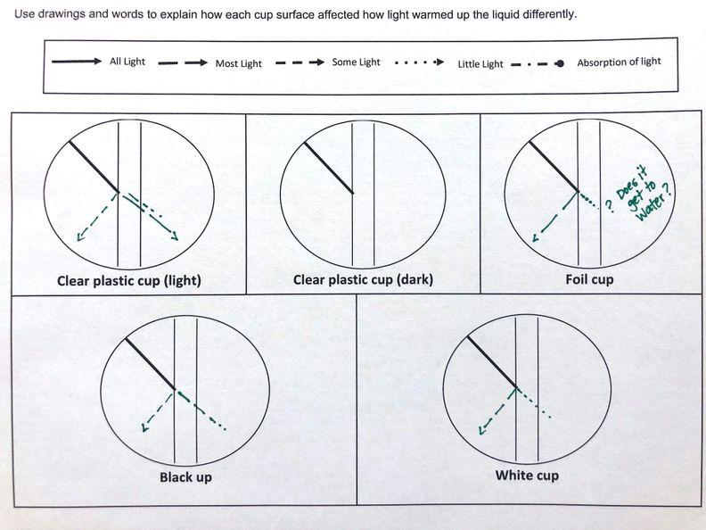 | ✱ SUPPORTING STUDENTS IN ENGAGING IN DEVELOPING AND USING MODELS  We encourage using the conventions developed in the light and matter unit, which were solid lines to represent all light and dashed and dotted lines to represent relative differences in the amount of light. We will assume the same incoming light for each cup, which is represented by a solid line. Students may want to use percentages to create a key for what constitutes “all”, “most” (50%-99%), “some” (16%-49%), and “little” light (1%-15%). How students represent the absorption of light can vary, though a suggestion is provided on the handout: drawing longer dashes transitioning to dots as more light is absorbed and less is transmitted.

6 · UPDATE PROGRESS TRACKER AND NAVIGATION | 5 min
MATERIALS: science notebook
Update progress tracker. Display slide R. Say, It looks like we’ve figured some stuff out, but we still have some questions. Ask students to take out their science notebooks and update their Progress Trackers with what they learned during this lesson. This work can be done individually or with a partner. Example points are included below.

Question | What figured out in words/pictures
How does a cup’s surface affect how light warms up a liquid inside the cup? | - When light that falls on a surface isn’t reflected or transmitted, it is absorbed.  - Transmitted and absorbed light can warm a liquid.  - Light that reflects off a cup’s surface does not affect the temperature of the liquid inside.  - Temperature changes can still occur even if light isn’t able to transmit through the cup and even if there’s no light.

Navigation. Encourage students to post any additional questions on the DQB. Based on what students say, problematize the need for more investigation. Say, So we figured out that the water warmed up even when there was no light or in situations where light couldn’t travel through the cup wall. How did the water warm up? What else is going in or out?

Suggested prompts | Sample student responses | Follow-up questions
How did the water warm up if light couldn’t pass through the cup wall or when there was no light at all? | The absorbed light warmed up the cup wall, which then warmed up the liquid.  Heat or cold moved through the cup wall. | What is heat?  How did the light warm up the cup wall?  How did the water get warmed up?  What’s the difference between matter (e.g., the liquid) that is at one temperature versus another?

Additional Lesson 8 Teacher Guidance

SUPPORTING STUDENTS IN MAKING CONNECTIONS IN MATH | CCSS.Math.Content.6.RP.A.3.c: Find a percent of a quantity as a rate per 100 (e.g., 30% of a quantity means 30/100 times the quantity); solve problems involving finding the whole, given a part and the percent.  Converting actual light measurements to percentages of incoming light is helpful for accounting for variation in experimental setups and facilitating comparisons between treatment conditions. The focus of this task is not the actual process of calculating percentages; rather, we are focused on students’ ability to compare percentages and use them to explain differences in observed temperature changes. However, during the 6th-grade year students learn about calculating percent in their math courses. If you anticipate challenges with these calculations, talk to the math teacher prior to the lesson to learn when and how students are taught this concept. Consider pairing students who may have difficulty with students who are able to help them.

