Name:_____________________
Communicating Through History Timeline: Handout

Directions: Use the space below to capture important events about changes in communication technology as you read the articles. When you are finished. Choose 5-8 important events and make a timeline of Communication Through History on the back of this page.

Important Events
The Pony Express
Transcontinental Railroad
Telegraph
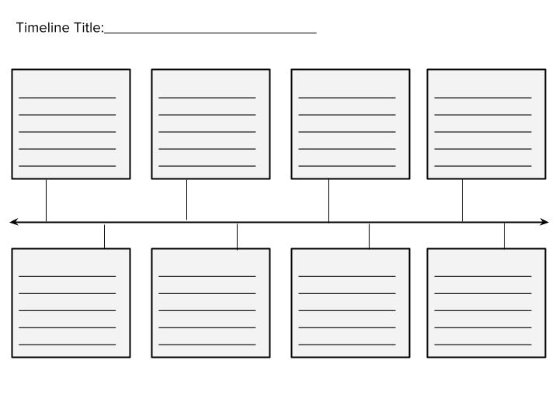
Be sure to include a date and short description of the important event. You must include between 5-8 important events.

