Lesson: Egg Drop
Level: Conceptual Physics High School
Phenomena: When an egg is dropped from a designated height, the potential energy transfers to kinetic energy. Students will attempt to increase the impulse so when the egg hits the ground, it doesn’t crack.
Target: Use a Microbit to determine the acceleration of the egg.
Criteria for Success: Your Microbit shows the egg’s values for acceleration.

Wyoming Standards
Science-HS-PS2-1. Analyze data to support the claim that Newton’s second law of motion describes the mathematical relationship among the net force on a macroscopic object, its mass, and its acceleration.
HS-PS2-3. Apply scientific and engineering ideas to design, evaluate, and refine a device that minimizes the force on a macroscopic object during a collision.
Computer Science- Add standards and appendix CS Practice 4.3: Create modules and develop points of interaction that can apply to multiple situations and reduce complexity.
Mathematics-MP.2 Reason abstractly and quantitatively.
MP.4 Model with mathematics.
HSN-Q.A.1 Use units as a way to understand problems and to guide the solution of multi-step problems; choose and interpret units consistently in formulas; choose and interpret the scale and the origin in graphs and data displays.
HSN-Q.A.2 Define appropriate quantities for the purpose of descriptive modeling.
Engineering-HS-ETS1-4. Use a computer simulation to model the impact of proposed solutions to a complex real-world problem with numerous criteria and constraints on interactions within and between systems relevant to the problem.

3-Dimensions of science learning:
Disciplinary core idea: The performance expectations in PS2 focus on students building an understanding of forces and interactions and Newton’s Second Law. Students also develop an understanding that the total momentum of a system of objects is conserved when there is no net force on the system. Students are able to use Newton’s Law of Gravitation and Coulomb’s Law to describe and predict the gravitational and electrostatic forces between objects.
Cross cutting concept: Empirical evidence is required to differentiate between cause and correlation and make claims about specific causes and effects.
Discipline core idea: Newton’s second law accurately predicts changes in the motion of macroscopic objects.
Science and engineering practices: Analyze data using tools, technologies, and/or models (e.g., computational, mathematical) in order to make valid and reliable scientific claims or determine an optimal design solution.

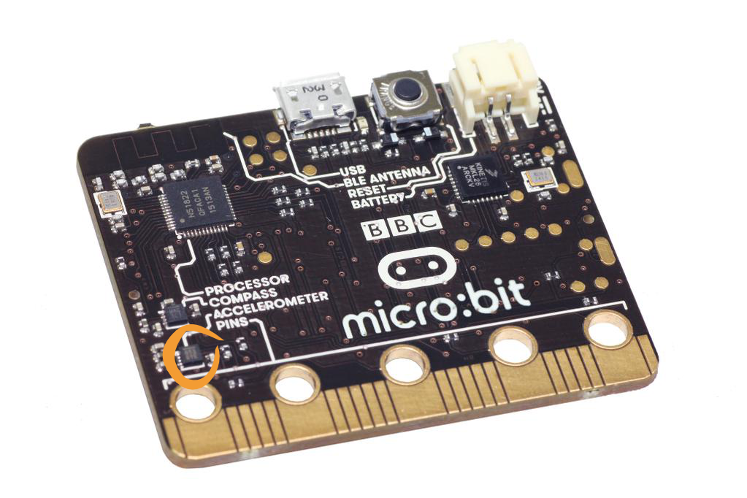
The micro:bit measures movement along three axes:
- X - tilting from left to right.
- Y - tilting forwards and backwards.
- Z - moving up and down.
Materials:
- One Microbit per student
- Battery pack for each Microbit
- Chromebook
- Large space outdoors such as the top tier of the bleachers at the football field.
- 1-raw egg
- Students select material that can be used to reduce the egg’s impact when it hits the ground from 4 m or more. Examples: foam, cotton, balloons, index cards, large plastic bag (parachute), string, corrugated cardboard, tape, glue, etc.

Catch: Can you engineer an apparatus that will prevent a raw egg from breaking when dropped from a height of 4 m?
Did you know your cell phone has an accelerometer in it?

Objectives:
Students will investigate and design an experiment that explores Newton’s 2nd Law, momentum and impulse using a microprocessor. They will study the phenomenon of gravity and -9.8 m/s². They will be able to calculate the force of the egg on impact and create an apparatus that increases the impulse so that the egg and Microbit do not break on impact.
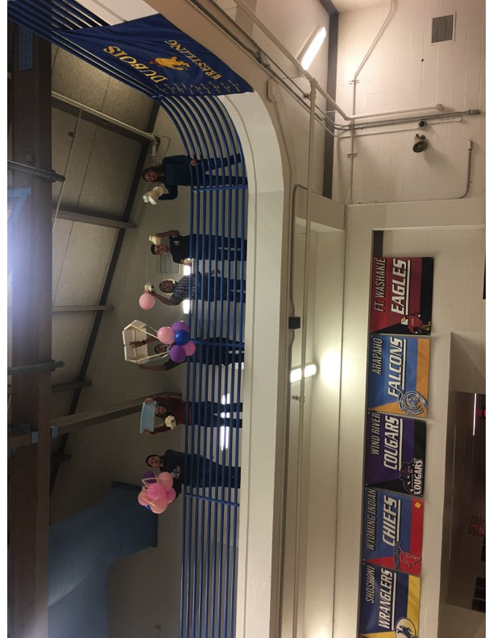

Evaluation:
Students will be given a pre-test to see if they have any misconceptions relating to x, y, z-axes, gravity, Newton’s 2nd Law and impulse.
Students will build an apparatus that will hold an egg and Microbit for a 4-m drop.
They will program a Microbit that determines acceleration.
Finally, students will be given a post-test and assessment to see if their misconceptions have been addressed.

Lesson Schedule with Review Strategies for instructor, embedded in green:
Examples of Pre-Test Questions (5-10 minutes):
Make a diagram the represents the g-forces as an object falls from 4-m.
Find the force of an object that has a mass of 10 g and another object that has a mass of .01 kg. If both objects take 1.5 seconds to fall, determine which object has the greater impulse.
Explain the purpose of an airbag in a vehicle and how does it affect impulse.
Identify any misconceptions in pre-test questions or conversations with students.

Pre-Assessment (15 minutes): All students will be given a pre-assessment (examples of assessment questions are listed at the bottom of this lesson). They will be required to submit a lab journal during this investigation.
Identify any misconceptions in pre-assessment questions.

Introduction and design (50 minutes): Review, if needed Newton’s 2nd Law, momentum and impulse. Students will first be shown the materials that are allowed for the egg apparatus and then they will sketch their apparatus that will hold the raw egg. Below the diagram they should include the exact amounts of materials they plan to use to build their apparatus.

Use an entrance ticket to check for understanding and misconceptions of the introduction.

Build the apparatus for the egg (40 minutes)
Next, students can collect materials they requested and build the egg apparatus.

Microbit (10-15 minutes) Students program a Microbit that functions as an accelerometer. This link shows an advanced program for the accelerometer.
Remind students to write in their lab book their trials, any errors and successes.
Monitor students’ progress and ask them questions.
Possible algorithm for Microbit compass. This was the first time I had taught an egg drop with a Microbit so the image below shows a simple accelerometer a student programmed. We were only interested in the data for the y-axis.
Once students have tested their program and it works to your/their satisfaction, the next step is to build a cage for the Microbit so that it can be attached to the egg apparatus.

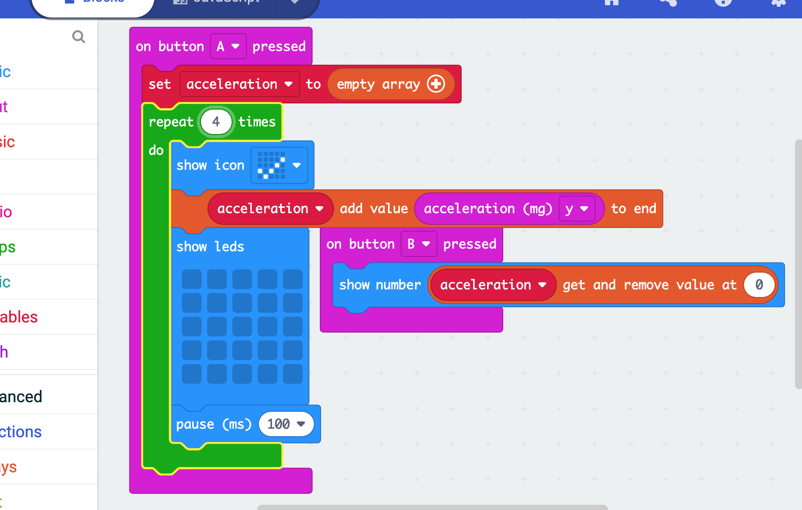

Time to test Microbit with the egg drop (20 minutes). Students will go out to the football bleachers and drop their eggs! Collect the data from the Microbit after the drop(s).

Student Microbit Lab write up criteria (50 minutes):

Title (1 point)
Question: Can I construct an apparatus that reduces impulse so the egg doesn't break?(1)
Hypothesis: If then statement.(1)
Explain impulse and write the equation. (2)
Materials: List all materials needed for this experiment. (1)
Procedure: Complete sentences explaining how to set up your experiment. (2)
Observations: (2)
Data Table: What values do you need to calculate impulse? (3)
Microbit: Can you implement a program to find the impulse? (3)
Graph the impulse. (2)
Conclusion: State your claim-this address the question. (1)
Use the evidence from the data table to support your claim. (2)
Discuss the reasoning-what scientific information supports your claim. Hint-force and impulse. (2)
Explain what you learned by conducting this experiment. (1)

Post-test questions (5-10 minutes) Give each student the pre-test questions (located at the top of this document) and determine if they have any misconception.

Closure (15 minutes): Review post-test questions for misconception, additional questions’ students might have, what they have learned and any thoughts for how to improve this lesson.
Pre and Post Assessment (20 minutes):
Make a diagram that represent the transfer of potential energy to kinetic and back to potential energy.

Explain if energy can be created or destroyed.

The Egg hitting the ground is a collision between the Earth and the Egg. When collisions occur, two properties of the colliding bodies are changed and/or transferred. Explain the 2-properties that affect the collision of the egg (answer, Energy and Momentum).

How is this change transferred? (Answer-This change and transfer is mediated by one or many forces.)

Explain the purpose of your apparatus.

What are the 2-variables for momentum (answer mass and velocity)?

Two trains, Big Red and Little Blue, have the same velocity. Big Red, however, has twice the mass of Little Blue. Compare their momentum. Answer: Because Big Red has twice the mass of Little Blue, and Big Red must have twice the momentum of Little Blue.
A supersonic bomber, with a mass of 21,000 kg, departs from its home airbase with a velocity of 400 m/s due east. What is the jet's momentum? Answer: p = mv p = 21,000 kg400 m/s east p = 8,400,000 kg m/s east
If the football halfback experienced a force of 800 N for 0.9 seconds to the north, determine the impulse. Answer: J = F ·t. J = 800N ( 0.9s ) J = 720 N·s
If the gravity reads -9.8 m/s², explain if the object is accelerating or decelerating and the direction. Answer, the object is accelerating on the negative y-axis.

Teacher’s Reflection: Your response to the lesson. What worked and improvements that need to be made.
After teaching this lesson I found an Egg Drop using a Microbit that gave a great explanation of how to set up this experiment. The instructor in this video talks about using the spiral method. So, if you have time this procedure is worth looking into.

Special thanks to Dr. Mike Borowczak, Dr. Andrea Burrow the WySLICE PI Leads and Graduate Students from The Computer Science College of Engineering and Applied Science at the University of Wyoming.

