Watershed Analysis

Use this link to complete the following instructions and questions.

- Which major watershed do you live in? (Follow the directions below to answer this question.) Write your answer after e.
  - Click the link above to launch the map.
  - In the upper-right corner, click Sign In. Your account should be your school login followed by _KCSchool. Your current password is Buckaroo26.
  - With the Details button underlined, click Content (Show Contents of Maps).
  - Turn off all layers, and then turn on only the layer US Watershed Boundaries. Click it to see its sublayers.
  - Identify the name of the major watershed (HUC 2) in which you live. Write it below.

  - Filter the HUC 2 layer to display only that watershed by clicking Filter and writing an expression.
    - Click on the region you want to study.
    - Find the HUC2 number
    - Under the HUC 2 Drainage Regions, click the yellow polygon with a funnel in front of it
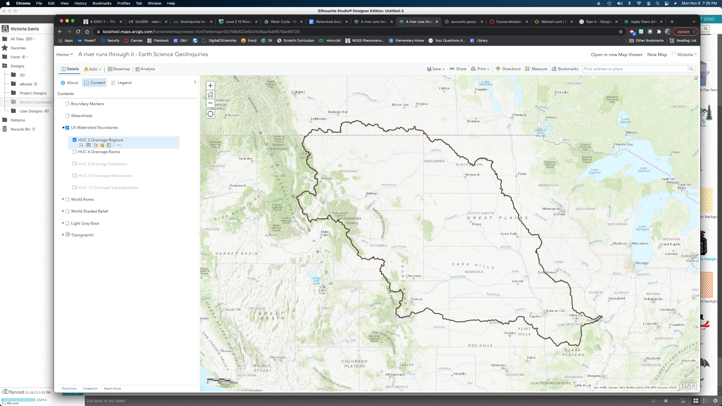
    - Adjust the formula bar so that the first dropdown reads HUC2 and the last box matches your region number. 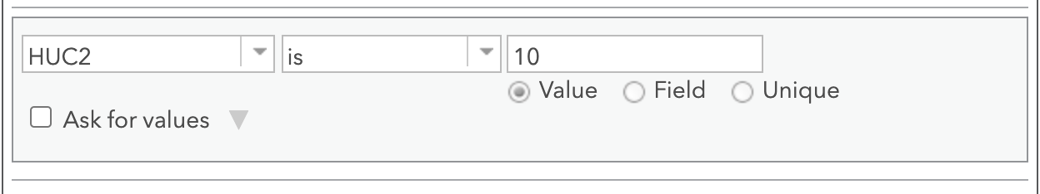
- Which rivers and streams does your watershed drain into? (Follow the directions below to answer this question.) Write your answer after b.
  - Turn on the World Rivers layer.
  - Write the major rivers and streams within your watershed below.

- Which cities are in your regional watershed? (Follow the directions below to answer this question.) Write your answers on the provided lines.
  - Using the basemap as a guide, what states are included in our watershed? Write your answers below.

  - Click the Add button and choose Search for Layers.
  - Search for USA Major Cities owner:esri_dm from ArchGIS Online. Add the layer to your map.
  - What major Wyoming cities are in this watershed? Write your answers below.

  - Click the Analysis button. Expand Find Locations and choose Find Existing Locations.
  - In the Find Existing Locations pane, set the following parameters:
    - Choose USA Major Cities
    - Click Add Expression and add the following expression: USA Major Cities Intersects US Watershed Boundaries-HUC 2 Drainage Regions.
    - Provide a unique name for the new later that will be created, uncheck the Use current map extent box, and run analysis.
  - Hover over the new layer’s name. Click the Show Table button.
  - How many cities are in your watershed?

  - Which city is the most populous?

  - Looking at the map, is there a spatial relationship between city locations and rivers?

- How can you represent your local watershed?
  - Turn off all layers and type Kaycee, Wyoming into the search feature.
  - Click on the Analysis button. Expand Find Locations and choose Create Watersheds.
  - In the Create Watersheds pane, set the following parameters.
    - Use the Draw marker symbol to drop a point on your location by clicking on the marker in the square and then clicking on Kaycee’s main street.
    - Type a search distance of 0.5 miles.
    - Give the layer a unique name, uncheck the Use current map extent box, and run the analysis.
  - In the map, click the new watershed to see its pop up information.
  - What is the local watershed’s area in square miles? Write it below.

  - How does our local watershed compare to the major watershed? Write your answer below.

  - Turn off all layers.
- How does the local watershed compare?
  - Use the same Create Watershed and pick another part of the U.S. to create a watershed.
  - How does the local watershed compare to the new location? Identify three similarities and three differences below.

  - Would you prefer to live in one watershed or the other? Explain your reasoning below.

- Where does the water go? See if you can figure out how to use the analysis tool to trace our water’s path from Kaycee to the Gulf of Mexico. Insert a screenshot below.

