Lesson: Geocaching with Microbits
Level: Middle School Earth Science
Phenomena: Geodynamics powers the Earth’s magnetic field, which is magnetic north. There is also a true north which is the Earth’s geographic north. Can you accurately determine Earth’s magnetic north using a micro-processor?
Target: Use a Microbit to find Earth’s magnetic north.
Criteria for Success: Your Microbit can find north!
You can accuratly locate objects on the map.
Determine the if there is a difference between magnetic and true north.
Name 1-object that uses magnetic north and 1-that uses true north.

Wyoming Standards
MS-ESS2-1. Develop a model to describe the cycling of Earth’s materials and the flow of energy that drives this process.
MS-ETS1-4. Develop a model for a proposed object, tool or process and then use an iterative process to test the model, collect data, and generate modification ideas trending toward an optimal design.
Computer Science- Add standards and appendix CS Practice 4.3: Create modules and develop points of interaction that can apply to multiple situations and reduce complexity.
SS8.4.2 Describe how tools and technology in different historical periods impacted the way people lived, made decisions, and saw the world.
Language Arts-WHST.6-8.2: Write informative/explanatory texts to examine a topic and convey ideas, concepts, and information through the selection, organization, and analysis of relevant content.
Mathematics-MP.2: Reason abstractly and quantitatively.

3-Dimensions of science learning:
Disciplinary core idea: All Earth processes are the result of energy flowing and matter cycling within and among the planet’s systems. This energy is derived from the sun and Earth’s hot interior causing magnetic forces. The energy that flows and matter that cycles produce chemical and physical changes in Earth’s materials and living organisms.
Cross cutting concept: Explanations of stability and change in natural or designed systems can be constructed by examining the changes over time and processes at different scales, including the atomic scale.
Science and engineering practices: Constructing explanations (for science) and designing solutions (for engineering)

Materials:
- One Microbit per student 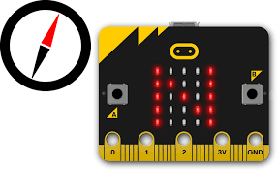
- Battery pack for each Microbit
- Chromebook
- Large space outdoors

Catch: How does your cell phone keep track of your location?

Objectives:
Students will investigate and design an experiment that explores the natural world using microprocessors. They will study the phenomenon of the Earth magnetic field. They will be able to explain the difference between true and magnetic north and everyday objects that use magnetic north. Students will create a program that runs a compass on a Microbit. They will also learn how a compass works and how to Geocache.

Evaluation:
Students will be given a pre-test to see if they have any misconceptions about the locations of true and magnetic north.
They will program a Microbit that determines magnetic north.
Then, students will locate objects using their Microbit, by Geocaching.
Finally, students will be given a post-test and assessment to see if their misconceptions have been addressed.

Lesson Schedule with Review Strategies embedded in green:
Pre-Test Questions (5-10 minutes):
Use colored pencils to make a diagram of the Earth. Label true north and south.
Next, label magnetic north and south on your Earth diagram.
Name 1-object that uses Earth’s magnetic field. Explain how you think this object works using the Earth magnetic field.
Name 1-object that uses geographic north and south. Explain how you think this object works using the Earth geographic north and south.
Identify any misconceptions in pre-test questions or conversations with students.

Pre-Assessment (10 minutes): All students will be given a pre-assessment (examples of assessment questions are listed at the bottom of this lesson). They will be required to submit a lab journal during this investigation.
Identify any misconceptions in pre-assessment questions.

Introduction (15 minutes): Review, if needed Earth magnetic fields (Arbor scientific video), how the hot interior causes Earth’s magnetic fields and what are geographic north and south poles. Have students read how the compass sensor works. Have students work in groups and brain storm how to program the Microbit so that it can work as a compass.

Use an entrance ticket to check for understanding and misconceptions of the introduction.

Microbit (10 minutes) Students make a Microbit that functions as a compass using magnetic north. Remind students to write in their lab book their trials, any errors and successes.
Monitor students’ progress and ask questions.
Possible algorithm for Microbit compass. This image was taken from microbit.org:

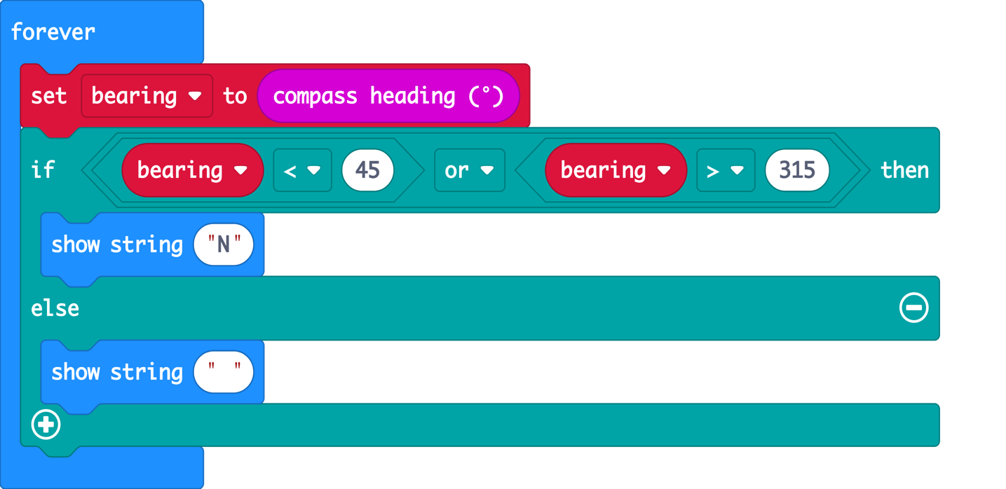

Time to test Microbit with Geocaching (40 minutes). The instructor has set up a course for the students to
test their Microbit compasses. This may take you an hour to set up the course and write down coordinates.


Student Assessment (30 minutes). Have students create a course for Geocaching using their own objects, measurements and diagrams. Number of objects vary according to students’ level of understanding. I recommend no more than 5 objects to be located. Once students have determined coordinates, they have another student or group complete this geocache. The second group will be graded on their accuracy and if were they able to locate all objects.

Post-test questions (5-10 minutes) Give each student the pre-test questions (located at the top of this document) and determine if they have any misconception.

Closure: Review post-test questions for misconception, additional questions’ students might have, what they have learned and any thoughts for how to improve this lesson.
Pre and Post Assessment:
Explain and make a diagram of how the Earth creates magnetic fields.

What materials (stuff/things) do you think need to be present in a Microbit so that it can work as a compass?

If you were in southern hemisphere, would that change how a Microbit function. Justify your reasoning.

How difficult or easier would this assignment have been, if you were assigned to Geocache without a programmed compass Microbit? Explain what would have been harder and easier for Geocaching.

Make a diagram that compares and contrast Earth’s magnetic poles versus geographic poles.

The magnetic poles of the Earth move continuously and very slowly over time. How do you think the Earth would be affected if the poles switched places? In other words, the magnetic north became the magnetic south and vis-versa.

Reflection: Your response to the lesson. What worked and improvement to be made.
Special thanks to Dr. Mike Borowczak, Dr. Andrea Burrow the WySLICE PI Leads and Graduate Students from The Computer Science College of Engineering and Applied Science at the University of Wyoming.

