Lesson: Geocaching with Microbits
Level: Middle School
Phenomena: Can you accurately determine Earth’s magnetic north with a micro-processor?
Target: Use a Microbit to find Earth’s magnetic north.
Criteria for Success: Microbit can find true north!
Wyoming Standards
Science-MS-ESS2-2: Develop a model to describe the cycling of Earth’s materials and the flow of energy that drives this process.
Computer Science- CS Practice 4.3: Create modules and develop points of interaction that can apply to multiple situations and reduce complexity,
Language Arts-WHST.6-8.2: Write informative/explanatory texts to examine a topic and convey ideas, concepts, and information through the selection, organization, and analysis of relevant content.
Mathematics-MP.2: Reason abstractly and quantitatively.

3-Dimensions of science learning:
Disciplinary core idea: All Earth processes are the result of energy flowing and matter cycling within and among the planet’s systems. This energy is derived from the sun and Earth’s hot interior. The energy that flows and matter that cycles produce chemical and physical changes in Earth’s materials and living organisms.
Cross cutting concept: Explanations of stability and change in natural or designed systems can be constructed by examining the changes over time and processes at different scales, including the atomic scale.
Science and engineering practices: Constructing explanations (for science) and designing solutions (for engineering)

Materials:
- One Microbit per student 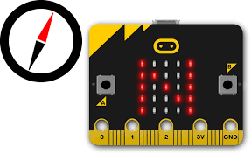
- Chromebook
- Large space outdoors

Pre-test: Make a diagram of the Earth and label true north and south.
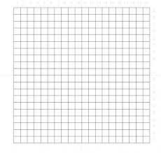

Closure:
Assessment: (must match objective/s)
Reflection: Your response to the lesson (to be completed after lesson; may be handwritten)

