Teacher: Minda Blevins  Grade: 1st  School: Dildine Elementary (LCSD#1) |  | Essential Learning Target(s):  Students model daily processes by creating and following algorithms (sets of  step-by-step instructions) to complete tasks. Students can create  and follow algorithms for making simple foods, brushing their teeth, getting  ready for school, or participating in clean-up time
Date: Q2- Intro to Coding: Unplugged
Subject: CS- AP.A.01  Topic: Domain: Algorithms & Programming |  | Essential Question(s):  - How does I use algorithms in my daily life?  - Do I use algorithms when I ride my bike or walk to the park?  - How can an algorithm help me plan a route?  VOCABULARY:  Go forward, Go backward, Turn right, Turn left
Standard(s):
1.AP.A.01 With guidance, model daily processes and follow algorithms (sets of step-by-step instructions) to complete tasks (e.g., verbally, kinesthetically, with robot devices, or a programing language).
Lesson Procedures:
- Discuss algorithm and how we’ve used them in the past (background knowledge).
- Whole group: Show direction cards. Use direction cards to have all students help me move from ‘start’ to a character on my coding mat.
- Table groups: Table groups will use direction cards to move from ‘start’ to a character on their coding mat. Students are given 5-10 minutes to create their directions using the cards. Then, each group will test their directions to see if they accomplished their task. Have students move to a new table and repeat 2-3 times, as time allows.
- Students will record their last algorithm as an exit ticket.
- Table groups discuss and share one thing they learned about algorithm.
- Whole group: What did your algorithm look like? What directions cards did you use?
Materials:  - Directions cards  - Coding mats  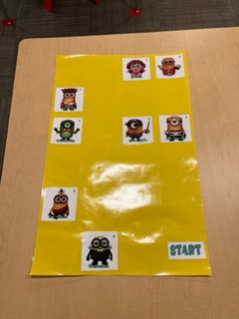  - Exit ticket | Assessments:  - Small group verbal share.  - Exit Ticket | Resources:  - Coding Mat Example: https://laramie1-my.sharepoint.com/:b:/g/personal/minda_blevins_laramie1_org/EbLis_co9NZLoULAiqEE3b8BLJJP3EX0CZvIgr99PaIocA?e=Ow3aIW  - Direction Cards: https://acrobat.adobe.com/link/review?uri=urn:aaid:scds:US:5b14a490-eb39-3a8c-b0c7-c5cba145e666  - Exit Ticket: 22-23 WYSLICE Lesson B Blevins- Recording algorithms page.docx

