Complete all Searches - Cipher Research

Cipher Scavenger Hunt
For each category document your research with weblinks, images, thinking, and evidence.

Find it! | Websites/images | Thinking/evidence/what are your thoughts about it?
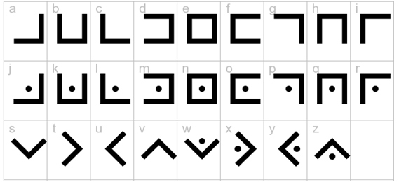

What is a Cipher?


What famous person is connected to the Cipher?



What is cryptography?

Continued

Find it! | Websites/images | Thinking/evidence/what are your thoughts about it?


Find examples of where secret codes are used and tell us about it!
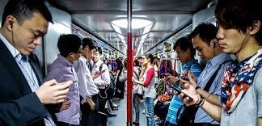
How are ciphers used in everyday life?
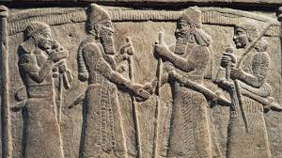
What are the origins of cryptography?



What kinds of threats exist for a cryptographic system?

