Kindergarten Q1-5 Senses (Senses)
Wit & Wisdom Module 1 Overview The Five Senses
Core Texts – Module 1
- • My Five Senses, Aliki
- • My Five Senses, Margaret Miller
- • Rap a Tap Tap, Leo and Diane Dillon
- • Chicka Chicka Boom Boom, Bill Martin Jr. and John Archambault; Illustrations, Lois Ehlert
- • Last Stop on Market Street, Matt de la Peña; Illustrations, Christian Robinson

Science Quarter 1 - Engineering, Technology, and Applications of Science. K-2-ETS1-1: Ask questions, make observations, and gather information about a situation people want to change to define a simple problem that can be solved through the development of a new or improved object or tool.
Computer Science Quarter 1 - K-2.IC.SI.01: Practice grade-level appropriate behaviors and responsibilities while participating in an online community. Identify and report inappropriate behavior
5 Senses:
The Five Senses | The Dr. Binocs Show | Educational Videos For Kids - YouTube 5 senses
The Five Senses • ABCya! Group activity introduction on the SMARTboard
Activities:
- Name That Sound: Using Hearing to Make Observations-take a listen walk and use the ipad record sounds you hear.
- It Feels Like: Using Touch to Make Observations-order the sandpaper in order from roughest to softest using the keynote document.
- Taste Test: Using Taste to Make Observations-video your reaction to different taste items
- How Does it Smell: Using Smell to Make Observations-match the smell using pages document
- I Spy With My Little Eye: Using Sight to Make Observations- using iPads to document what you see
- Pop Pop Pop: Engaging the 5 Senses- Use all your senses to explore popcorn
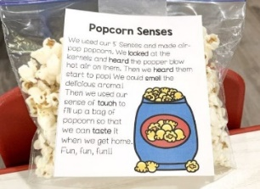
Popcorn is a terrific food for senses activities, especially if you can use an air popper to make it fresh while kids watch. Plus, you get a yummy, healthy snack

