WY-SLICE– Summer 2022
Lesson Plan - Multiplication with MicroBits
Kalista Pendleton

P = Pretest (think essential questions)
O = Objectives (measurable - see Bloom's taxonomy)
C = Catch (hook, anticipatory set, etc... use different senses, not a question)
A = Activity (procedure of what the students should do)
R = Review (how will students go over what they've learned?)
A = Assessment (formative and/or summative)
P = Posttest (same as pretest for comparison purposes)
S = Standards (Wyoming, NGSS, etc...) showcasing crosscutting concepts

Pretest Questions | - What is a Micro:Bit?  - What is coding?  - Can you solve one-digit by one-digit multiplication problems using a Micro:Bit?  - Do you know your multiplication facts?
Objectives | Vocab: Input, output, software, hardware  - Students will be able to fluently multiply one-digit by one-digit numbers.  - Students will be able to code a Micro:Bit to display and answer multiplication questions.
Catch | - On the SMART board I will display a Micro:Bit that will display 4x2=8.  - Ask students how they think the Micro:Bit knows that 4 multiplied by 2 equals 8?  - Ask students how I got the Micro:Bit to display this information?  - Show students makecode.microbit.org and show them the input that told the MicroBit to show an output.  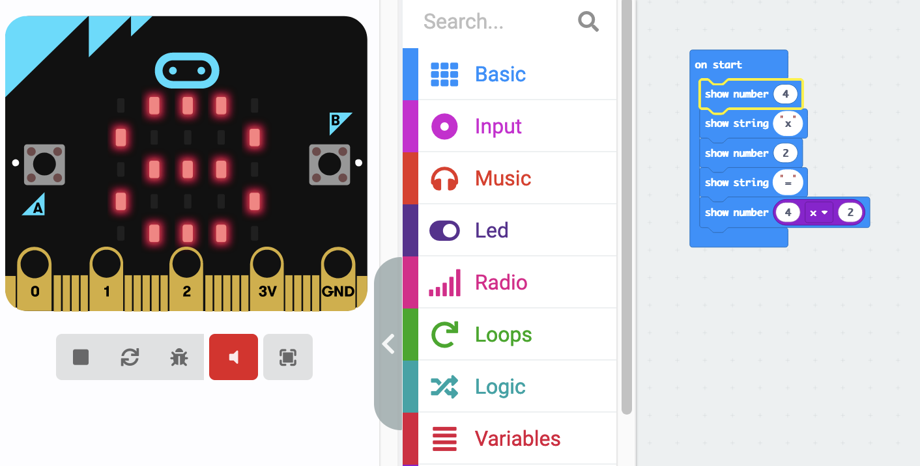  - Ask students if they are ready to try coding a Micro:Bit to answer multiplication problems?  - Give directions on how to use the Micro:Bit responsibly and respectfully and have students go to makecode.microbit.org on their laptops.  - Pass out Micro:Bits and their USB cables.  - Have students plug their Micro:Bit into their laptop.  - Show students how to start a new project and give students time to explore.  - As they explore, walk around and help students troubleshoot any problems.
Activity | - Have students put their computer and MicroBit to the side.  - Pass out a blank piece of paper to each student.  - Have them write their name on top and write 10 one-digit by one-digit multiplication facts down on their paper without answering them. Encourage them not to use x1 or x0. Once they are done, have them flip their paper over.  - Once everyone is done, have them pass their paper to their right. Everyone should now have a paper that is not their own.  - Have them flip over the paper and solve the 10 multiplication problems. Once they finish, have them flip the paper back over and wait patiently for everyone else to finish.  - Pass the papers back to their original owners. Have the owners check their papers to make sure that all of the problems are correct. If they are not correct, have them fix it.  - “Now we are going to program our Micro:bit to answer these questions.”  - “First we are going to do one together.” Walk students through how to use the make code space to program their Microbit to display 9x9=81. Walk around and ensure that students understand.  - Once most students understand the concept, have them erase that code and start their own code to answer the first 3 problems on their paper.  - As students are working you can walk around the room and help as needed.
Review | - Have students use the stand up, hand up, pair up strategy to share what was easy and what was difficult about this project with three people. Once they have shared with three different people they may sit back down.  - Call on volunteers to come up and display their MicroBit code over the projector. Have them explain what they did, what was easy, and what was difficult to the class.
Assessments | - As students are working, take notes based on your observations. Who really understands this, who may need a little more help, and who may need a lot more help.  Observations can tell you who may need more help with their multiplication facts and who may need more help with coding their MicroBit. They can also tell you who is ready to extend their learning and take it to the next level.
Posttest Questions  (same as pretest questions) | - What is a MicroBit?  - What is coding?  - Can you solve one-digit by one-digit multiplication problems using a MicroBit?  - Do you know your multiplication facts?
Standards | Common Core Mathematics  CCSS.Math.Content.3.OA.C.7  CCSS.Math.Content.3.OA.A.1  CCSS.Math.Content.4.OA.B.4  Computer Science  5.CS.D.01  5.CS.HS.01  5.AP.A.01  5.AP.C.01
Extension Activities | - Can you program your MicroBit to display all 10 of your equations?  - Try this with 2-digit by 1-digit. Write out ten problems and solve them. Then have your MicroBit display them.  - What other mathematical equations can your MicroBit display?

