WY-SLICE– Summer 2022
Lesson Plan - HexBug Maze
Kalista Pendleton

P = Pretest (think essential questions)
O = Objectives (measurable - see Bloom's taxonomy)
C = Catch (hook, anticipatory set, etc... use different senses, not a question)
A = Activity (procedure of what the students should do)
R = Review (how will students go over what they've learned?)
A = Assessment (formative and/or summative)
P = Posttest (same as pretest for comparison purposes)
S = Standards (Wyoming, NGSS, etc...) showcasing crosscutting concepts

Pretest Questions | - -Who is Margaret Hamilton?  - -What name did Margaret Hamilton come up with to describe her job?  - -What is a lunar lander?  - -When was the first lunar landing? What was the name of the mission?  - What went wrong during the Apollo 11 mission?  - -How has computer technology changed the world?  - -How can I create a maze for a bug to successfully make it from the computer to the trash?
Objectives | - Students will learn about how Margaret Hamilton saved the first lunar landing.  - Students will use collaboration and problem solving skills to create a maze that can lead a bug from the computer to the trash.  - Students will learn about how computing technologies have changed the world.
Catch | - “Did you know that a woman was responsible for safely landing a man on the moon in 1969?”  - Read the story “Margaret and the Moon” to students. This is a story about Margaret Hamilton who loved numbers as a young girl. She always liked to ask questions and find solutions to problems. She ends up putting this skill to good use by helping astronauts land on the moon! Throughout the book it talks about how she used code to tell the computer what to do.  
Activity | - When you are working on computer programming you will often find mistakes (bugs) in your program. You will need to think of all of the things that could go wrong and how you will tell the computer to fix these problems.  - Relate this to having bugs in a computer program and how you need to put the bug in the trash and then re-write or fix your program.  - Set up: Use painters tape to make 3 feet by 3 feet squares on the floor for each group of students. In one corner tape a clipart bug. In the other corner tape a clipart trash. Students will need to build their maze so that their HexBug starts at the bug and makes it to the trash can.  - For this activity we will be using the engineering design process. Show students an image of this and walk them through each step. Students will be working with a team of 2-4 students. Review how to work as a team with students.  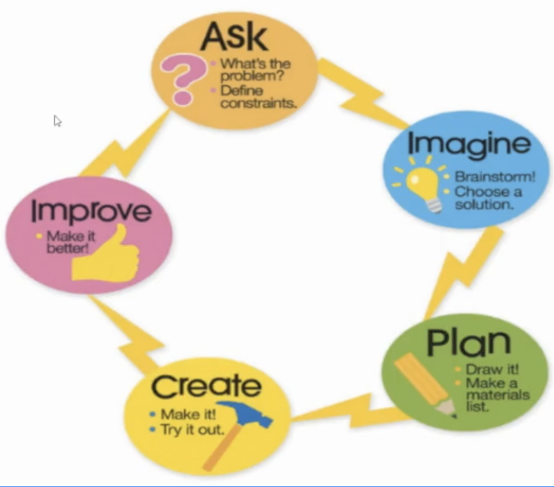  - For ask: How can I create a maze for a bug to successfully make it from the computer to the trash?  - Discuss Supplies and Constraints for this challenge. This will allow students to think about their ideas further. Examples of supplies and constraints are in the attached Google Slides doc.  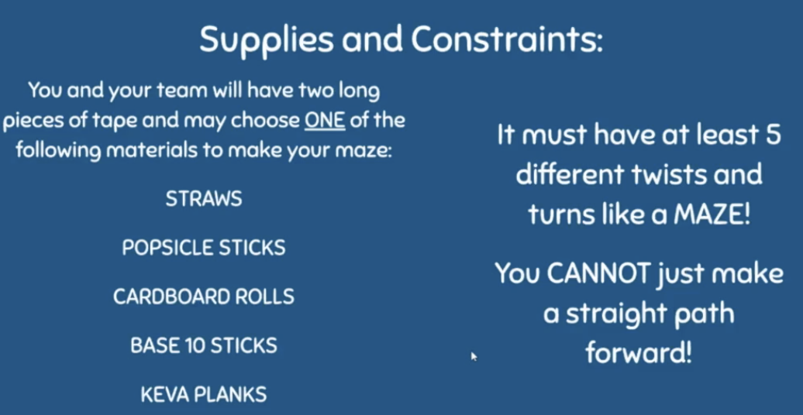  - For imagine: Build schema about mazes. Show students images of different mazes (some students may have never seen a maze.) Talk about how a lot of times in mazes there are trick passages or dead ends. Talk about how a path in a maze is different then building a road. A maze usually has to have 3D walls.  - For Plan: Have students work with their teammates to discuss and draw out their plan. Give them around 10 minutes to plan.  - For Create: Assign a square to each team. Have one teammate gather supplies. “When I say “go” you may begin creating.” Give students a set amount of time to build their design- around 20 minutes.  - For Improve: Once the timer goes off, have students stop and look at their design. How can you make it better? Could you add another twist or turn? Do you need to make your walls bigger? Is there enough room for your HexBug to travel through the maze? Then give them 5 minutes to make improvements. Engineers are always looking at how they can make it better.
Review | - Gallery Walk -At then end have students take a gallery walk around the room to look at each other's designs. Each team can model their maze and tell their peers about what they did and what worked and did not work.
Assessments | - Observations on how students work together.
Posttest Questions  (same as pretest questions) | - -Who is Margaret Hamilton?  - -What name did Margaret Hamilton come up with to describe her job?  - -What is a lunar lander?  - -When was the first lunar landing? What was the name of the mission?  - What went wrong during the Apollo 11 mission?  - -How has computer technology changed the world?  - -How can I create a maze for a bug to successfully make it from the computer to the trash?
Standards | Computer Science  5.CS.T.01  5.AP.A.01  5.AP.M.01  5.IC.C.01
Crosscutting Concepts from NGSS | CCSS.ELA-Literacy.RF.3.4  CCSS.ELA-Literacy.SL.3.1  CCSS.ELA-Literacy.SL.3.2  CCSS.ELA-Literacy.RI.3.10
Extension Activities | - Have students write out the steps that the HexBug would need to follow in order to make it through the maze.  - Have students add on to their maze. Add dead ends, trick paths, shortcuts, twists and turns.  - Use code.org or Scratch to create a maze and a character. Then code your character to go through the maze.  - You could also have your students engineer a Bristlebot for this activity instead of using HexBugs

