Order of Operations MICRO:BIT Calculator

Math using parentheses!

Make a Micro:bit calculator to solve order of operations expressions

Goal-Solve mathematical expressions with parentheses using order of operations.

CCSS

5.OA.1 Use parentheses, brackets, or braces in numerical expressions, and evaluate expressions with these symbols

- Students will practice solving expressions with parentheses using order of operations.
- Check their correctness using a created Micro:bit calculator

Assessment

Pre and post-

1.) 3 x 9 + 7

2.) (67-18)/7*3

Below Basic | Basic | Proficient | Advanced
Needs 1-1 teacher help to solve mathematical expressions with parentheses using order of operations | solves mathematical expressions with parentheses using order of operations with some teacher help | Independently solves mathematical expressions with parentheses using order of operations. | Can teach a peer-
Needs 1-1 teacher help to create Micro:bit calculator program | creates Micro:bit calculator program with some teacher help | Independently creates Micro:bit calculator program | Makes a micro:bit calculator communicate with another.

- Pre-test without calculator

1.) 3 x 9 + 7

2.) (67-18)/7*3

- Using https://makecode.microbit.org/-

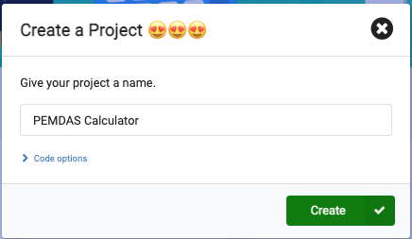

- Share PEMDAS
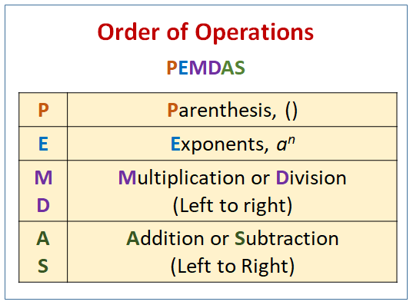
5. Give a PEMDAS expression such as (10 x 5) +( 6 / 2)

6. Tell students that the code will need to change based on the expression and won’t be in the same order as in the expression, this shows us visually how a real calculator works.
7. Code the calculator for (10 x 5) +( 6 / 2)

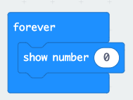

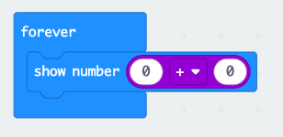
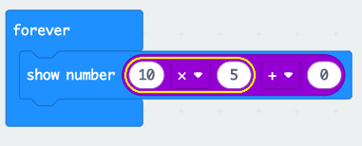

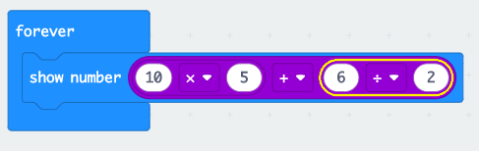
These steps show how to set up the calculator.

For the assessment Solutions:

1.) 3 x 9 + 7

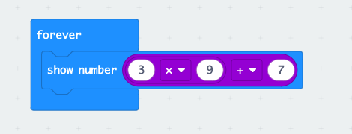

2.) (67-18)/7*3

