Prelab Handout

Predict what will happen to the particles when thermal energy is added:

Before After
Adding or Removing Thermal Energy

State Before:_____________ State After:_____________
Particle Movement: ___________ Particle Movement: ___________

Base Code for Micro:bit

https://makecode.microbit.org/_ipjfDDgLMDM8

  - Log onto https://makecode.microbit.org/
  - Select “New Project”
  - Title project “Timer”

On Start
  - Select variables (red color)
  - Make a variable
  - New variable name: timer
  - Select set timer to 0
  - Drag into on start
  - Switch set timer to 60 (so that it is counting down 1 minute)

On Button A – this will reset the timer when button A is pressed
  - Select input (pink color)
  - Select on button A pressed
  - Select variables (red)
  - Select set timer to 0
  - Drag into on button A
  - Switch set timer to 60 (so that it is counting down 1 minute)

On Button B- this will start the timer counting down when button B is pressed
  - Select input (pink color)
  - Select on button A pressed
  - Click the A and switch it to B so it reads On Button B pressed
  - Select loops (green color)
  - Select while false do
  - Drag while false do under on button B pressed
  - Select logic (teal color)
  - Select under comparisons 0 < 0
  - Drag 0<0 over false in while false do
  - Select < sign and change to > sign
  - Select variables (red)
  - Select timer
  - Drag timer over first 0 so it reads timer > 0
  - Select basic (blue color)
  - Select pause (ms)
  - Drag pause (ms) next to do
  - Select variable (red color)
  - Select change timer by 1
  - Drag change timer by 1 below pause (ms)
  - Select basic (blue color)
  - Select show number 0
  - Select variable (red color)
  - Select timer
  - Drag timer over 0 in show number 0 so it reads show number timer
  - Drag show number timer below change timer by 1
  - Select basic (blue color)
  - Select show icon
  - Change icon to heart symbol
  - Drag show icon heart below while do

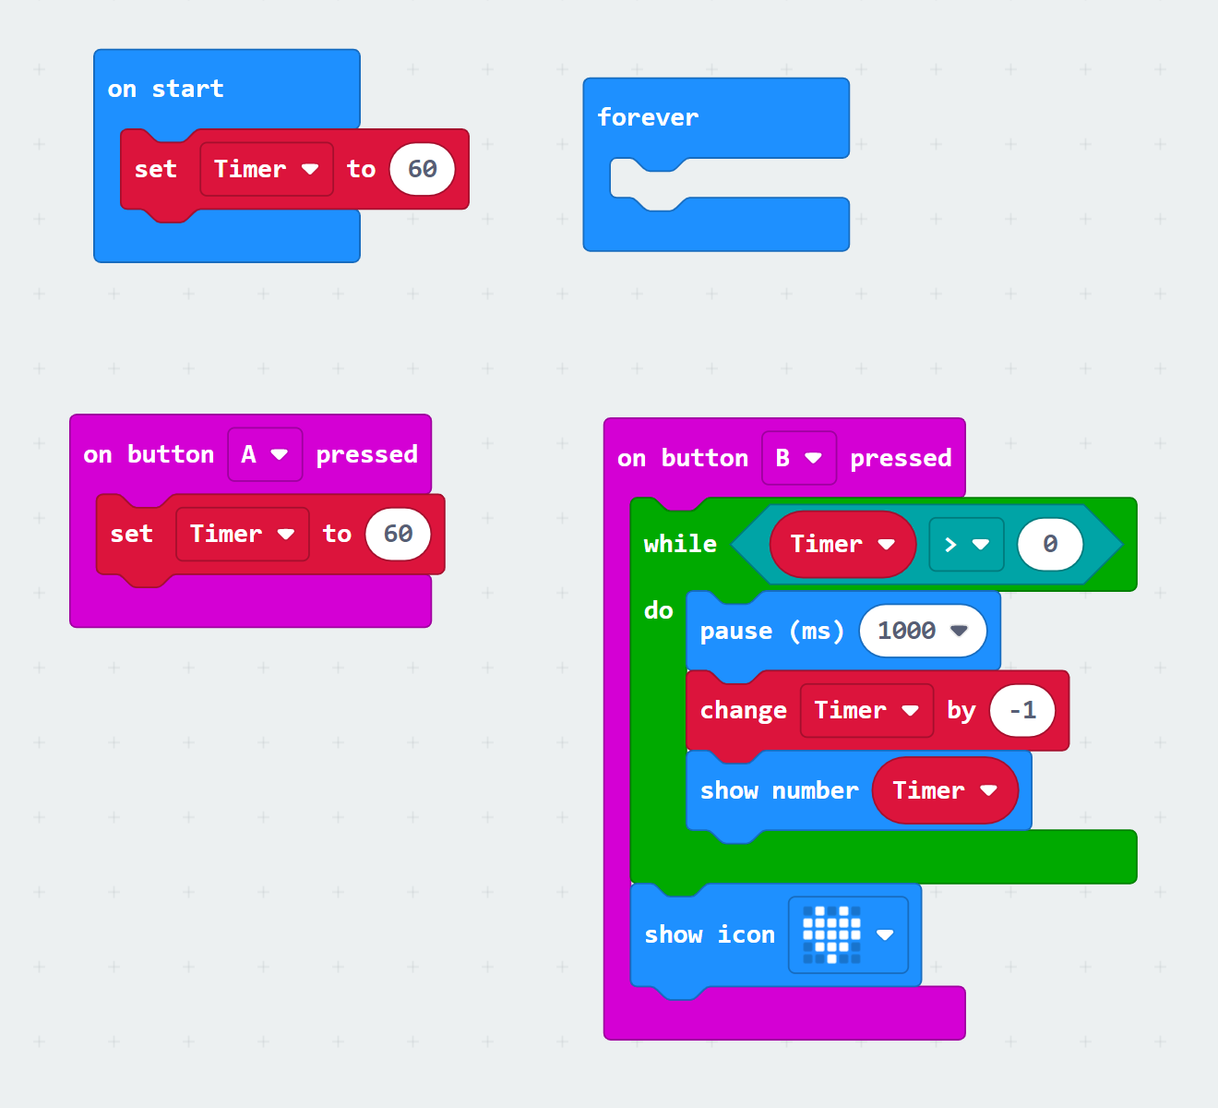

References

Microsoft. Countdown timer. MakeCode. https://makecode.microbit.org/projects/watch/timer
Phase Change Lab

Team Captain: ____________________________ Timekeeper: ____________________________

Materials Manager: ____________________________ Recorder: ____________________________

Lab Safety:
- Wear goggles at all times!
- Do not touch the hot plates!
- Do not touch the beakers on the hot plates!
- Report any injuries right away
- Be very careful of the thermometers
- Tell teacher right away if glass breaks or if the thermometer breaks
-DO NOT PICK IT UP!
- Listen to instructions
- No horseplay
- Clean up all materials

Materials:
One larger beaker with 75 mL of water
One small beaker with 75 mL of water
One beaker on hot plate
One hot plate
Team lab handout
Student notebooks
Goggles
Hot hands mitts/ protectors
Micro:bit - keep away from hot plate and water!

Data Table End of Lab Observations
Observation # | Temperature in Celsius  (observe and record every minute)
1
2
3
4
5
6
7
8
9
10
11
12
13
14
15
16
17
18
19
Room temperature beaker

Temperature ________ °C

State of matter (circle all that apply)

Solid Liquid Gas

Dye spreading throughout beaker
(circle the one that applies)

Dye not moving

Dye spreading a little

Dye spreading out fast

Dye all over beaker

Beaker on hot plate

Ending Temperature ________ °C

State of matter (circle all that apply)

Solid Liquid Gas

Dye spreading throughout beaker
(circle the one that applies)

Dye not moving

Dye spreading a little

Dye spreading out fast

Dye all over beaker

Directions
Materials Manager and Recorder

- Get goggles for team
- Grab one thermometer for team
- Grab one hot hands mitt/ hand protector
- Measure 75 mL of water
- Pour 75 mL of water into large beaker
- Measure 75 mL of water
- Pour 75 mL of water into small beaker
- Bring supplies to Hot Plate Station

- Materials Manager – pour 75 mL water from small beaker into beaker on hot plate. Add thermometer to beaker. Set large beaker with 75mL from prep area next to hot plate
- Team Captain- read beginning temperature of thermometer
- Recorder- write down beginning temperature on team handout Celsius (C)
- Timekeeper- Grab micro:bit. Turn hot plate on high & start timer (press Button B on micro:bit). Tell team when timer is done (shows heart). Start timer again. Repeat for 19 minutes.
- Team Captain- read temperature of thermometer in Celsius (C)
- Recorder- write down temperature on team handout

Directions

Directions continue on back
Directions Continued

- Materials Manager - turn hot plate completely off. Leave hot beaker on hot plate.
- Recorder – Write down team’s answers to “End of Lab Observations” questions
- Team Captain- read ending temperature of thermometer in hot beaker and room temperature beaker
- Team- decide states of matter observed in both beakers
- Timekeeper- Raise hand for teacher to bring food coloring
- Team- decide how quickly dye is spreading in each beaker
- Recorder- write down team responses

Clean Up

- Materials Manager- turn hot plate completely off. Leave hot beaker on hot plate. Take thermometer and other beakers back to lab prep area

- Recorder- return team’s goggles to cabinet

- Timekeeper- check that lab area is clean, and nothing is left at lab station

- Team Captain- raise hand to signal that teacher should check your area
- Team- wash hands

Post Lab

- Look at your temperature data. What patterns did you notice when you were recording the temperature?
___________________________________________________________________________
__________________________________________________________________________
- Revise the model of the before and after state of matter. Was thermal energy added or removed during this phase change? Circle the answer below.
Before After
Adding or Removing Thermal Energy

- When adding thermal energy, how did the particle movement change?:___________________________________________________________________________________________________________________________________________
- Explain what happened to the temperature when thermal energy is added:________________________________________________________________________________________________________________________________
- Explain what happens to the state of matter when thermal energy is added:________________________________________________________________________________________________________________________________

