Name:_____________________
MicroBit Morse Code: Handout

Directions: Write a secret word below. Make sure that your word is appropriate for school. Then, use the code to encode your message for transmission.
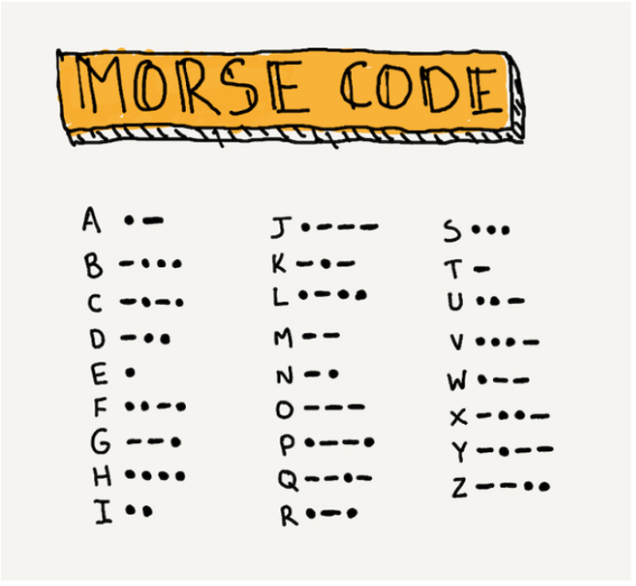

Example Secret Word:
“banana”

-ᐧᐧᐧ ᐧ- -ᐧ ᐧ- ᐧ- ᐧ-

My Secret Word:

_________________________________________

Encoded into Morse Code:

Once your Micro:Bit is coded, try sending your message to your partner. When it is your turn to receive the message, record what you see below. What was your partner’s secret word?

Message I received:

My Partner’s Secret Word:
___________________________________________

Challenge: Can you send and receive a short phrase message to your partner?

Reflection:
- How did communication change? Give specific examples to explain your thinking.
__________________________________________________________________________________________________________________________________________________________________________________________________________________________________________________________________________________________________________________________________________________________________________________________________________________________________________________________________________________________________________
- Which form of historical communication do you think is the best? Why?
__________________________________________________________________________________________________________________________________________________________________________________________________________________________________________________________________________________________________________________________________________________________________________________________________________________________________________________________________________________________________________

